All Phthalates animal - no strain grouping.FinalDraft2

Weihsueh Chiu

May 18, 2017

## AGD animal details

## [1] "AGD log(Ratio of mean) Rat"  
## [1] "AGD log(Ratio of mean) Mouse"  
## [1] "AGD log(Ratio of mean) Rat"  
## [1] "Overall Effect---------------------"  
##   
## Random-Effects Model (k = 107; tau^2 estimator: REML)  
##   
## logLik deviance AIC BIC AICc   
## -337.9647 675.9294 679.9294 685.2562 680.0459   
##   
## tau^2 (estimated amount of total heterogeneity): 12.1222 (SE = 4.2087)  
## tau (square root of estimated tau^2 value): 3.4817  
## I^2 (total heterogeneity / total variability): 45.74%  
## H^2 (total variability / sampling variability): 1.84  
##   
## Test for Heterogeneity:   
## Q(df = 106) = 187.2555, p-val < .0001  
##   
## Model Results:  
##   
## estimate se zval pval ci.lb ci.ub   
## -3.9588 0.5664 -6.9893 <.0001 -5.0690 -2.8487 ***   
##   
## ---  
## Signif. codes: 0 '***' 0.001 '**' 0.01 '*' 0.05 '.' 0.1 ' ' 1

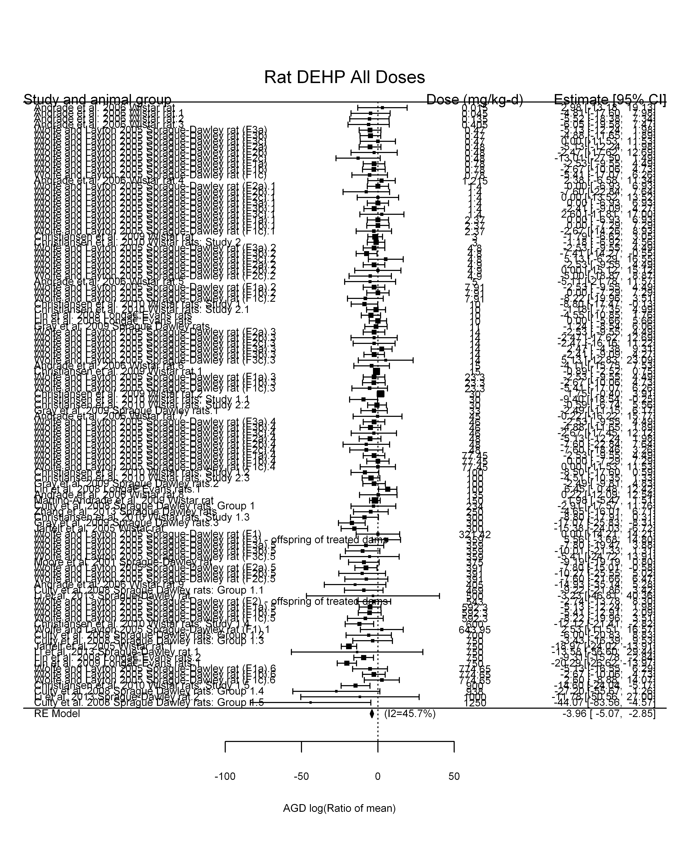

## [1] "Leave one out---------------------"  
##   
## Random-Effects Model (k = 104; tau^2 estimator: REML)  
##   
## tau^2 (estimated amount of total heterogeneity): 11.7529 (SE = 4.4417)  
## tau (square root of estimated tau^2 value): 3.4283  
## I^2 (total heterogeneity / total variability): 37.58%  
## H^2 (total variability / sampling variability): 1.60  
##   
## Test for Heterogeneity:   
## Q(df = 103) = 155.2445, p-val = 0.0007  
##   
## Model Results:  
##   
## estimate se zval pval ci.lb ci.ub   
## -4.2277 0.5826 -7.2570 <.0001 -5.3695 -3.0859 ***   
##   
## ---  
## Signif. codes: 0 '***' 0.001 '**' 0.01 '*' 0.05 '.' 0.1 ' ' 1   
##   
##   
## Random-Effects Model (k = 97; tau^2 estimator: REML)  
##   
## tau^2 (estimated amount of total heterogeneity): 12.4602 (SE = 4.5622)  
## tau (square root of estimated tau^2 value): 3.5299  
## I^2 (total heterogeneity / total variability): 46.25%  
## H^2 (total variability / sampling variability): 1.86  
##   
## Test for Heterogeneity:   
## Q(df = 96) = 168.7985, p-val < .0001  
##   
## Model Results:  
##   
## estimate se zval pval ci.lb ci.ub   
## -3.6932 0.6065 -6.0898 <.0001 -4.8818 -2.5046 ***   
##   
## ---  
## Signif. codes: 0 '***' 0.001 '**' 0.01 '*' 0.05 '.' 0.1 ' ' 1   
##   
##   
## Random-Effects Model (k = 101; tau^2 estimator: REML)  
##   
## tau^2 (estimated amount of total heterogeneity): 12.3512 (SE = 4.2716)  
## tau (square root of estimated tau^2 value): 3.5144  
## I^2 (total heterogeneity / total variability): 47.34%  
## H^2 (total variability / sampling variability): 1.90  
##   
## Test for Heterogeneity:   
## Q(df = 100) = 179.0901, p-val < .0001  
##   
## Model Results:  
##   
## estimate se zval pval ci.lb ci.ub   
## -3.8621 0.5756 -6.7102 <.0001 -4.9902 -2.7340 ***   
##   
## ---  
## Signif. codes: 0 '***' 0.001 '**' 0.01 '*' 0.05 '.' 0.1 ' ' 1   
##   
##   
## Random-Effects Model (k = 104; tau^2 estimator: REML)  
##   
## tau^2 (estimated amount of total heterogeneity): 11.0893 (SE = 4.1345)  
## tau (square root of estimated tau^2 value): 3.3301  
## I^2 (total heterogeneity / total variability): 43.19%  
## H^2 (total variability / sampling variability): 1.76  
##   
## Test for Heterogeneity:   
## Q(df = 103) = 173.8020, p-val < .0001  
##   
## Model Results:  
##   
## estimate se zval pval ci.lb ci.ub   
## -4.0202 0.5680 -7.0779 <.0001 -5.1335 -2.9070 ***   
##   
## ---  
## Signif. codes: 0 '***' 0.001 '**' 0.01 '*' 0.05 '.' 0.1 ' ' 1   
##   
##   
## Random-Effects Model (k = 103; tau^2 estimator: REML)  
##   
## tau^2 (estimated amount of total heterogeneity): 11.7899 (SE = 4.2425)  
## tau (square root of estimated tau^2 value): 3.4336  
## I^2 (total heterogeneity / total variability): 45.13%  
## H^2 (total variability / sampling variability): 1.82  
##   
## Test for Heterogeneity:   
## Q(df = 102) = 176.9060, p-val < .0001  
##   
## Model Results:  
##   
## estimate se zval pval ci.lb ci.ub   
## -3.8865 0.5760 -6.7478 <.0001 -5.0154 -2.7576 ***   
##   
## ---  
## Signif. codes: 0 '***' 0.001 '**' 0.01 '*' 0.05 '.' 0.1 ' ' 1   
##   
##   
## Random-Effects Model (k = 105; tau^2 estimator: REML)  
##   
## tau^2 (estimated amount of total heterogeneity): 8.8420 (SE = 3.6744)  
## tau (square root of estimated tau^2 value): 2.9735  
## I^2 (total heterogeneity / total variability): 37.79%  
## H^2 (total variability / sampling variability): 1.61  
##   
## Test for Heterogeneity:   
## Q(df = 104) = 156.8614, p-val = 0.0006  
##   
## Model Results:  
##   
## estimate se zval pval ci.lb ci.ub   
## -3.7210 0.5387 -6.9076 <.0001 -4.7768 -2.6652 ***   
##   
## ---  
## Signif. codes: 0 '***' 0.001 '**' 0.01 '*' 0.05 '.' 0.1 ' ' 1   
##   
##   
## Random-Effects Model (k = 104; tau^2 estimator: REML)  
##   
## tau^2 (estimated amount of total heterogeneity): 12.1535 (SE = 4.2146)  
## tau (square root of estimated tau^2 value): 3.4862  
## I^2 (total heterogeneity / total variability): 46.49%  
## H^2 (total variability / sampling variability): 1.87  
##   
## Test for Heterogeneity:   
## Q(df = 103) = 186.8135, p-val < .0001  
##   
## Model Results:  
##   
## estimate se zval pval ci.lb ci.ub   
## -3.9472 0.5673 -6.9575 <.0001 -5.0592 -2.8353 ***   
##   
## ---  
## Signif. codes: 0 '***' 0.001 '**' 0.01 '*' 0.05 '.' 0.1 ' ' 1   
##   
##   
## Random-Effects Model (k = 105; tau^2 estimator: REML)  
##   
## tau^2 (estimated amount of total heterogeneity): 6.7231 (SE = 3.2363)  
## tau (square root of estimated tau^2 value): 2.5929  
## I^2 (total heterogeneity / total variability): 31.65%  
## H^2 (total variability / sampling variability): 1.46  
##   
## Test for Heterogeneity:   
## Q(df = 104) = 138.9820, p-val = 0.0125  
##   
## Model Results:  
##   
## estimate se zval pval ci.lb ci.ub   
## -3.4370 0.5116 -6.7177 <.0001 -4.4397 -2.4342 ***   
##   
## ---  
## Signif. codes: 0 '***' 0.001 '**' 0.01 '*' 0.05 '.' 0.1 ' ' 1   
##   
##   
## Random-Effects Model (k = 106; tau^2 estimator: REML)  
##   
## tau^2 (estimated amount of total heterogeneity): 12.1452 (SE = 4.2259)  
## tau (square root of estimated tau^2 value): 3.4850  
## I^2 (total heterogeneity / total variability): 45.89%  
## H^2 (total variability / sampling variability): 1.85  
##   
## Test for Heterogeneity:   
## Q(df = 105) = 185.7075, p-val < .0001  
##   
## Model Results:  
##   
## estimate se zval pval ci.lb ci.ub   
## -3.9148 0.5691 -6.8794 <.0001 -5.0301 -2.7994 ***   
##   
## ---  
## Signif. codes: 0 '***' 0.001 '**' 0.01 '*' 0.05 '.' 0.1 ' ' 1   
##   
##   
## Random-Effects Model (k = 106; tau^2 estimator: REML)  
##   
## tau^2 (estimated amount of total heterogeneity): 12.2638 (SE = 4.2433)  
## tau (square root of estimated tau^2 value): 3.5020  
## I^2 (total heterogeneity / total variability): 46.16%  
## H^2 (total variability / sampling variability): 1.86  
##   
## Test for Heterogeneity:   
## Q(df = 105) = 187.1597, p-val < .0001  
##   
## Model Results:  
##   
## estimate se zval pval ci.lb ci.ub   
## -3.9559 0.5699 -6.9415 <.0001 -5.0729 -2.8390 ***   
##   
## ---  
## Signif. codes: 0 '***' 0.001 '**' 0.01 '*' 0.05 '.' 0.1 ' ' 1   
##   
##   
## Random-Effects Model (k = 97; tau^2 estimator: REML)  
##   
## tau^2 (estimated amount of total heterogeneity): 12.9087 (SE = 4.4154)  
## tau (square root of estimated tau^2 value): 3.5929  
## I^2 (total heterogeneity / total variability): 48.97%  
## H^2 (total variability / sampling variability): 1.96  
##   
## Test for Heterogeneity:   
## Q(df = 96) = 183.1427, p-val < .0001  
##   
## Model Results:  
##   
## estimate se zval pval ci.lb ci.ub   
## -4.0447 0.5910 -6.8435 <.0001 -5.2031 -2.8863 ***   
##   
## ---  
## Signif. codes: 0 '***' 0.001 '**' 0.01 '*' 0.05 '.' 0.1 ' ' 1   
##   
##   
## Random-Effects Model (k = 106; tau^2 estimator: REML)  
##   
## tau^2 (estimated amount of total heterogeneity): 12.4637 (SE = 4.3504)  
## tau (square root of estimated tau^2 value): 3.5304  
## I^2 (total heterogeneity / total variability): 45.56%  
## H^2 (total variability / sampling variability): 1.84  
##   
## Test for Heterogeneity:   
## Q(df = 105) = 186.9992, p-val < .0001  
##   
## Model Results:  
##   
## estimate se zval pval ci.lb ci.ub   
## -4.0057 0.5760 -6.9546 <.0001 -5.1346 -2.8768 ***   
##   
## ---  
## Signif. codes: 0 '***' 0.001 '**' 0.01 '*' 0.05 '.' 0.1 ' ' 1   
##   
##   
## Random-Effects Model (k = 46; tau^2 estimator: REML)  
##   
## tau^2 (estimated amount of total heterogeneity): 28.8570 (SE = 10.4985)  
## tau (square root of estimated tau^2 value): 5.3719  
## I^2 (total heterogeneity / total variability): 72.75%  
## H^2 (total variability / sampling variability): 3.67  
##   
## Test for Heterogeneity:   
## Q(df = 45) = 156.9458, p-val < .0001  
##   
## Model Results:  
##   
## estimate se zval pval ci.lb ci.ub   
## -5.5850 1.0883 -5.1318 <.0001 -7.7181 -3.4520 ***   
##   
## ---  
## Signif. codes: 0 '***' 0.001 '**' 0.01 '*' 0.05 '.' 0.1 ' ' 1   
##   
## [1] "Linear in log10(dose)---------------------"  
##   
## Mixed-Effects Model (k = 107; tau^2 estimator: REML)  
##   
## logLik deviance AIC BIC AICc   
## -328.3611 656.7223 662.7223 670.6842 662.9599   
##   
## tau^2 (estimated amount of residual heterogeneity): 9.0101 (SE = 3.6558)  
## tau (square root of estimated tau^2 value): 3.0017  
## I^2 (residual heterogeneity / unaccounted variability): 38.46%  
## H^2 (unaccounted variability / sampling variability): 1.62  
## R^2 (amount of heterogeneity accounted for): 25.67%  
##   
## Test for Residual Heterogeneity:   
## QE(df = 105) = 160.0317, p-val = 0.0004  
##   
## Test of Moderators (coefficient(s) 2):   
## QM(df = 1) = 14.6638, p-val = 0.0001  
##   
## Model Results:  
##   
## estimate se zval pval ci.lb ci.ub   
## intrcpt -1.1764 0.8895 -1.3225 0.1860 -2.9198 0.5670   
## log10(dose) -1.9742 0.5155 -3.8293 0.0001 -2.9846 -0.9637 ***  
##   
## ---  
## Signif. codes: 0 '***' 0.001 '**' 0.01 '*' 0.05 '.' 0.1 ' ' 1

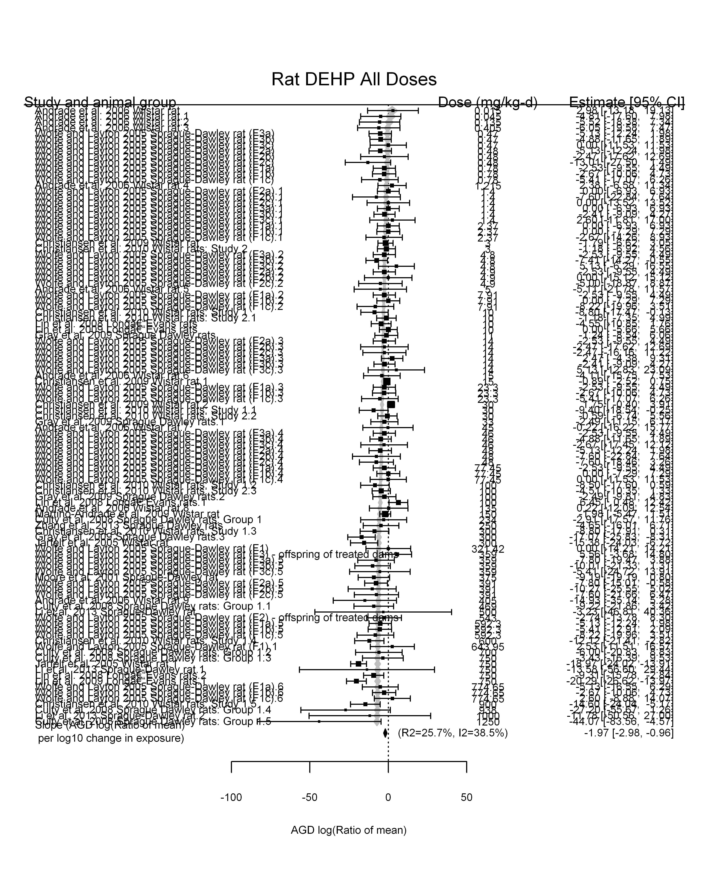

## [1] "Linear in dose---------------------"  
##   
## Mixed-Effects Model (k = 107; tau^2 estimator: REML)  
##   
## logLik deviance AIC BIC AICc   
## -327.6719 655.3439 659.3439 664.6707 659.4604   
##   
## tau^2 (estimated amount of residual heterogeneity): 3.8914 (SE = 2.5076)  
## tau (square root of estimated tau^2 value): 1.9727  
## I^2 (residual heterogeneity / unaccounted variability): 22.05%  
## H^2 (unaccounted variability / sampling variability): 1.28  
##   
## Test for Residual Heterogeneity:   
## QE(df = 106) = 122.9984, p-val = 0.1239  
##   
## Model Results:  
##   
## estimate se zval pval ci.lb ci.ub   
## dose100 -1.5468 0.1588 -9.7397 <.0001 -1.8580 -1.2355 ***  
##   
## ---  
## Signif. codes: 0 '***' 0.001 '**' 0.01 '*' 0.05 '.' 0.1 ' ' 1

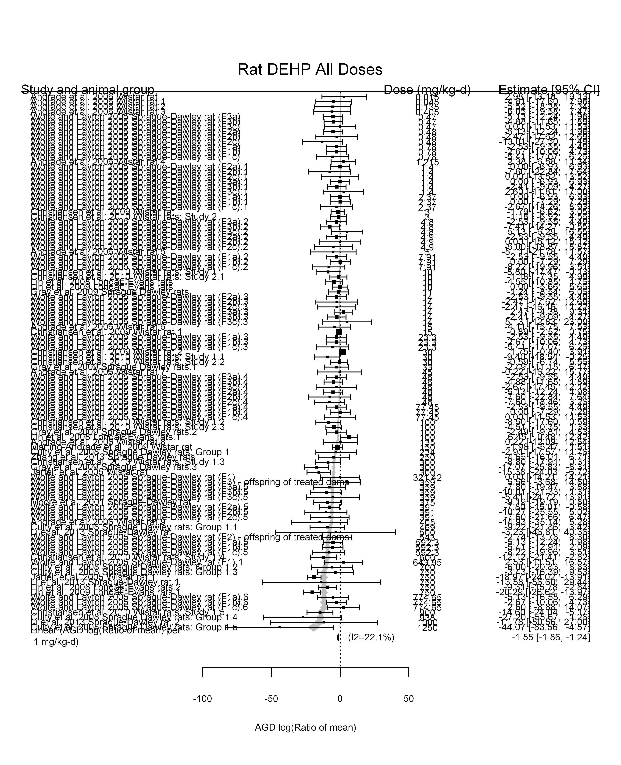

## [1] "Linear or LinearQuadratic in dose---------------------"  
##   
## Mixed-Effects Model (k = 107; tau^2 estimator: REML)  
##   
## logLik deviance AIC BIC AICc   
## -324.1745 648.3490 654.3490 662.3109 654.5867   
##   
## tau^2 (estimated amount of residual heterogeneity): 4.1134 (SE = 2.5840)  
## tau (square root of estimated tau^2 value): 2.0281  
## I^2 (residual heterogeneity / unaccounted variability): 22.94%  
## H^2 (unaccounted variability / sampling variability): 1.30  
##   
## Test for Residual Heterogeneity:   
## QE(df = 105) = 122.4645, p-val = 0.1171  
##   
## Test of Moderators (coefficient(s) 1,2):   
## QM(df = 2) = 94.4806, p-val < .0001  
##   
## Model Results:  
##   
## estimate se zval pval ci.lb ci.ub   
## dose100 -2.1087 0.6090 -3.4623 0.0005 -3.3024 -0.9150 ***  
## I(dose100^2) 0.0834 0.0869 0.9593 0.3374 -0.0870 0.2537   
##   
## ---  
## Signif. codes: 0 '***' 0.001 '**' 0.01 '*' 0.05 '.' 0.1 ' ' 1

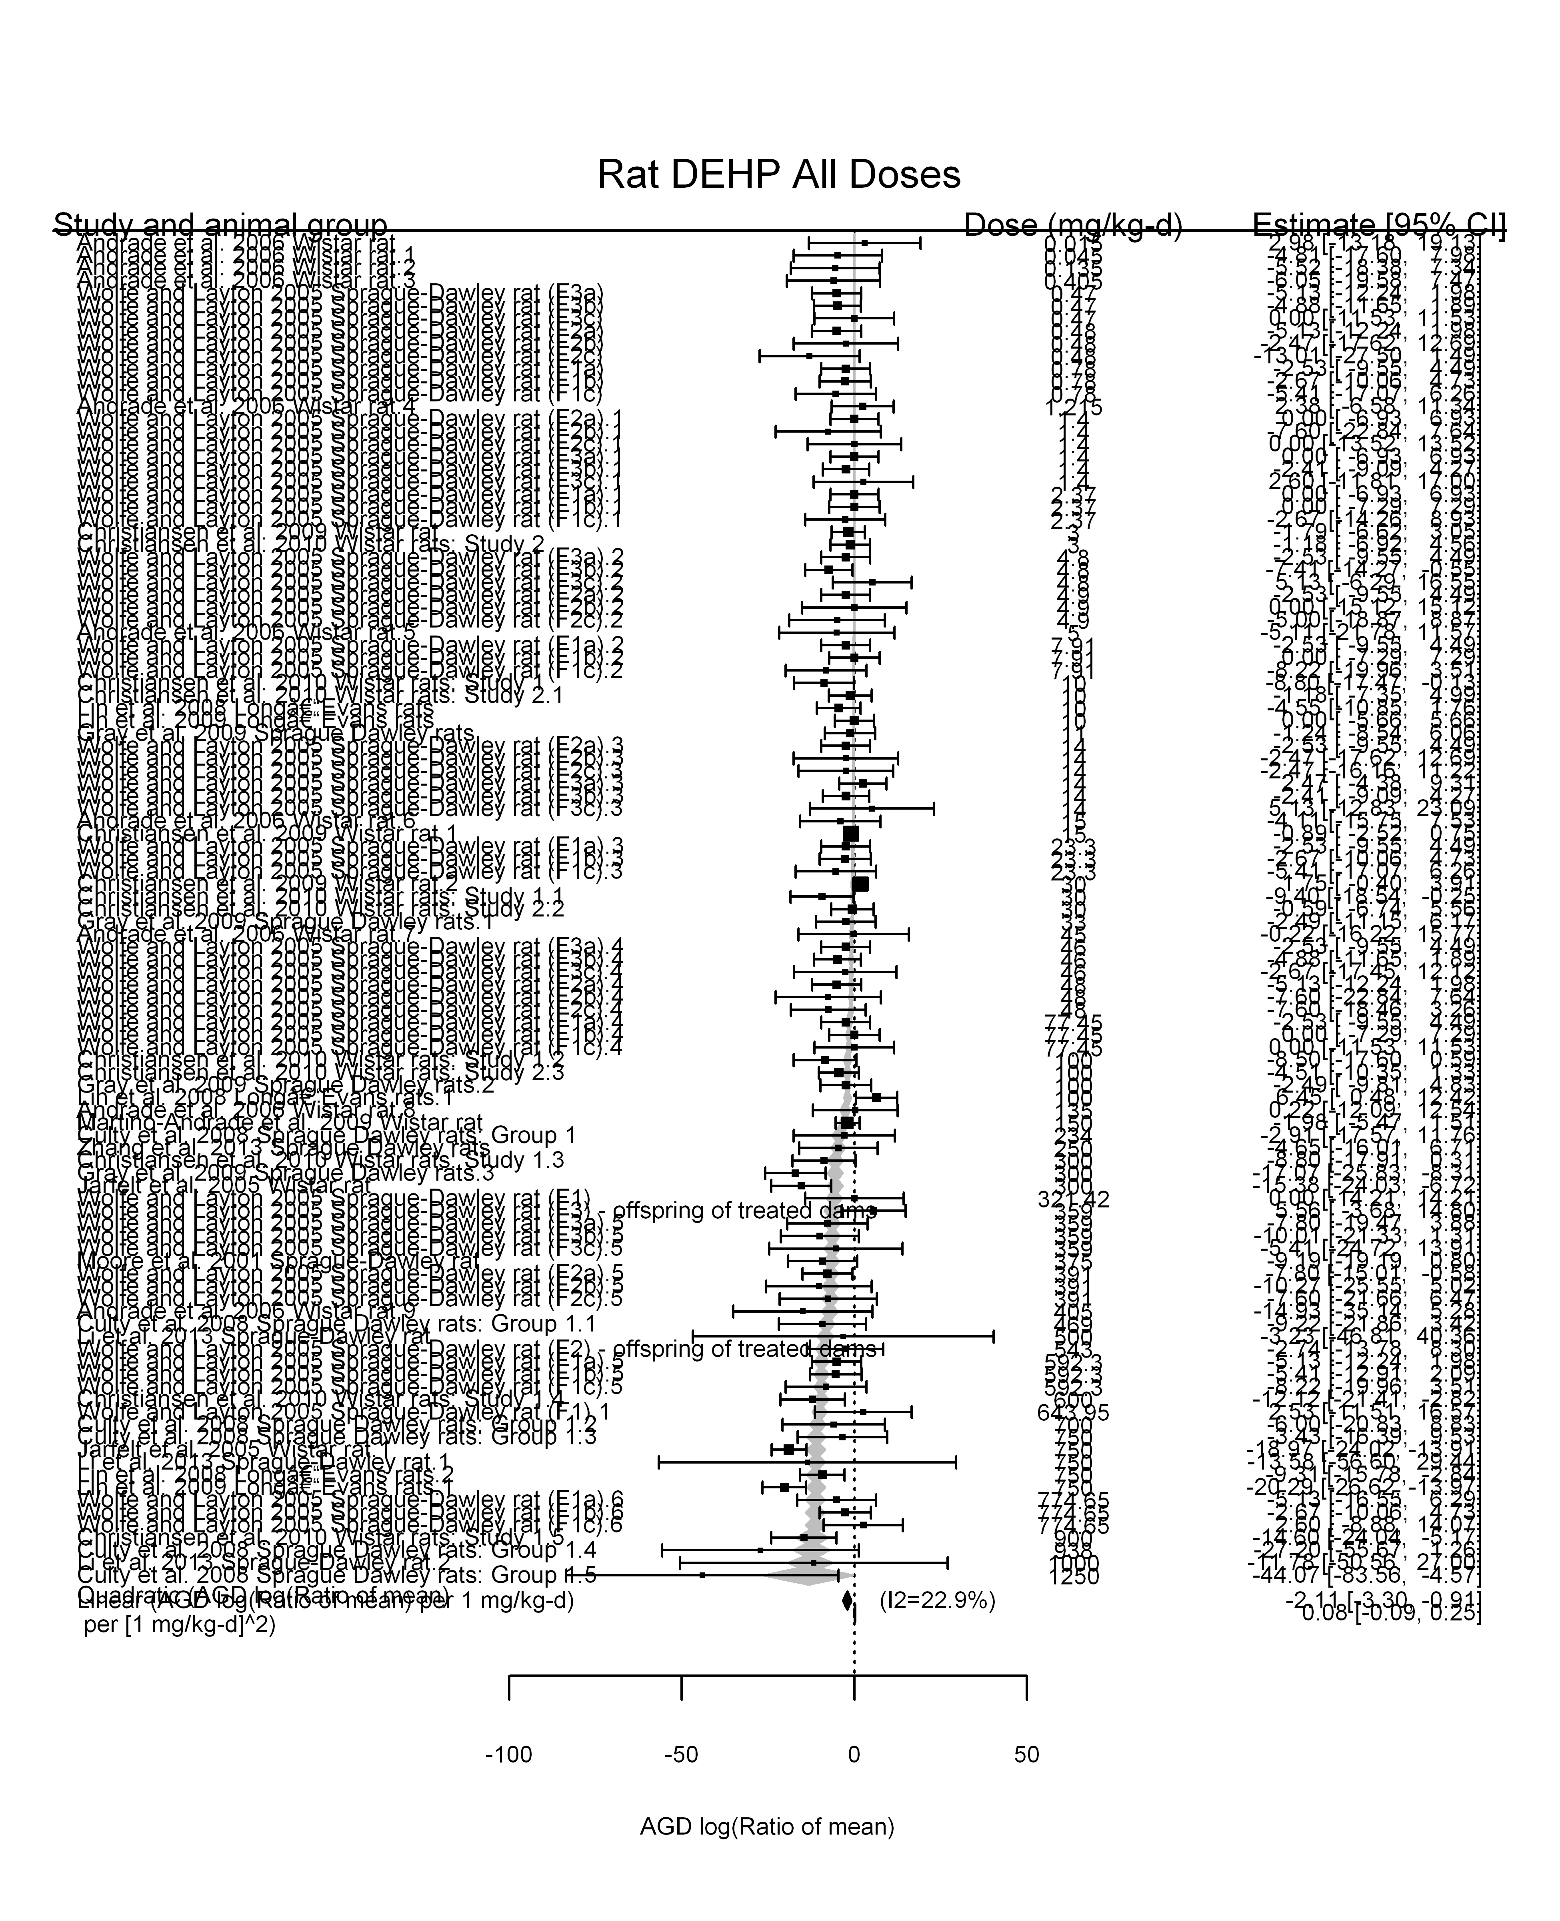

## [1] ""

## [1] ""  
## m ci.lb ci.ub bmr  
## 1 331.6191 276.0631 415.1607 -5.129329

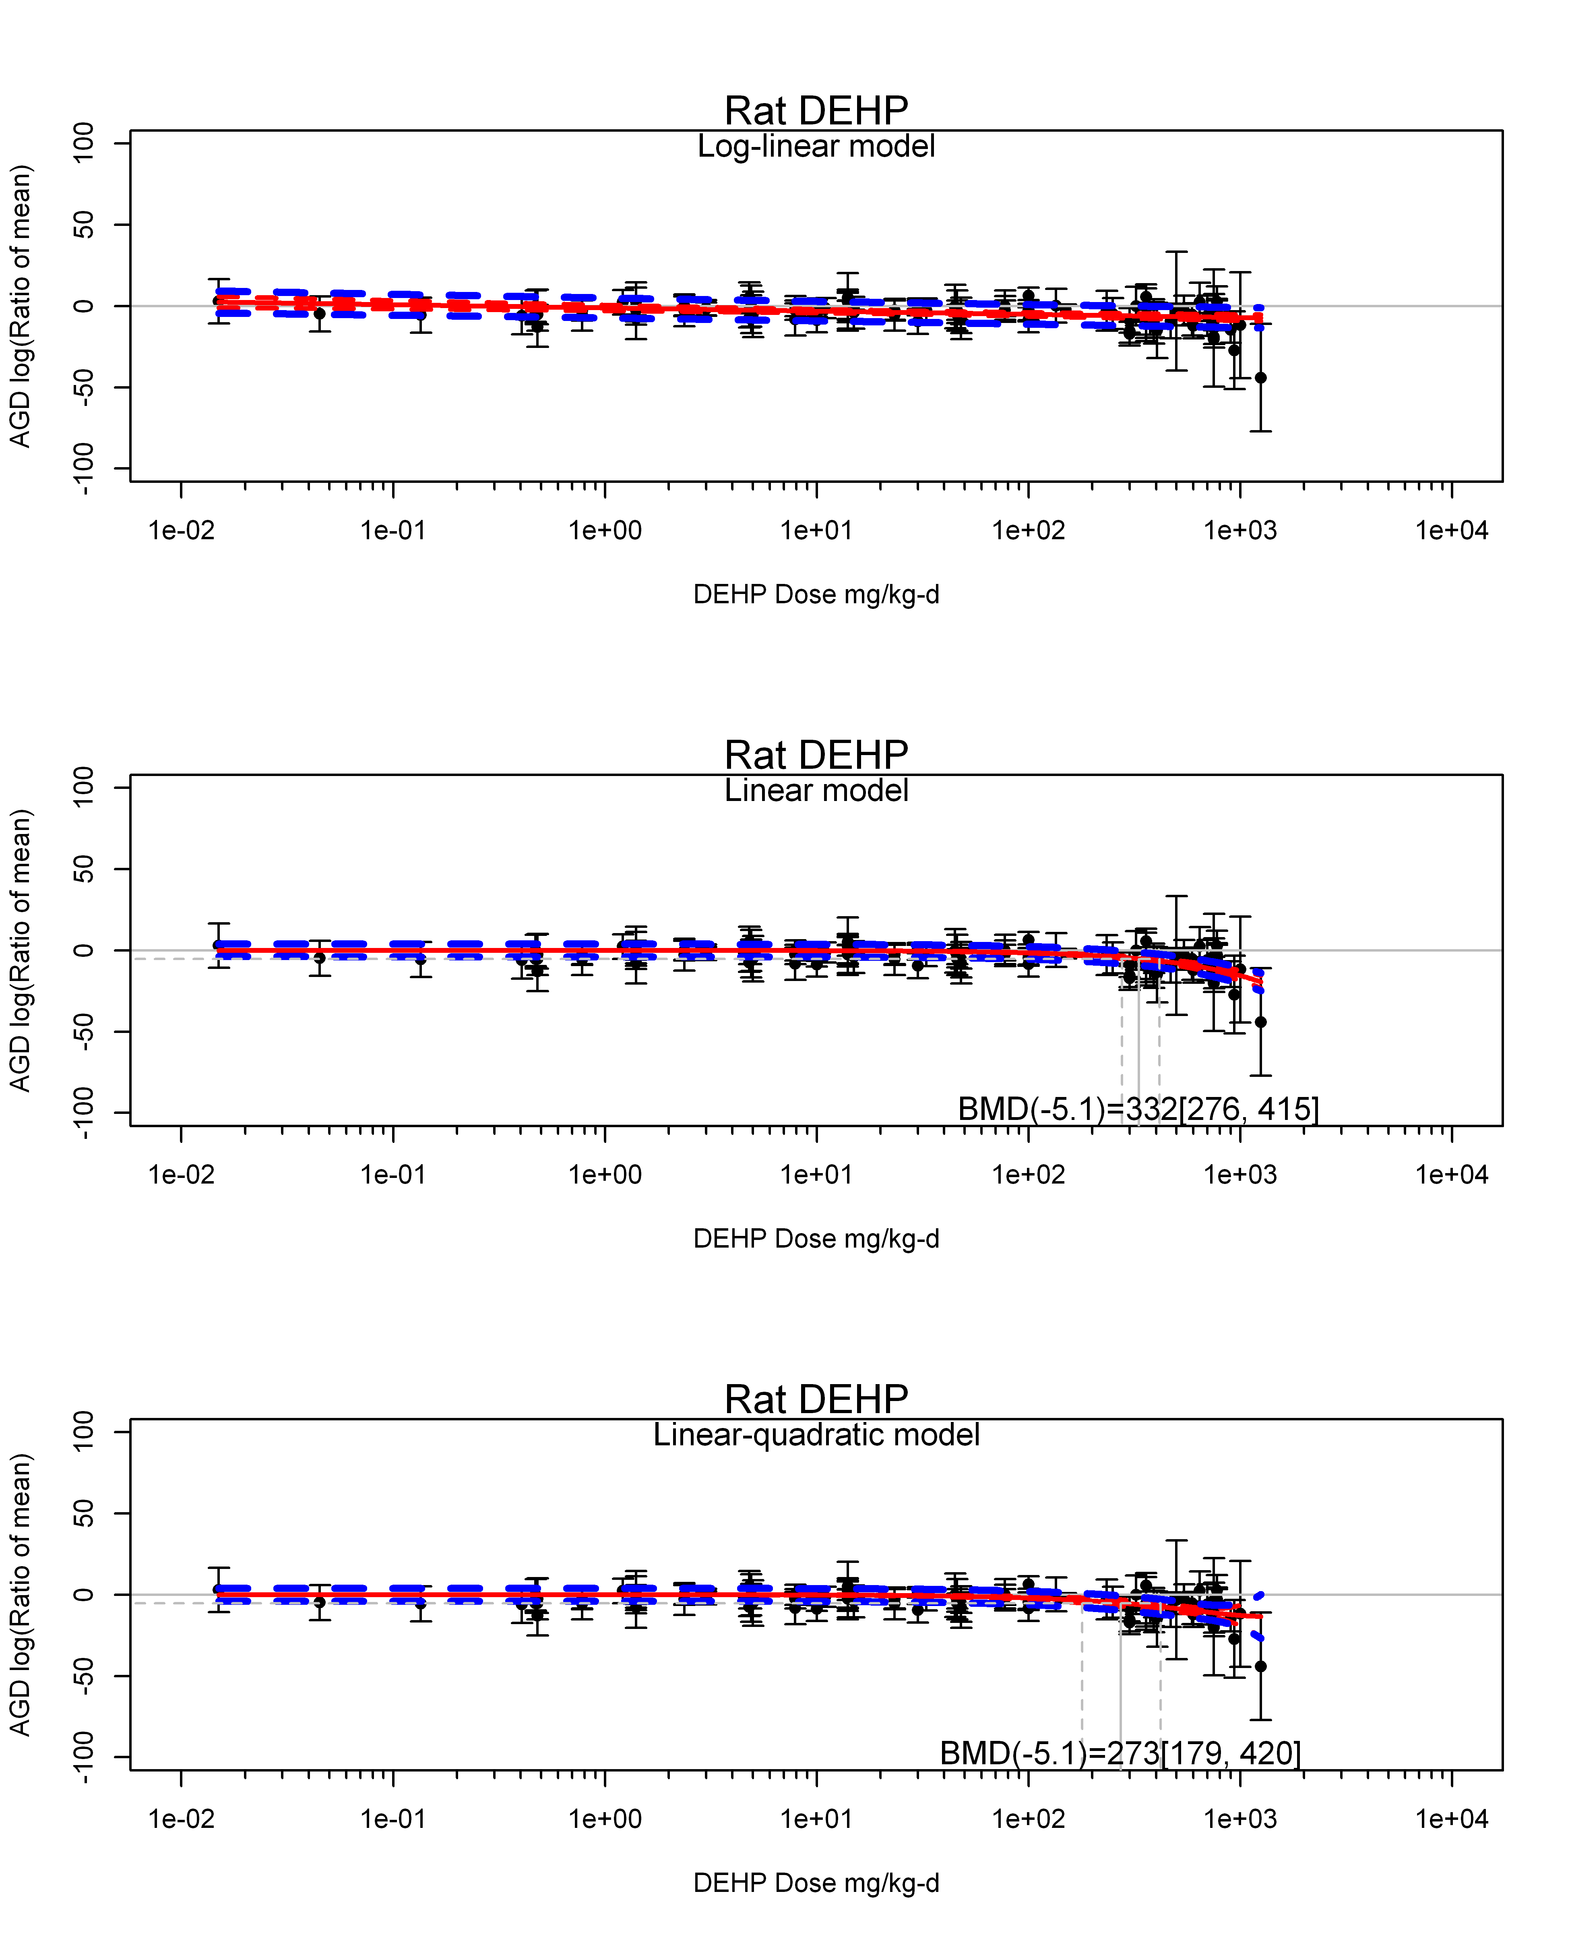

## [1] ""  
## m ci.lb ci.ub bmr  
## 1 272.6419 179.2315 419.9649 -5.129329  
## [1] "AGD log(Ratio of mean) Rat Highest Dose"  
## [1] "Overall Effect---------------------"  
##   
## Random-Effects Model (k = 18; tau^2 estimator: REML)  
##   
## logLik deviance AIC BIC AICc   
## -62.5192 125.0383 129.0383 130.7048 129.8955   
##   
## tau^2 (estimated amount of total heterogeneity): 52.6455 (SE = 26.9062)  
## tau (square root of estimated tau^2 value): 7.2557  
## I^2 (total heterogeneity / total variability): 81.76%  
## H^2 (total variability / sampling variability): 5.48  
##   
## Test for Heterogeneity:   
## Q(df = 17) = 115.5261, p-val < .0001  
##   
## Model Results:  
##   
## estimate se zval pval ci.lb ci.ub   
## -8.0826 2.1569 -3.7474 0.0002 -12.3099 -3.8552 ***   
##   
## ---  
## Signif. codes: 0 '***' 0.001 '**' 0.01 '*' 0.05 '.' 0.1 ' ' 1

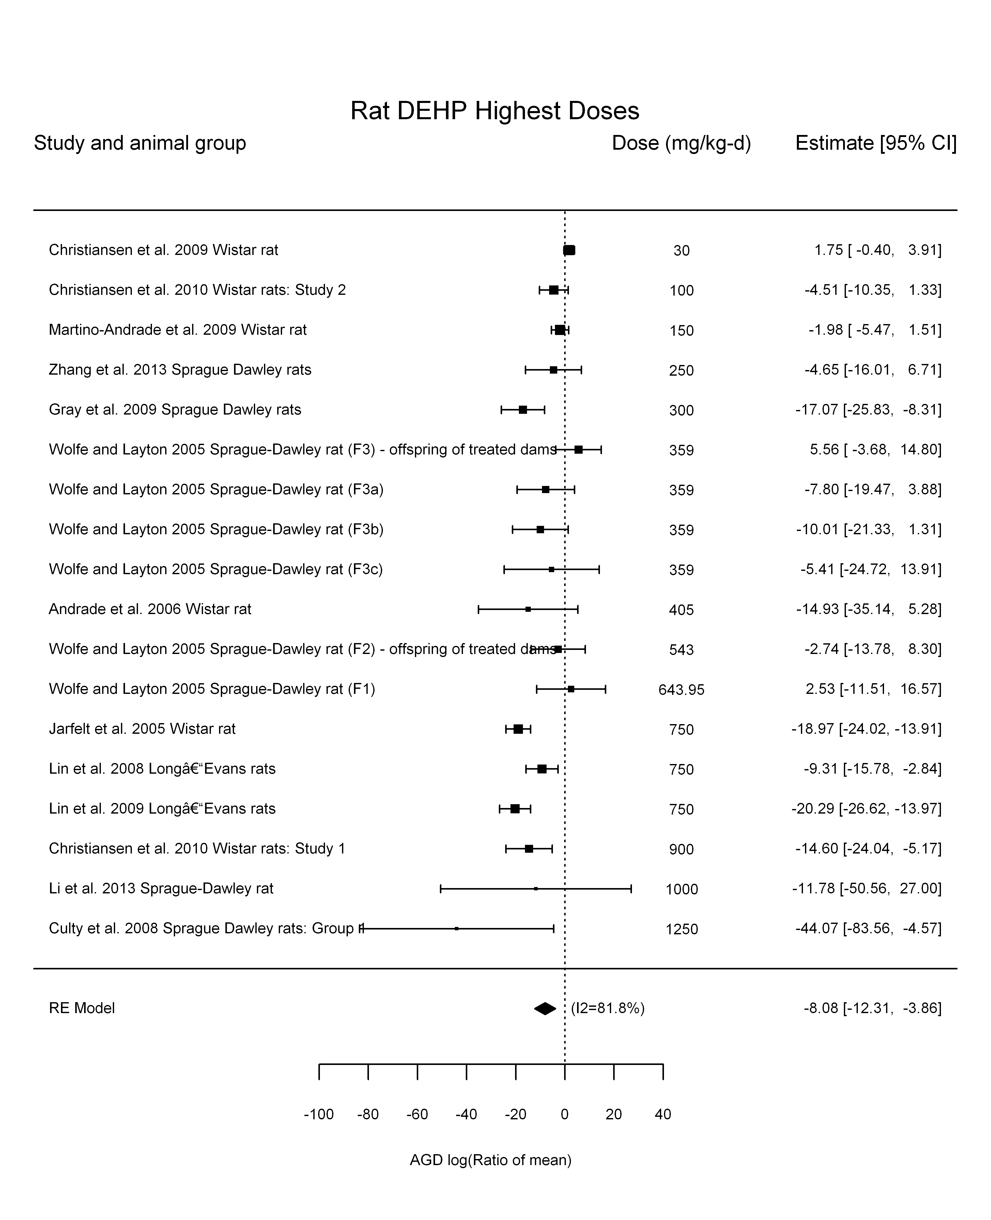

## [1] "Linear or LinearQuadratic in dose---------------------"  
##   
## Mixed-Effects Model (k = 18; tau^2 estimator: REML)  
##   
## logLik deviance AIC BIC AICc   
## -58.0566 116.1132 120.1132 121.7796 120.9703   
##   
## tau^2 (estimated amount of residual heterogeneity): 17.8236 (SE = 12.2677)  
## tau (square root of estimated tau^2 value): 4.2218  
## I^2 (residual heterogeneity / unaccounted variability): 65.26%  
## H^2 (unaccounted variability / sampling variability): 2.88  
##   
## Test for Residual Heterogeneity:   
## QE(df = 17) = 36.0642, p-val = 0.0045  
##   
## Model Results:  
##   
## estimate se zval pval ci.lb ci.ub   
## dose100 -1.8739 0.2936 -6.3827 <.0001 -2.4493 -1.2985 ***  
##   
## ---  
## Signif. codes: 0 '***' 0.001 '**' 0.01 '*' 0.05 '.' 0.1 ' ' 1

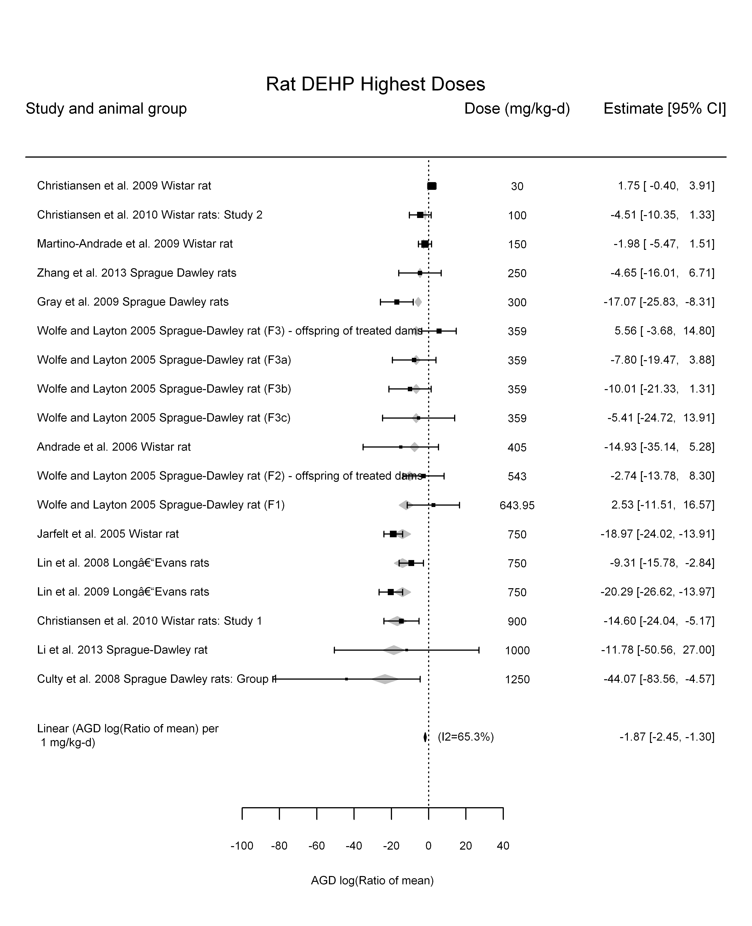

## [1] "Linear in log10(dose)---------------------"  
##   
## Mixed-Effects Model (k = 18; tau^2 estimator: REML)  
##   
## logLik deviance AIC BIC AICc   
## -56.4147 112.8294 118.8294 121.1472 120.8294   
##   
## tau^2 (estimated amount of residual heterogeneity): 27.1940 (SE = 17.7672)  
## tau (square root of estimated tau^2 value): 5.2148  
## I^2 (residual heterogeneity / unaccounted variability): 63.51%  
## H^2 (unaccounted variability / sampling variability): 2.74  
## R^2 (amount of heterogeneity accounted for): 48.35%  
##   
## Test for Residual Heterogeneity:   
## QE(df = 16) = 38.9170, p-val = 0.0011  
##   
## Test of Moderators (coefficient(s) 2):   
## QM(df = 1) = 8.7398, p-val = 0.0031  
##   
## Model Results:  
##   
## estimate se zval pval ci.lb ci.ub   
## intrcpt 20.4214 9.7375 2.0972 0.0360 1.3363 39.5065 *  
## log10(dose) -11.4441 3.8711 -2.9563 0.0031 -19.0312 -3.8569 **  
##   
## ---  
## Signif. codes: 0 '***' 0.001 '**' 0.01 '*' 0.05 '.' 0.1 ' ' 1

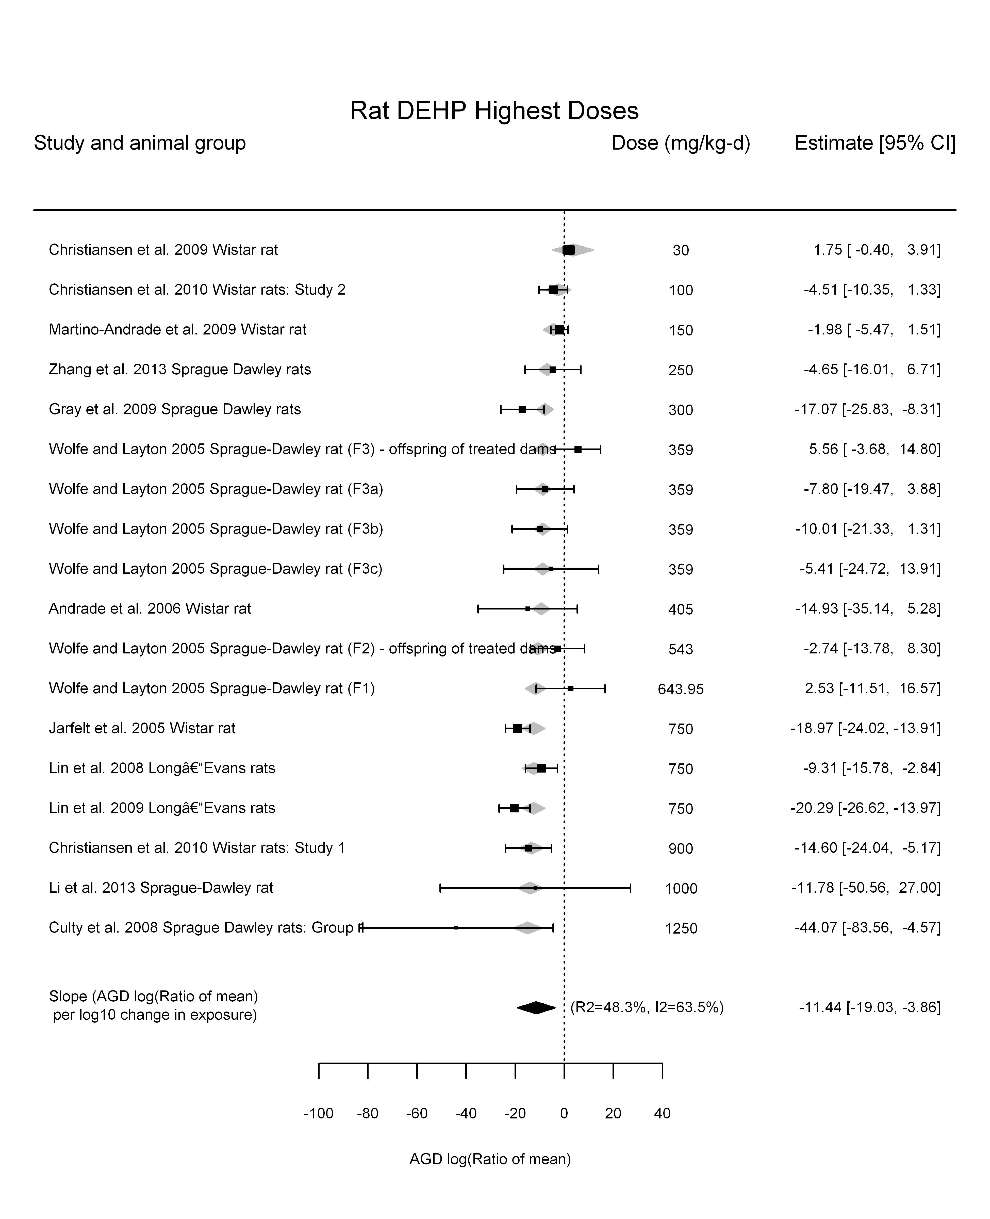

## [1] "Linear or LinearQuadratic in dose---------------------"  
##   
## Mixed-Effects Model (k = 18; tau^2 estimator: REML)  
##   
## logLik deviance AIC BIC AICc   
## -54.6155 109.2311 115.2311 117.5488 117.2311   
##   
## tau^2 (estimated amount of residual heterogeneity): 19.9306 (SE = 13.5926)  
## tau (square root of estimated tau^2 value): 4.4644  
## I^2 (residual heterogeneity / unaccounted variability): 67.35%  
## H^2 (unaccounted variability / sampling variability): 3.06  
##   
## Test for Residual Heterogeneity:   
## QE(df = 16) = 35.1824, p-val = 0.0038  
##   
## Test of Moderators (coefficient(s) 1,2):   
## QM(df = 2) = 38.4172, p-val < .0001  
##   
## Model Results:  
##   
## estimate se zval pval ci.lb ci.ub   
## dose100 -1.3389 1.1191 -1.1964 0.2315 -3.5322 0.8544   
## I(dose100^2) -0.0732 0.1489 -0.4915 0.6231 -0.3651 0.2187   
##   
## ---  
## Signif. codes: 0 '***' 0.001 '**' 0.01 '*' 0.05 '.' 0.1 ' ' 1

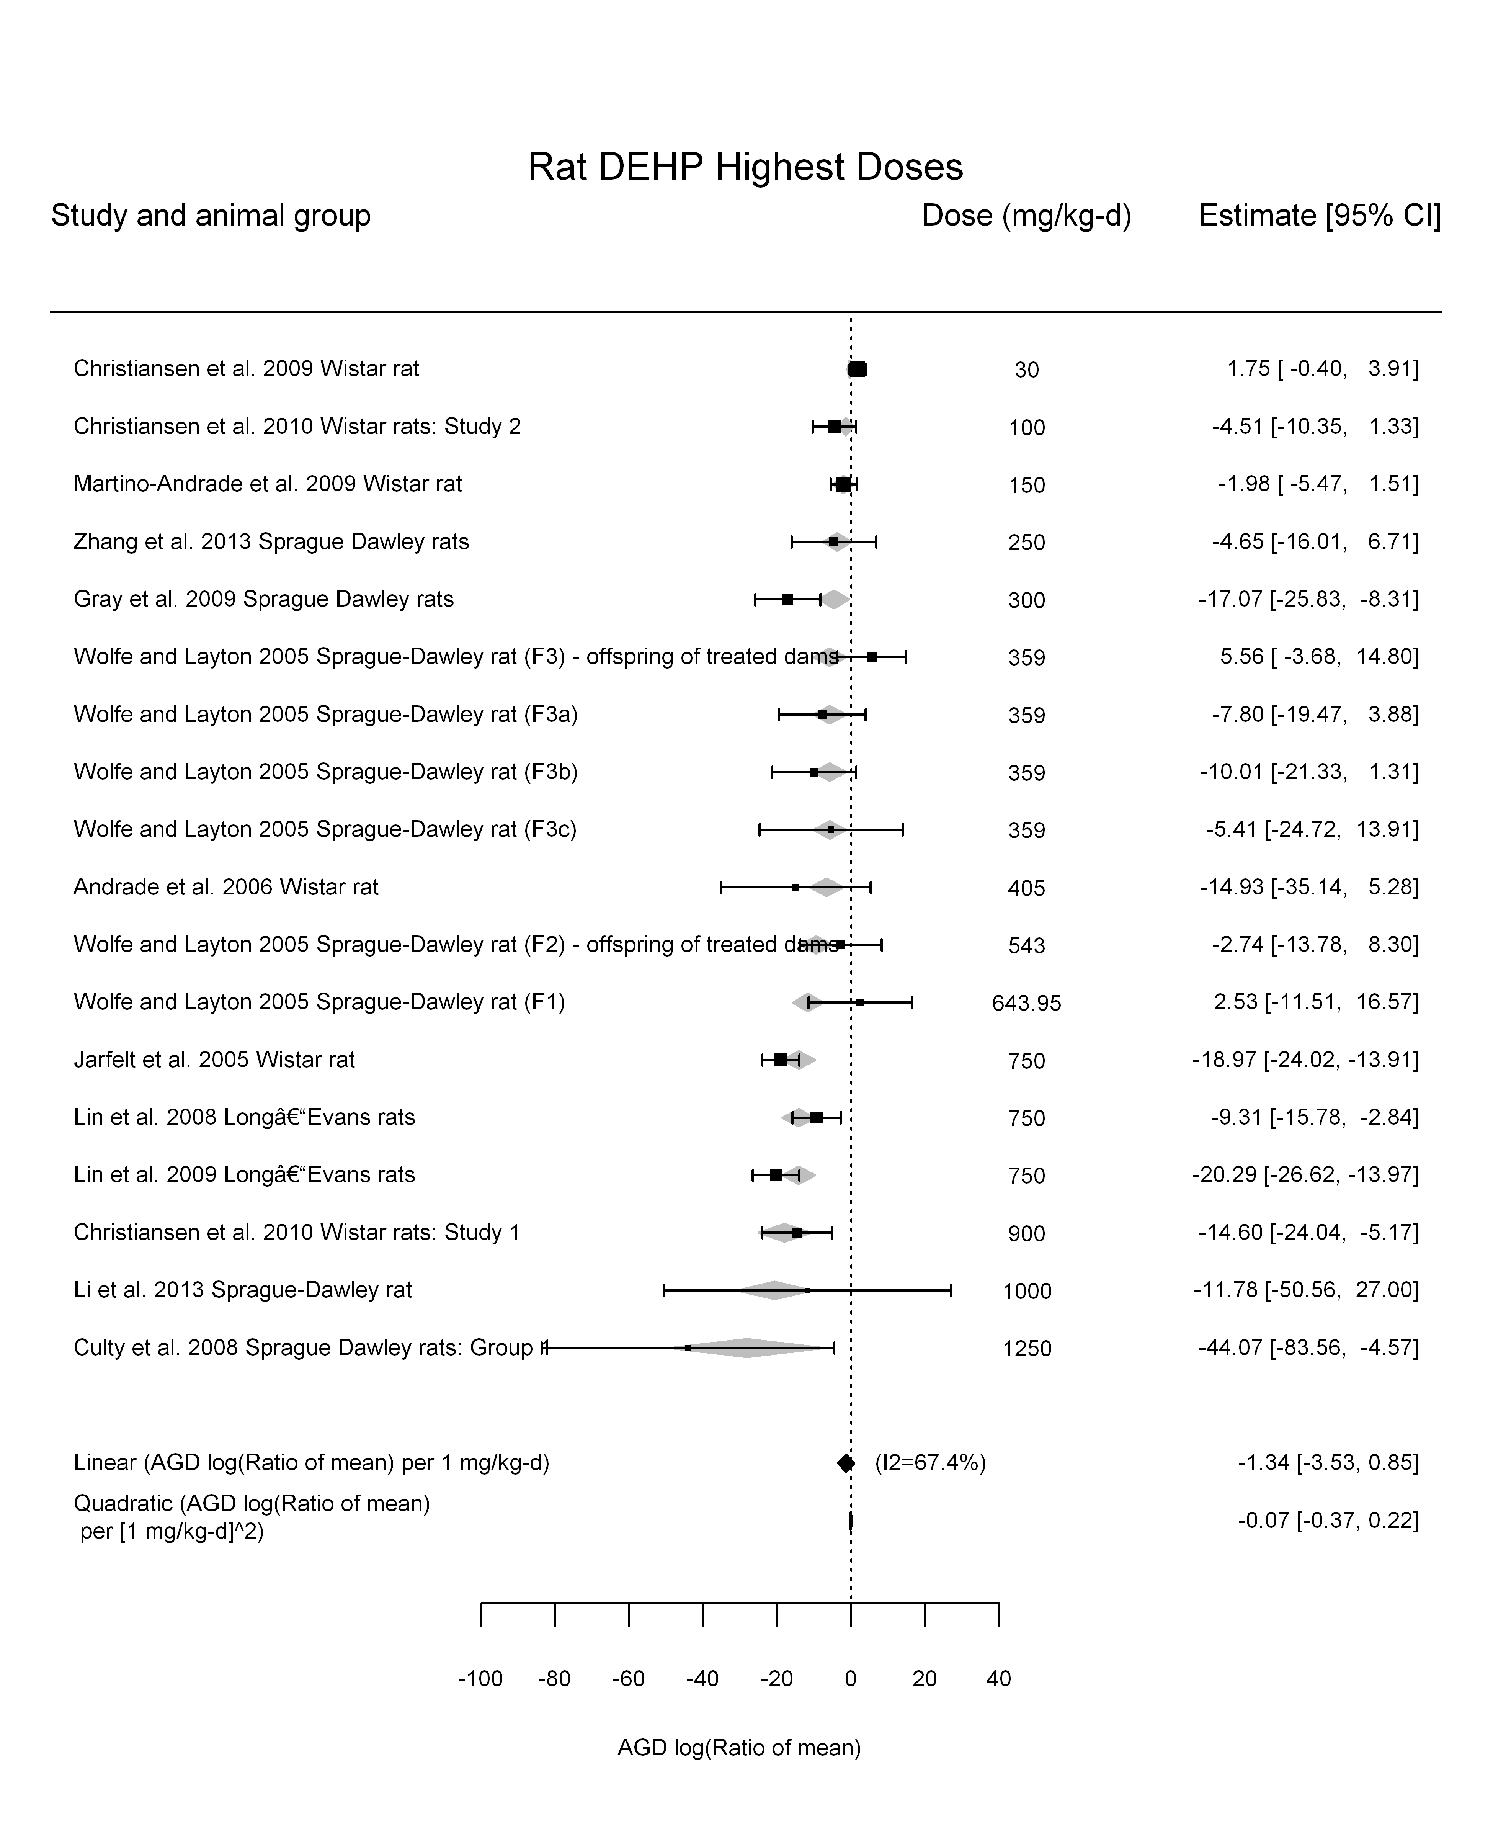

## [1] ""

## [1] ""  
## m ci.lb ci.ub bmr  
## 1 273.7211 209.4152 395.0209 -5.129329

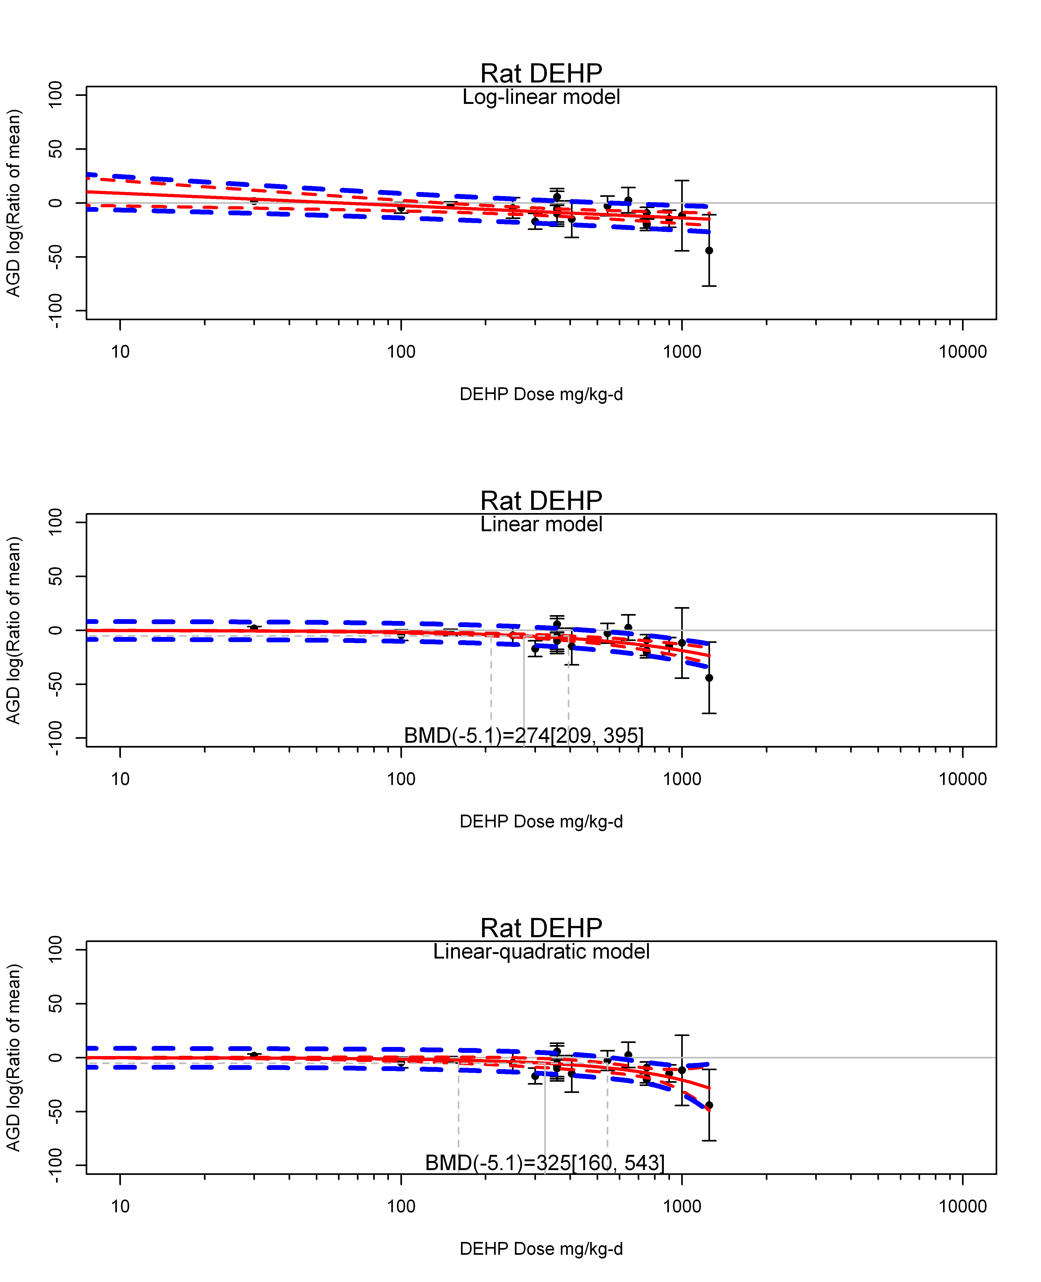

## [1] ""  
## m ci.lb ci.ub bmr  
## 1 325.2631 160.0906 543.2569 -5.129329  
## [1] "AGD log(Ratio of mean) Mouse"  
## [1] "Overall Effect---------------------"  
##   
## Random-Effects Model (k = 11; tau^2 estimator: REML)  
##   
## logLik deviance AIC BIC AICc   
## -31.5630 63.1261 67.1261 67.7312 68.8404   
##   
## tau^2 (estimated amount of total heterogeneity): 15.5124 (SE = 11.0952)  
## tau (square root of estimated tau^2 value): 3.9386  
## I^2 (total heterogeneity / total variability): 82.39%  
## H^2 (total variability / sampling variability): 5.68  
##   
## Test for Heterogeneity:   
## Q(df = 10) = 42.3710, p-val < .0001  
##   
## Model Results:  
##   
## estimate se zval pval ci.lb ci.ub   
## -1.5743 1.5512 -1.0149 0.3102 -4.6145 1.4660   
##   
## ---  
## Signif. codes: 0 '***' 0.001 '**' 0.01 '*' 0.05 '.' 0.1 ' ' 1

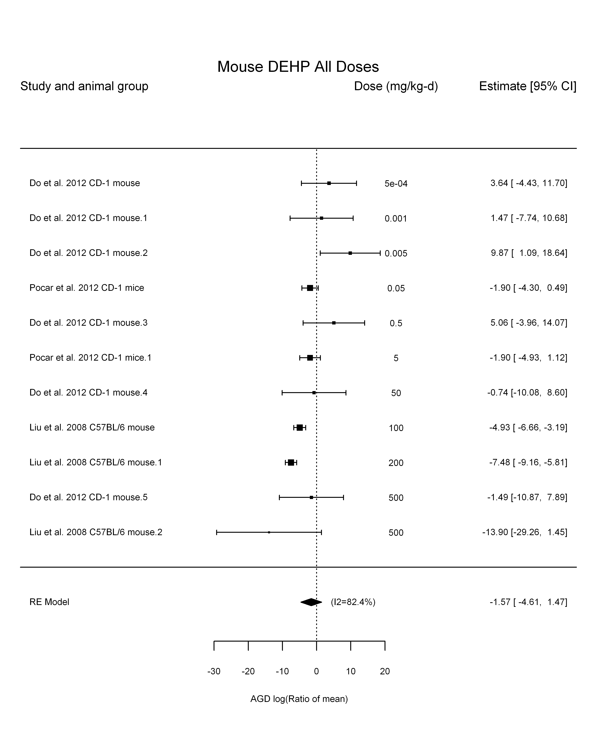

## [1] "Leave one out---------------------"  
##   
## Random-Effects Model (k = 5; tau^2 estimator: REML)  
##   
## tau^2 (estimated amount of total heterogeneity): 6.1281 (SE = 6.0379)  
## tau (square root of estimated tau^2 value): 2.4755  
## I^2 (total heterogeneity / total variability): 80.24%  
## H^2 (total variability / sampling variability): 5.06  
##   
## Test for Heterogeneity:   
## Q(df = 4) = 20.2052, p-val = 0.0005  
##   
## Model Results:  
##   
## estimate se zval pval ci.lb ci.ub   
## -4.4836 1.3435 -3.3373 0.0008 -7.1168 -1.8504 ***   
##   
## ---  
## Signif. codes: 0 '***' 0.001 '**' 0.01 '*' 0.05 '.' 0.1 ' ' 1   
##   
##   
## Random-Effects Model (k = 9; tau^2 estimator: REML)  
##   
## tau^2 (estimated amount of total heterogeneity): 26.0498 (SE = 20.3941)  
## tau (square root of estimated tau^2 value): 5.1039  
## I^2 (total heterogeneity / total variability): 85.14%  
## H^2 (total variability / sampling variability): 6.73  
##   
## Test for Heterogeneity:   
## Q(df = 8) = 32.7974, p-val < .0001  
##   
## Model Results:  
##   
## estimate se zval pval ci.lb ci.ub   
## -1.0829 2.1623 -0.5008 0.6165 -5.3209 3.1552   
##   
## ---  
## Signif. codes: 0 '***' 0.001 '**' 0.01 '*' 0.05 '.' 0.1 ' ' 1   
##   
##   
## Random-Effects Model (k = 8; tau^2 estimator: REML)  
##   
## tau^2 (estimated amount of total heterogeneity): 4.7976 (SE = 7.3004)  
## tau (square root of estimated tau^2 value): 2.1903  
## I^2 (total heterogeneity / total variability): 38.54%  
## H^2 (total variability / sampling variability): 1.63  
##   
## Test for Heterogeneity:   
## Q(df = 7) = 10.0402, p-val = 0.1863  
##   
## Model Results:  
##   
## estimate se zval pval ci.lb ci.ub   
## 0.3096 1.3702 0.2259 0.8213 -2.3760 2.9952   
##   
## ---  
## Signif. codes: 0 '***' 0.001 '**' 0.01 '*' 0.05 '.' 0.1 ' ' 1   
##   
## [1] "Linear in log10(dose)---------------------"  
##   
## Mixed-Effects Model (k = 11; tau^2 estimator: REML)  
##   
## logLik deviance AIC BIC AICc   
## -24.9197 49.8394 55.8394 56.4311 60.6394   
##   
## tau^2 (estimated amount of residual heterogeneity): 2.5496 (SE = 3.3682)  
## tau (square root of estimated tau^2 value): 1.5967  
## I^2 (residual heterogeneity / unaccounted variability): 40.12%  
## H^2 (unaccounted variability / sampling variability): 1.67  
## R^2 (amount of heterogeneity accounted for): 83.56%  
##   
## Test for Residual Heterogeneity:   
## QE(df = 9) = 14.8646, p-val = 0.0947  
##   
## Test of Moderators (coefficient(s) 2):   
## QM(df = 1) = 13.6116, p-val = 0.0002  
##   
## Model Results:  
##   
## estimate se zval pval ci.lb ci.ub   
## intrcpt -1.7929 0.9307 -1.9265 0.0540 -3.6170 0.0311 .  
## log10(dose) -1.7678 0.4792 -3.6894 0.0002 -2.7069 -0.8287 ***  
##   
## ---  
## Signif. codes: 0 '***' 0.001 '**' 0.01 '*' 0.05 '.' 0.1 ' ' 1

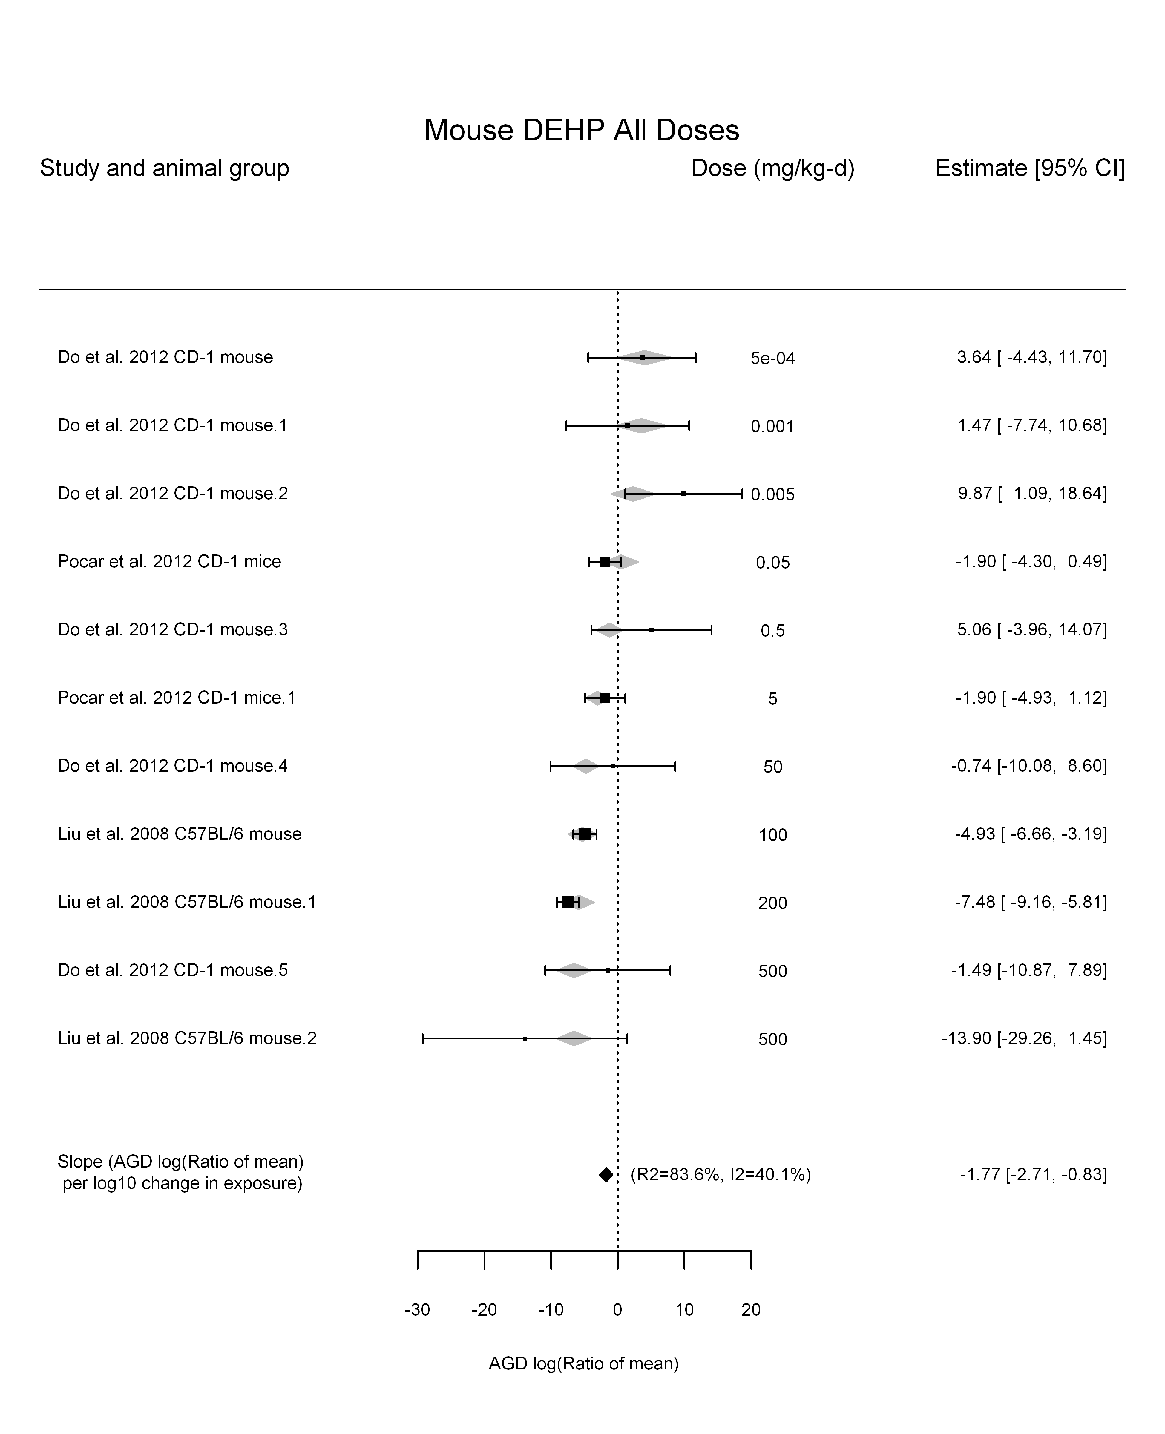

## [1] "Linear in dose---------------------"  
##   
## Mixed-Effects Model (k = 11; tau^2 estimator: REML)  
##   
## logLik deviance AIC BIC AICc   
## -29.4289 58.8577 62.8577 63.4629 64.5720   
##   
## tau^2 (estimated amount of residual heterogeneity): 7.8976 (SE = 6.4350)  
## tau (square root of estimated tau^2 value): 2.8103  
## I^2 (residual heterogeneity / unaccounted variability): 69.81%  
## H^2 (unaccounted variability / sampling variability): 3.31  
##   
## Test for Residual Heterogeneity:   
## QE(df = 10) = 24.9420, p-val = 0.0055  
##   
## Model Results:  
##   
## estimate se zval pval ci.lb ci.ub   
## dose100 -2.0284 0.7539 -2.6906 0.0071 -3.5060 -0.5508 **  
##   
## ---  
## Signif. codes: 0 '***' 0.001 '**' 0.01 '*' 0.05 '.' 0.1 ' ' 1

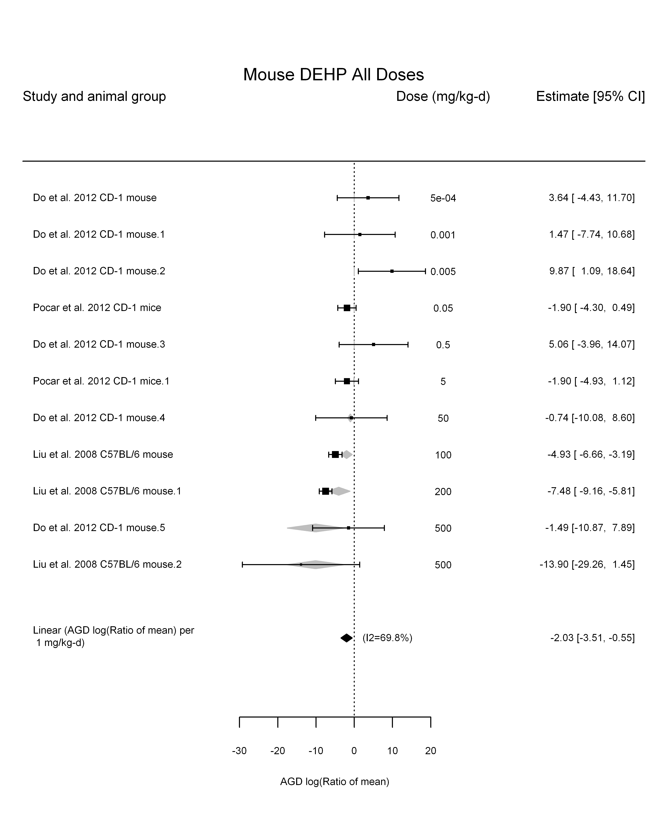

## [1] "Linear or LinearQuadratic in dose---------------------"  
##   
## Mixed-Effects Model (k = 11; tau^2 estimator: REML)  
##   
## logLik deviance AIC BIC AICc   
## -24.4405 48.8811 54.8811 55.4727 59.6811   
##   
## tau^2 (estimated amount of residual heterogeneity): 0.0000 (SE = 0.9679)  
## tau (square root of estimated tau^2 value): 0.0004  
## I^2 (residual heterogeneity / unaccounted variability): 0.00%  
## H^2 (unaccounted variability / sampling variability): 1.00  
##   
## Test for Residual Heterogeneity:   
## QE(df = 9) = 12.5223, p-val = 0.1854  
##   
## Test of Moderators (coefficient(s) 1,2):   
## QM(df = 2) = 109.4781, p-val < .0001  
##   
## Model Results:  
##   
## estimate se zval pval ci.lb ci.ub   
## dose100 -5.7100 0.7358 -7.7606 <.0001 -7.1521 -4.2679 ***  
## I(dose100^2) 0.9574 0.2717 3.5241 0.0004 0.4249 1.4899 ***  
##   
## ---  
## Signif. codes: 0 '***' 0.001 '**' 0.01 '*' 0.05 '.' 0.1 ' ' 1

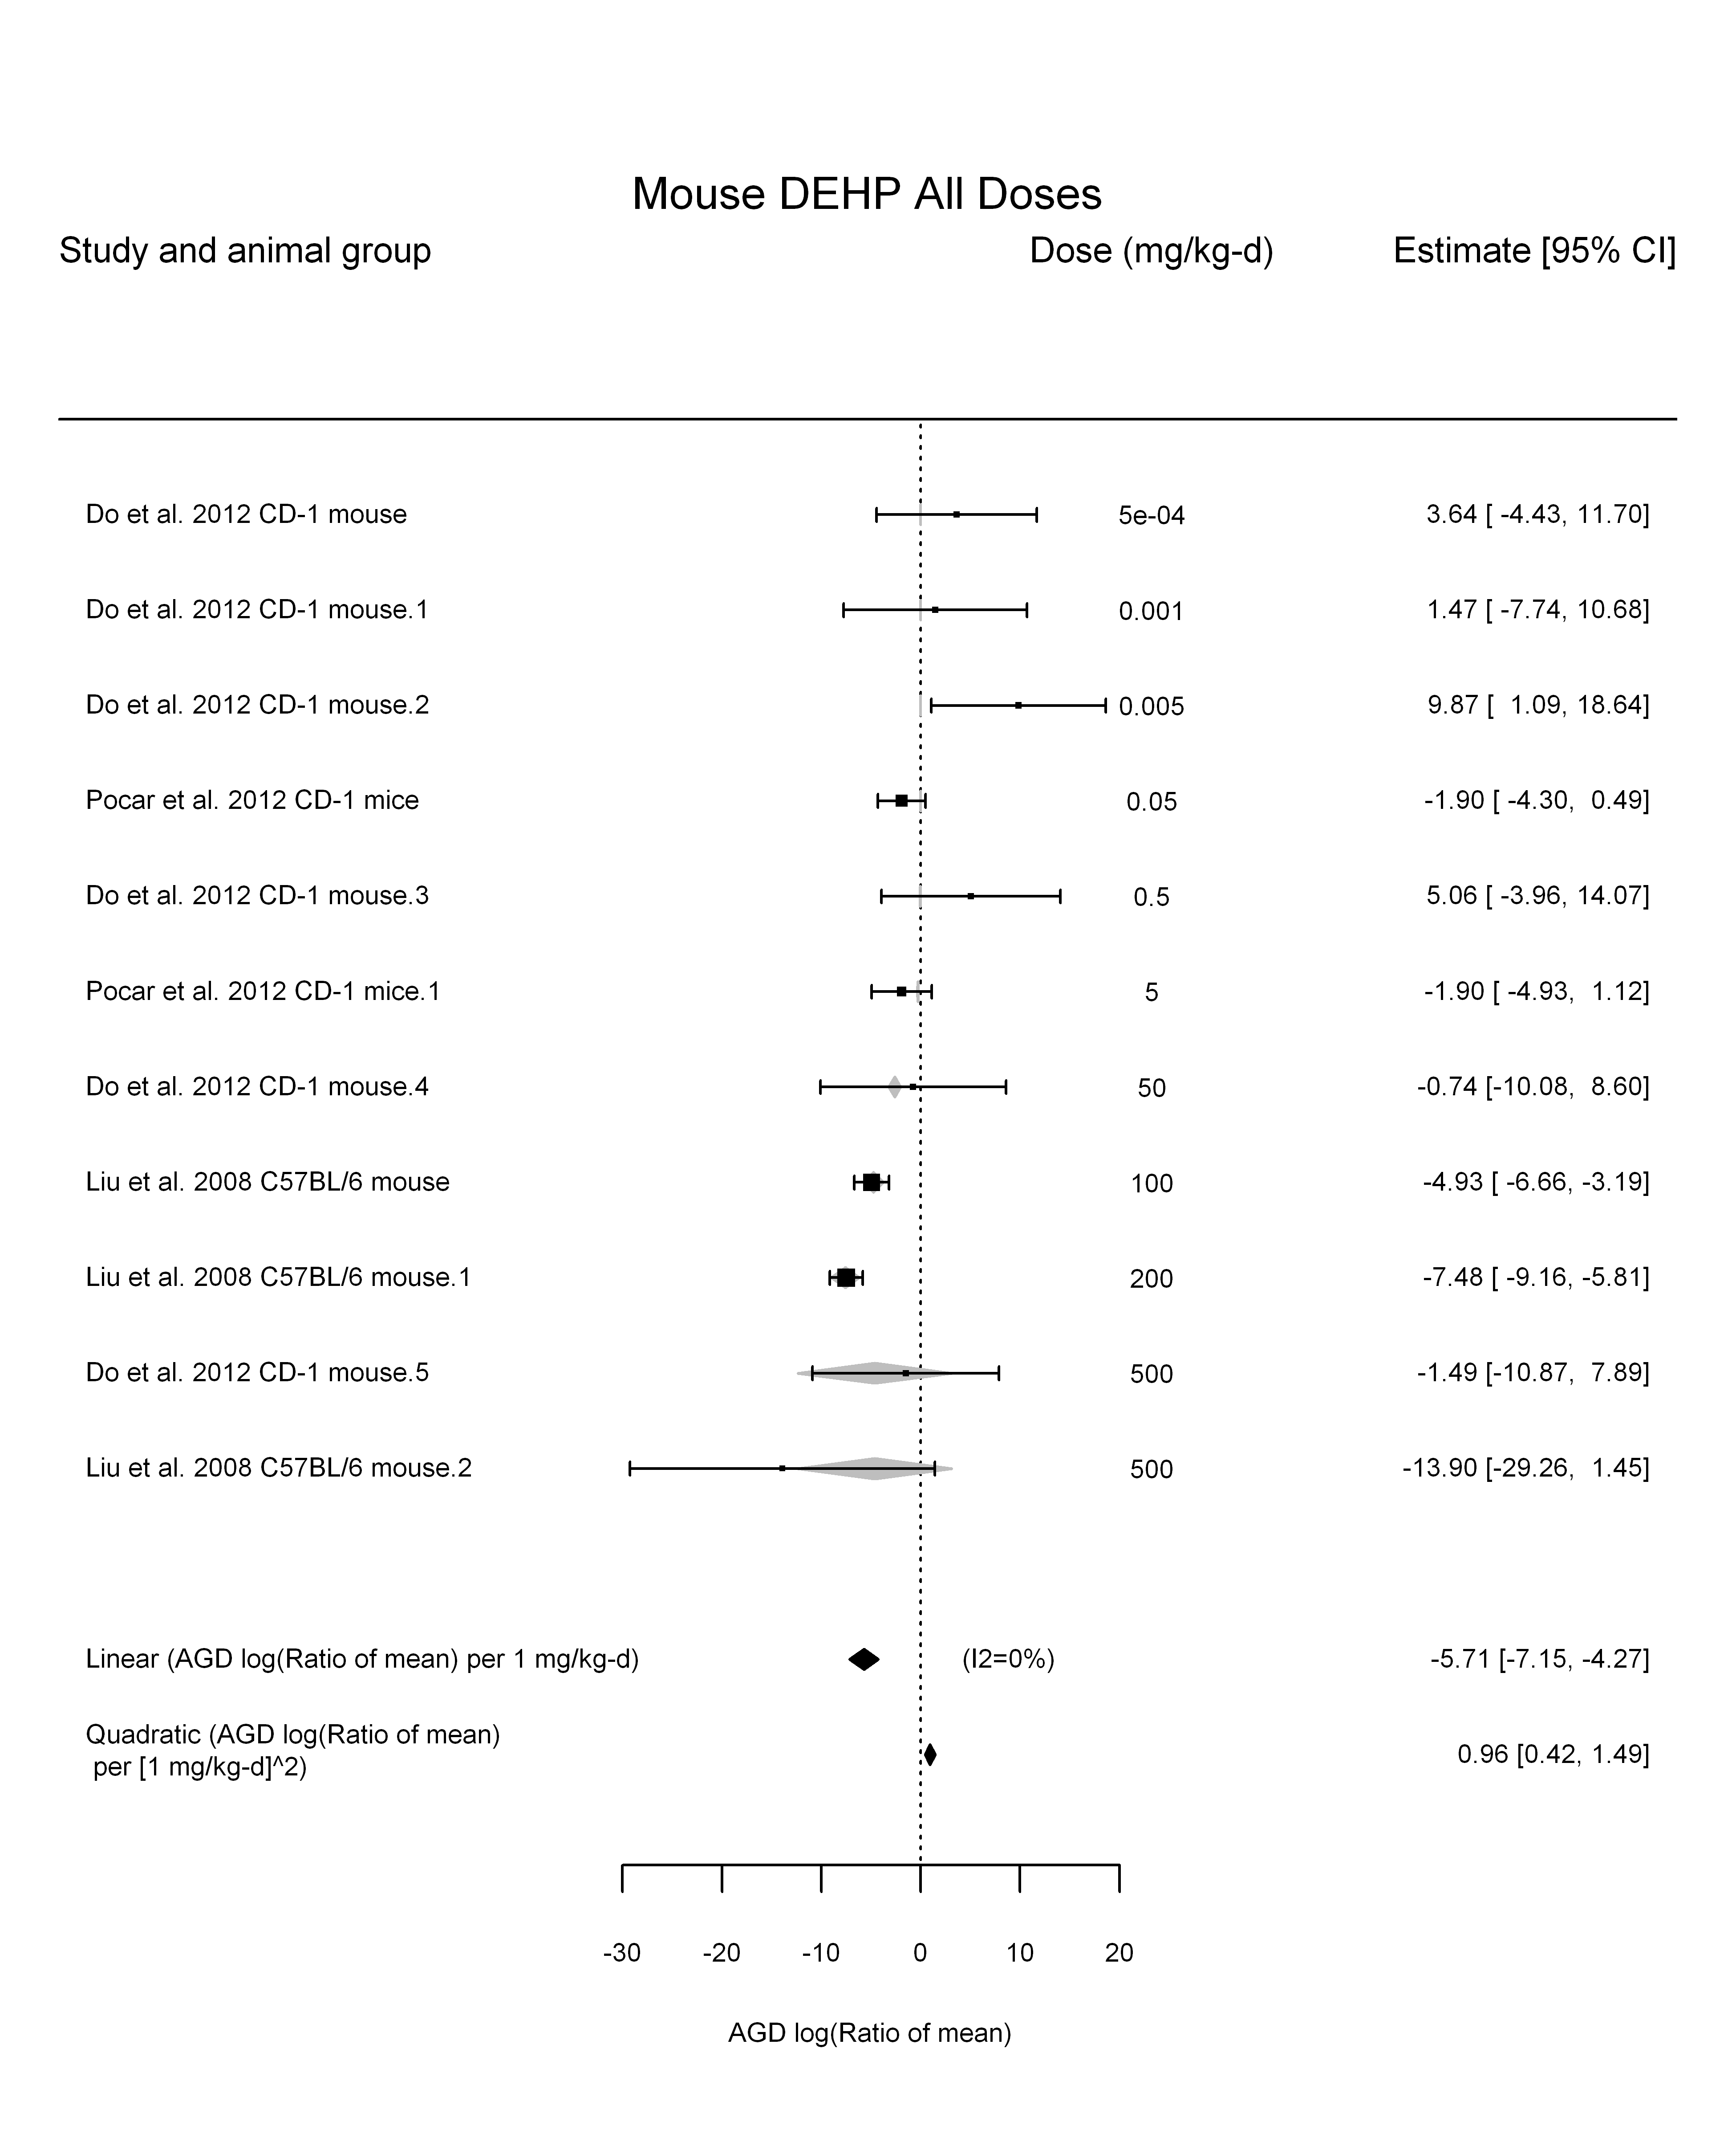

## [1] ""

## [1] ""  
## m ci.lb ci.ub bmr  
## 1 252.8701 146.3006 NA -5.129329

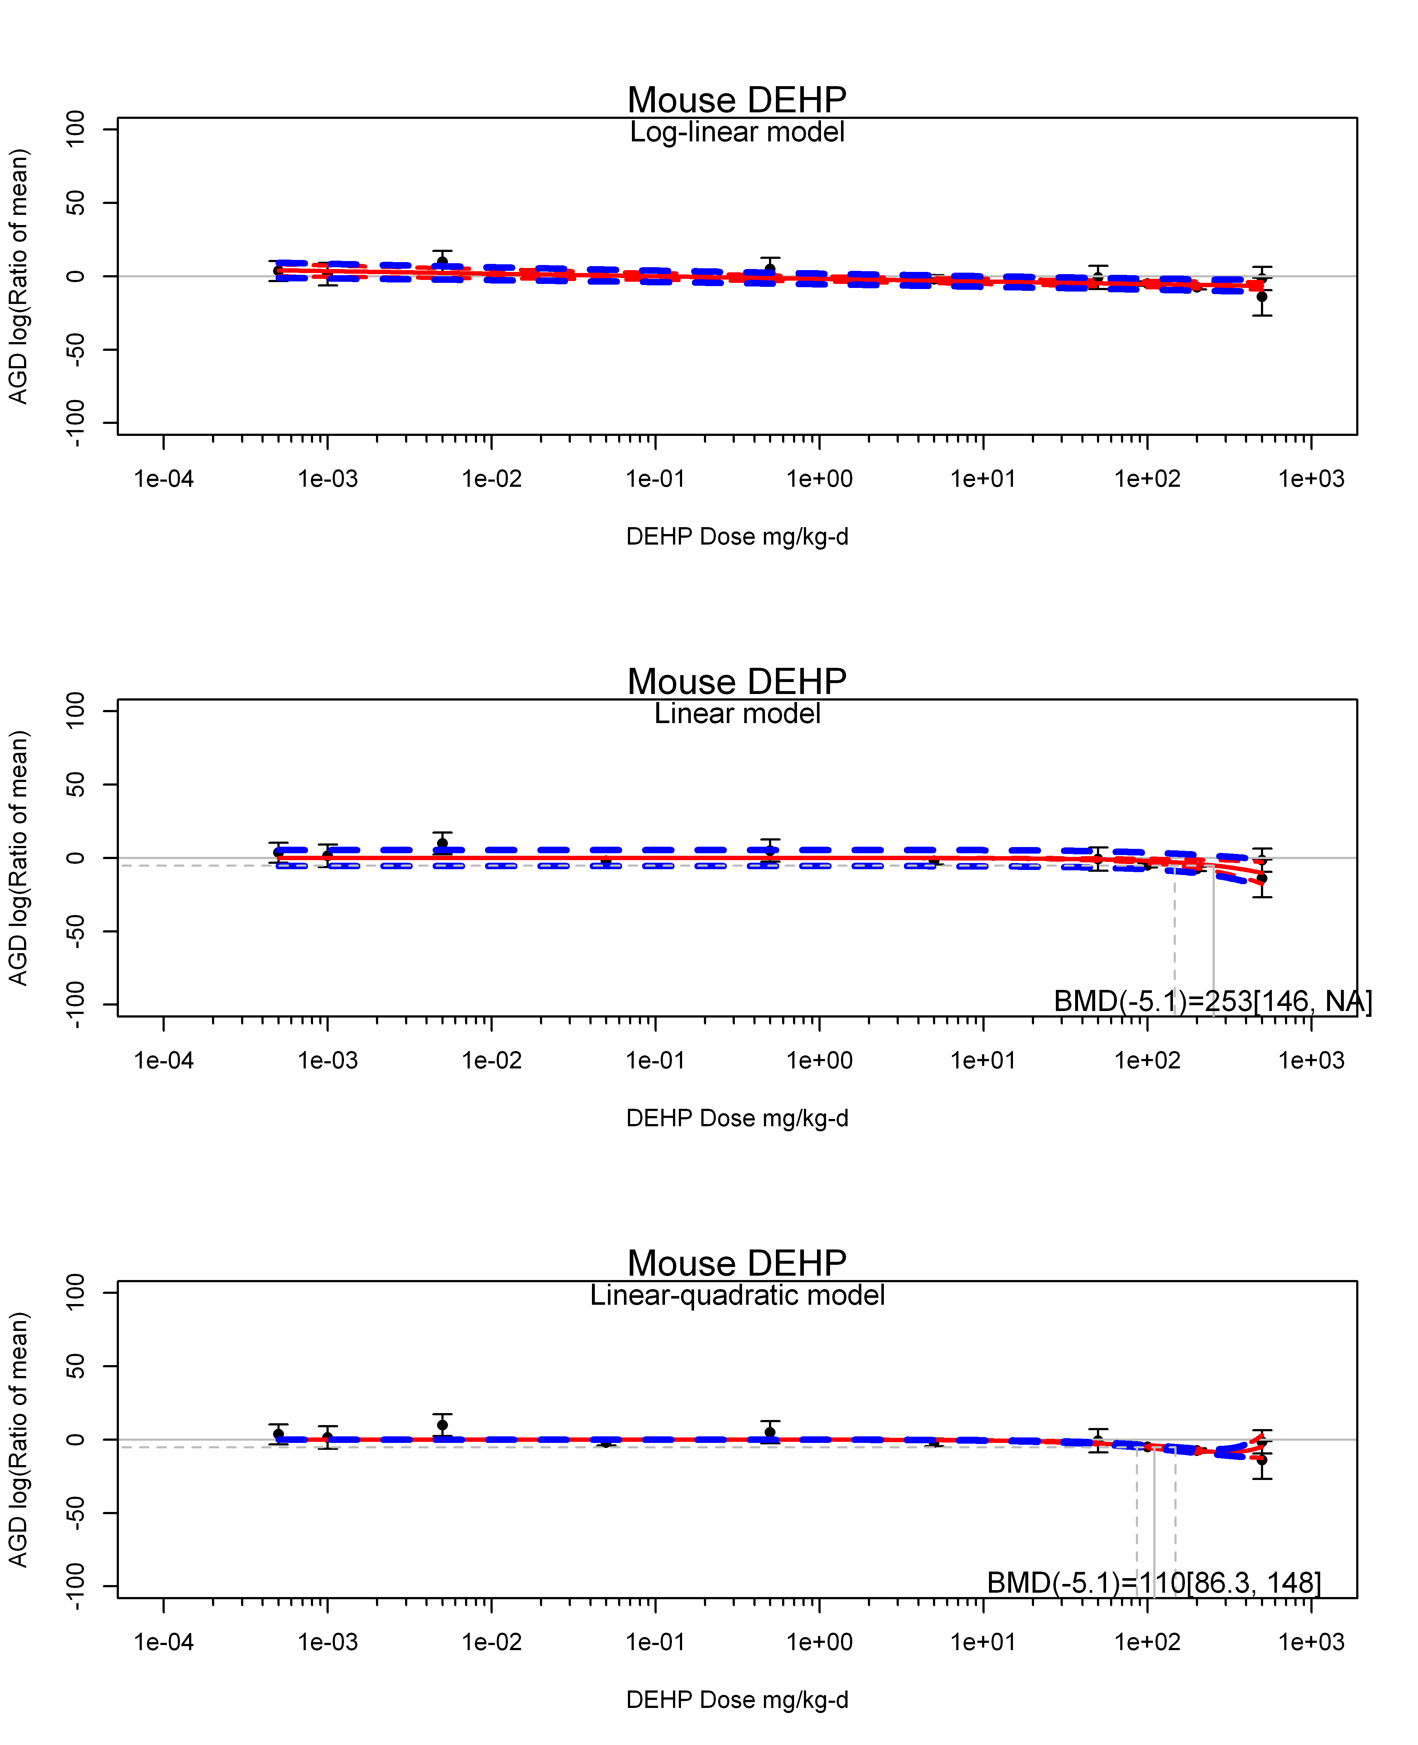

## [1] ""  
## m ci.lb ci.ub bmr  
## 1 110.1874 86.3049 148.4656 -5.129329  
## [1] "AGD log(Ratio of mean) Mouse Highest Dose"  
## [1] "Overall Effect---------------------"  
##   
## Random-Effects Model (k = 3; tau^2 estimator: REML)  
##   
## logLik deviance AIC BIC AICc   
## -6.1233 12.2466 16.2466 13.6329 28.2466   
##   
## tau^2 (estimated amount of total heterogeneity): 0.0000 (SE = 15.9107)  
## tau (square root of estimated tau^2 value): 0.0011  
## I^2 (total heterogeneity / total variability): 0.00%  
## H^2 (total variability / sampling variability): 1.00  
##   
## Test for Heterogeneity:   
## Q(df = 2) = 2.2870, p-val = 0.3187  
##   
## Model Results:  
##   
## estimate se zval pval ci.lb ci.ub   
## -2.2747 1.4437 -1.5756 0.1151 -5.1042 0.5549   
##   
## ---  
## Signif. codes: 0 '***' 0.001 '**' 0.01 '*' 0.05 '.' 0.1 ' ' 1

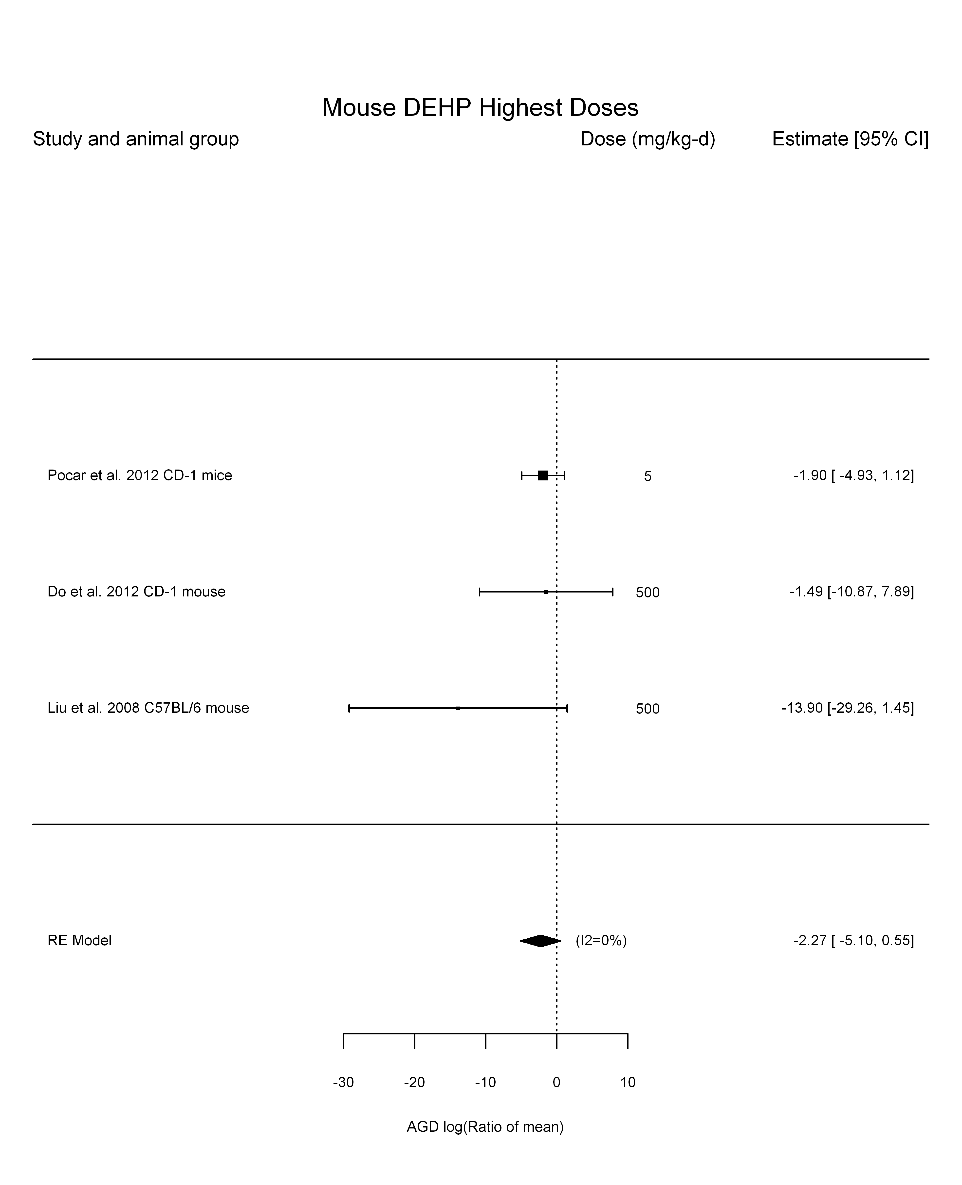

## [1] "Linear or LinearQuadratic in dose---------------------"  
##   
## Mixed-Effects Model (k = 3; tau^2 estimator: REML)  
##   
## logLik deviance AIC BIC AICc   
## -5.7292 11.4583 15.4583 12.8446 27.4583   
##   
## tau^2 (estimated amount of residual heterogeneity): 1.3097 (SE = 5.2038)  
## tau (square root of estimated tau^2 value): 1.1444  
## I^2 (residual heterogeneity / unaccounted variability): 22.50%  
## H^2 (unaccounted variability / sampling variability): 1.29  
##   
## Test for Residual Heterogeneity:   
## QE(df = 2) = 3.2728, p-val = 0.1947  
##   
## Model Results:  
##   
## estimate se zval pval ci.lb ci.ub   
## dose100 -1.0078 0.8358 -1.2058 0.2279 -2.6459 0.6304   
##   
## ---  
## Signif. codes: 0 '***' 0.001 '**' 0.01 '*' 0.05 '.' 0.1 ' ' 1

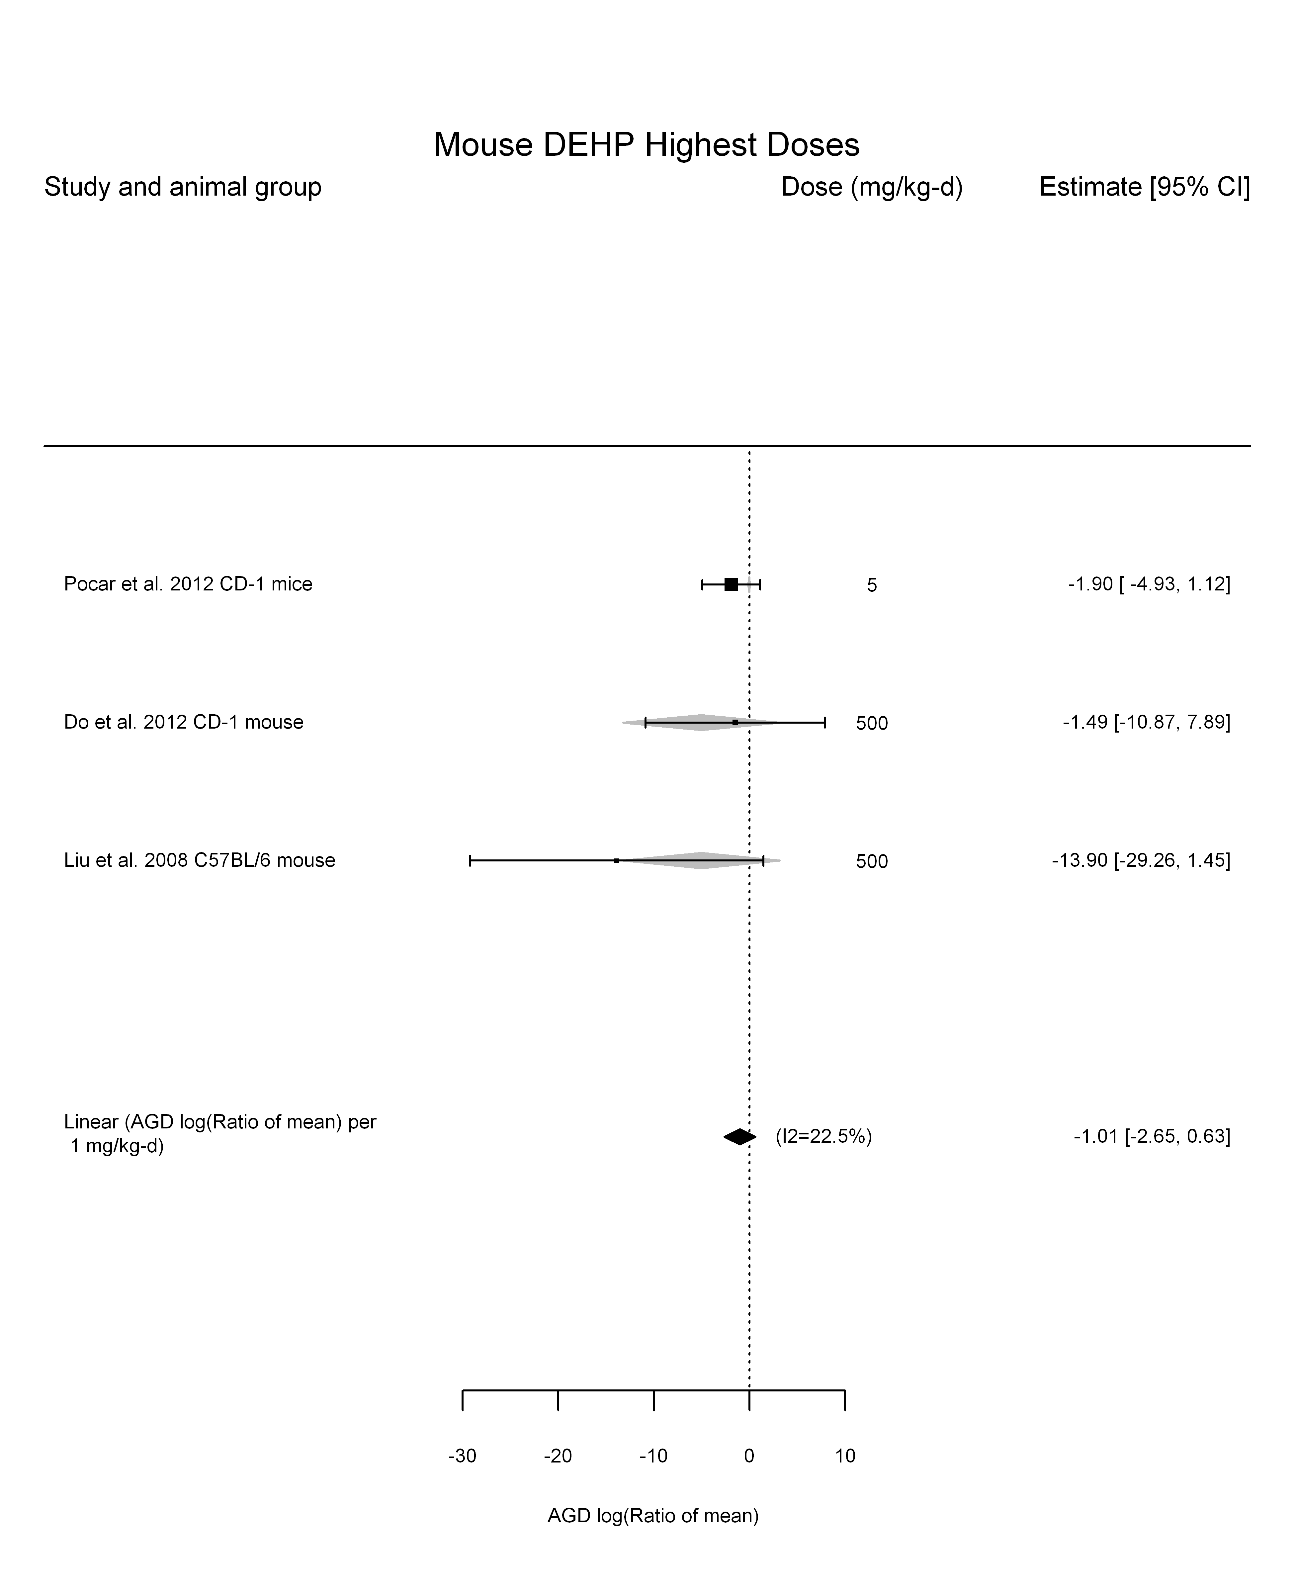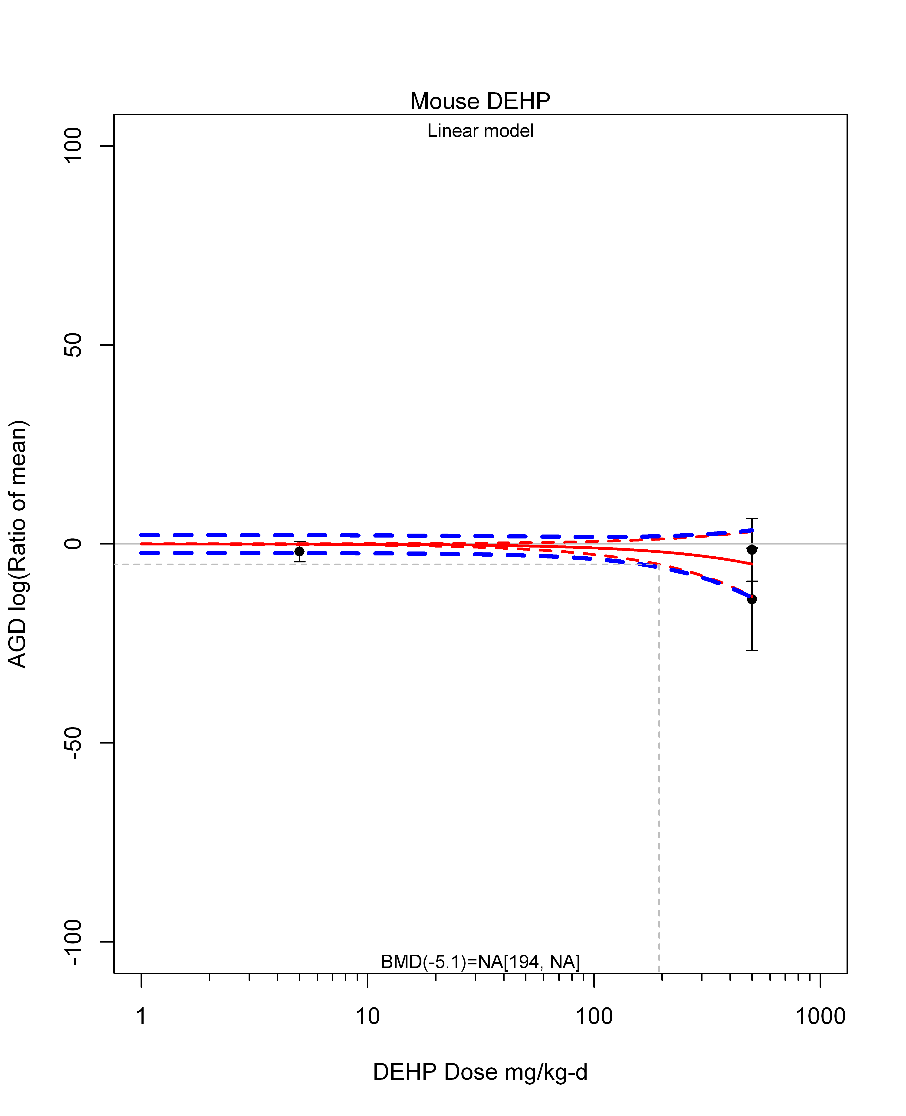

## [1] ""  
## m ci.lb ci.ub bmr  
## 1 NA 193.8578 NA -5.129329  
## [1] "AGD log(Ratio of mean) Rat"  
## [1] "Overall Effect---------------------"  
##   
## Random-Effects Model (k = 70; tau^2 estimator: REML)  
##   
## logLik deviance AIC BIC AICc   
## -248.0509 496.1017 500.1017 504.5699 500.2836   
##   
## tau^2 (estimated amount of total heterogeneity): 61.4214 (SE = 12.8716)  
## tau (square root of estimated tau^2 value): 7.8372  
## I^2 (total heterogeneity / total variability): 89.12%  
## H^2 (total variability / sampling variability): 9.19  
##   
## Test for Heterogeneity:   
## Q(df = 69) = 787.6711, p-val < .0001  
##   
## Model Results:  
##   
## estimate se zval pval ci.lb ci.ub   
## -6.8832 1.0499 -6.5558 <.0001 -8.9410 -4.8254 ***   
##   
## ---  
## Signif. codes: 0 '***' 0.001 '**' 0.01 '*' 0.05 '.' 0.1 ' ' 1

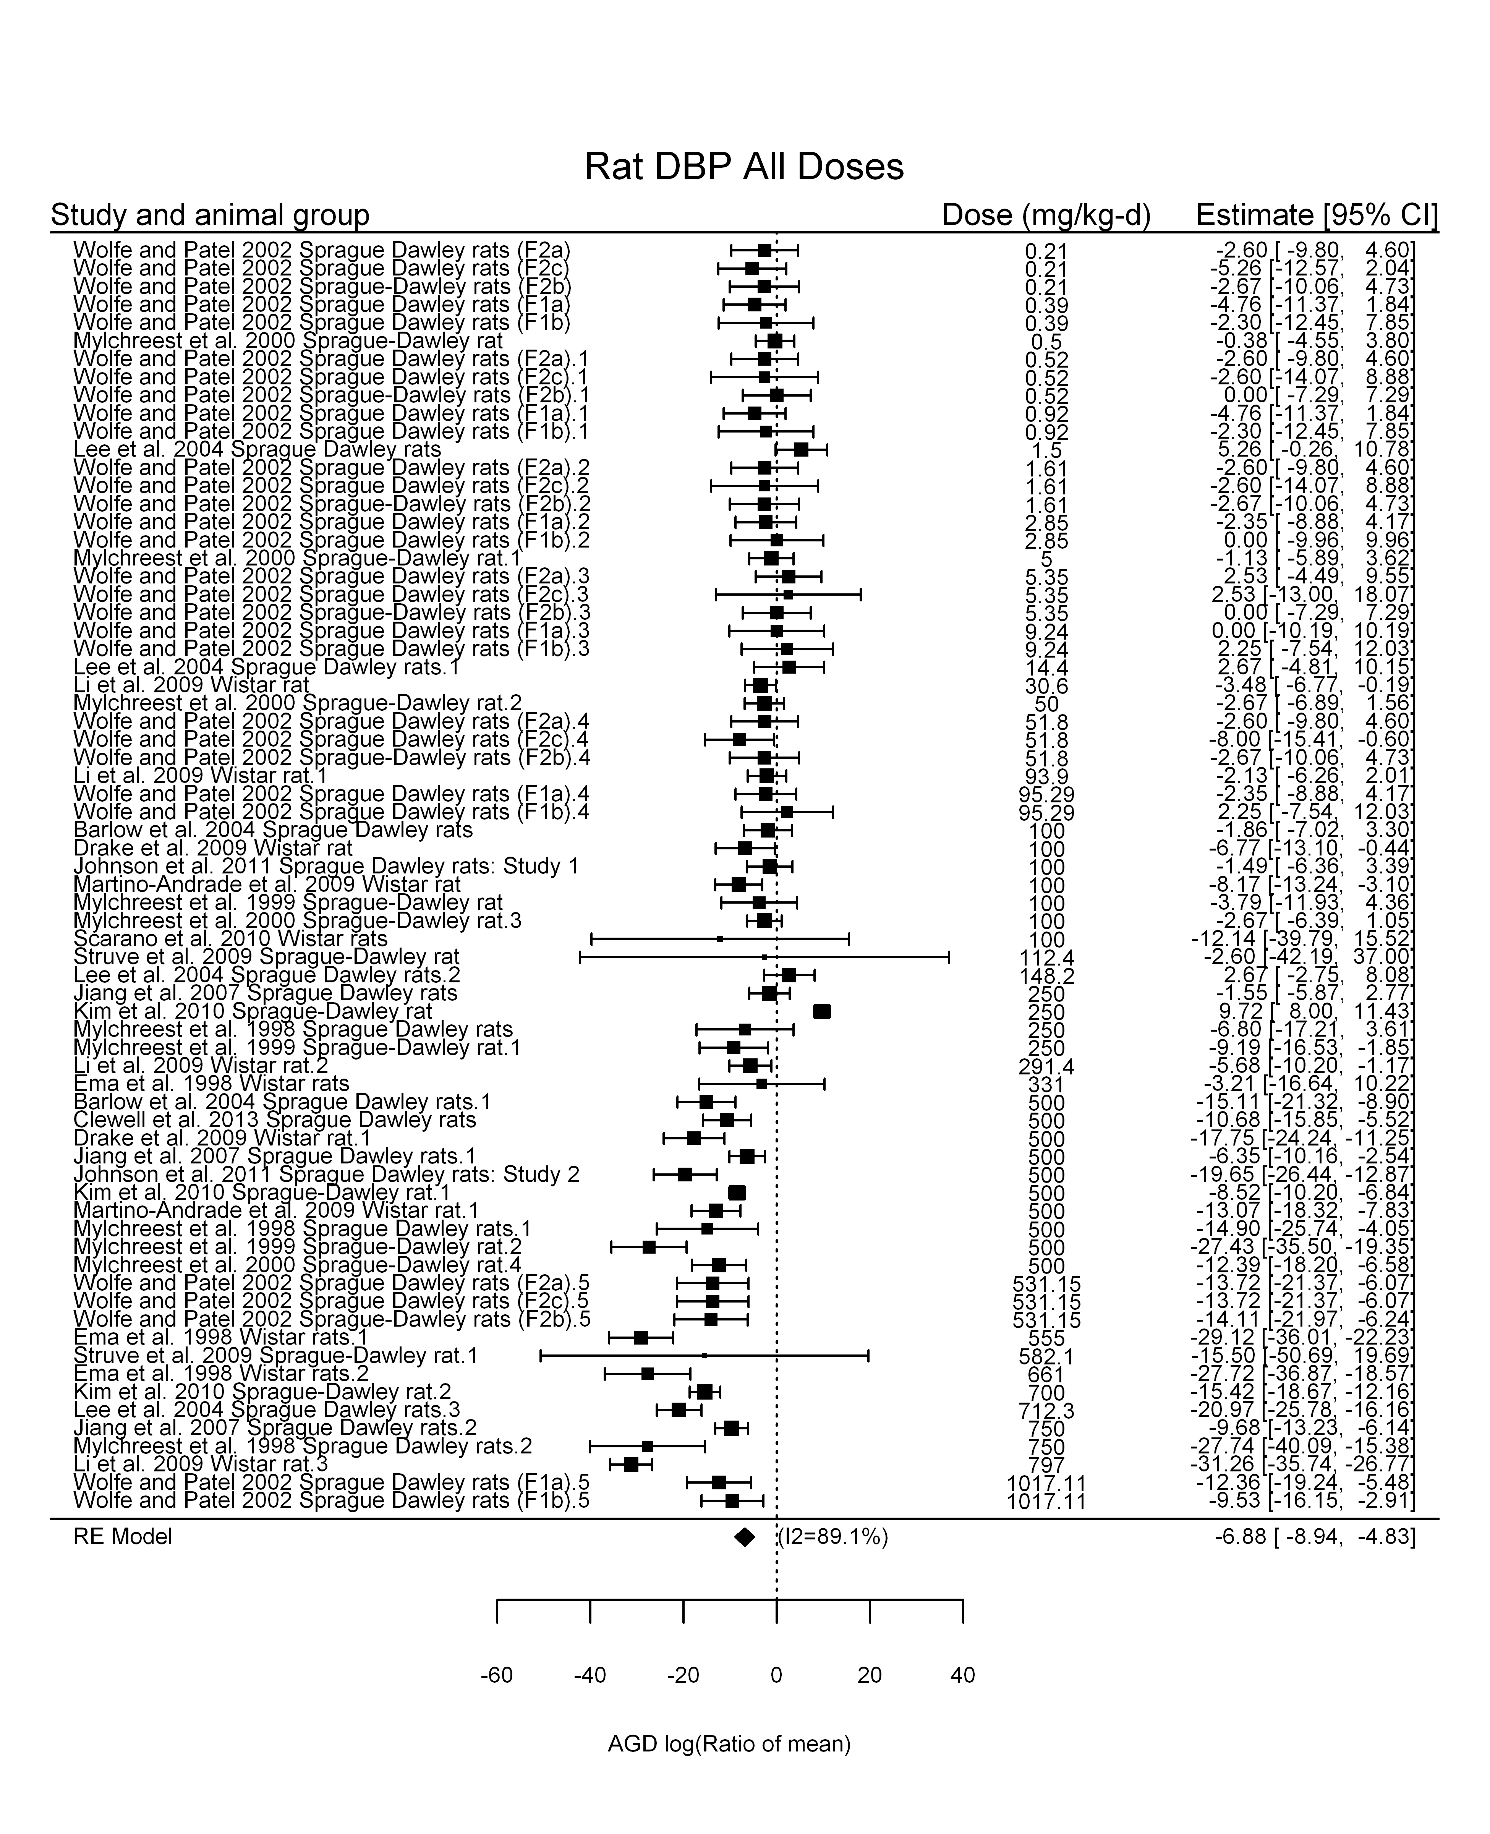

## [1] "Leave one out---------------------"  
##   
## Random-Effects Model (k = 68; tau^2 estimator: REML)  
##   
## tau^2 (estimated amount of total heterogeneity): 61.7626 (SE = 12.9384)  
## tau (square root of estimated tau^2 value): 7.8589  
## I^2 (total heterogeneity / total variability): 89.45%  
## H^2 (total variability / sampling variability): 9.48  
##   
## Test for Heterogeneity:   
## Q(df = 67) = 787.3216, p-val < .0001  
##   
## Model Results:  
##   
## estimate se zval pval ci.lb ci.ub   
## -6.8686 1.0551 -6.5098 <.0001 -8.9365 -4.8006 ***   
##   
## ---  
## Signif. codes: 0 '***' 0.001 '**' 0.01 '*' 0.05 '.' 0.1 ' ' 1   
##   
##   
## Random-Effects Model (k = 68; tau^2 estimator: REML)  
##   
## tau^2 (estimated amount of total heterogeneity): 62.2449 (SE = 13.2437)  
## tau (square root of estimated tau^2 value): 7.8895  
## I^2 (total heterogeneity / total variability): 89.27%  
## H^2 (total variability / sampling variability): 9.32  
##   
## Test for Heterogeneity:   
## Q(df = 67) = 776.1810, p-val < .0001  
##   
## Model Results:  
##   
## estimate se zval pval ci.lb ci.ub   
## -6.8362 1.0728 -6.3723 <.0001 -8.9389 -4.7336 ***   
##   
## ---  
## Signif. codes: 0 '***' 0.001 '**' 0.01 '*' 0.05 '.' 0.1 ' ' 1   
##   
##   
## Random-Effects Model (k = 66; tau^2 estimator: REML)  
##   
## tau^2 (estimated amount of total heterogeneity): 54.0812 (SE = 12.0476)  
## tau (square root of estimated tau^2 value): 7.3540  
## I^2 (total heterogeneity / total variability): 87.25%  
## H^2 (total variability / sampling variability): 7.84  
##   
## Test for Heterogeneity:   
## Q(df = 65) = 652.6503, p-val < .0001  
##   
## Model Results:  
##   
## estimate se zval pval ci.lb ci.ub   
## -6.6125 1.0320 -6.4073 <.0001 -8.6352 -4.5897 ***   
##   
## ---  
## Signif. codes: 0 '***' 0.001 '**' 0.01 '*' 0.05 '.' 0.1 ' ' 1   
##   
##   
## Random-Effects Model (k = 68; tau^2 estimator: REML)  
##   
## tau^2 (estimated amount of total heterogeneity): 60.7165 (SE = 12.9656)  
## tau (square root of estimated tau^2 value): 7.7921  
## I^2 (total heterogeneity / total variability): 89.03%  
## H^2 (total variability / sampling variability): 9.11  
##   
## Test for Heterogeneity:   
## Q(df = 67) = 767.9015, p-val < .0001  
##   
## Model Results:  
##   
## estimate se zval pval ci.lb ci.ub   
## -6.7757 1.0617 -6.3821 <.0001 -8.8566 -4.6949 ***   
##   
## ---  
## Signif. codes: 0 '***' 0.001 '**' 0.01 '*' 0.05 '.' 0.1 ' ' 1   
##   
##   
## Random-Effects Model (k = 67; tau^2 estimator: REML)  
##   
## tau^2 (estimated amount of total heterogeneity): 59.8637 (SE = 12.7765)  
## tau (square root of estimated tau^2 value): 7.7372  
## I^2 (total heterogeneity / total variability): 89.20%  
## H^2 (total variability / sampling variability): 9.26  
##   
## Test for Heterogeneity:   
## Q(df = 66) = 771.4948, p-val < .0001  
##   
## Model Results:  
##   
## estimate se zval pval ci.lb ci.ub   
## -6.5501 1.0575 -6.1940 <.0001 -8.6227 -4.4774 ***   
##   
## ---  
## Signif. codes: 0 '***' 0.001 '**' 0.01 '*' 0.05 '.' 0.1 ' ' 1   
##   
##   
## Random-Effects Model (k = 67; tau^2 estimator: REML)  
##   
## tau^2 (estimated amount of total heterogeneity): 64.5882 (SE = 13.8350)  
## tau (square root of estimated tau^2 value): 8.0367  
## I^2 (total heterogeneity / total variability): 89.17%  
## H^2 (total variability / sampling variability): 9.23  
##   
## Test for Heterogeneity:   
## Q(df = 66) = 778.1843, p-val < .0001  
##   
## Model Results:  
##   
## estimate se zval pval ci.lb ci.ub   
## -6.9373 1.1002 -6.3057 <.0001 -9.0937 -4.7810 ***   
##   
## ---  
## Signif. codes: 0 '***' 0.001 '**' 0.01 '*' 0.05 '.' 0.1 ' ' 1   
##   
##   
## Random-Effects Model (k = 65; tau^2 estimator: REML)  
##   
## tau^2 (estimated amount of total heterogeneity): 65.1406 (SE = 14.1960)  
## tau (square root of estimated tau^2 value): 8.0710  
## I^2 (total heterogeneity / total variability): 89.27%  
## H^2 (total variability / sampling variability): 9.32  
##   
## Test for Heterogeneity:   
## Q(df = 64) = 770.4713, p-val < .0001  
##   
## Model Results:  
##   
## estimate se zval pval ci.lb ci.ub   
## -7.1648 1.1230 -6.3800 <.0001 -9.3658 -4.9637 ***   
##   
## ---  
## Signif. codes: 0 '***' 0.001 '**' 0.01 '*' 0.05 '.' 0.1 ' ' 1   
##   
##   
## Random-Effects Model (k = 67; tau^2 estimator: REML)  
##   
## tau^2 (estimated amount of total heterogeneity): 58.6185 (SE = 12.6384)  
## tau (square root of estimated tau^2 value): 7.6563  
## I^2 (total heterogeneity / total variability): 88.89%  
## H^2 (total variability / sampling variability): 9.00  
##   
## Test for Heterogeneity:   
## Q(df = 66) = 756.8727, p-val < .0001  
##   
## Model Results:  
##   
## estimate se zval pval ci.lb ci.ub   
## -6.5904 1.0525 -6.2617 <.0001 -8.6533 -4.5276 ***   
##   
## ---  
## Signif. codes: 0 '***' 0.001 '**' 0.01 '*' 0.05 '.' 0.1 ' ' 1   
##   
##   
## Random-Effects Model (k = 69; tau^2 estimator: REML)  
##   
## tau^2 (estimated amount of total heterogeneity): 61.7019 (SE = 12.9294)  
## tau (square root of estimated tau^2 value): 7.8551  
## I^2 (total heterogeneity / total variability): 89.30%  
## H^2 (total variability / sampling variability): 9.35  
##   
## Test for Heterogeneity:   
## Q(df = 68) = 787.4244, p-val < .0001  
##   
## Model Results:  
##   
## estimate se zval pval ci.lb ci.ub   
## -6.8610 1.0542 -6.5085 <.0001 -8.9271 -4.7949 ***   
##   
## ---  
## Signif. codes: 0 '***' 0.001 '**' 0.01 '*' 0.05 '.' 0.1 ' ' 1   
##   
##   
## Random-Effects Model (k = 67; tau^2 estimator: REML)  
##   
## tau^2 (estimated amount of total heterogeneity): 57.7347 (SE = 12.6266)  
## tau (square root of estimated tau^2 value): 7.5983  
## I^2 (total heterogeneity / total variability): 85.07%  
## H^2 (total variability / sampling variability): 6.70  
##   
## Test for Heterogeneity:   
## Q(df = 66) = 429.0424, p-val < .0001  
##   
## Model Results:  
##   
## estimate se zval pval ci.lb ci.ub   
## -7.0079 1.0517 -6.6632 <.0001 -9.0692 -4.9465 ***   
##   
## ---  
## Signif. codes: 0 '***' 0.001 '**' 0.01 '*' 0.05 '.' 0.1 ' ' 1   
##   
##   
## Random-Effects Model (k = 68; tau^2 estimator: REML)  
##   
## tau^2 (estimated amount of total heterogeneity): 61.8108 (SE = 13.1517)  
## tau (square root of estimated tau^2 value): 7.8620  
## I^2 (total heterogeneity / total variability): 89.26%  
## H^2 (total variability / sampling variability): 9.31  
##   
## Test for Heterogeneity:   
## Q(df = 67) = 772.7241, p-val < .0001  
##   
## Model Results:  
##   
## estimate se zval pval ci.lb ci.ub   
## -6.7146 1.0692 -6.2803 <.0001 -8.8101 -4.6191 ***   
##   
## ---  
## Signif. codes: 0 '***' 0.001 '**' 0.01 '*' 0.05 '.' 0.1 ' ' 1   
##   
##   
## Random-Effects Model (k = 66; tau^2 estimator: REML)  
##   
## tau^2 (estimated amount of total heterogeneity): 56.8206 (SE = 12.4837)  
## tau (square root of estimated tau^2 value): 7.5379  
## I^2 (total heterogeneity / total variability): 88.37%  
## H^2 (total variability / sampling variability): 8.60  
##   
## Test for Heterogeneity:   
## Q(df = 65) = 720.2588, p-val < .0001  
##   
## Model Results:  
##   
## estimate se zval pval ci.lb ci.ub   
## -7.1510 1.0503 -6.8084 <.0001 -9.2095 -5.0924 ***   
##   
## ---  
## Signif. codes: 0 '***' 0.001 '**' 0.01 '*' 0.05 '.' 0.1 ' ' 1   
##   
##   
## Random-Effects Model (k = 68; tau^2 estimator: REML)  
##   
## tau^2 (estimated amount of total heterogeneity): 63.1206 (SE = 13.4113)  
## tau (square root of estimated tau^2 value): 7.9448  
## I^2 (total heterogeneity / total variability): 89.35%  
## H^2 (total variability / sampling variability): 9.39  
##   
## Test for Heterogeneity:   
## Q(df = 67) = 777.2120, p-val < .0001  
##   
## Model Results:  
##   
## estimate se zval pval ci.lb ci.ub   
## -6.7601 1.0794 -6.2626 <.0001 -8.8757 -4.6444 ***   
##   
## ---  
## Signif. codes: 0 '***' 0.001 '**' 0.01 '*' 0.05 '.' 0.1 ' ' 1   
##   
##   
## Random-Effects Model (k = 40; tau^2 estimator: REML)  
##   
## tau^2 (estimated amount of total heterogeneity): 90.2620 (SE = 23.4780)  
## tau (square root of estimated tau^2 value): 9.5006  
## I^2 (total heterogeneity / total variability): 94.35%  
## H^2 (total variability / sampling variability): 17.69  
##   
## Test for Heterogeneity:   
## Q(df = 39) = 744.8204, p-val < .0001  
##   
## Model Results:  
##   
## estimate se zval pval ci.lb ci.ub   
## -9.1698 1.6289 -5.6295 <.0001 -12.3623 -5.9772 ***   
##   
## ---  
## Signif. codes: 0 '***' 0.001 '**' 0.01 '*' 0.05 '.' 0.1 ' ' 1   
##   
##   
## Random-Effects Model (k = 67; tau^2 estimator: REML)  
##   
## tau^2 (estimated amount of total heterogeneity): 51.2263 (SE = 11.2481)  
## tau (square root of estimated tau^2 value): 7.1573  
## I^2 (total heterogeneity / total variability): 87.54%  
## H^2 (total variability / sampling variability): 8.02  
##   
## Test for Heterogeneity:   
## Q(df = 66) = 716.7320, p-val < .0001  
##   
## Model Results:  
##   
## estimate se zval pval ci.lb ci.ub   
## -6.2864 0.9936 -6.3272 <.0001 -8.2337 -4.3391 ***   
##   
## ---  
## Signif. codes: 0 '***' 0.001 '**' 0.01 '*' 0.05 '.' 0.1 ' ' 1   
##   
##   
## Random-Effects Model (k = 69; tau^2 estimator: REML)  
##   
## tau^2 (estimated amount of total heterogeneity): 62.3562 (SE = 13.1538)  
## tau (square root of estimated tau^2 value): 7.8966  
## I^2 (total heterogeneity / total variability): 89.25%  
## H^2 (total variability / sampling variability): 9.30  
##   
## Test for Heterogeneity:   
## Q(df = 68) = 783.1661, p-val < .0001  
##   
## Model Results:  
##   
## estimate se zval pval ci.lb ci.ub   
## -6.8215 1.0652 -6.4042 <.0001 -8.9092 -4.7338 ***   
##   
## ---  
## Signif. codes: 0 '***' 0.001 '**' 0.01 '*' 0.05 '.' 0.1 ' ' 1   
##   
## [1] "Linear in log10(dose)---------------------"  
##   
## Mixed-Effects Model (k = 70; tau^2 estimator: REML)  
##   
## logLik deviance AIC BIC AICc   
## -232.3875 464.7750 470.7750 477.4335 471.1500   
##   
## tau^2 (estimated amount of residual heterogeneity): 40.7024 (SE = 9.2471)  
## tau (square root of estimated tau^2 value): 6.3798  
## I^2 (residual heterogeneity / unaccounted variability): 84.31%  
## H^2 (unaccounted variability / sampling variability): 6.37  
## R^2 (amount of heterogeneity accounted for): 33.73%  
##   
## Test for Residual Heterogeneity:   
## QE(df = 68) = 693.8230, p-val < .0001  
##   
## Test of Moderators (coefficient(s) 2):   
## QM(df = 1) = 29.6347, p-val < .0001  
##   
## Model Results:  
##   
## estimate se zval pval ci.lb ci.ub   
## intrcpt 0.0057 1.5445 0.0037 0.9971 -3.0214 3.0328   
## log10(dose) -4.1393 0.7604 -5.4438 <.0001 -5.6296 -2.6490 ***  
##   
## ---  
## Signif. codes: 0 '***' 0.001 '**' 0.01 '*' 0.05 '.' 0.1 ' ' 1

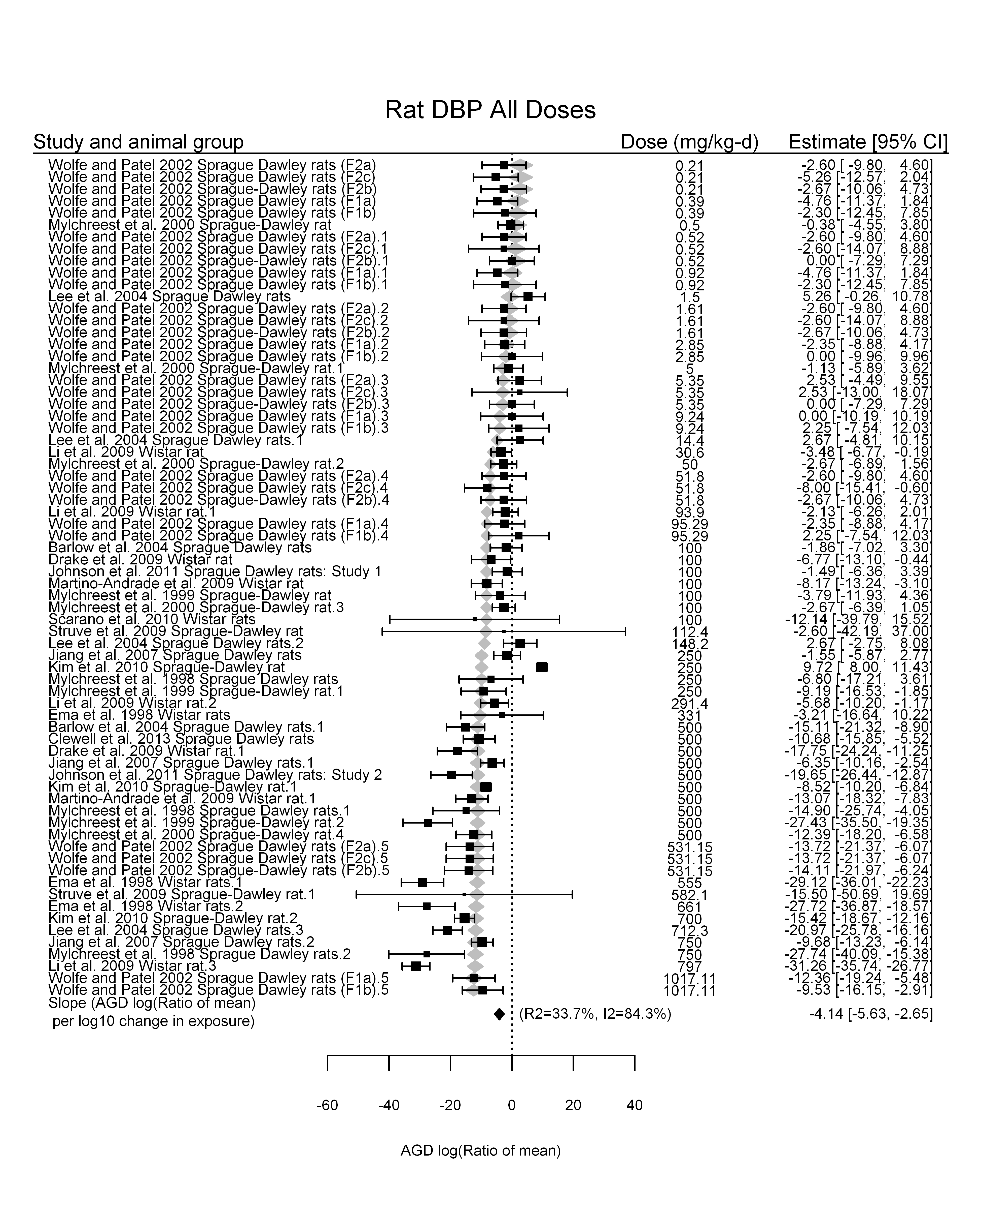

## [1] "Linear in dose---------------------"  
##   
## Mixed-Effects Model (k = 70; tau^2 estimator: REML)  
##   
## logLik deviance AIC BIC AICc   
## -222.5305 445.0609 449.0609 453.5291 449.2427   
##   
## tau^2 (estimated amount of residual heterogeneity): 24.5446 (SE = 6.2355)  
## tau (square root of estimated tau^2 value): 4.9542  
## I^2 (residual heterogeneity / unaccounted variability): 76.58%  
## H^2 (unaccounted variability / sampling variability): 4.27  
##   
## Test for Residual Heterogeneity:   
## QE(df = 69) = 481.6983, p-val < .0001  
##   
## Model Results:  
##   
## estimate se zval pval ci.lb ci.ub   
## dose100 -2.4204 0.1922 -12.5934 <.0001 -2.7971 -2.0437 ***  
##   
## ---  
## Signif. codes: 0 '***' 0.001 '**' 0.01 '*' 0.05 '.' 0.1 ' ' 1

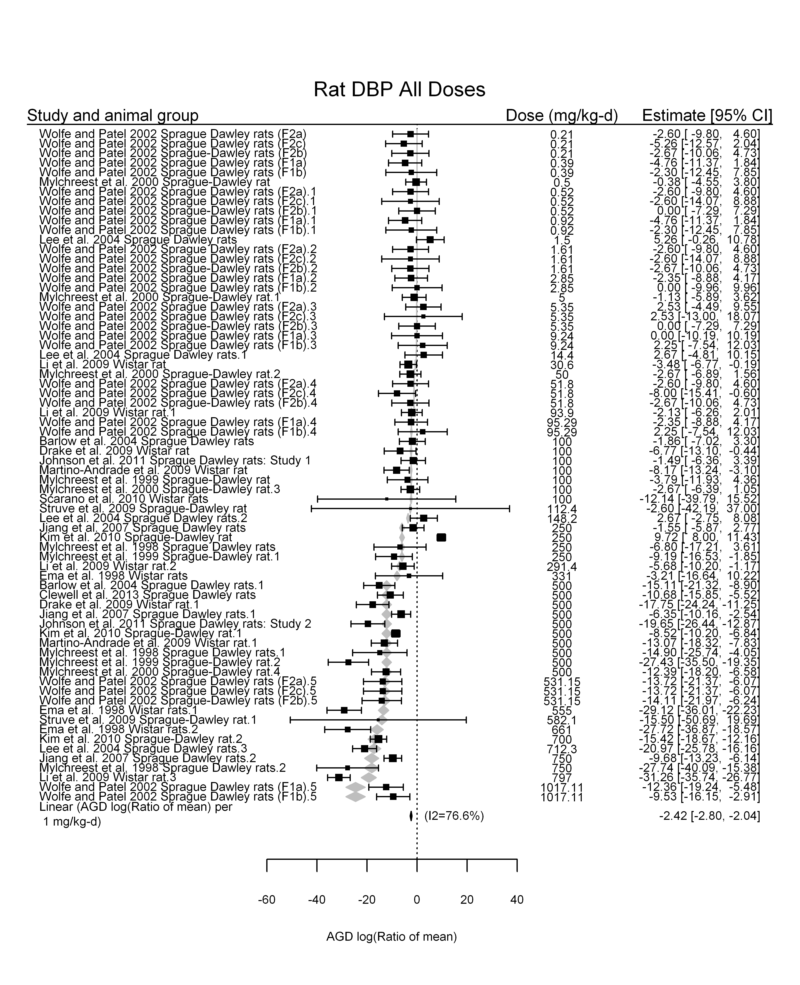

## [1] "Linear or LinearQuadratic in dose---------------------"  
##   
## Mixed-Effects Model (k = 70; tau^2 estimator: REML)  
##   
## logLik deviance AIC BIC AICc   
## -217.6870 435.3739 441.3739 448.0325 441.7489   
##   
## tau^2 (estimated amount of residual heterogeneity): 24.0201 (SE = 6.1910)  
## tau (square root of estimated tau^2 value): 4.9010  
## I^2 (residual heterogeneity / unaccounted variability): 75.57%  
## H^2 (unaccounted variability / sampling variability): 4.09  
##   
## Test for Residual Heterogeneity:   
## QE(df = 68) = 453.4163, p-val < .0001  
##   
## Test of Moderators (coefficient(s) 1,2):   
## QM(df = 2) = 165.1927, p-val < .0001  
##   
## Model Results:  
##   
## estimate se zval pval ci.lb ci.ub   
## dose100 -3.6365 0.6188 -5.8771 <.0001 -4.8493 -2.4238 ***  
## I(dose100^2) 0.1791 0.0866 2.0682 0.0386 0.0094 0.3489 *  
##   
## ---  
## Signif. codes: 0 '***' 0.001 '**' 0.01 '*' 0.05 '.' 0.1 ' ' 1

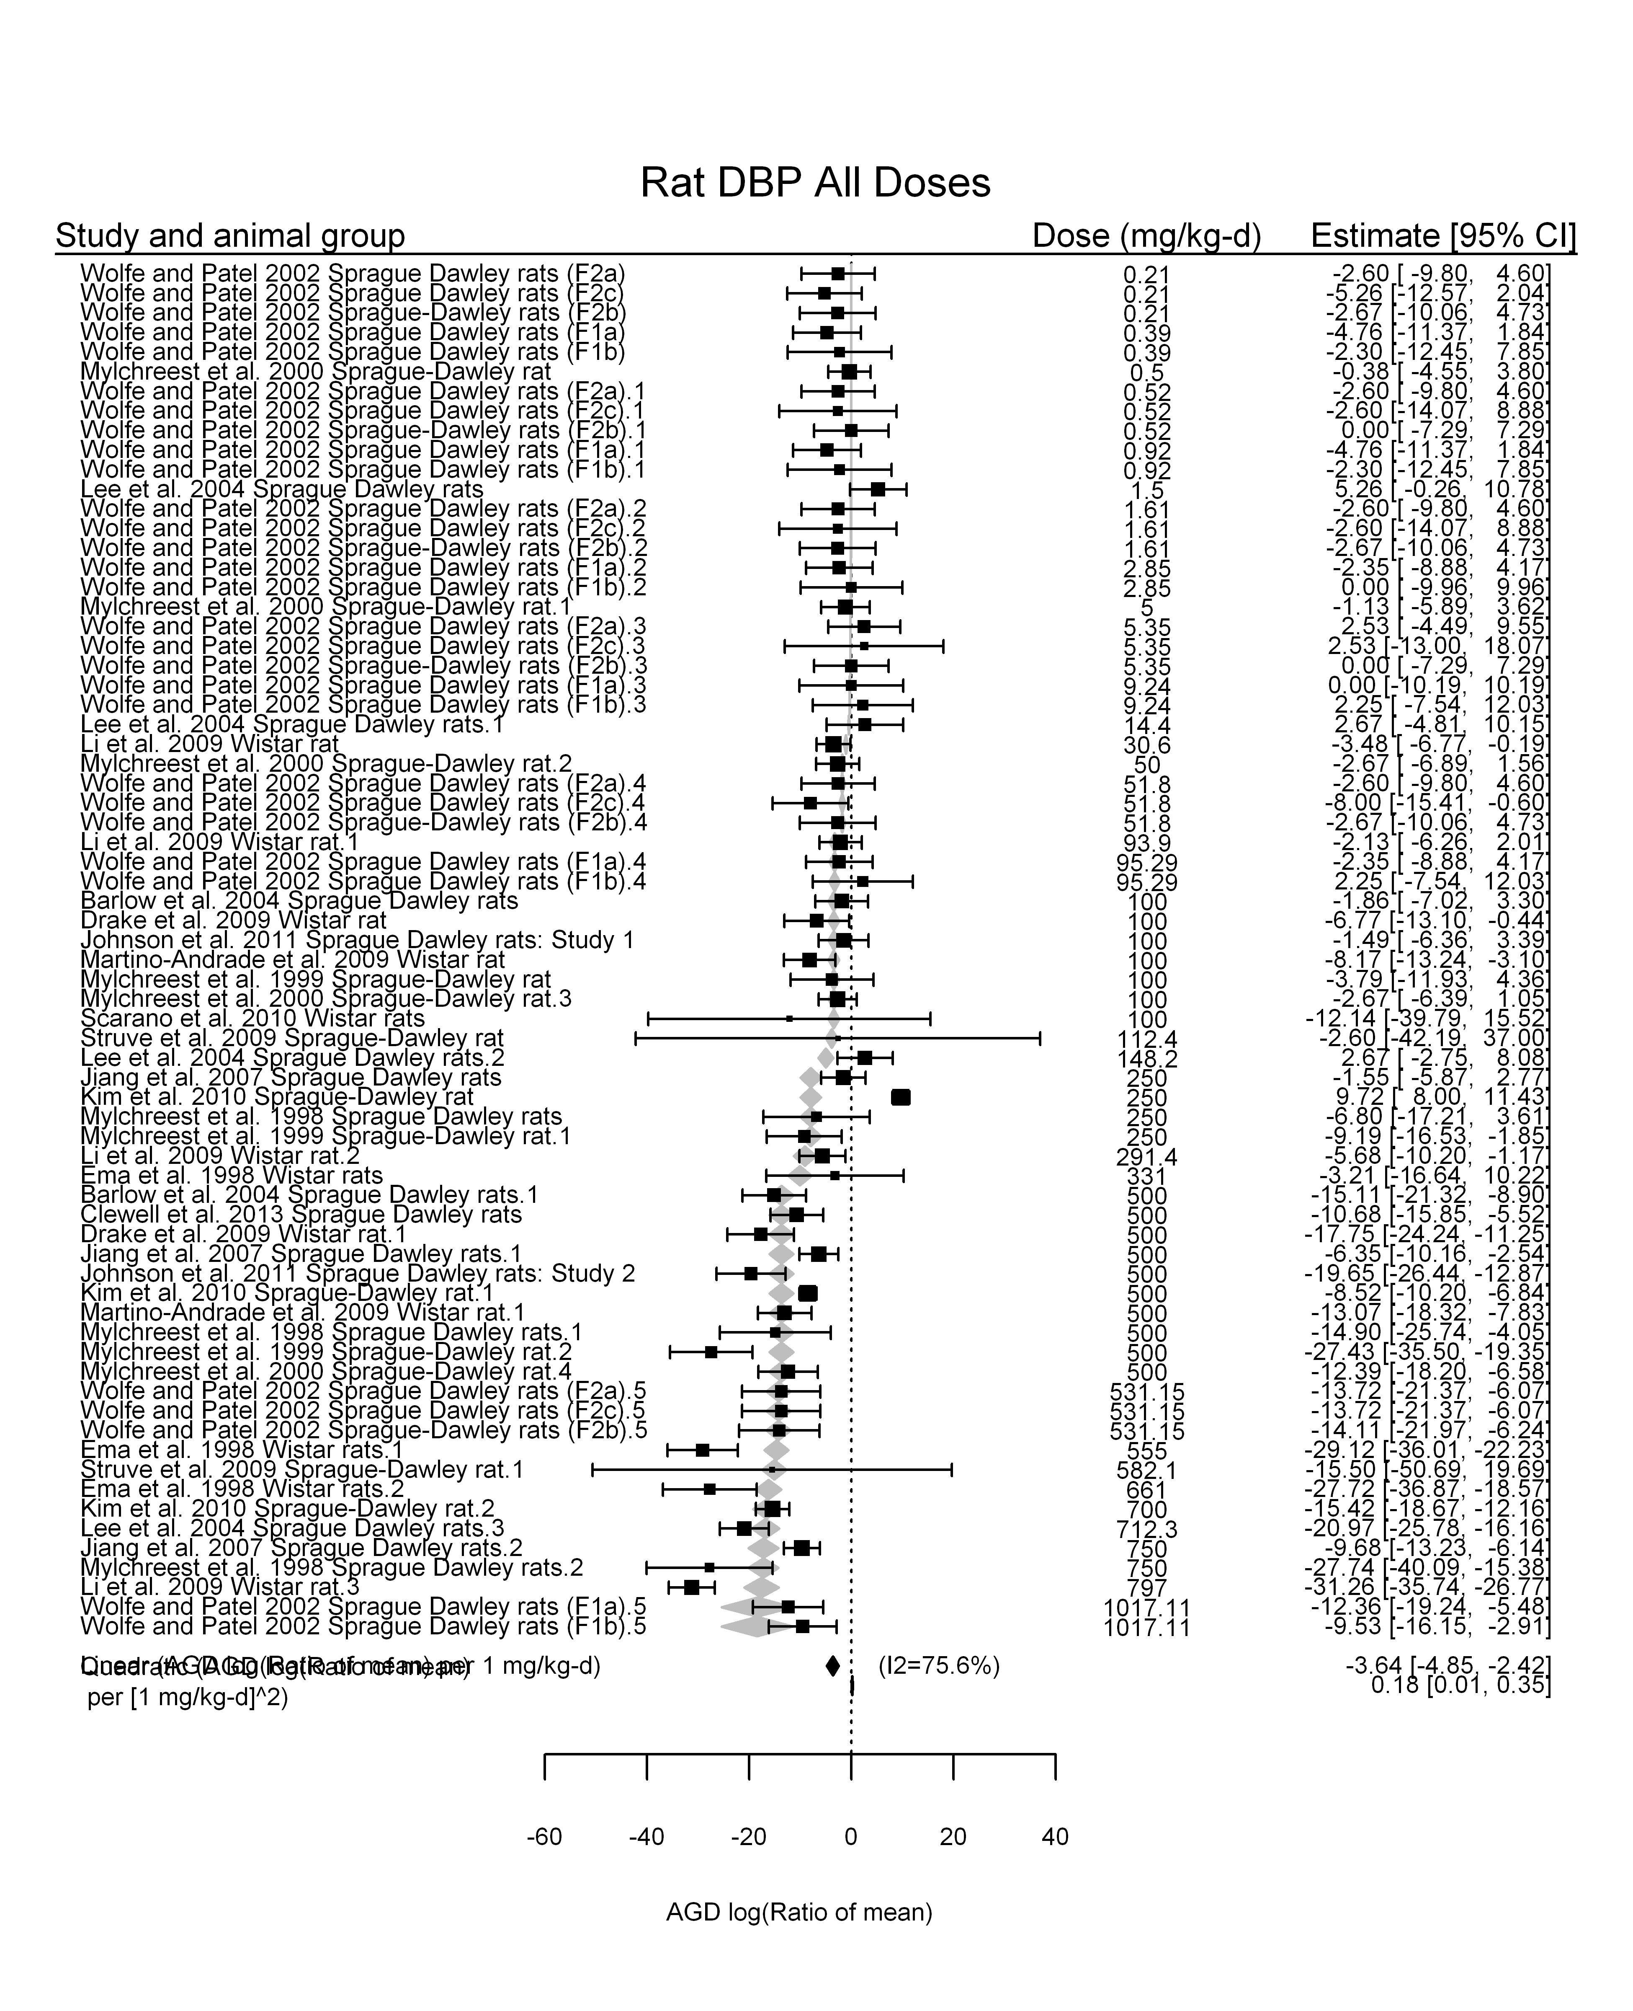

## [1] ""

## [1] ""  
## m ci.lb ci.ub bmr  
## 1 211.9163 183.3767 250.9771 -5.129329

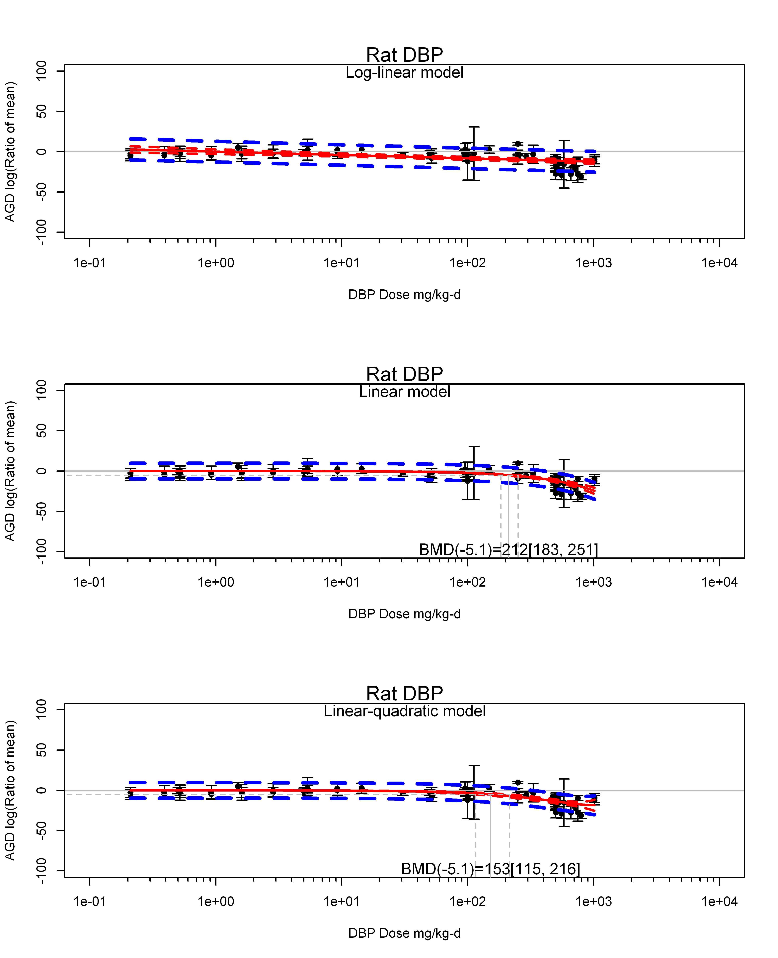

## [1] ""  
## m ci.lb ci.ub bmr  
## 1 152.5077 115.0277 215.6626 -5.129329  
## [1] "AGD log(Ratio of mean) Rat Highest Dose"  
## [1] "Overall Effect---------------------"  
##   
## Random-Effects Model (k = 21; tau^2 estimator: REML)  
##   
## logLik deviance AIC BIC AICc   
## -69.5391 139.0782 143.0782 145.0697 143.7841   
##   
## tau^2 (estimated amount of total heterogeneity): 45.0507 (SE = 18.5494)  
## tau (square root of estimated tau^2 value): 6.7120  
## I^2 (total heterogeneity / total variability): 83.07%  
## H^2 (total variability / sampling variability): 5.91  
##   
## Test for Heterogeneity:   
## Q(df = 20) = 125.0232, p-val < .0001  
##   
## Model Results:  
##   
## estimate se zval pval ci.lb ci.ub   
## -16.0706 1.7014 -9.4455 <.0001 -19.4053 -12.7359 ***   
##   
## ---  
## Signif. codes: 0 '***' 0.001 '**' 0.01 '*' 0.05 '.' 0.1 ' ' 1

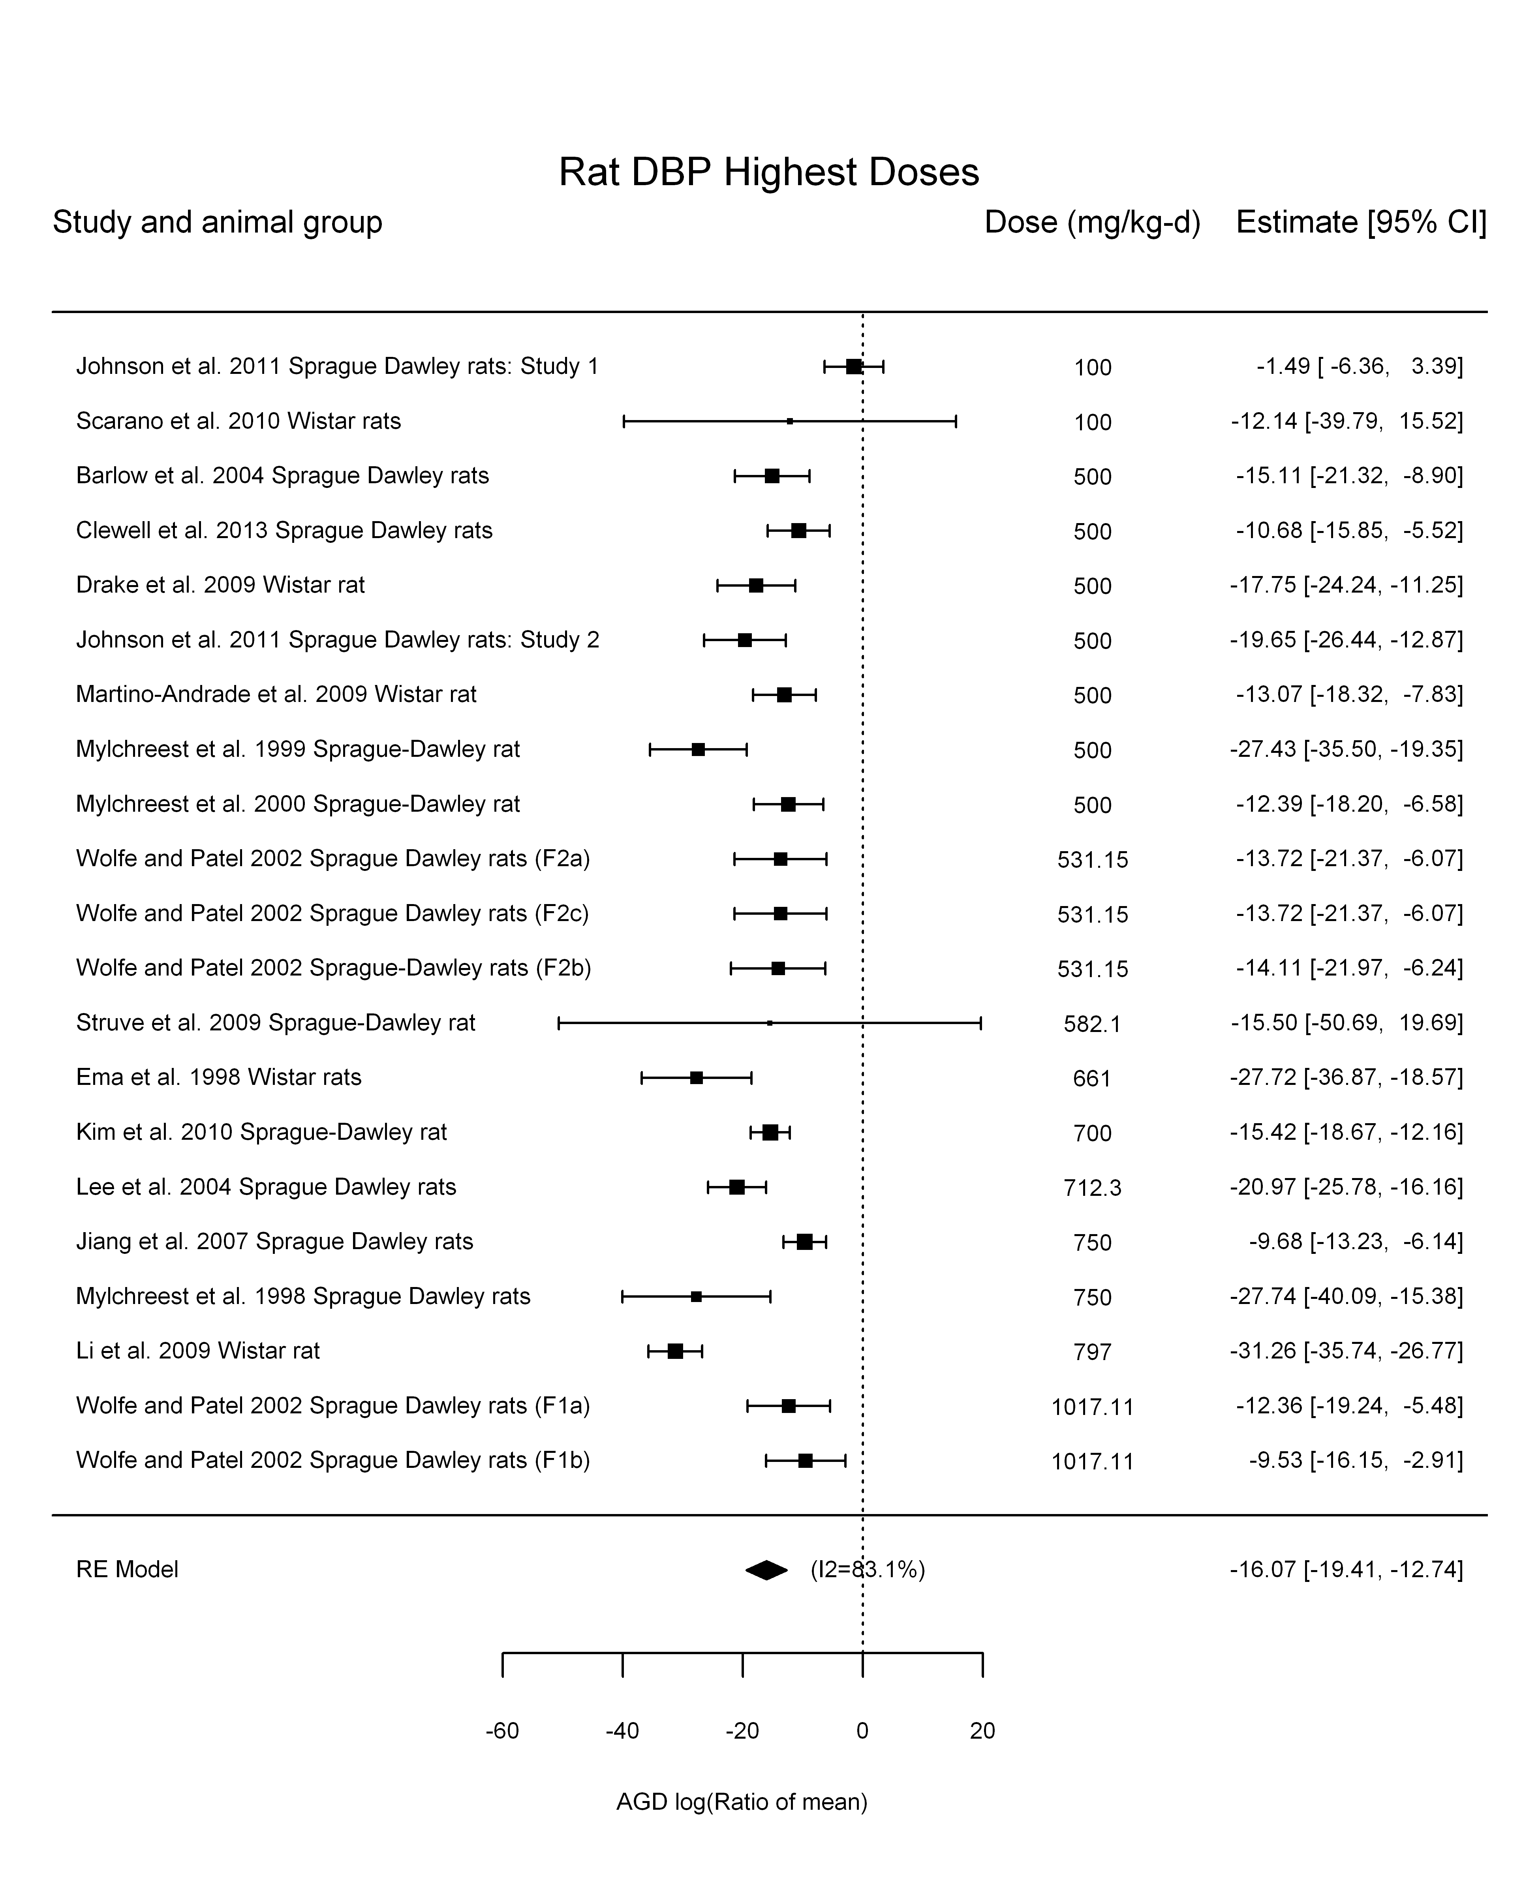

## [1] "Linear or LinearQuadratic in dose---------------------"  
##   
## Mixed-Effects Model (k = 21; tau^2 estimator: REML)  
##   
## logLik deviance AIC BIC AICc   
## -70.5653 141.1307 145.1307 147.1222 145.8366   
##   
## tau^2 (estimated amount of residual heterogeneity): 49.0151 (SE = 19.8890)  
## tau (square root of estimated tau^2 value): 7.0011  
## I^2 (residual heterogeneity / unaccounted variability): 84.14%  
## H^2 (unaccounted variability / sampling variability): 6.31  
##   
## Test for Residual Heterogeneity:   
## QE(df = 20) = 116.3872, p-val < .0001  
##   
## Model Results:  
##   
## estimate se zval pval ci.lb ci.ub   
## dose100 -2.4912 0.2758 -9.0312 <.0001 -3.0319 -1.9506 ***  
##   
## ---  
## Signif. codes: 0 '***' 0.001 '**' 0.01 '*' 0.05 '.' 0.1 ' ' 1

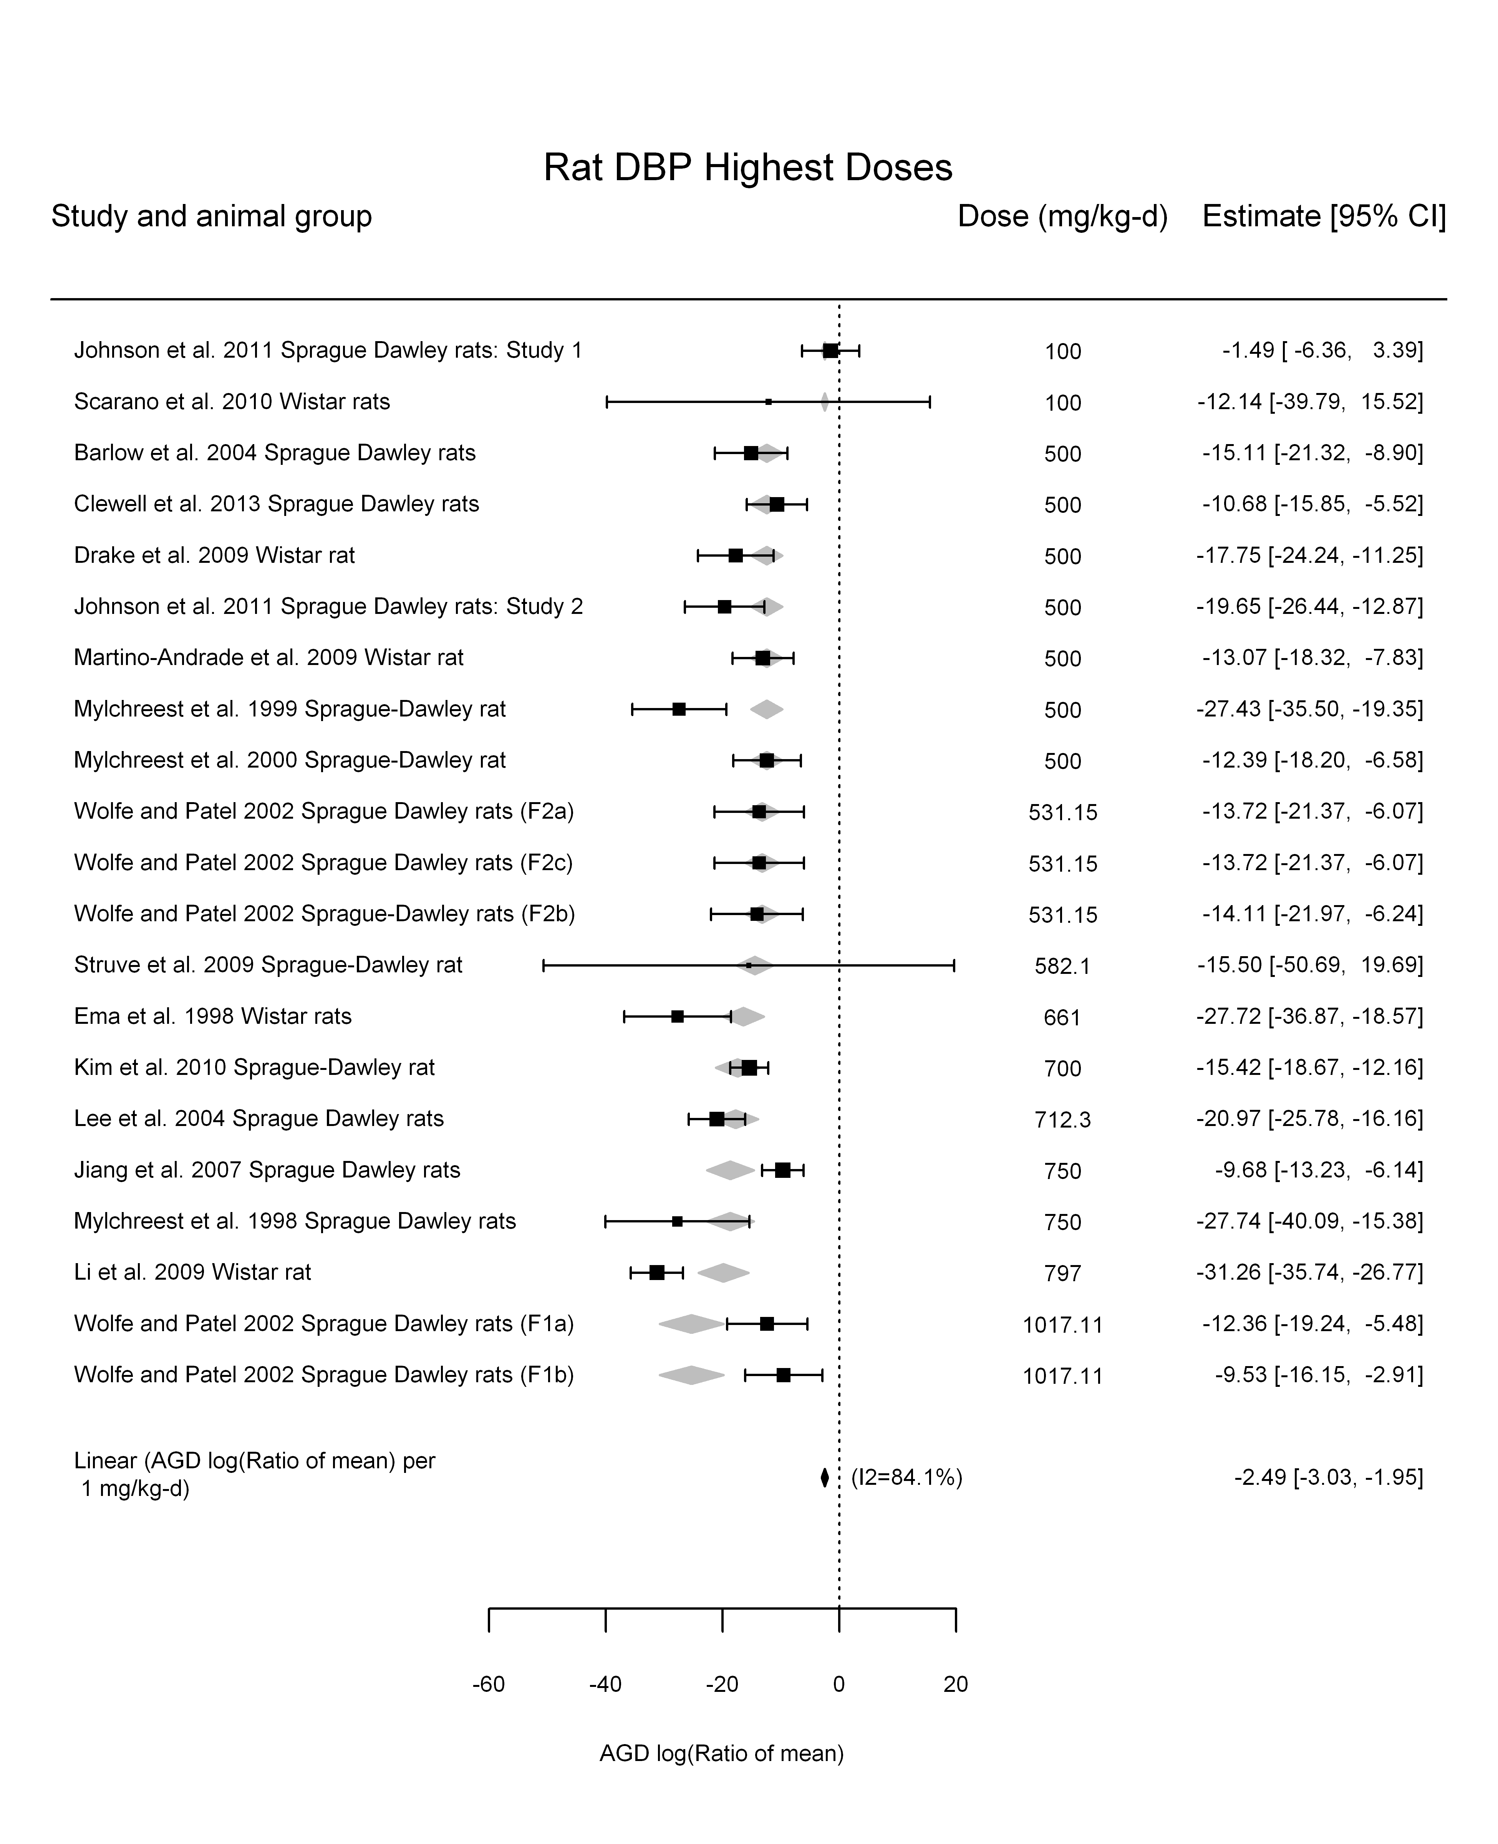

## [1] "Linear in log10(dose)---------------------"  
##   
## Mixed-Effects Model (k = 21; tau^2 estimator: REML)  
##   
## logLik deviance AIC BIC AICc   
## -64.5495 129.0990 135.0990 137.9323 136.6990   
##   
## tau^2 (estimated amount of residual heterogeneity): 35.8464 (SE = 15.9344)  
## tau (square root of estimated tau^2 value): 5.9872  
## I^2 (residual heterogeneity / unaccounted variability): 79.18%  
## H^2 (unaccounted variability / sampling variability): 4.80  
## R^2 (amount of heterogeneity accounted for): 20.43%  
##   
## Test for Residual Heterogeneity:   
## QE(df = 19) = 94.4049, p-val < .0001  
##   
## Test of Moderators (coefficient(s) 2):   
## QM(df = 1) = 4.3093, p-val = 0.0379  
##   
## Model Results:  
##   
## estimate se zval pval ci.lb ci.ub   
## intrcpt 23.5222 19.1116 1.2308 0.2184 -13.9358 60.9803   
## log10(dose) -14.4391 6.9556 -2.0759 0.0379 -28.0719 -0.8063 *  
##   
## ---  
## Signif. codes: 0 '***' 0.001 '**' 0.01 '*' 0.05 '.' 0.1 ' ' 1

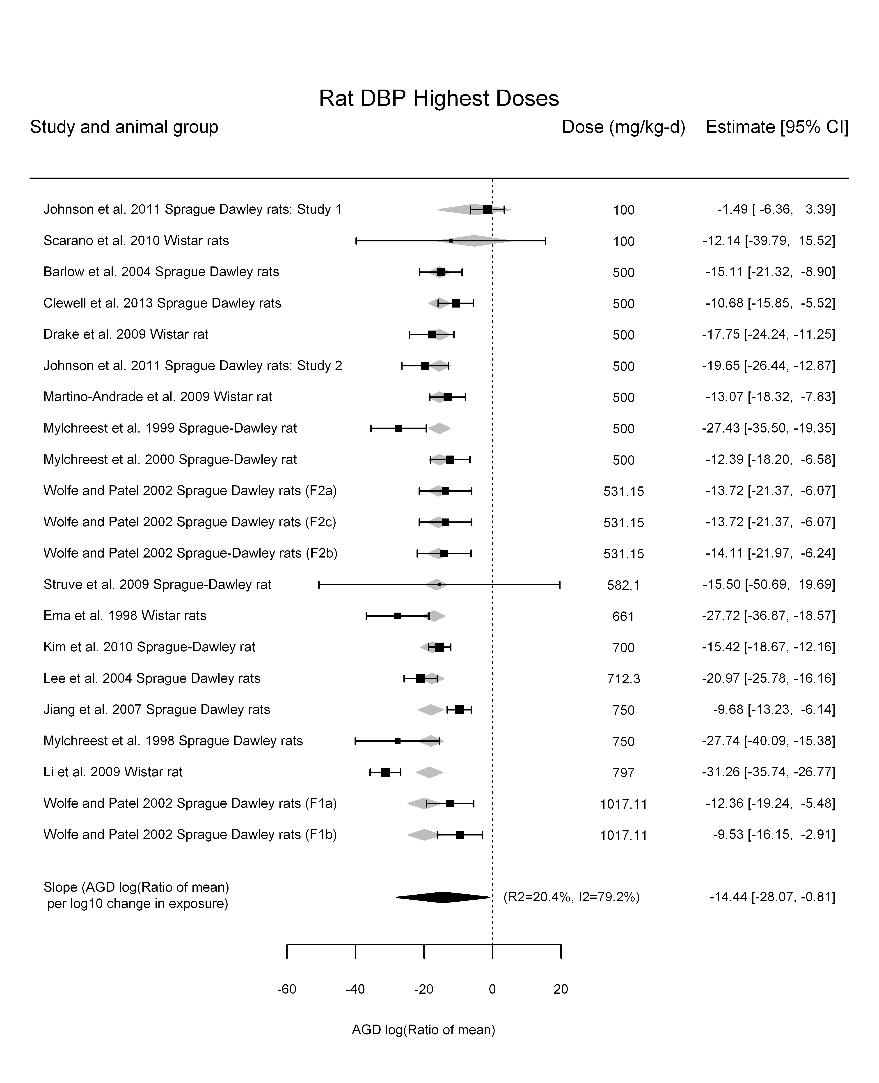

## [1] "Linear or LinearQuadratic in dose---------------------"  
##   
## Mixed-Effects Model (k = 21; tau^2 estimator: REML)  
##   
## logLik deviance AIC BIC AICc   
## -63.3677 126.7353 132.7353 135.5686 134.3353   
##   
## tau^2 (estimated amount of residual heterogeneity): 30.0762 (SE = 13.8385)  
## tau (square root of estimated tau^2 value): 5.4842  
## I^2 (residual heterogeneity / unaccounted variability): 76.59%  
## H^2 (unaccounted variability / sampling variability): 4.27  
##   
## Test for Residual Heterogeneity:   
## QE(df = 19) = 87.8722, p-val < .0001  
##   
## Test of Moderators (coefficient(s) 1,2):   
## QM(df = 2) = 128.4036, p-val < .0001  
##   
## Model Results:  
##   
## estimate se zval pval ci.lb ci.ub   
## dose100 -5.2040 0.8821 -5.8995 <.0001 -6.9329 -3.4751 ***  
## I(dose100^2) 0.3725 0.1163 3.2029 0.0014 0.1445 0.6004 **  
##   
## ---  
## Signif. codes: 0 '***' 0.001 '**' 0.01 '*' 0.05 '.' 0.1 ' ' 1

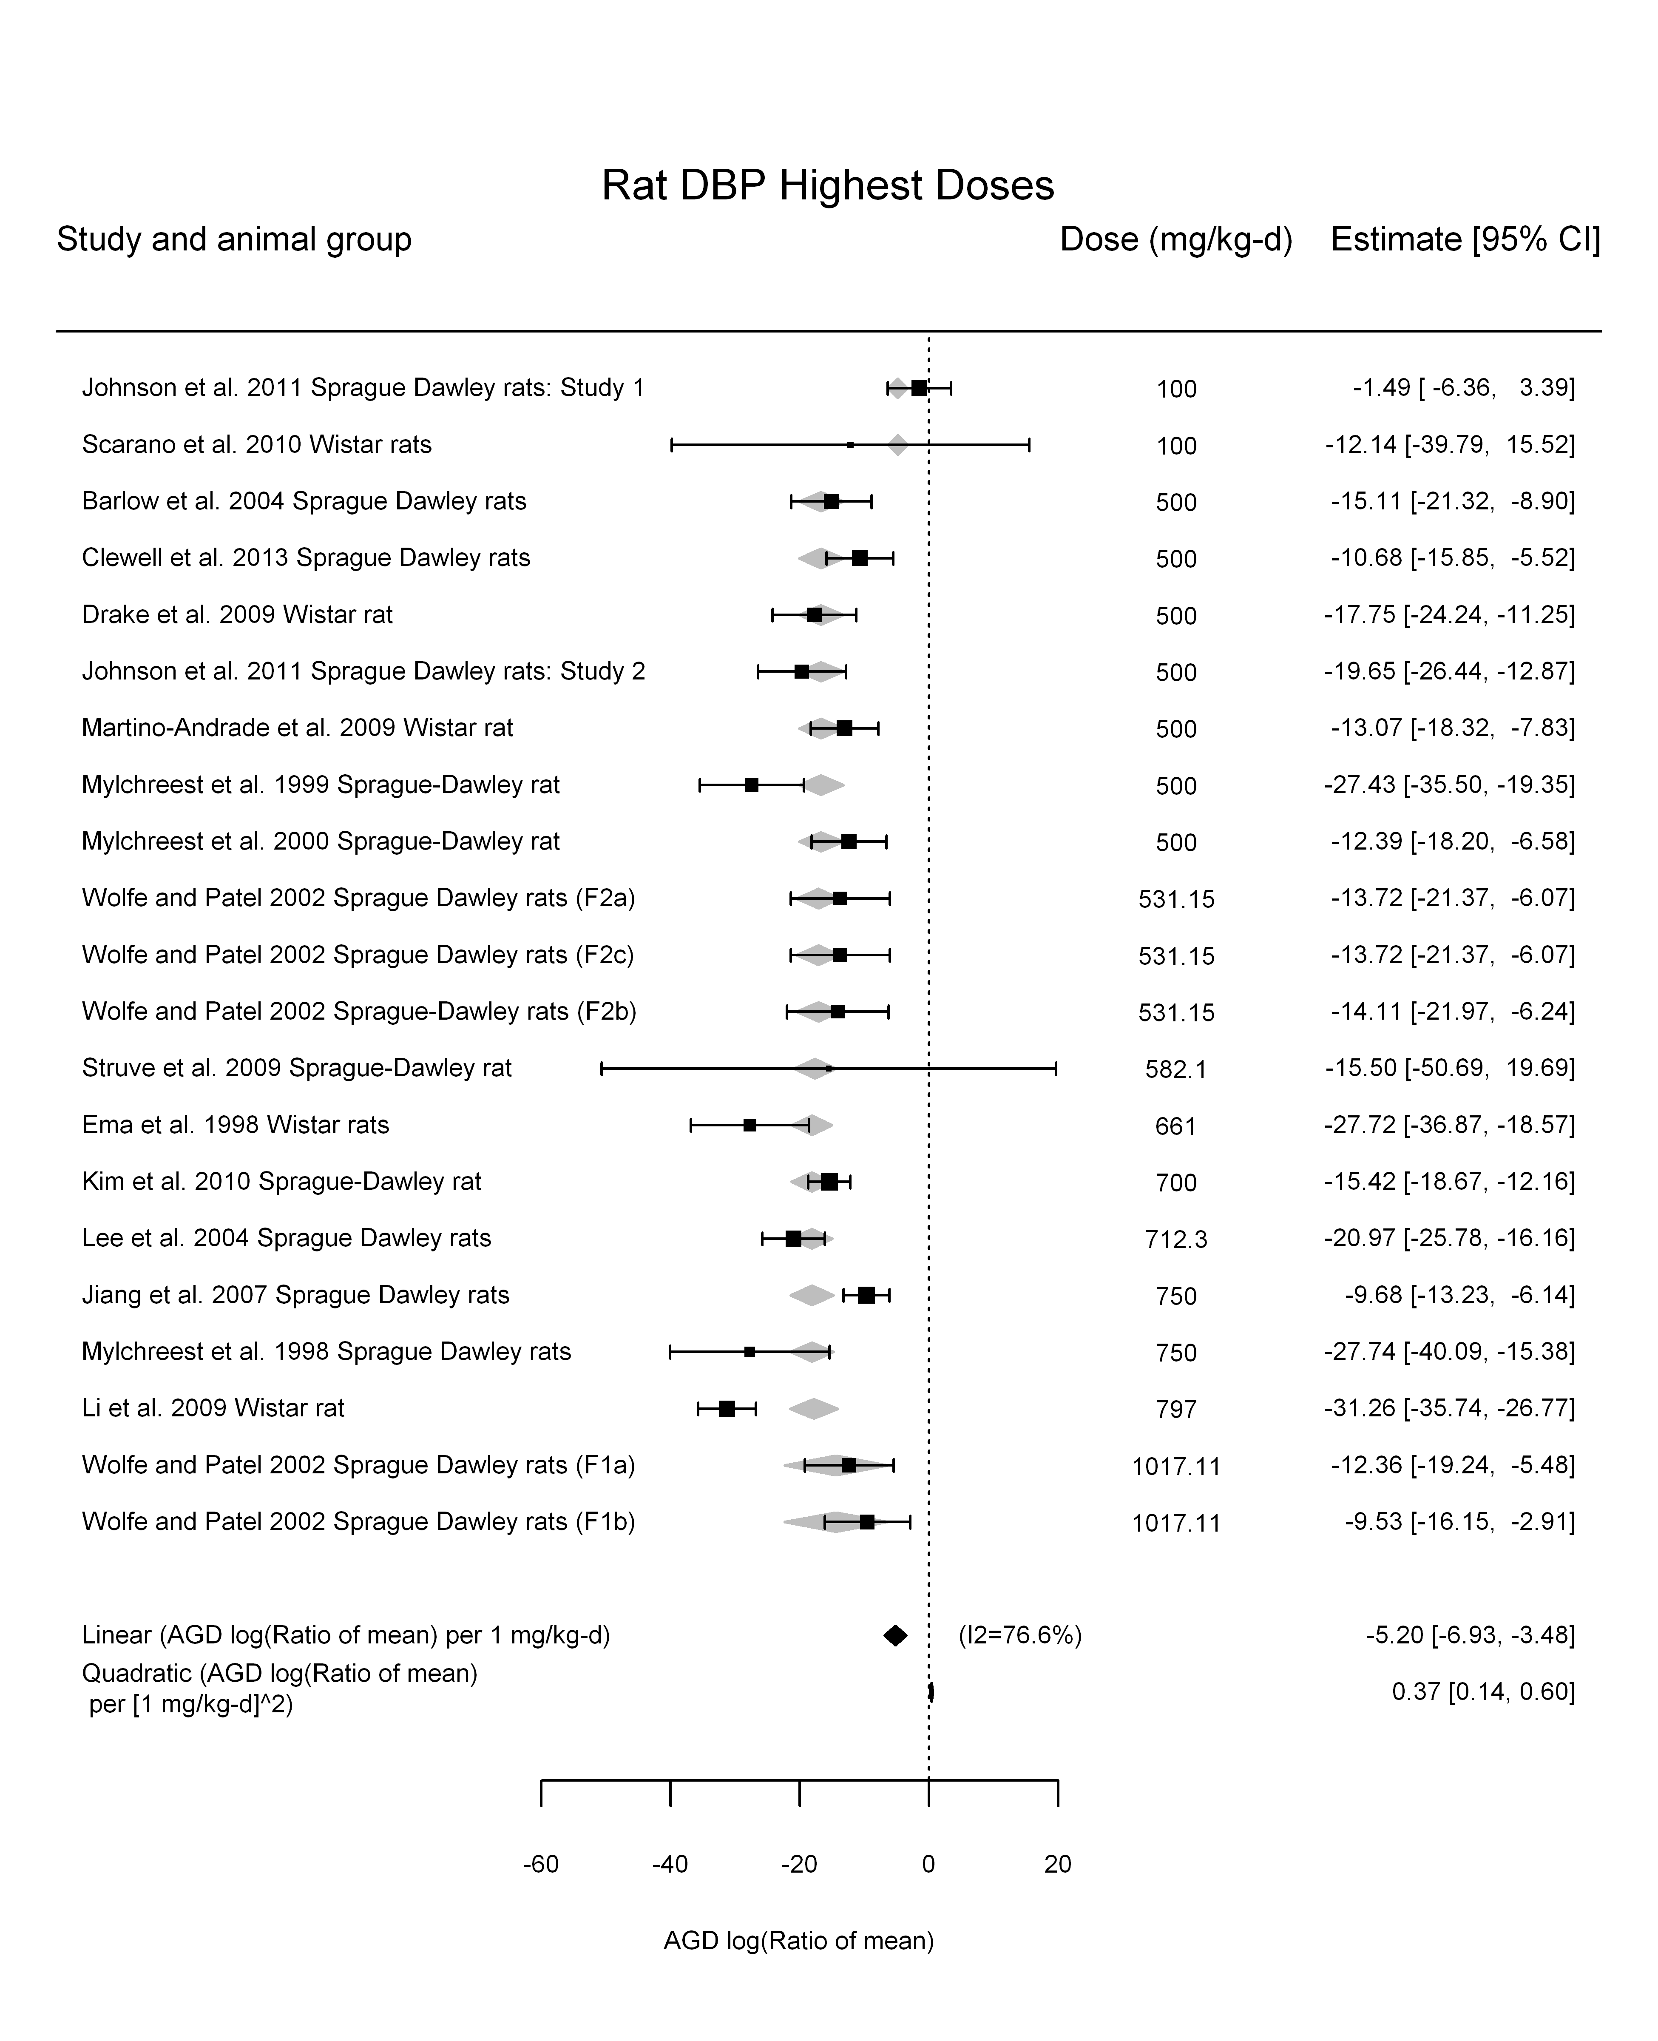

## [1] ""

## [1] ""  
## m ci.lb ci.ub bmr  
## 1 205.8937 169.1786 262.963 -5.129329

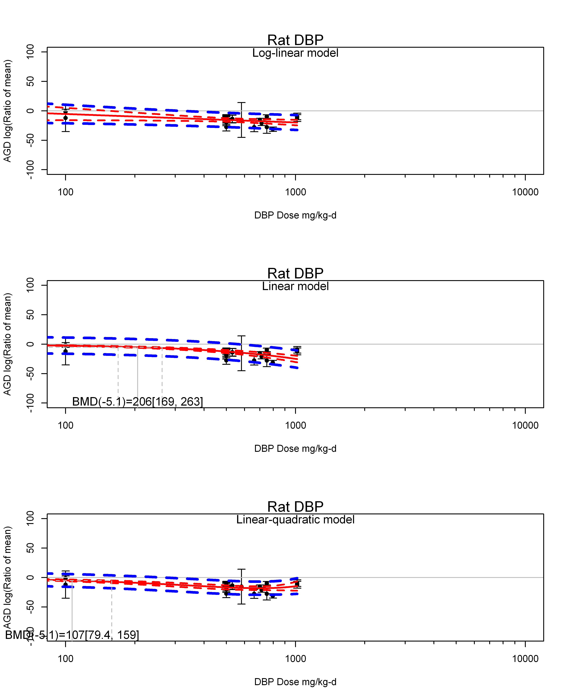

## [1] ""  
## m ci.lb ci.ub bmr  
## 1 106.7159 79.36144 158.7957 -5.129329  
## [1] "AGD log(Ratio of mean) Mouse"  
## [1] "AGD log(Ratio of mean) Rat"  
## [1] "Overall Effect---------------------"  
##   
## Random-Effects Model (k = 16; tau^2 estimator: REML)  
##   
## logLik deviance AIC BIC AICc   
## -48.5363 97.0727 101.0727 102.4888 102.0727   
##   
## tau^2 (estimated amount of total heterogeneity): 33.3886 (SE = 13.7508)  
## tau (square root of estimated tau^2 value): 5.7783  
## I^2 (total heterogeneity / total variability): 94.87%  
## H^2 (total variability / sampling variability): 19.48  
##   
## Test for Heterogeneity:   
## Q(df = 15) = 197.1370, p-val < .0001  
##   
## Model Results:  
##   
## estimate se zval pval ci.lb ci.ub   
## -5.3409 1.5370 -3.4749 0.0005 -8.3533 -2.3285 ***   
##   
## ---  
## Signif. codes: 0 '***' 0.001 '**' 0.01 '*' 0.05 '.' 0.1 ' ' 1

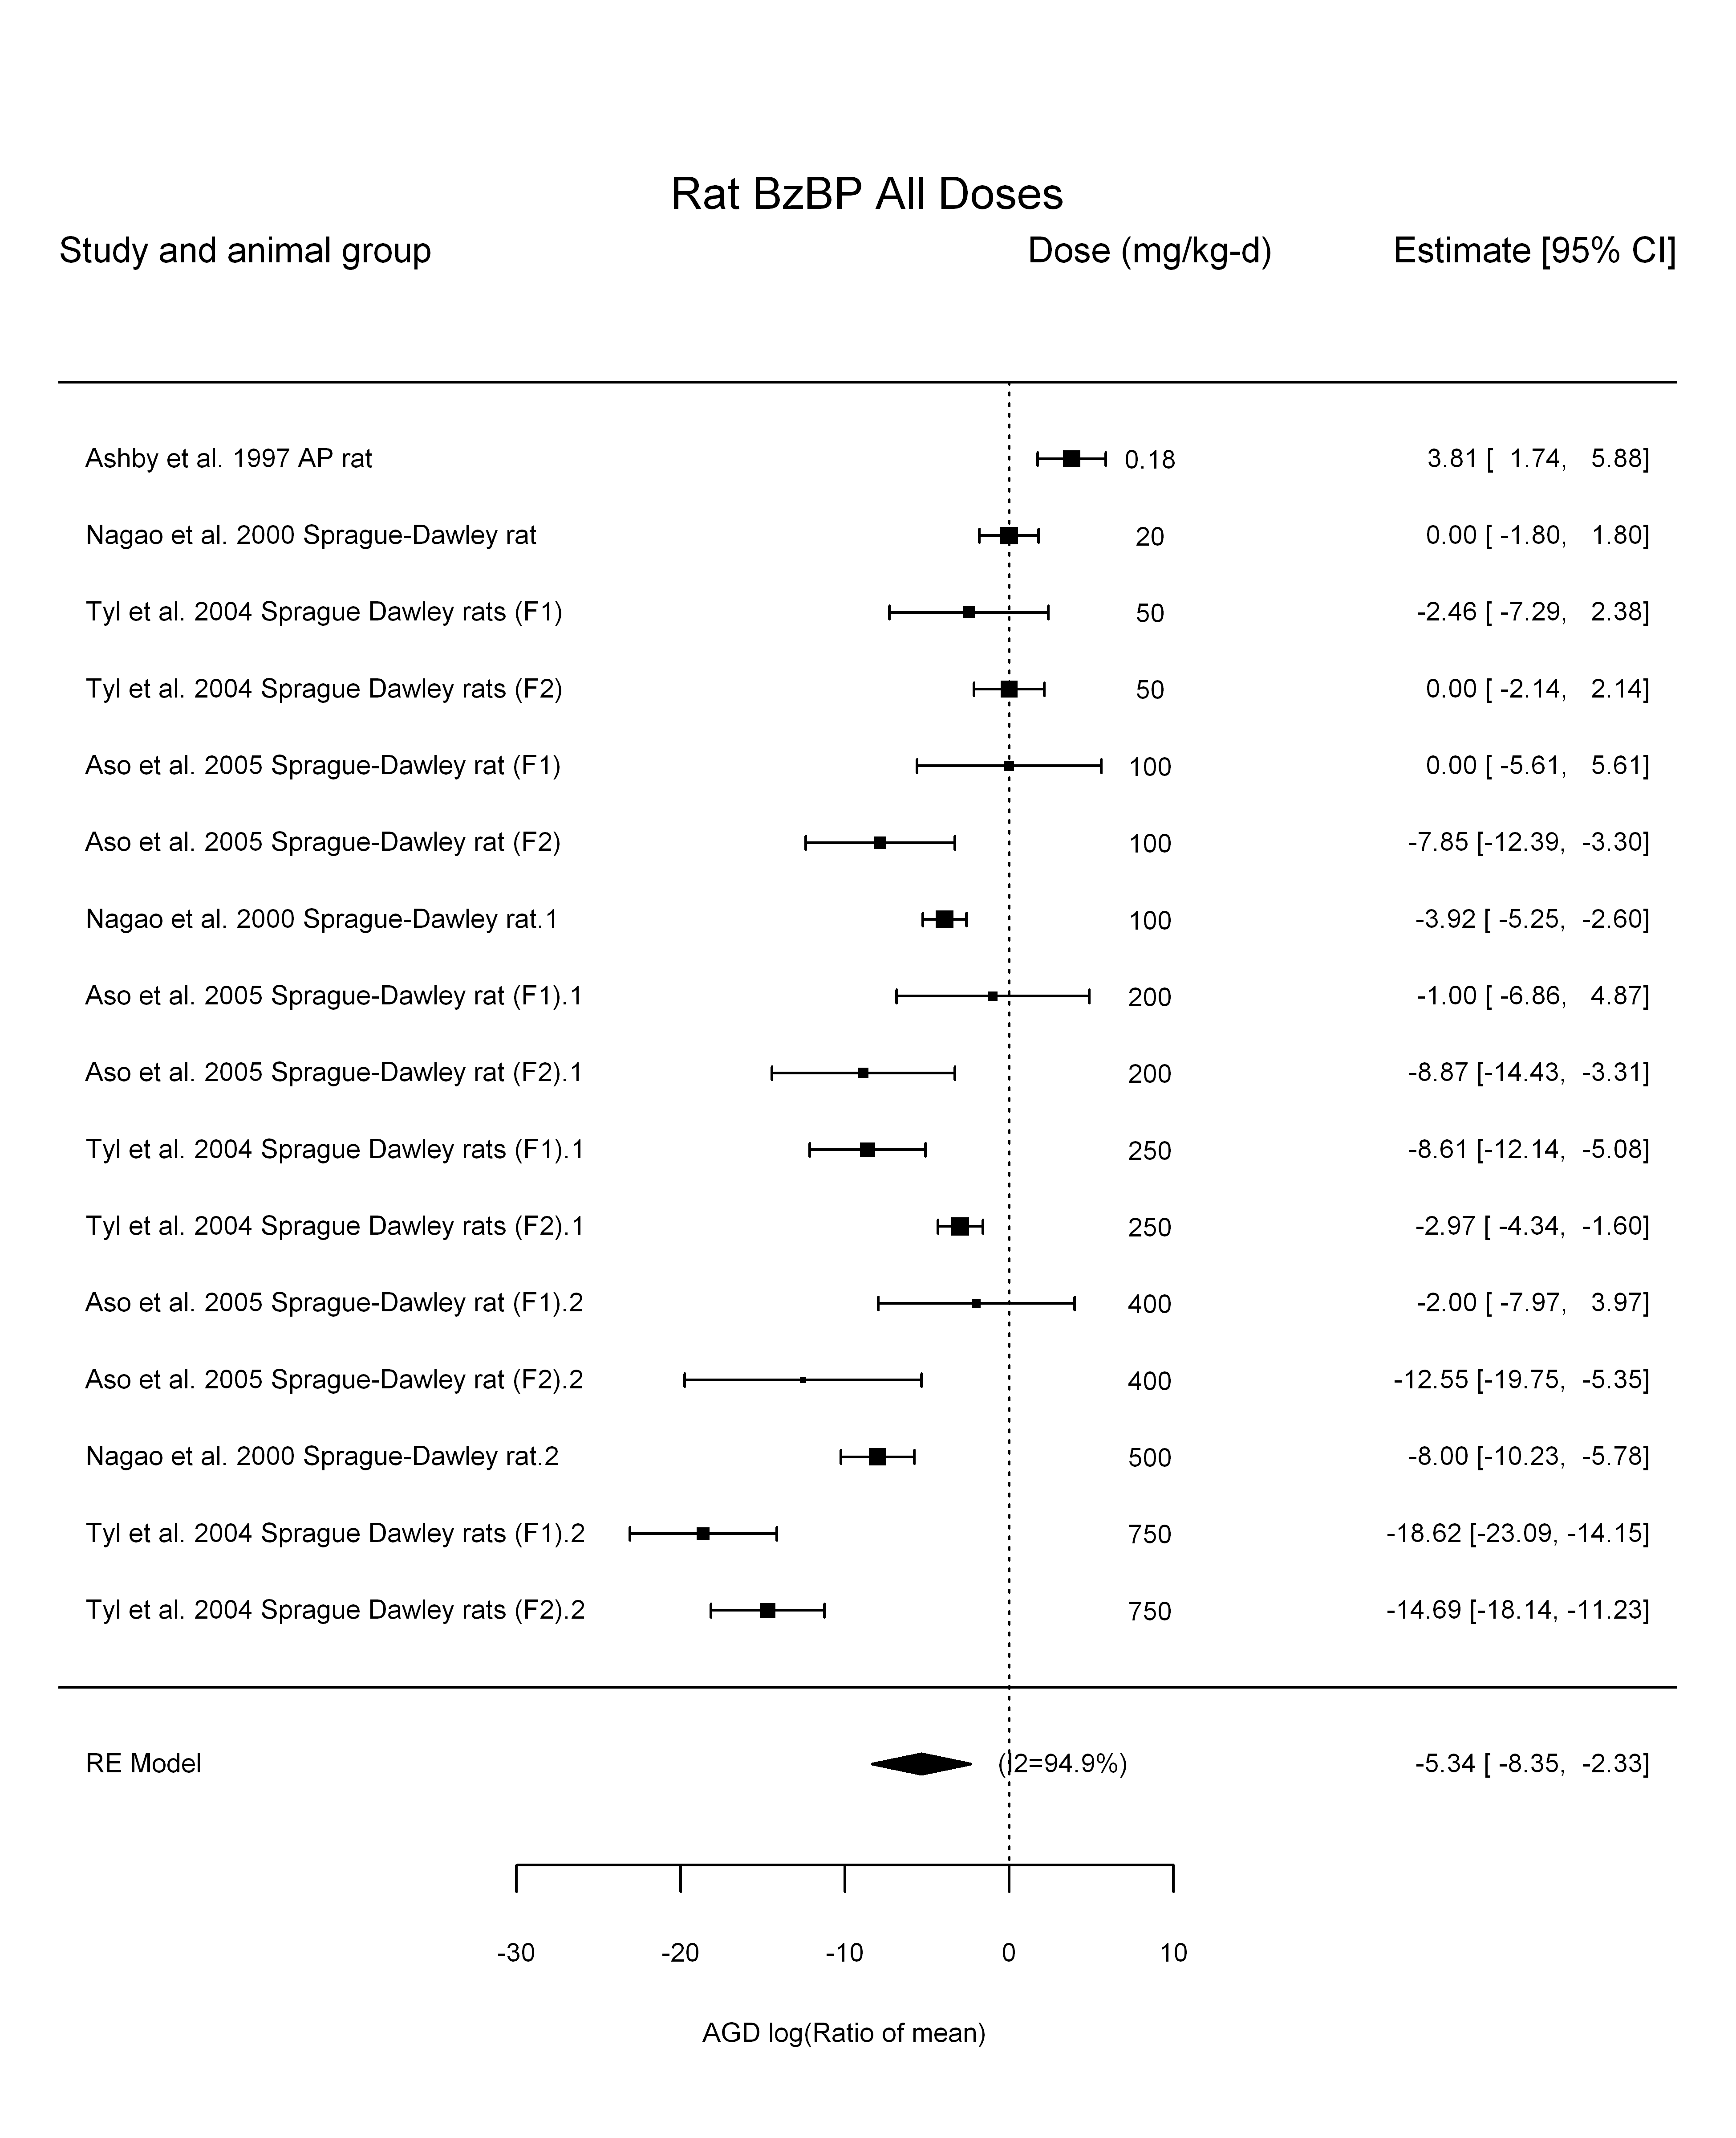

## [1] "Leave one out---------------------"  
##   
## Random-Effects Model (k = 15; tau^2 estimator: REML)  
##   
## tau^2 (estimated amount of total heterogeneity): 28.7299 (SE = 12.5390)  
## tau (square root of estimated tau^2 value): 5.3600  
## I^2 (total heterogeneity / total variability): 93.79%  
## H^2 (total variability / sampling variability): 16.11  
##   
## Test for Heterogeneity:   
## Q(df = 14) = 146.2043, p-val < .0001  
##   
## Model Results:  
##   
## estimate se zval pval ci.lb ci.ub   
## -6.0001 1.4907 -4.0252 <.0001 -8.9218 -3.0785 ***   
##   
## ---  
## Signif. codes: 0 '***' 0.001 '**' 0.01 '*' 0.05 '.' 0.1 ' ' 1   
##   
##   
## Random-Effects Model (k = 10; tau^2 estimator: REML)  
##   
## tau^2 (estimated amount of total heterogeneity): 44.5741 (SE = 22.0505)  
## tau (square root of estimated tau^2 value): 6.6764  
## I^2 (total heterogeneity / total variability): 97.37%  
## H^2 (total variability / sampling variability): 38.03  
##   
## Test for Heterogeneity:   
## Q(df = 9) = 181.0249, p-val < .0001  
##   
## Model Results:  
##   
## estimate se zval pval ci.lb ci.ub   
## -5.4050 2.1633 -2.4985 0.0125 -9.6451 -1.1649 *   
##   
## ---  
## Signif. codes: 0 '***' 0.001 '**' 0.01 '*' 0.05 '.' 0.1 ' ' 1   
##   
##   
## Random-Effects Model (k = 10; tau^2 estimator: REML)  
##   
## tau^2 (estimated amount of total heterogeneity): 19.9908 (SE = 11.6645)  
## tau (square root of estimated tau^2 value): 4.4711  
## I^2 (total heterogeneity / total variability): 90.78%  
## H^2 (total variability / sampling variability): 10.85  
##   
## Test for Heterogeneity:   
## Q(df = 9) = 89.6382, p-val < .0001  
##   
## Model Results:  
##   
## estimate se zval pval ci.lb ci.ub   
## -3.7231 1.5804 -2.3558 0.0185 -6.8206 -0.6256 *   
##   
## ---  
## Signif. codes: 0 '***' 0.001 '**' 0.01 '*' 0.05 '.' 0.1 ' ' 1   
##   
##   
## Random-Effects Model (k = 13; tau^2 estimator: REML)  
##   
## tau^2 (estimated amount of total heterogeneity): 39.9071 (SE = 18.4454)  
## tau (square root of estimated tau^2 value): 6.3172  
## I^2 (total heterogeneity / total variability): 93.59%  
## H^2 (total variability / sampling variability): 15.59  
##   
## Test for Heterogeneity:   
## Q(df = 12) = 166.2688, p-val < .0001  
##   
## Model Results:  
##   
## estimate se zval pval ci.lb ci.ub   
## -5.7213 1.8665 -3.0653 0.0022 -9.3796 -2.0630 **   
##   
## ---  
## Signif. codes: 0 '***' 0.001 '**' 0.01 '*' 0.05 '.' 0.1 ' ' 1   
##   
## [1] "Linear in log10(dose)---------------------"  
##   
## Mixed-Effects Model (k = 16; tau^2 estimator: REML)  
##   
## logLik deviance AIC BIC AICc   
## -41.0159 82.0319 88.0319 89.9490 90.4319   
##   
## tau^2 (estimated amount of residual heterogeneity): 15.2892 (SE = 7.3083)  
## tau (square root of estimated tau^2 value): 3.9101  
## I^2 (residual heterogeneity / unaccounted variability): 88.95%  
## H^2 (unaccounted variability / sampling variability): 9.05  
## R^2 (amount of heterogeneity accounted for): 54.21%  
##   
## Test for Residual Heterogeneity:   
## QE(df = 14) = 87.6034, p-val < .0001  
##   
## Test of Moderators (coefficient(s) 2):   
## QM(df = 1) = 14.5002, p-val = 0.0001  
##   
## Model Results:  
##   
## estimate se zval pval ci.lb ci.ub   
## intrcpt 4.2038 2.7044 1.5545 0.1201 -1.0966 9.5043   
## log10(dose) -4.6835 1.2299 -3.8079 0.0001 -7.0941 -2.2729 ***  
##   
## ---  
## Signif. codes: 0 '***' 0.001 '**' 0.01 '*' 0.05 '.' 0.1 ' ' 1

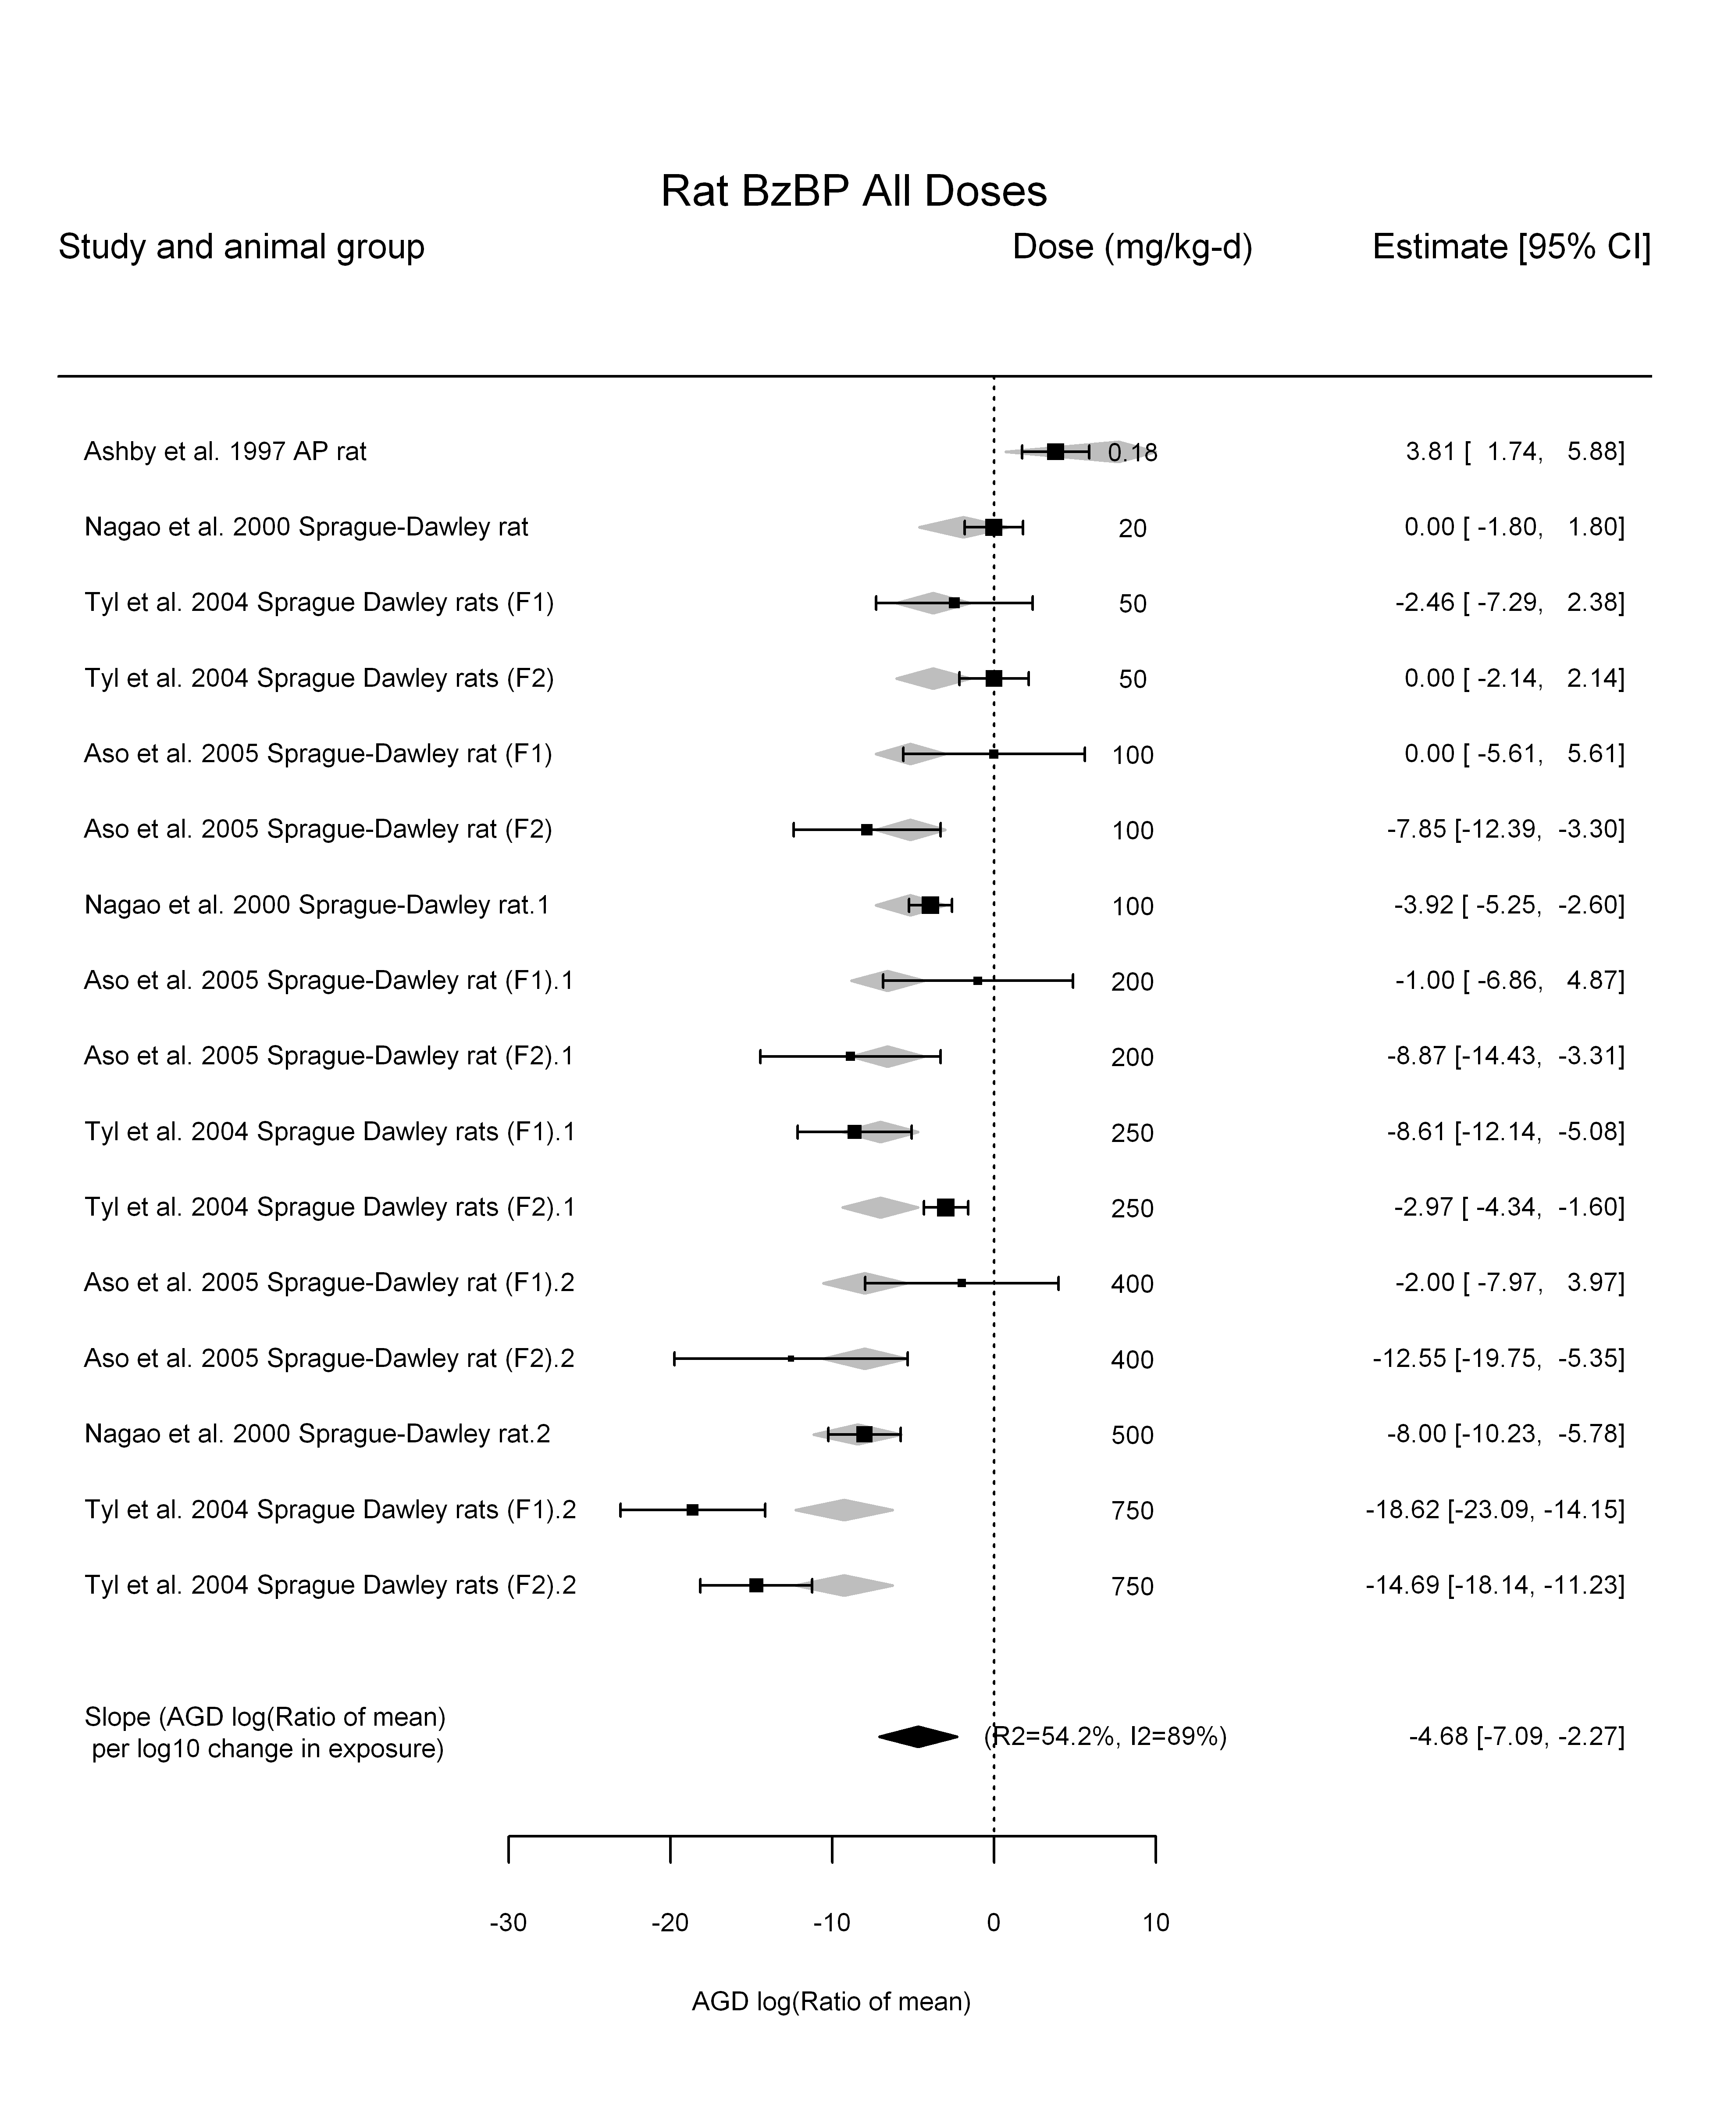

## [1] "Linear in dose---------------------"  
##   
## Mixed-Effects Model (k = 16; tau^2 estimator: REML)  
##   
## logLik deviance AIC BIC AICc   
## -38.9619 77.9238 81.9238 83.3399 82.9238   
##   
## tau^2 (estimated amount of residual heterogeneity): 5.5681 (SE = 3.1321)  
## tau (square root of estimated tau^2 value): 2.3597  
## I^2 (residual heterogeneity / unaccounted variability): 76.64%  
## H^2 (unaccounted variability / sampling variability): 4.28  
##   
## Test for Residual Heterogeneity:   
## QE(df = 15) = 56.0247, p-val < .0001  
##   
## Model Results:  
##   
## estimate se zval pval ci.lb ci.ub   
## dose100 -2.0655 0.2238 -9.2307 <.0001 -2.5040 -1.6269 ***  
##   
## ---  
## Signif. codes: 0 '***' 0.001 '**' 0.01 '*' 0.05 '.' 0.1 ' ' 1

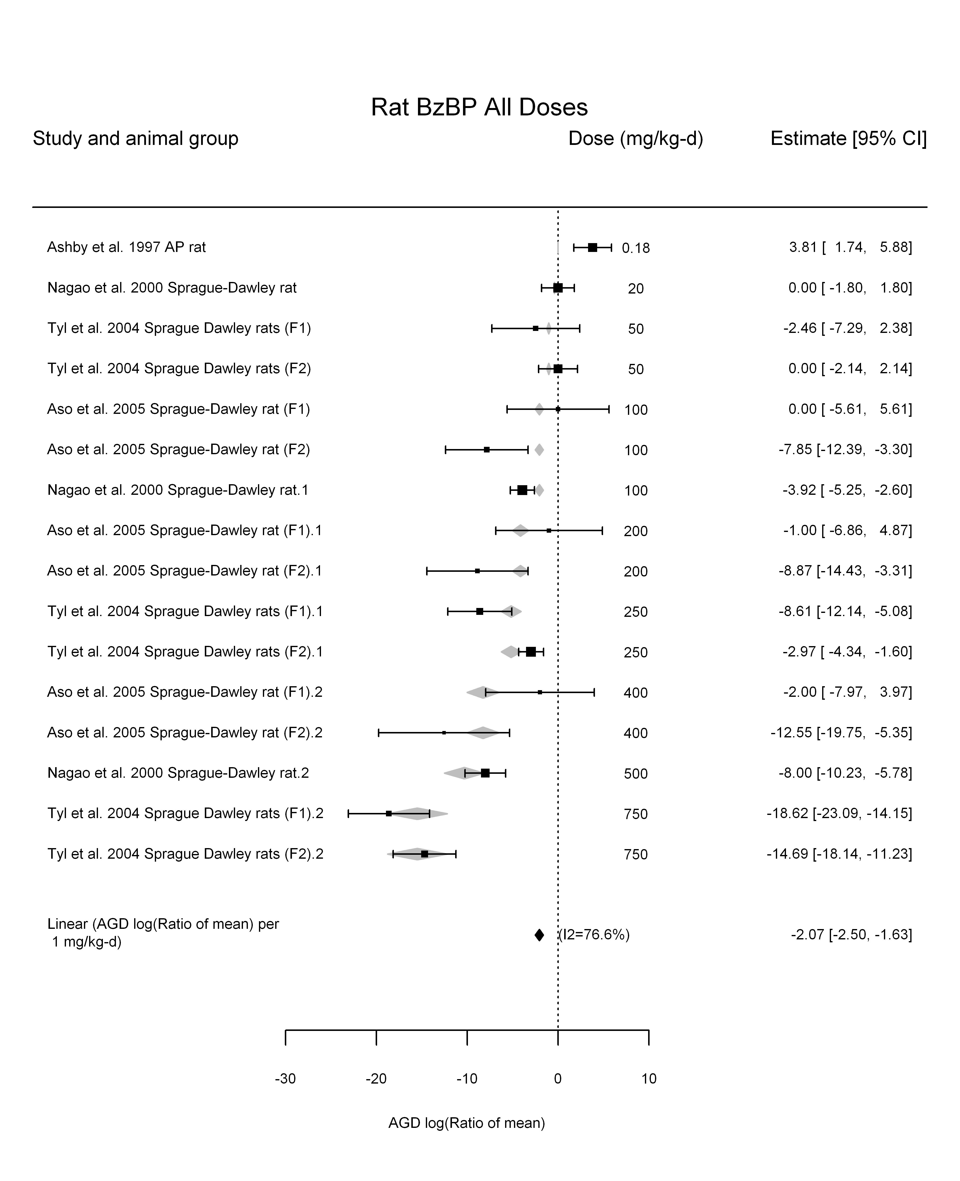

## [1] "Linear or LinearQuadratic in dose---------------------"  
##   
## Mixed-Effects Model (k = 16; tau^2 estimator: REML)  
##   
## logLik deviance AIC BIC AICc   
## -36.8722 73.7443 79.7443 81.6615 82.1443   
##   
## tau^2 (estimated amount of residual heterogeneity): 6.2568 (SE = 3.5500)  
## tau (square root of estimated tau^2 value): 2.5014  
## I^2 (residual heterogeneity / unaccounted variability): 77.70%  
## H^2 (unaccounted variability / sampling variability): 4.48  
##   
## Test for Residual Heterogeneity:   
## QE(df = 14) = 55.4888, p-val < .0001  
##   
## Test of Moderators (coefficient(s) 1,2):   
## QM(df = 2) = 79.4880, p-val < .0001  
##   
## Model Results:  
##   
## estimate se zval pval ci.lb ci.ub   
## dose100 -2.0051 0.7397 -2.7107 0.0067 -3.4549 -0.5553 **  
## I(dose100^2) -0.0107 0.1173 -0.0917 0.9270 -0.2406 0.2191   
##   
## ---  
## Signif. codes: 0 '***' 0.001 '**' 0.01 '*' 0.05 '.' 0.1 ' ' 1

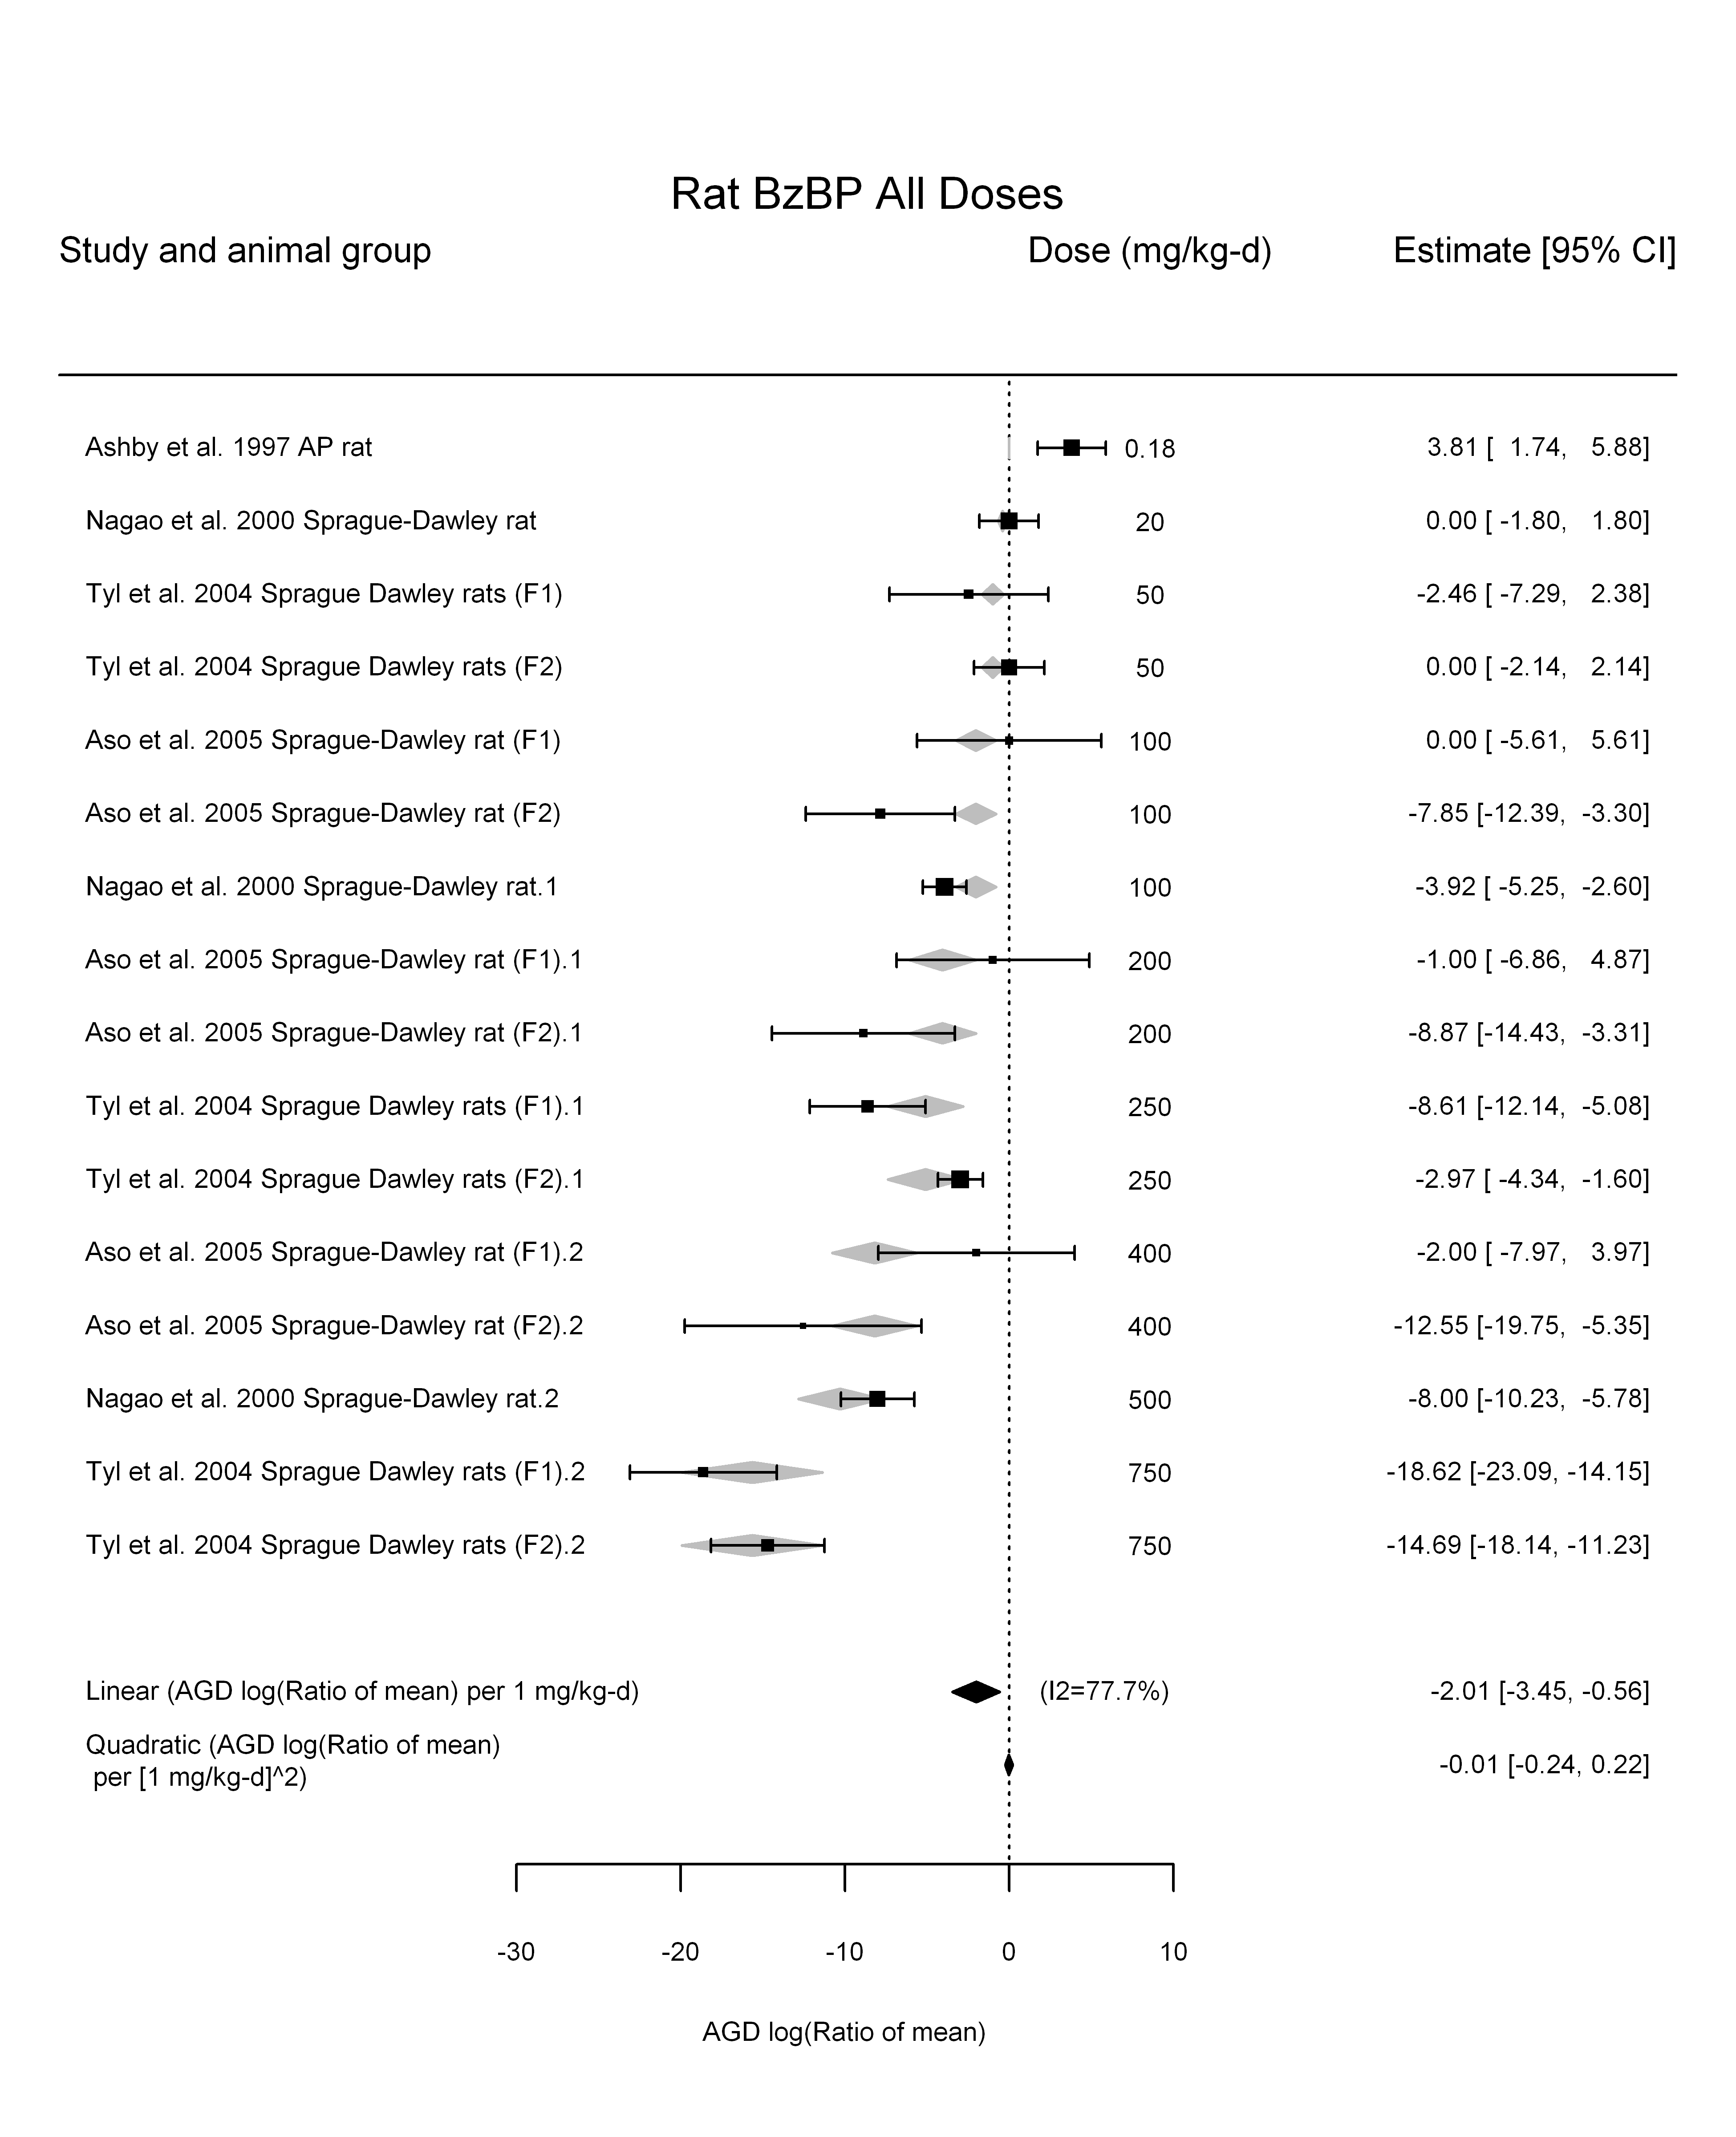

## [1] ""

## [1] ""  
## m ci.lb ci.ub bmr  
## 1 248.3367 204.8425 315.2817 -5.129329

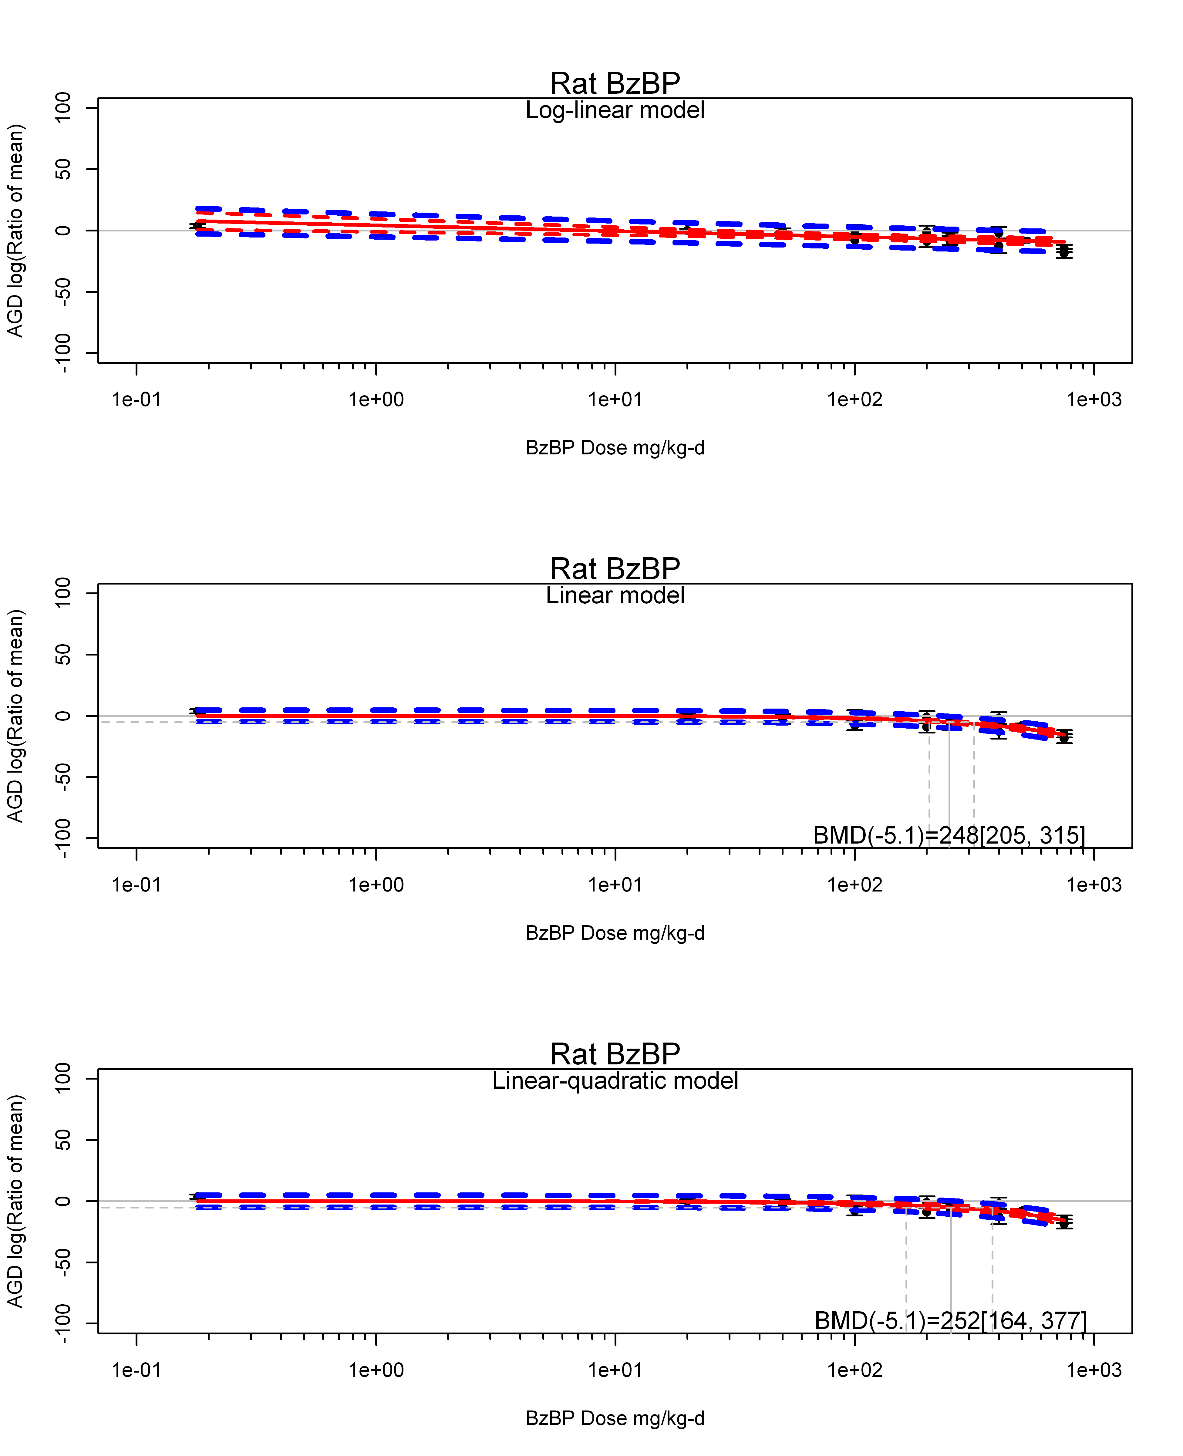

## [1] ""  
## m ci.lb ci.ub bmr  
## 1 252.3965 164.3843 376.7255 -5.129329  
## [1] "AGD log(Ratio of mean) Rat Highest Dose"  
## [1] "Overall Effect---------------------"  
##   
## Random-Effects Model (k = 6; tau^2 estimator: REML)  
##   
## logLik deviance AIC BIC AICc   
## -17.7775 35.5550 39.5550 38.7739 45.5550   
##   
## tau^2 (estimated amount of total heterogeneity): 67.8553 (SE = 46.2467)  
## tau (square root of estimated tau^2 value): 8.2374  
## I^2 (total heterogeneity / total variability): 95.86%  
## H^2 (total variability / sampling variability): 24.15  
##   
## Test for Heterogeneity:   
## Q(df = 5) = 147.2097, p-val < .0001  
##   
## Model Results:  
##   
## estimate se zval pval ci.lb ci.ub   
## -8.5680 3.4923 -2.4534 0.0142 -15.4127 -1.7233 *   
##   
## ---  
## Signif. codes: 0 '***' 0.001 '**' 0.01 '*' 0.05 '.' 0.1 ' ' 1

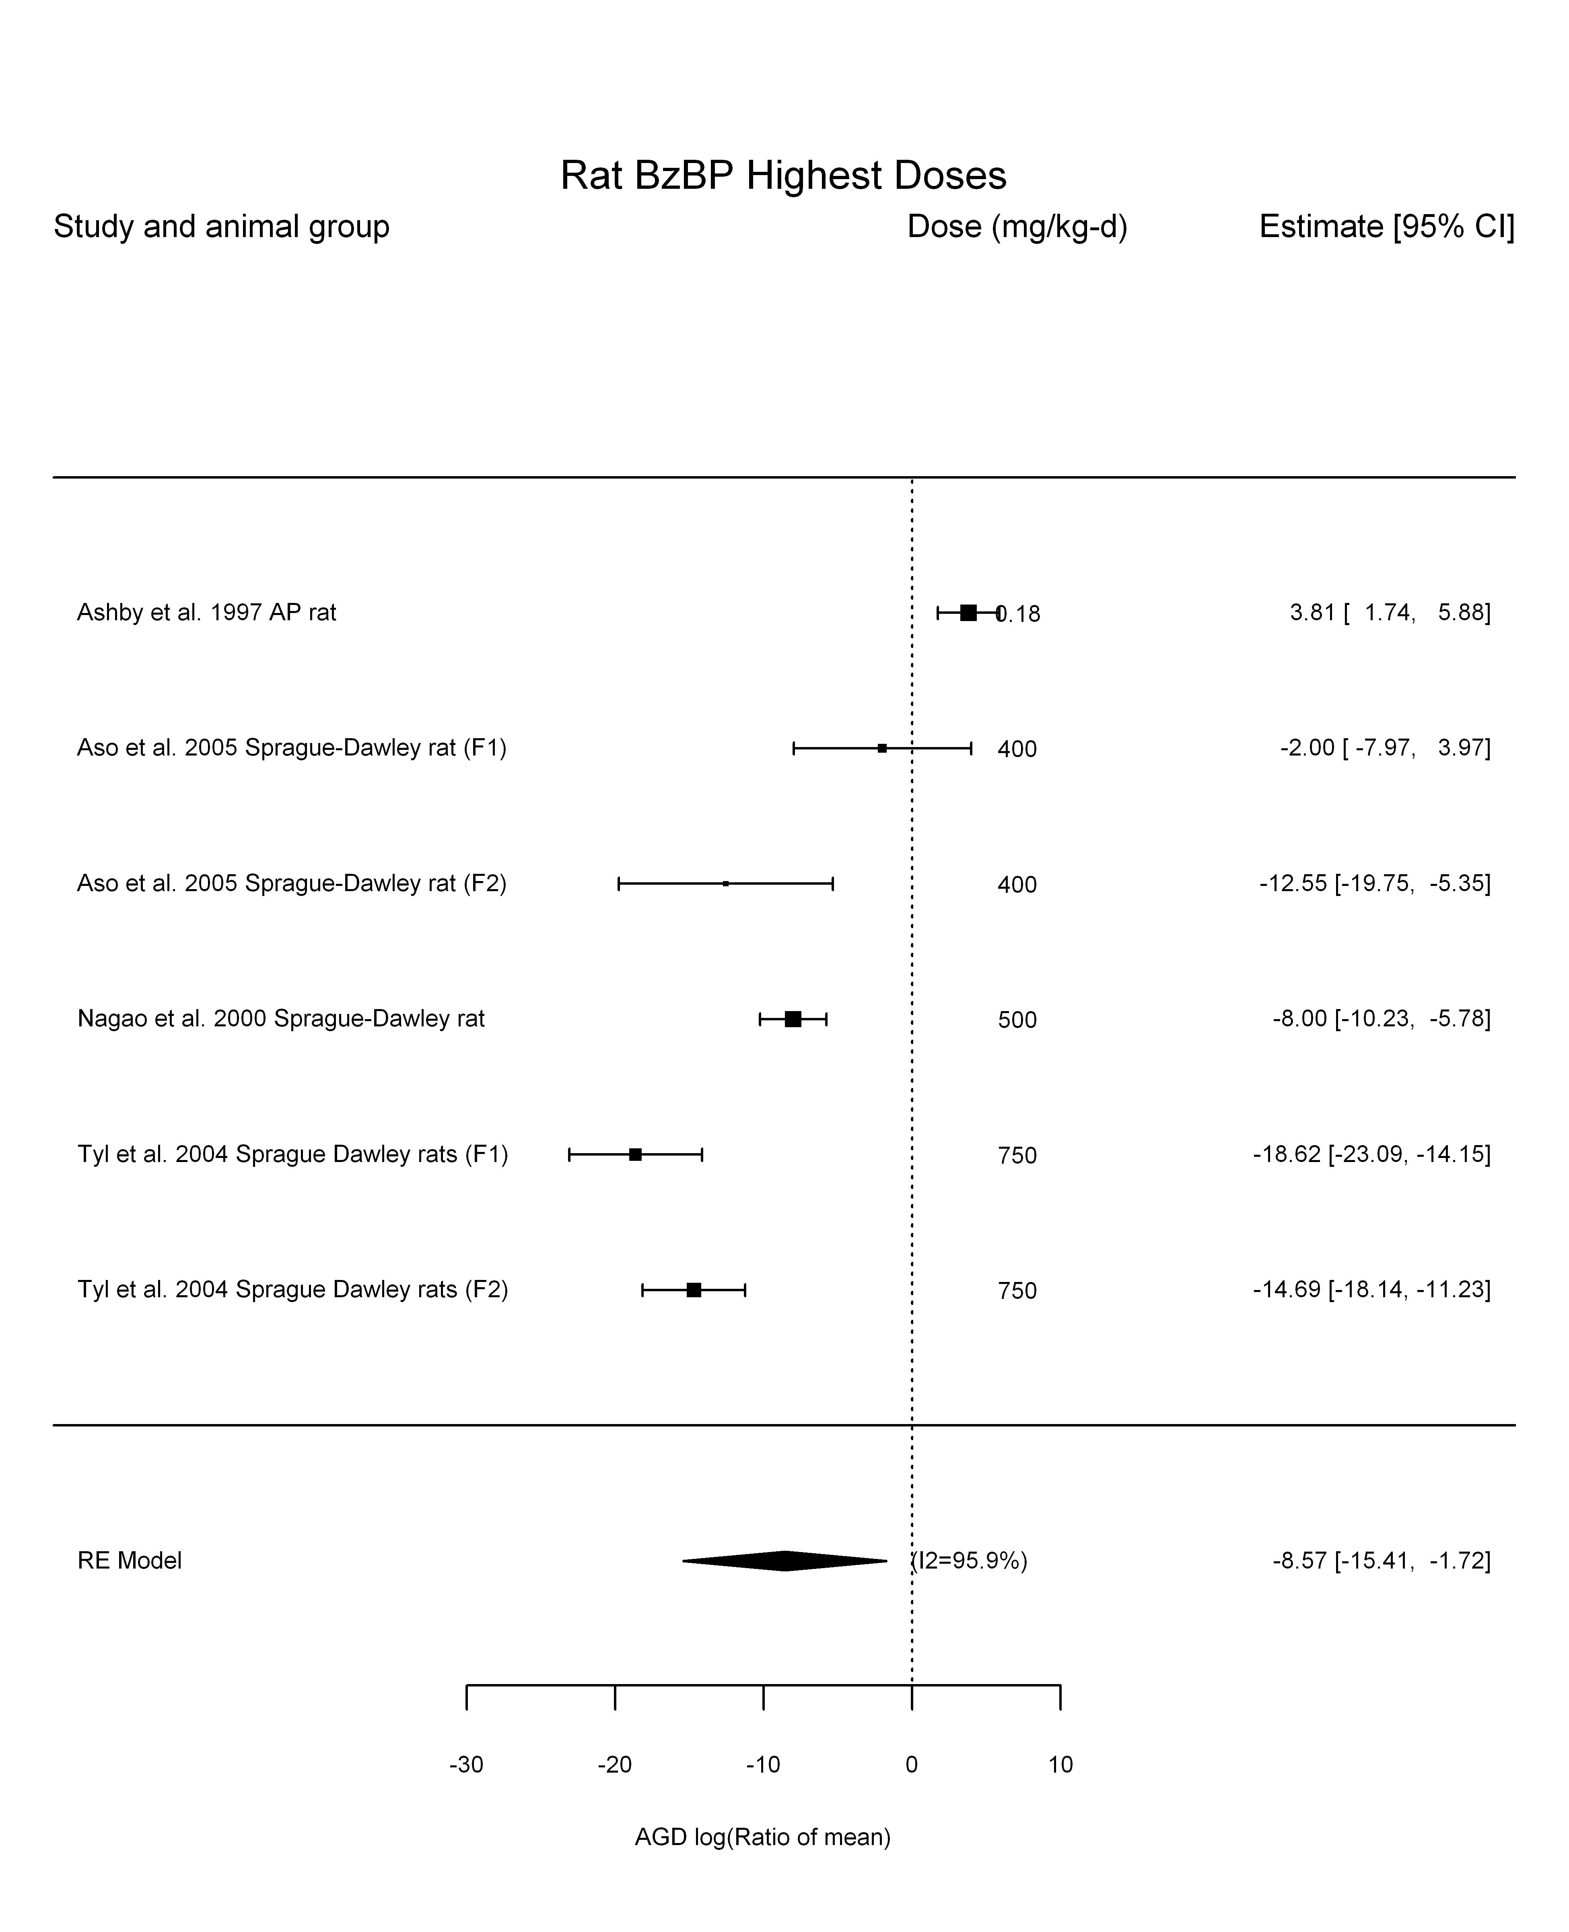

## [1] "Linear or LinearQuadratic in dose---------------------"  
##   
## Mixed-Effects Model (k = 6; tau^2 estimator: REML)  
##   
## logLik deviance AIC BIC AICc   
## -14.0166 28.0332 32.0332 31.2521 38.0332   
##   
## tau^2 (estimated amount of residual heterogeneity): 9.8993 (SE = 8.8479)  
## tau (square root of estimated tau^2 value): 3.1463  
## I^2 (residual heterogeneity / unaccounted variability): 79.09%  
## H^2 (unaccounted variability / sampling variability): 4.78  
##   
## Test for Residual Heterogeneity:   
## QE(df = 5) = 23.6304, p-val = 0.0003  
##   
## Model Results:  
##   
## estimate se zval pval ci.lb ci.ub   
## dose100 -2.0213 0.2911 -6.9440 <.0001 -2.5919 -1.4508 ***  
##   
## ---  
## Signif. codes: 0 '***' 0.001 '**' 0.01 '*' 0.05 '.' 0.1 ' ' 1

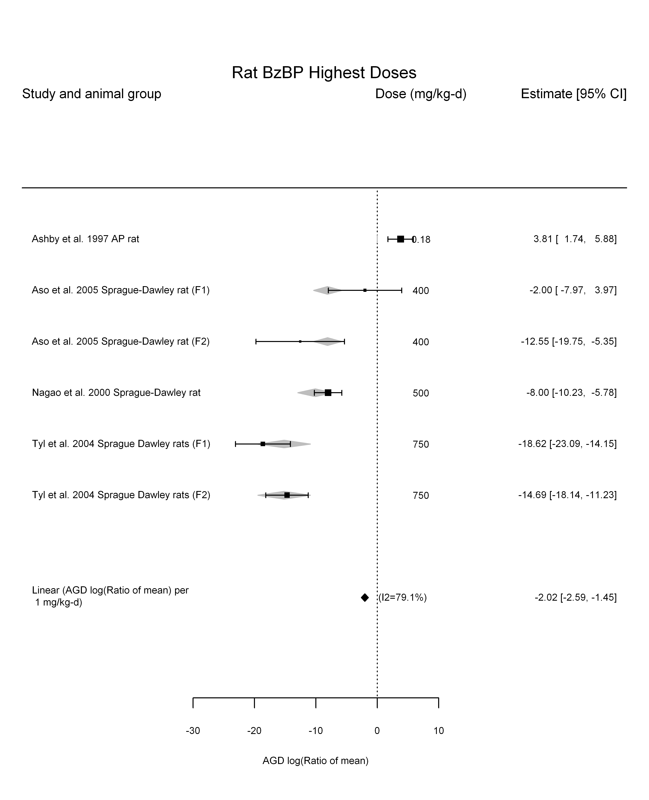

## [1] "Linear in log10(dose)---------------------"  
##   
## Mixed-Effects Model (k = 6; tau^2 estimator: REML)  
##   
## logLik deviance AIC BIC AICc   
## -12.7712 25.5423 31.5423 29.7012 55.5423   
##   
## tau^2 (estimated amount of residual heterogeneity): 27.7946 (SE = 23.8208)  
## tau (square root of estimated tau^2 value): 5.2721  
## I^2 (residual heterogeneity / unaccounted variability): 86.99%  
## H^2 (unaccounted variability / sampling variability): 7.68  
## R^2 (amount of heterogeneity accounted for): 59.04%  
##   
## Test for Residual Heterogeneity:   
## QE(df = 4) = 26.6506, p-val < .0001  
##   
## Test of Moderators (coefficient(s) 2):   
## QM(df = 1) = 7.0536, p-val = 0.0079  
##   
## Model Results:  
##   
## estimate se zval pval ci.lb ci.ub   
## intrcpt 1.0119 4.2549 0.2378 0.8120 -7.3276 9.3513   
## log10(dose) -4.5369 1.7083 -2.6559 0.0079 -7.8850 -1.1888 **  
##   
## ---  
## Signif. codes: 0 '***' 0.001 '**' 0.01 '*' 0.05 '.' 0.1 ' ' 1

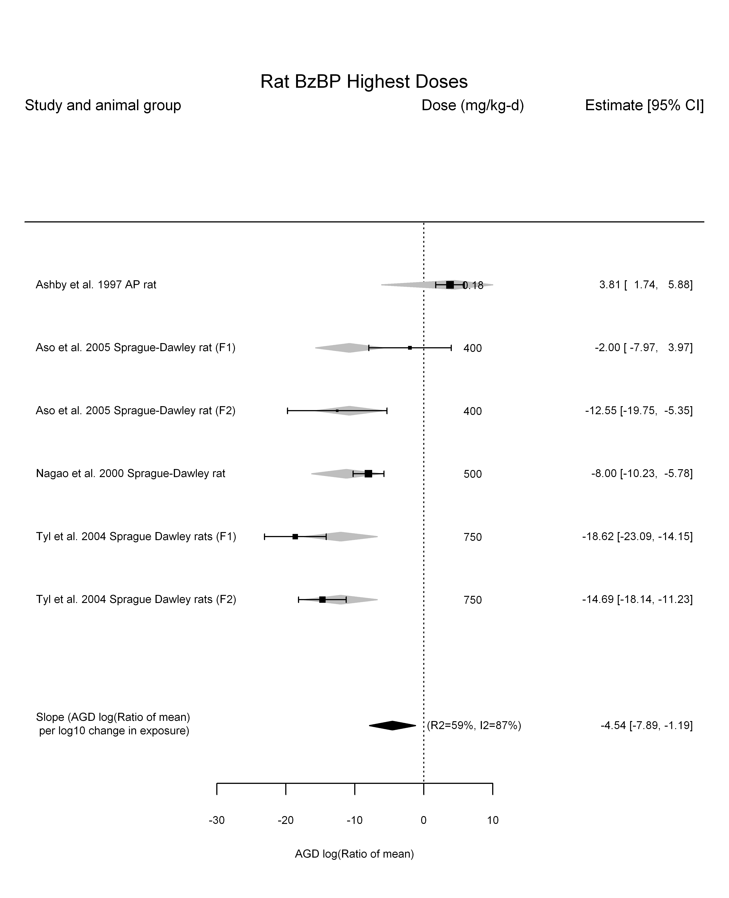

## [1] "Linear or LinearQuadratic in dose---------------------"  
##   
## Mixed-Effects Model (k = 6; tau^2 estimator: REML)  
##   
## logLik deviance AIC BIC AICc   
## -11.3212 22.6424 28.6424 26.8013 52.6424   
##   
## tau^2 (estimated amount of residual heterogeneity): 10.0783 (SE = 9.9768)  
## tau (square root of estimated tau^2 value): 3.1746  
## I^2 (residual heterogeneity / unaccounted variability): 78.74%  
## H^2 (unaccounted variability / sampling variability): 4.70  
##   
## Test for Residual Heterogeneity:   
## QE(df = 4) = 19.7900, p-val = 0.0005  
##   
## Test of Moderators (coefficient(s) 1,2):   
## QM(df = 2) = 48.3672, p-val < .0001  
##   
## Model Results:  
##   
## estimate se zval pval ci.lb ci.ub   
## dose100 -0.8179 1.4251 -0.5739 0.5660 -3.6109 1.9752   
## I(dose100^2) -0.1831 0.2121 -0.8632 0.3880 -0.5987 0.2326   
##   
## ---  
## Signif. codes: 0 '***' 0.001 '**' 0.01 '*' 0.05 '.' 0.1 ' ' 1

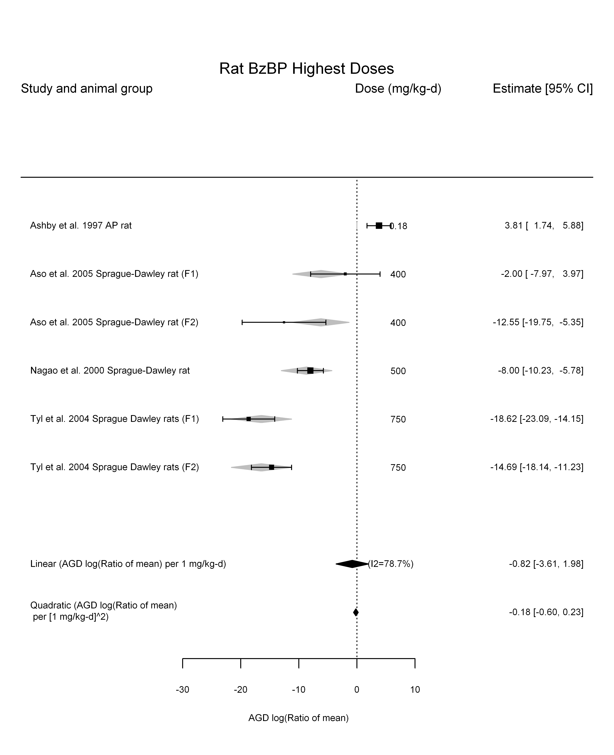

## [1] ""

## [1] ""  
## m ci.lb ci.ub bmr  
## 1 253.7572 197.8987 353.5463 -5.129329

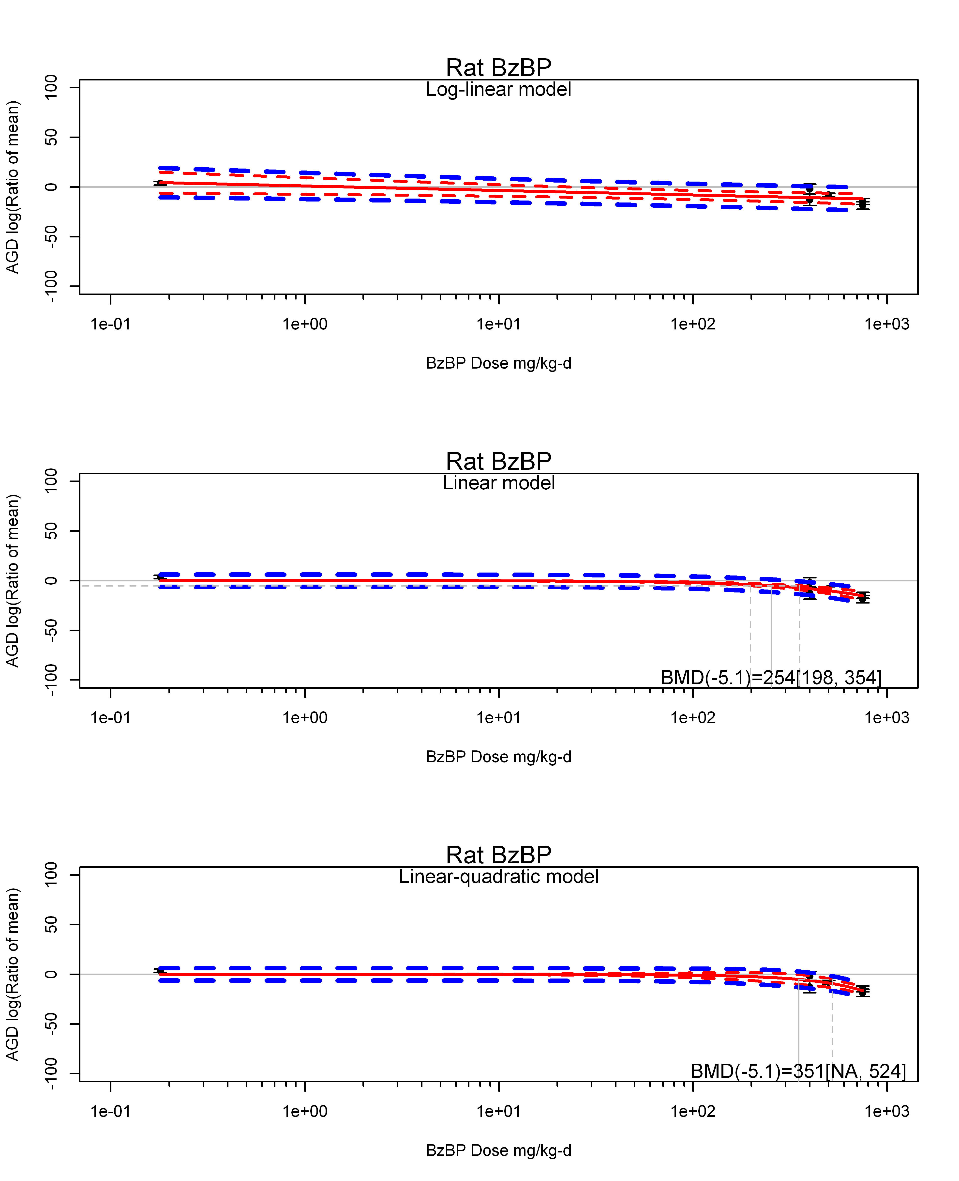

## [1] ""  
## m ci.lb ci.ub bmr  
## 1 351.1522 NA 524.0839 -5.129329  
## [1] "AGD log(Ratio of mean) Mouse"  
## [1] "AGD log(Ratio of mean) Rat"  
## [1] "Overall Effect---------------------"  
##   
## Random-Effects Model (k = 10; tau^2 estimator: REML)  
##   
## logLik deviance AIC BIC AICc   
## -24.8050 49.6101 53.6101 54.0045 55.6101   
##   
## tau^2 (estimated amount of total heterogeneity): 0.5636 (SE = 4.8950)  
## tau (square root of estimated tau^2 value): 0.7508  
## I^2 (total heterogeneity / total variability): 4.63%  
## H^2 (total variability / sampling variability): 1.05  
##   
## Test for Heterogeneity:   
## Q(df = 9) = 8.2599, p-val = 0.5082  
##   
## Model Results:  
##   
## estimate se zval pval ci.lb ci.ub   
## -1.0254 1.0866 -0.9437 0.3453 -3.1551 1.1042   
##   
## ---  
## Signif. codes: 0 '***' 0.001 '**' 0.01 '*' 0.05 '.' 0.1 ' ' 1

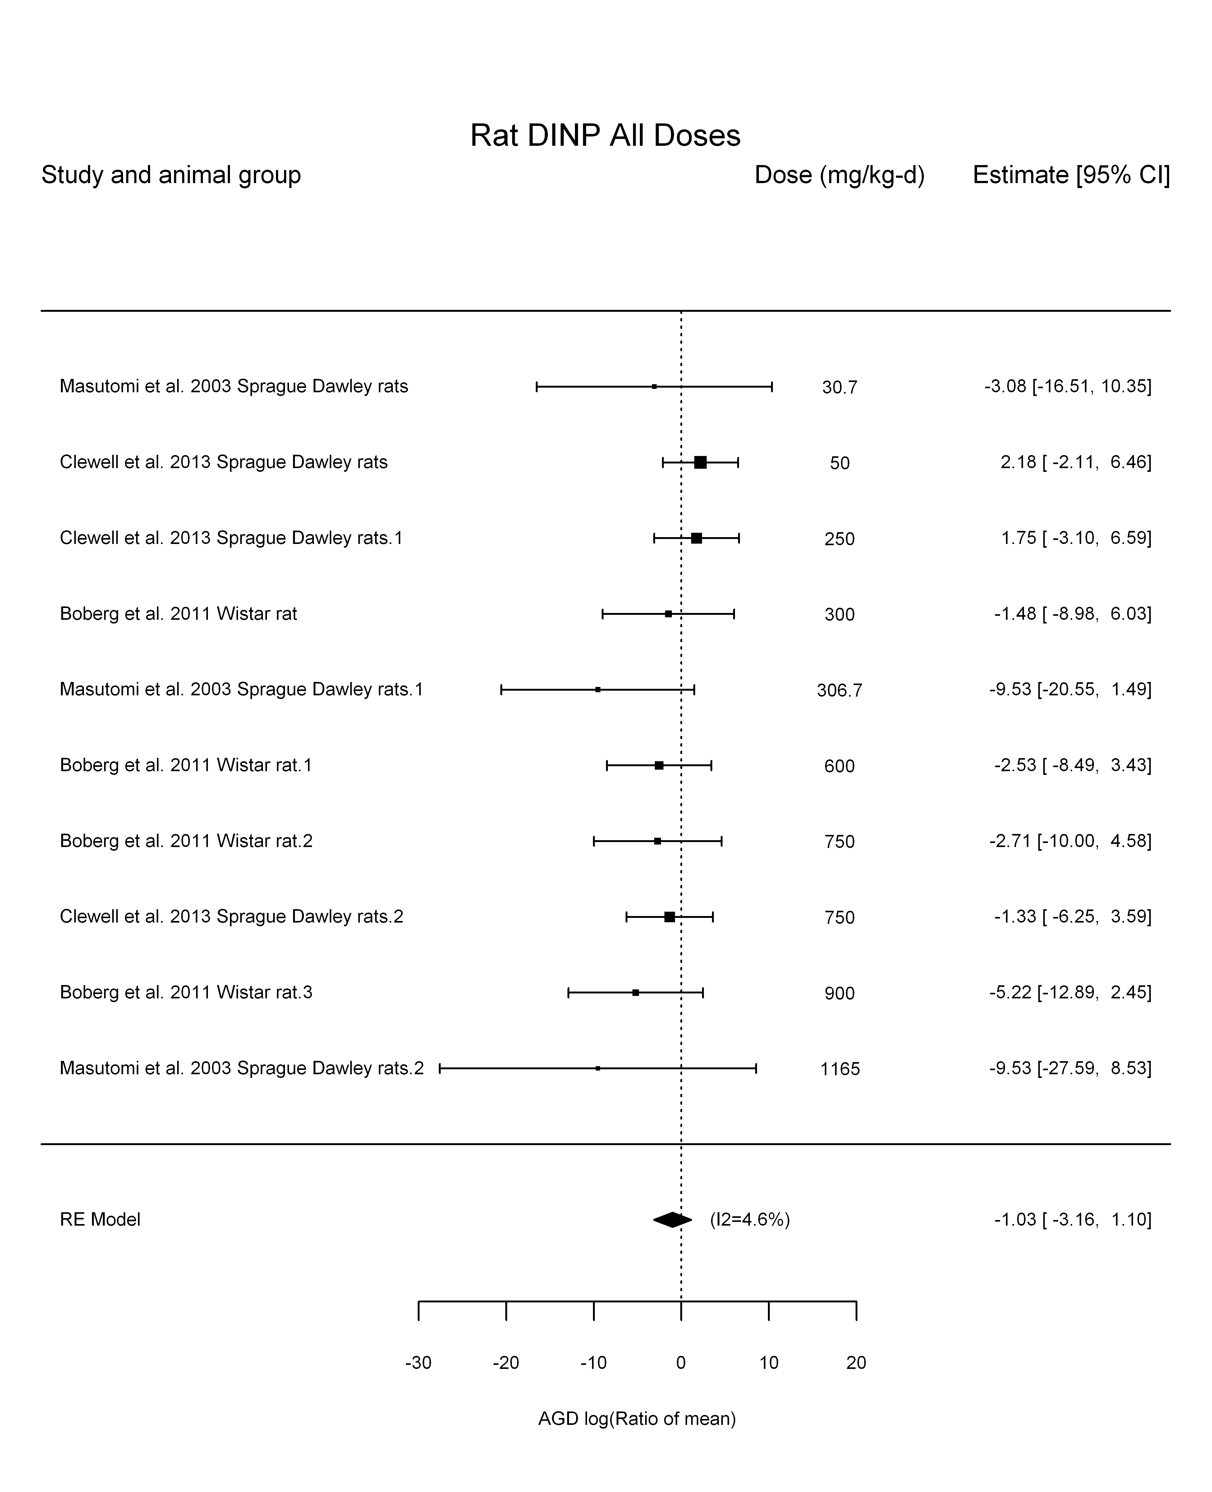

## [1] "Leave one out---------------------"  
##   
## Random-Effects Model (k = 6; tau^2 estimator: REML)  
##   
## tau^2 (estimated amount of total heterogeneity): 0 (SE = 5.5416)  
## tau (square root of estimated tau^2 value): 0  
## I^2 (total heterogeneity / total variability): 0.00%  
## H^2 (total variability / sampling variability): 1.00  
##   
## Test for Heterogeneity:   
## Q(df = 5) = 5.9155, p-val = 0.3145  
##   
## Model Results:  
##   
## estimate se zval pval ci.lb ci.ub   
## 0.0865 1.2945 0.0668 0.9467 -2.4507 2.6236   
##   
## ---  
## Signif. codes: 0 '***' 0.001 '**' 0.01 '*' 0.05 '.' 0.1 ' ' 1   
##   
##   
## Random-Effects Model (k = 7; tau^2 estimator: REML)  
##   
## tau^2 (estimated amount of total heterogeneity): 0 (SE = 4.5737)  
## tau (square root of estimated tau^2 value): 0  
## I^2 (total heterogeneity / total variability): 0.00%  
## H^2 (total variability / sampling variability): 1.00  
##   
## Test for Heterogeneity:   
## Q(df = 6) = 4.7552, p-val = 0.5756  
##   
## Model Results:  
##   
## estimate se zval pval ci.lb ci.ub   
## -0.4495 1.0872 -0.4135 0.6793 -2.5804 1.6813   
##   
## ---  
## Signif. codes: 0 '***' 0.001 '**' 0.01 '*' 0.05 '.' 0.1 ' ' 1   
##   
##   
## Random-Effects Model (k = 7; tau^2 estimator: REML)  
##   
## tau^2 (estimated amount of total heterogeneity): 0 (SE = 9.8448)  
## tau (square root of estimated tau^2 value): 0  
## I^2 (total heterogeneity / total variability): 0.00%  
## H^2 (total variability / sampling variability): 1.00  
##   
## Test for Heterogeneity:   
## Q(df = 6) = 2.1910, p-val = 0.9013  
##   
## Model Results:  
##   
## estimate se zval pval ci.lb ci.ub   
## -3.6717 1.6250 -2.2595 0.0239 -6.8566 -0.4868 *   
##   
## ---  
## Signif. codes: 0 '***' 0.001 '**' 0.01 '*' 0.05 '.' 0.1 ' ' 1   
##   
## [1] "Linear in log10(dose)---------------------"  
##   
## Mixed-Effects Model (k = 10; tau^2 estimator: REML)  
##   
## logLik deviance AIC BIC AICc   
## -21.0661 42.1323 48.1323 48.3706 54.1323   
##   
## tau^2 (estimated amount of residual heterogeneity): 0 (SE = 5.4799)  
## tau (square root of estimated tau^2 value): 0  
## I^2 (residual heterogeneity / unaccounted variability): 0.00%  
## H^2 (unaccounted variability / sampling variability): 1.00  
## R^2 (amount of heterogeneity accounted for): 100.00%  
##   
## Test for Residual Heterogeneity:   
## QE(df = 8) = 5.0927, p-val = 0.7476  
##   
## Test of Moderators (coefficient(s) 2):   
## QM(df = 1) = 3.1672, p-val = 0.0751  
##   
## Model Results:  
##   
## estimate se zval pval ci.lb ci.ub   
## intrcpt 8.4700 5.3924 1.5707 0.1163 -2.0990 19.0390   
## log10(dose) -3.8585 2.1681 -1.7797 0.0751 -8.1078 0.3909 .  
##   
## ---  
## Signif. codes: 0 '***' 0.001 '**' 0.01 '*' 0.05 '.' 0.1 ' ' 1

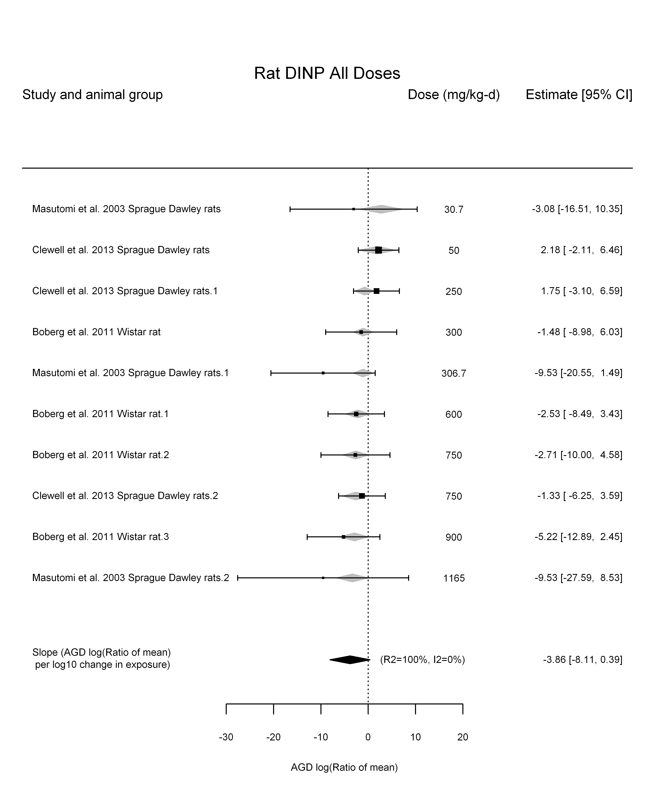

## [1] "Linear in dose---------------------"  
##   
## Mixed-Effects Model (k = 10; tau^2 estimator: REML)  
##   
## logLik deviance AIC BIC AICc   
## -23.3532 46.7063 50.7063 51.1008 52.7063   
##   
## tau^2 (estimated amount of residual heterogeneity): 0 (SE = 4.3124)  
## tau (square root of estimated tau^2 value): 0  
## I^2 (residual heterogeneity / unaccounted variability): 0.00%  
## H^2 (unaccounted variability / sampling variability): 1.00  
##   
## Test for Residual Heterogeneity:   
## QE(df = 9) = 5.6612, p-val = 0.7733  
##   
## Model Results:  
##   
## estimate se zval pval ci.lb ci.ub   
## dose100 -0.3637 0.1970 -1.8466 0.0648 -0.7498 0.0223 .  
##   
## ---  
## Signif. codes: 0 '***' 0.001 '**' 0.01 '*' 0.05 '.' 0.1 ' ' 1

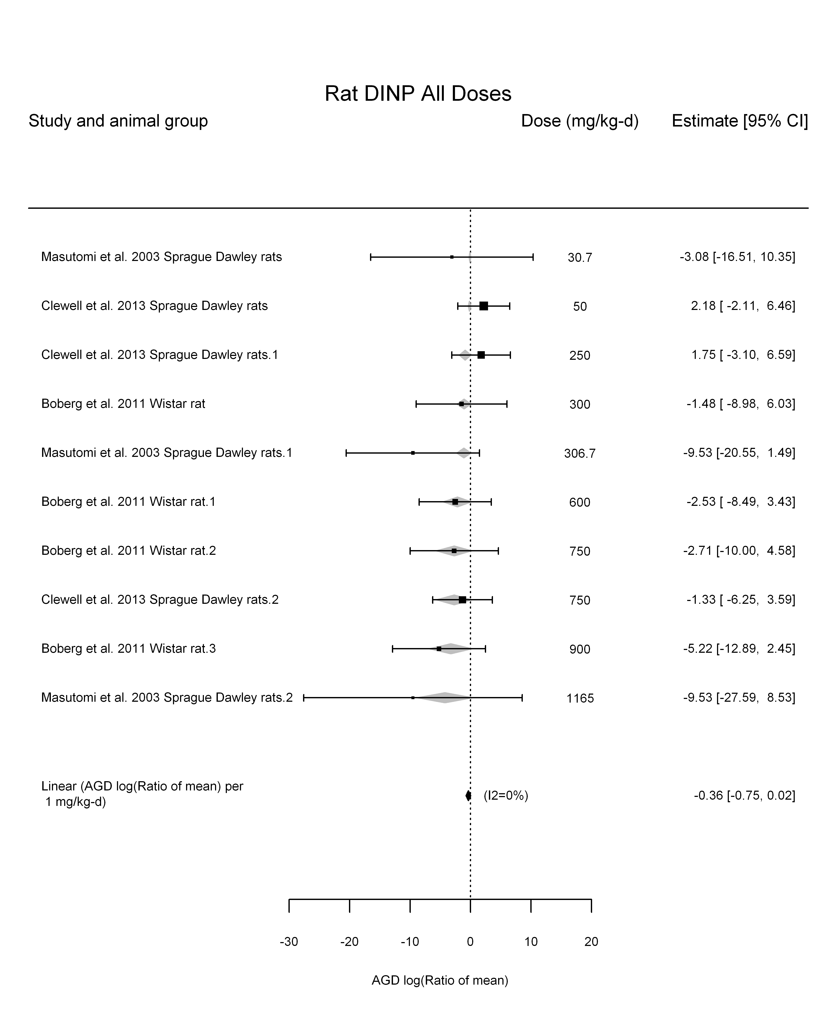

## [1] "Linear or LinearQuadratic in dose---------------------"  
##   
## Mixed-Effects Model (k = 10; tau^2 estimator: REML)  
##   
## logLik deviance AIC BIC AICc   
## -20.5128 41.0256 47.0256 47.2639 53.0256   
##   
## tau^2 (estimated amount of residual heterogeneity): 0 (SE = 4.6144)  
## tau (square root of estimated tau^2 value): 0  
## I^2 (residual heterogeneity / unaccounted variability): 0.00%  
## H^2 (unaccounted variability / sampling variability): 1.00  
##   
## Test for Residual Heterogeneity:   
## QE(df = 8) = 5.0762, p-val = 0.7494  
##   
## Test of Moderators (coefficient(s) 1,2):   
## QM(df = 2) = 3.9950, p-val = 0.1357  
##   
## Model Results:  
##   
## estimate se zval pval ci.lb ci.ub   
## dose100 0.2231 0.7921 0.2816 0.7783 -1.3295 1.7756   
## I(dose100^2) -0.0786 0.1028 -0.7648 0.4444 -0.2800 0.1228   
##   
## ---  
## Signif. codes: 0 '***' 0.001 '**' 0.01 '*' 0.05 '.' 0.1 ' ' 1

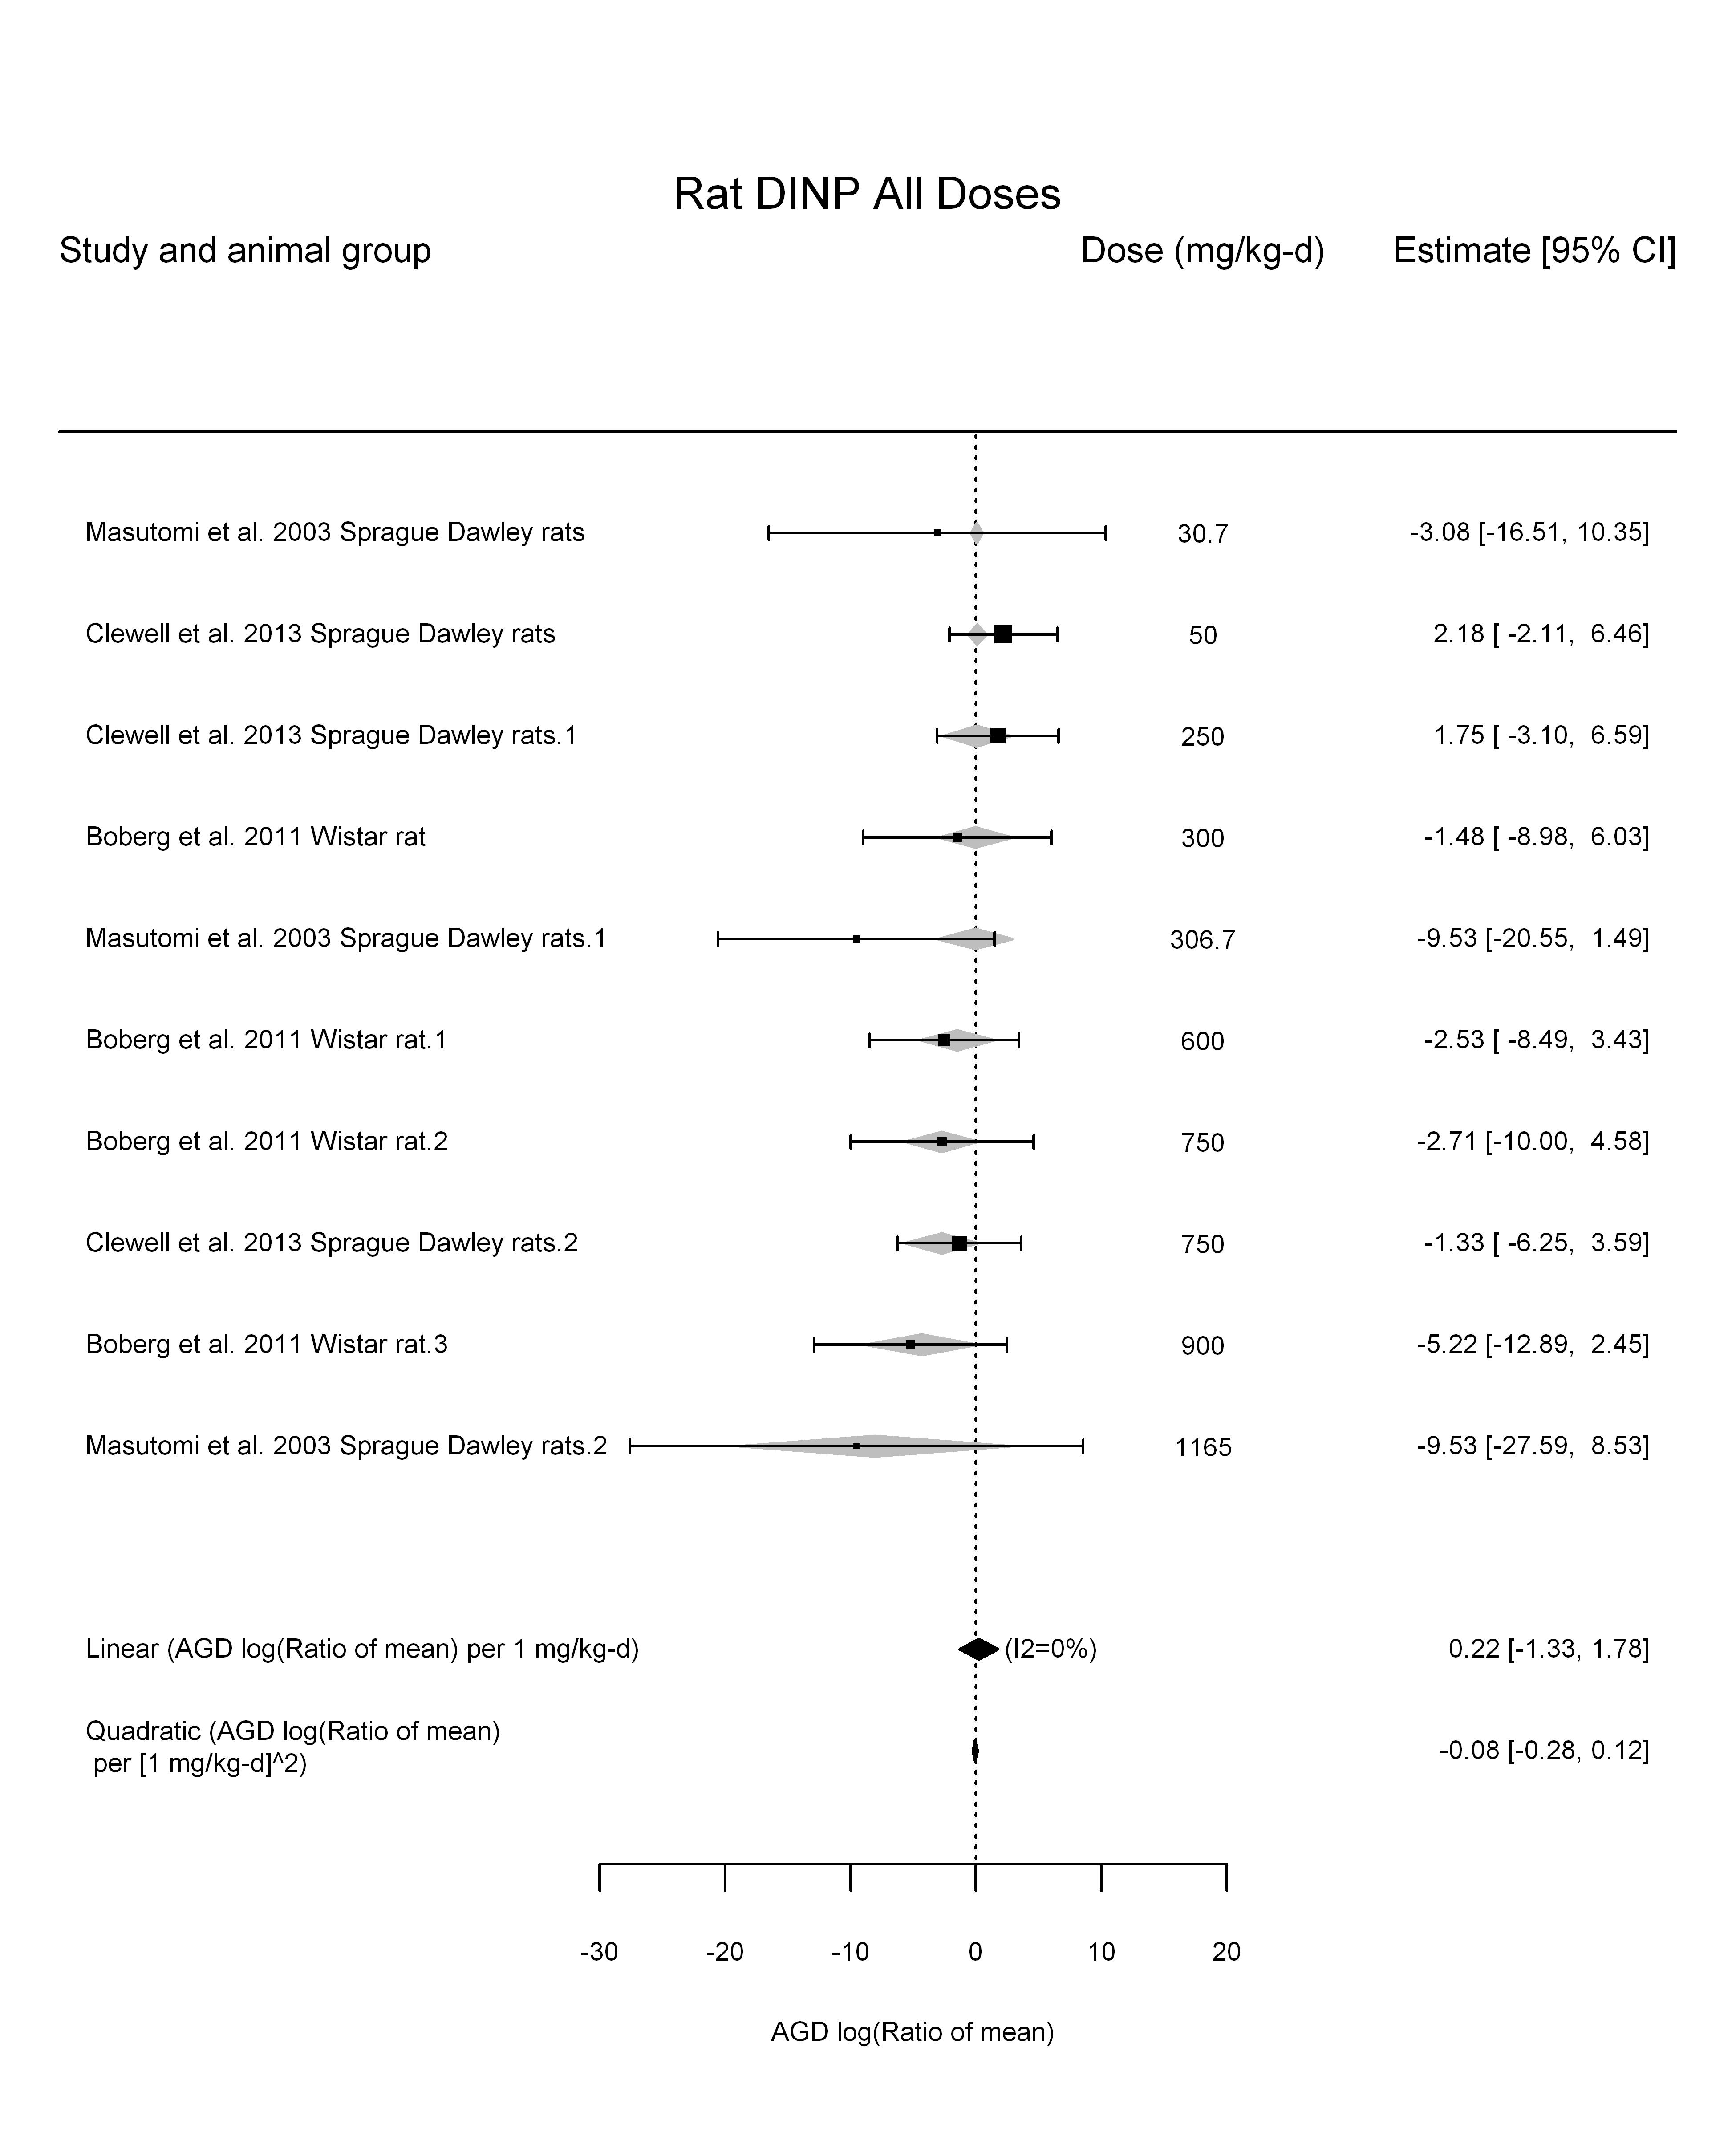

## [1] ""

## [1] ""  
## m ci.lb ci.ub bmr  
## 1 NA 684.0766 NA -5.129329

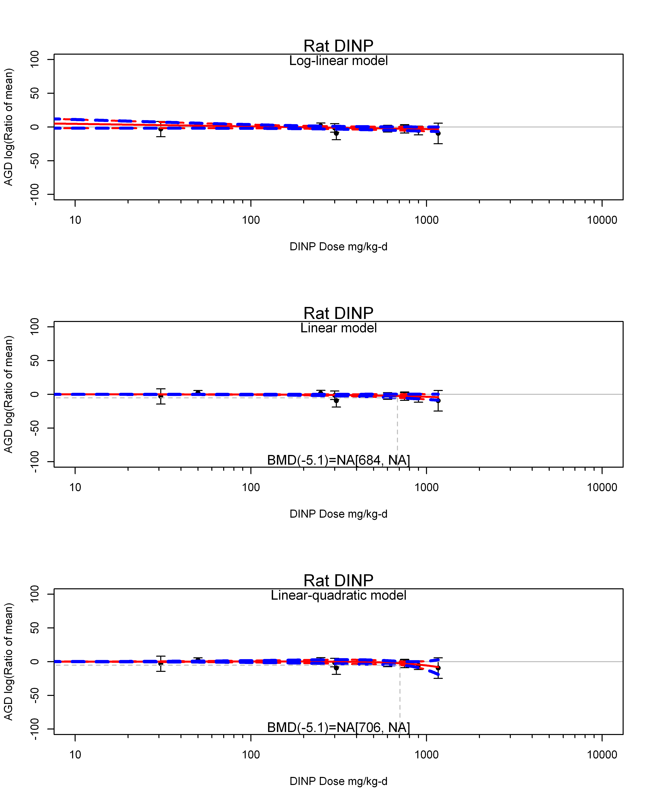

## [1] ""  
## m ci.lb ci.ub bmr  
## 1 NA 706.0441 NA -5.129329  
## [1] "AGD log(Ratio of mean) Rat Highest Dose"  
## [1] "Overall Effect---------------------"  
##   
## Random-Effects Model (k = 3; tau^2 estimator: REML)  
##   
## logLik deviance AIC BIC AICc   
## -5.7012 11.4024 15.4024 12.7887 27.4024   
##   
## tau^2 (estimated amount of total heterogeneity): 0 (SE = 14.8589)  
## tau (square root of estimated tau^2 value): 0  
## I^2 (total heterogeneity / total variability): 0.00%  
## H^2 (total variability / sampling variability): 1.00  
##   
## Test for Heterogeneity:   
## Q(df = 2) = 1.2588, p-val = 0.5329  
##   
## Model Results:  
##   
## estimate se zval pval ci.lb ci.ub   
## -2.8158 2.0588 -1.3677 0.1714 -6.8508 1.2193   
##   
## ---  
## Signif. codes: 0 '***' 0.001 '**' 0.01 '*' 0.05 '.' 0.1 ' ' 1

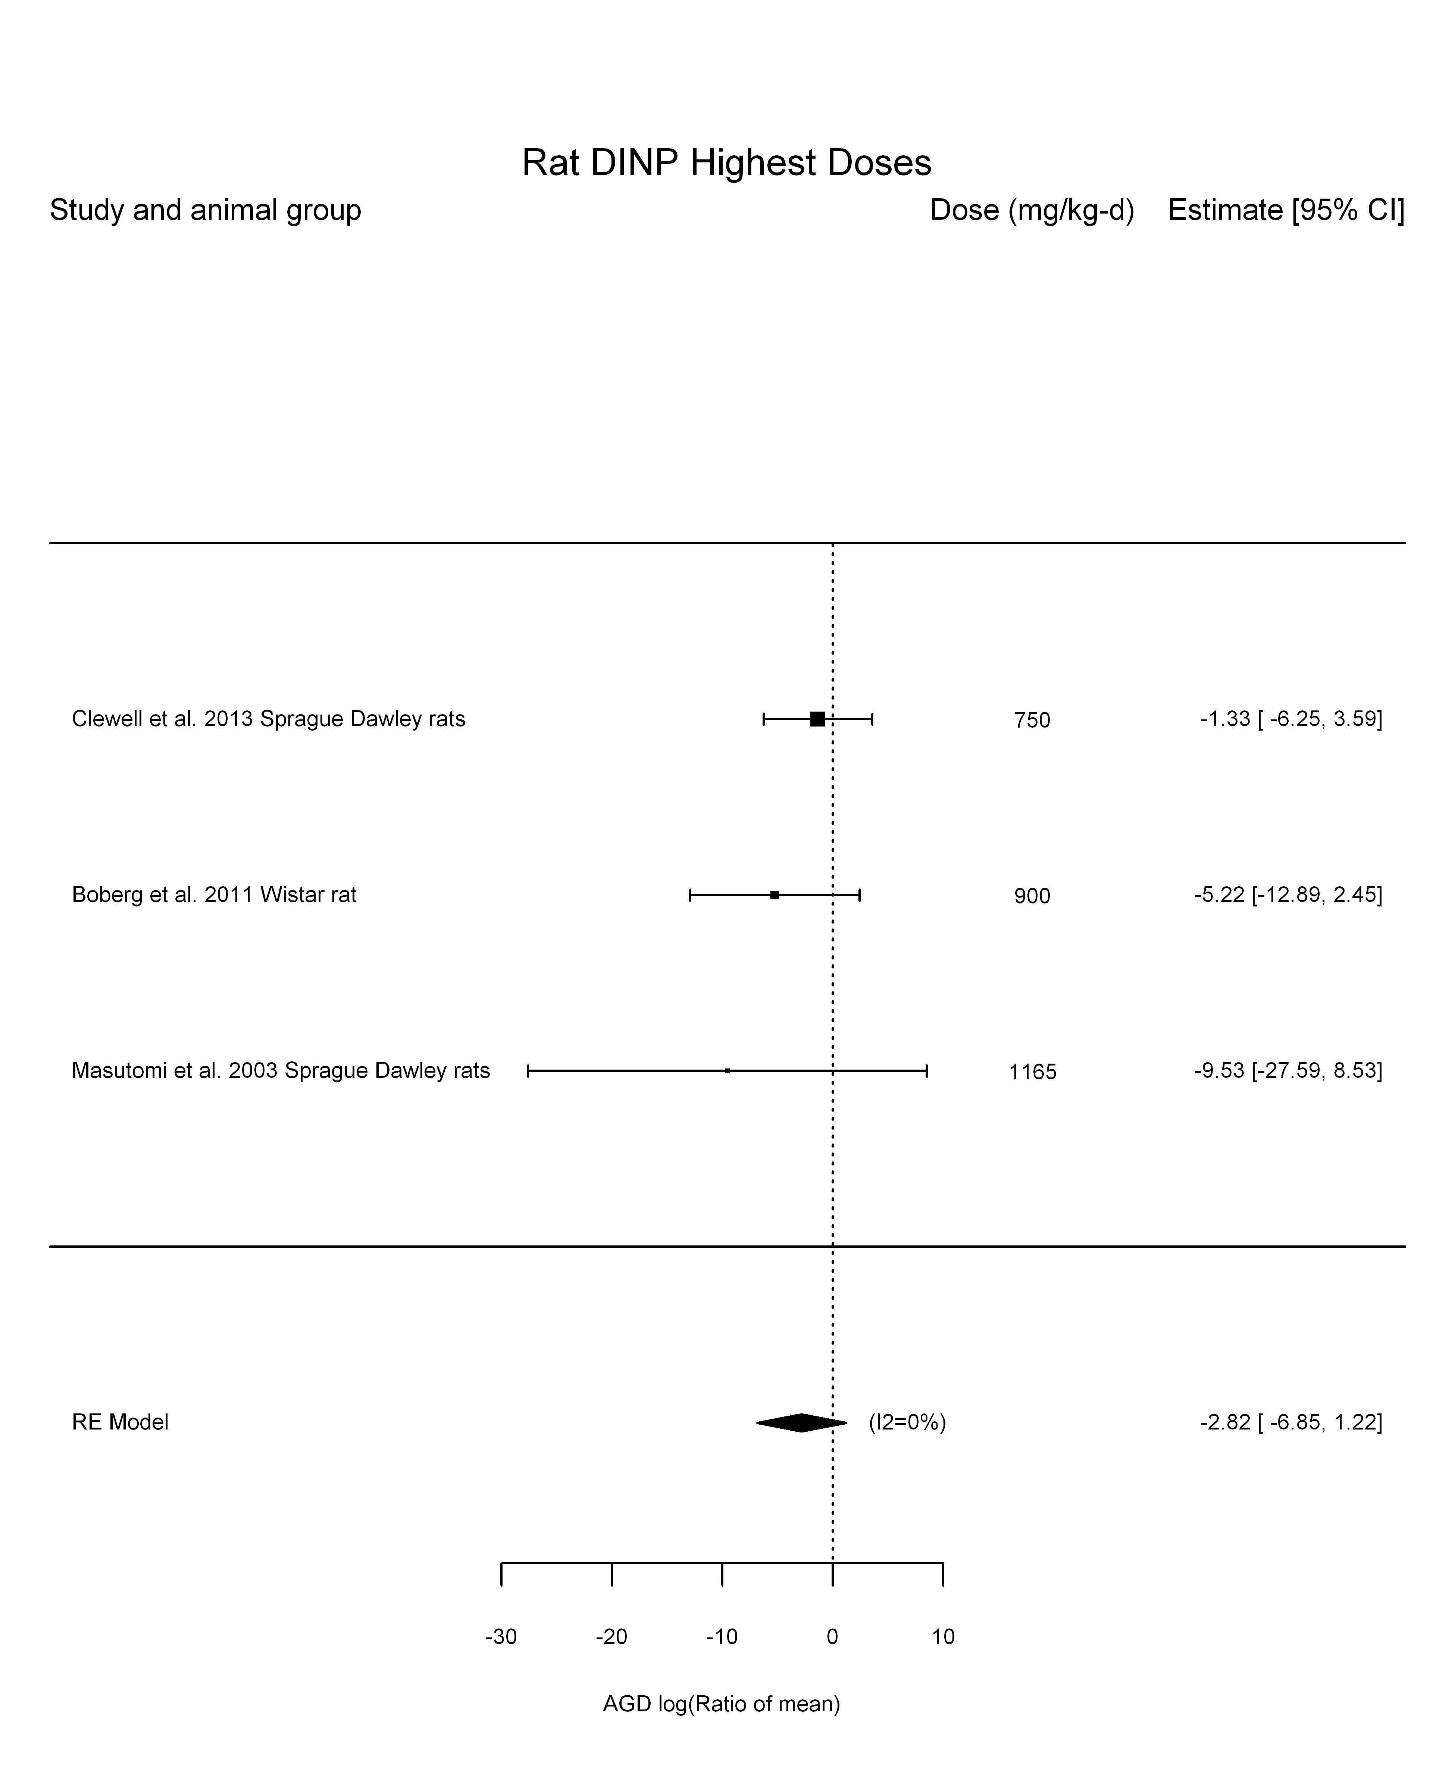

## [1] "Linear or LinearQuadratic in dose---------------------"  
##   
## Mixed-Effects Model (k = 3; tau^2 estimator: REML)  
##   
## logLik deviance AIC BIC AICc   
## -5.3617 10.7234 14.7234 12.1097 26.7234   
##   
## tau^2 (estimated amount of residual heterogeneity): 0 (SE = 13.5074)  
## tau (square root of estimated tau^2 value): 0  
## I^2 (residual heterogeneity / unaccounted variability): 0.00%  
## H^2 (unaccounted variability / sampling variability): 1.00  
##   
## Test for Residual Heterogeneity:   
## QE(df = 2) = 0.8849, p-val = 0.6424  
##   
## Model Results:  
##   
## estimate se zval pval ci.lb ci.ub   
## dose100 -0.3766 0.2514 -1.4982 0.1341 -0.8694 0.1161   
##   
## ---  
## Signif. codes: 0 '***' 0.001 '**' 0.01 '*' 0.05 '.' 0.1 ' ' 1

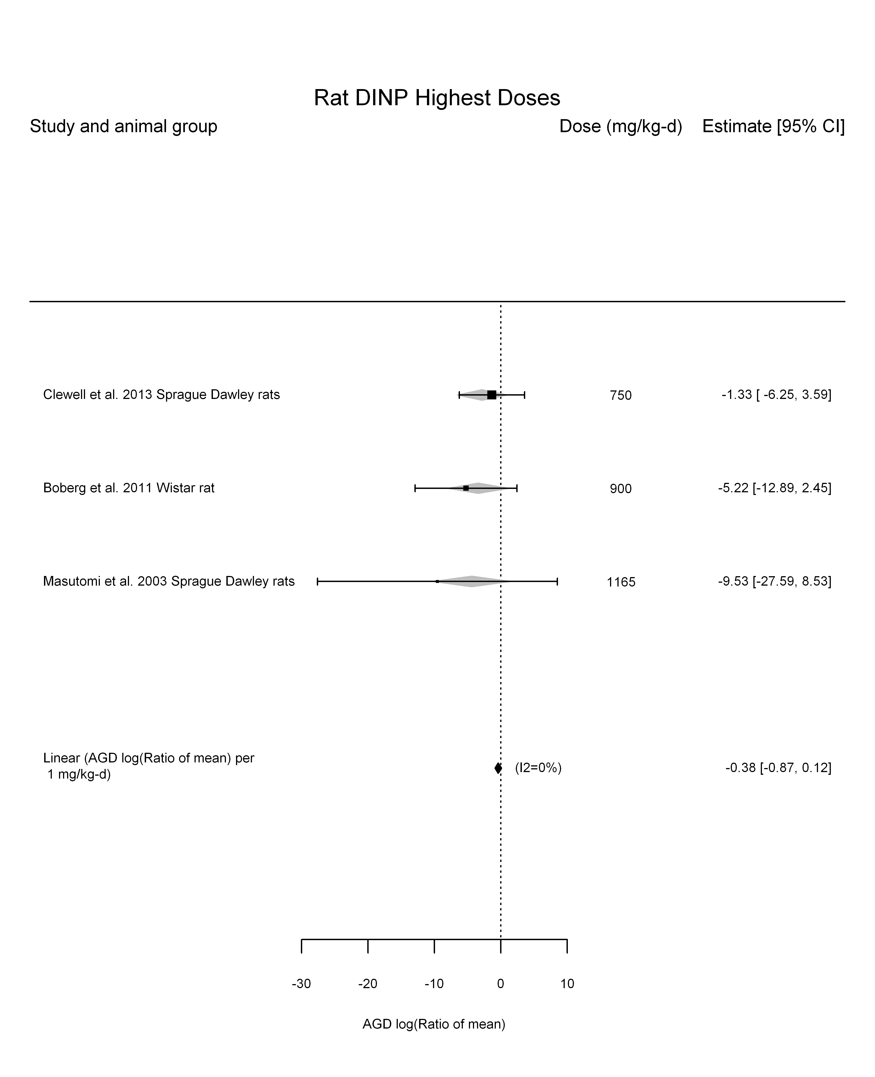

## [1] "Linear in log10(dose)---------------------"  
##   
## Mixed-Effects Model (k = 3; tau^2 estimator: REML)  
##   
## logLik deviance AIC BIC AICc   
## -2.4486 4.8972 10.8972 4.8972 34.8972   
##   
## tau^2 (estimated amount of residual heterogeneity): 0 (SE = 29.9111)  
## tau (square root of estimated tau^2 value): 0  
## I^2 (residual heterogeneity / unaccounted variability): 0.00%  
## H^2 (unaccounted variability / sampling variability): 1.00  
## R^2 (amount of heterogeneity accounted for): NA%  
##   
## Test for Residual Heterogeneity:   
## QE(df = 1) = 0.0076, p-val = 0.9303  
##   
## Test of Moderators (coefficient(s) 2):   
## QM(df = 1) = 1.2512, p-val = 0.2633  
##   
## Model Results:  
##   
## estimate se zval pval ci.lb ci.ub   
## intrcpt 129.1897 118.0323 1.0945 0.2737 -102.1493 360.5288   
## log10(dose) -45.4171 40.6034 -1.1186 0.2633 -124.9984 34.1641   
##   
## ---  
## Signif. codes: 0 '***' 0.001 '**' 0.01 '*' 0.05 '.' 0.1 ' ' 1

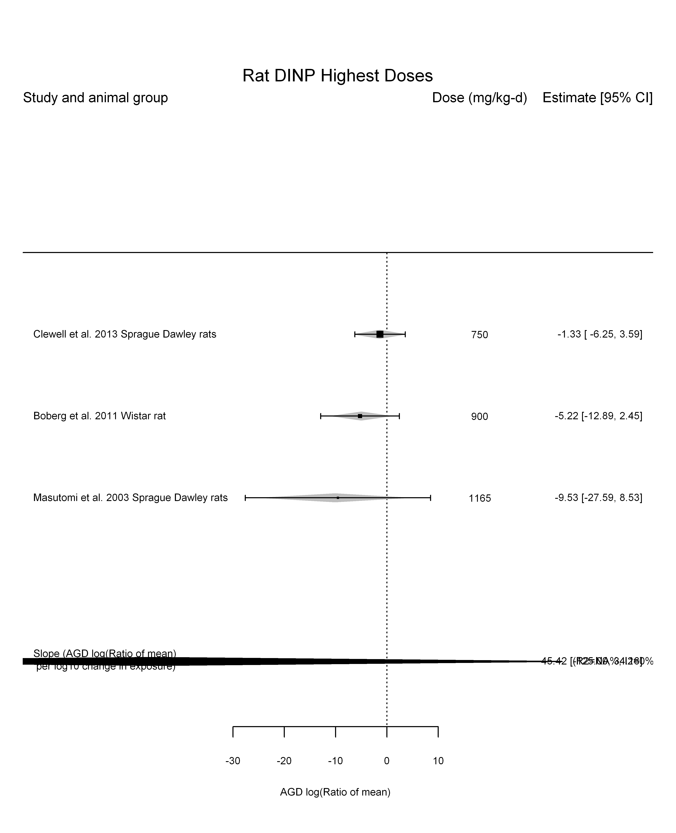

## [1] "Linear or LinearQuadratic in dose---------------------"  
##   
## Mixed-Effects Model (k = 3; tau^2 estimator: REML)  
##   
## logLik deviance AIC BIC AICc   
## -2.3322 4.6645 10.6645 4.6645 34.6645   
##   
## tau^2 (estimated amount of residual heterogeneity): 0 (SE = 21.7744)  
## tau (square root of estimated tau^2 value): 0  
## I^2 (residual heterogeneity / unaccounted variability): 0.00%  
## H^2 (unaccounted variability / sampling variability): 1.00  
##   
## Test for Residual Heterogeneity:   
## QE(df = 1) = 0.0924, p-val = 0.7611  
##   
## Test of Moderators (coefficient(s) 1,2):   
## QM(df = 2) = 3.0370, p-val = 0.2190  
##   
## Model Results:  
##   
## estimate se zval pval ci.lb ci.ub   
## dose100 1.0931 1.6700 0.6546 0.5128 -2.1800 4.3662   
## I(dose100^2) -0.1745 0.1961 -0.8902 0.3733 -0.5588 0.2097   
##   
## ---  
## Signif. codes: 0 '***' 0.001 '**' 0.01 '*' 0.05 '.' 0.1 ' ' 1

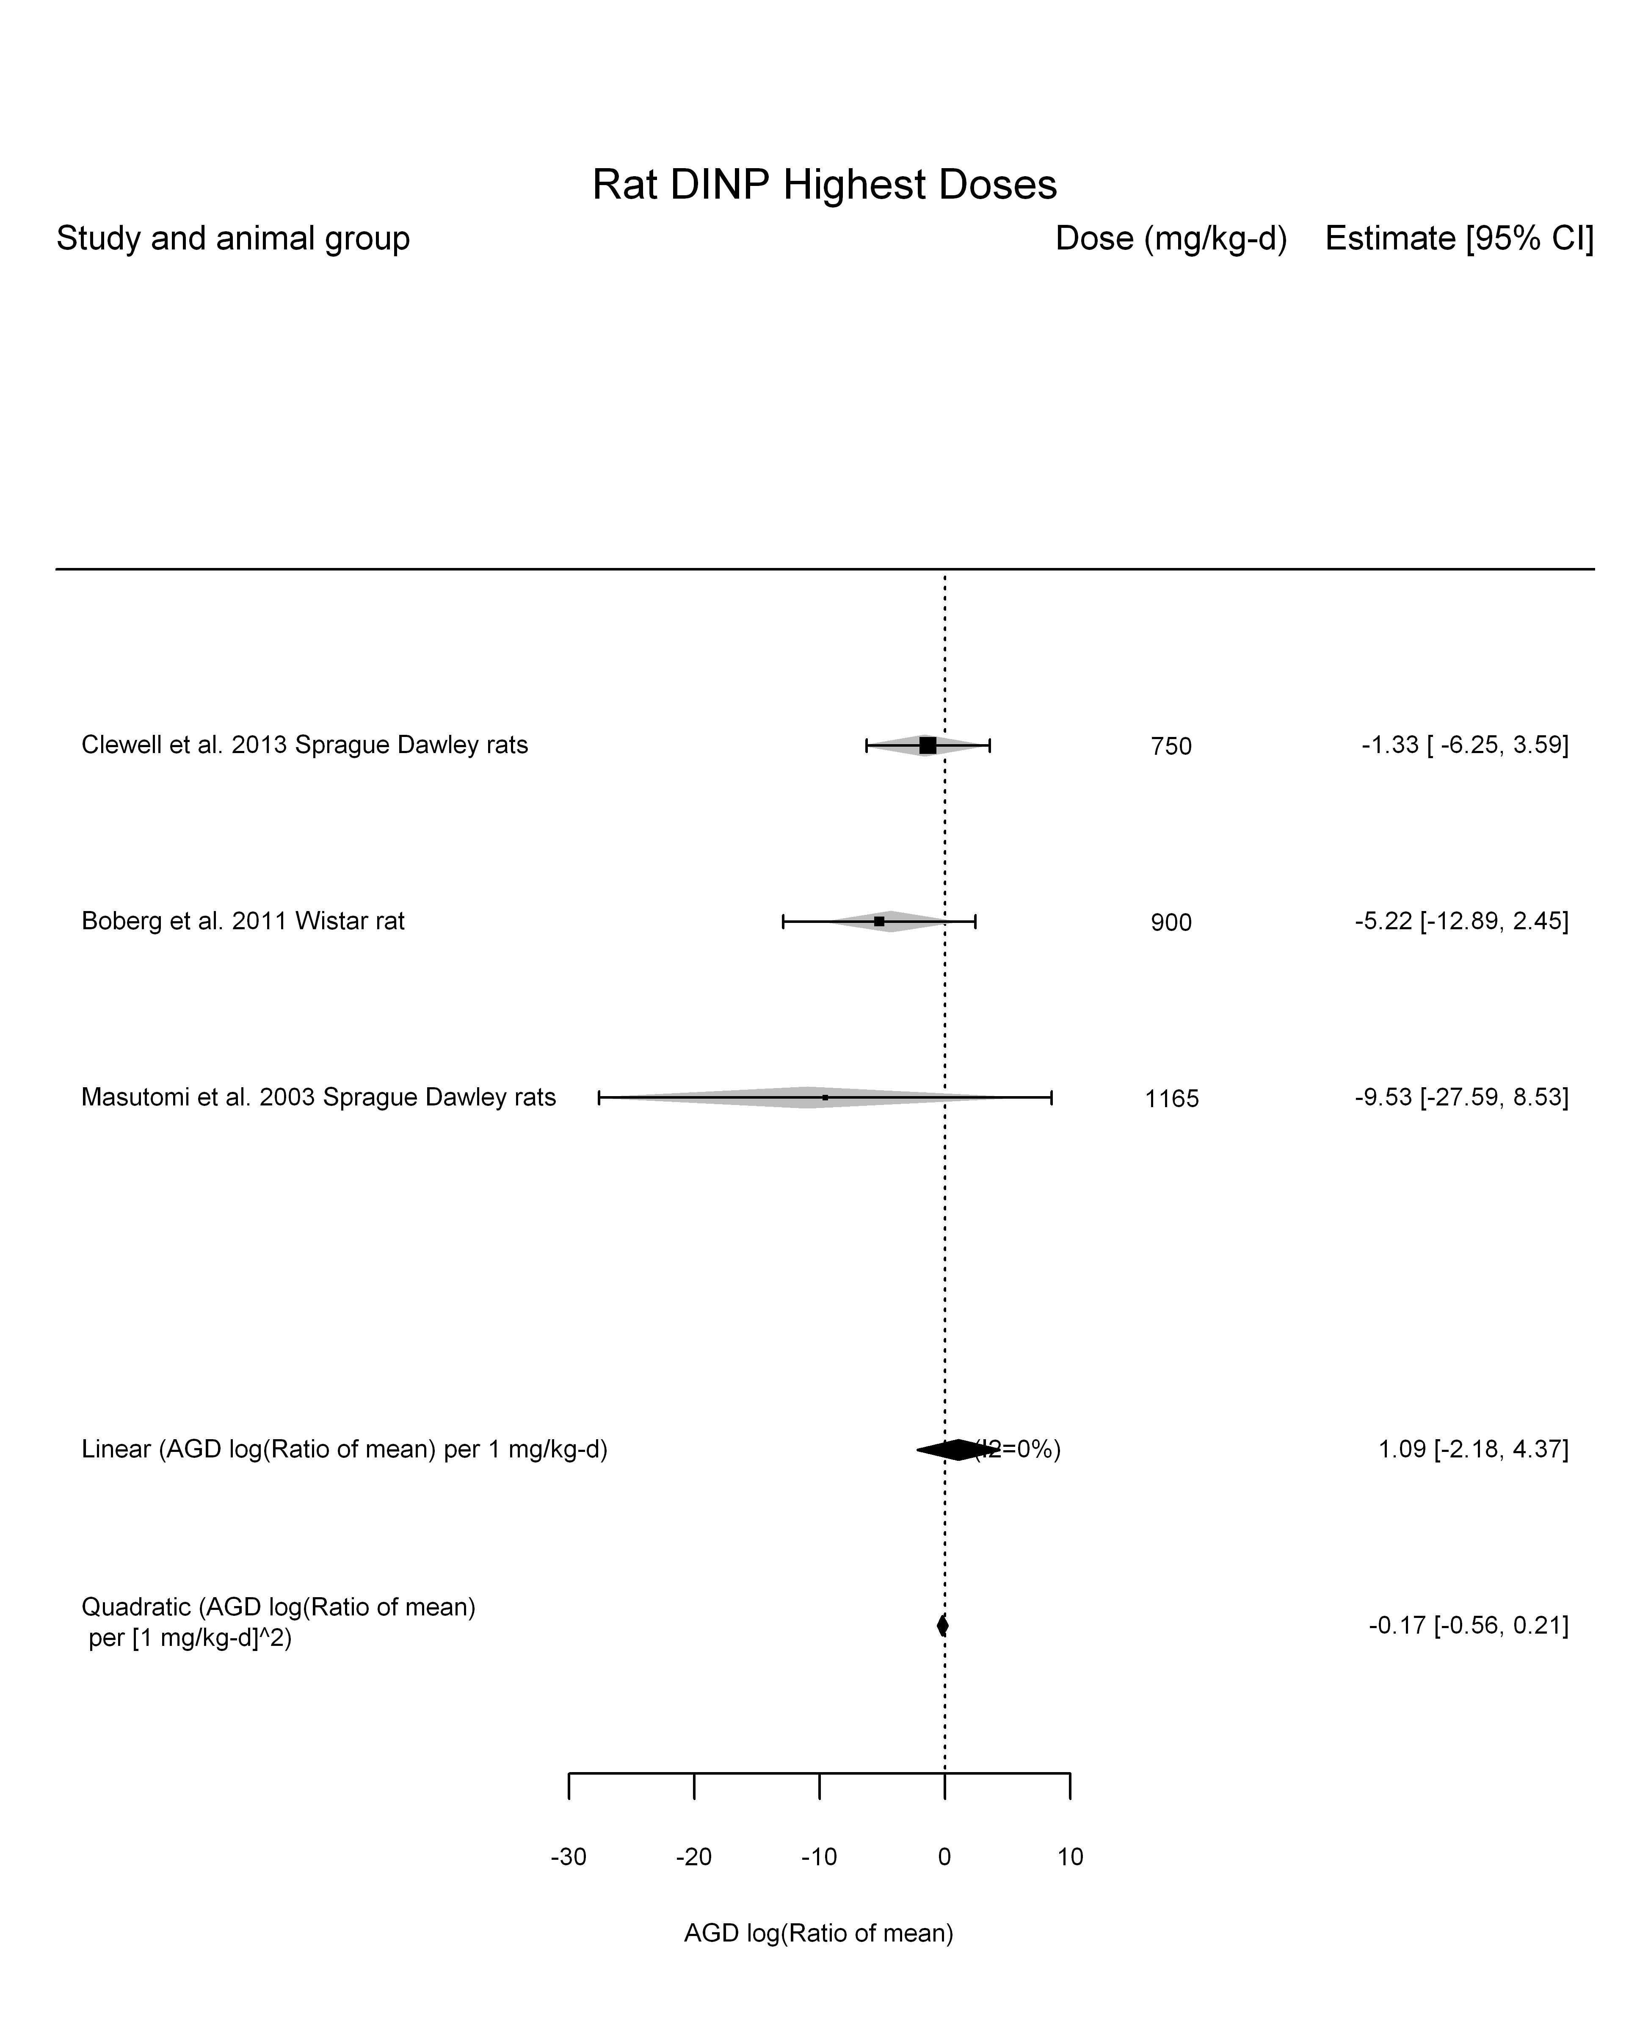

## [1] ""

## [1] ""  
## m ci.lb ci.ub bmr  
## 1 NA 590.0054 NA -5.129329

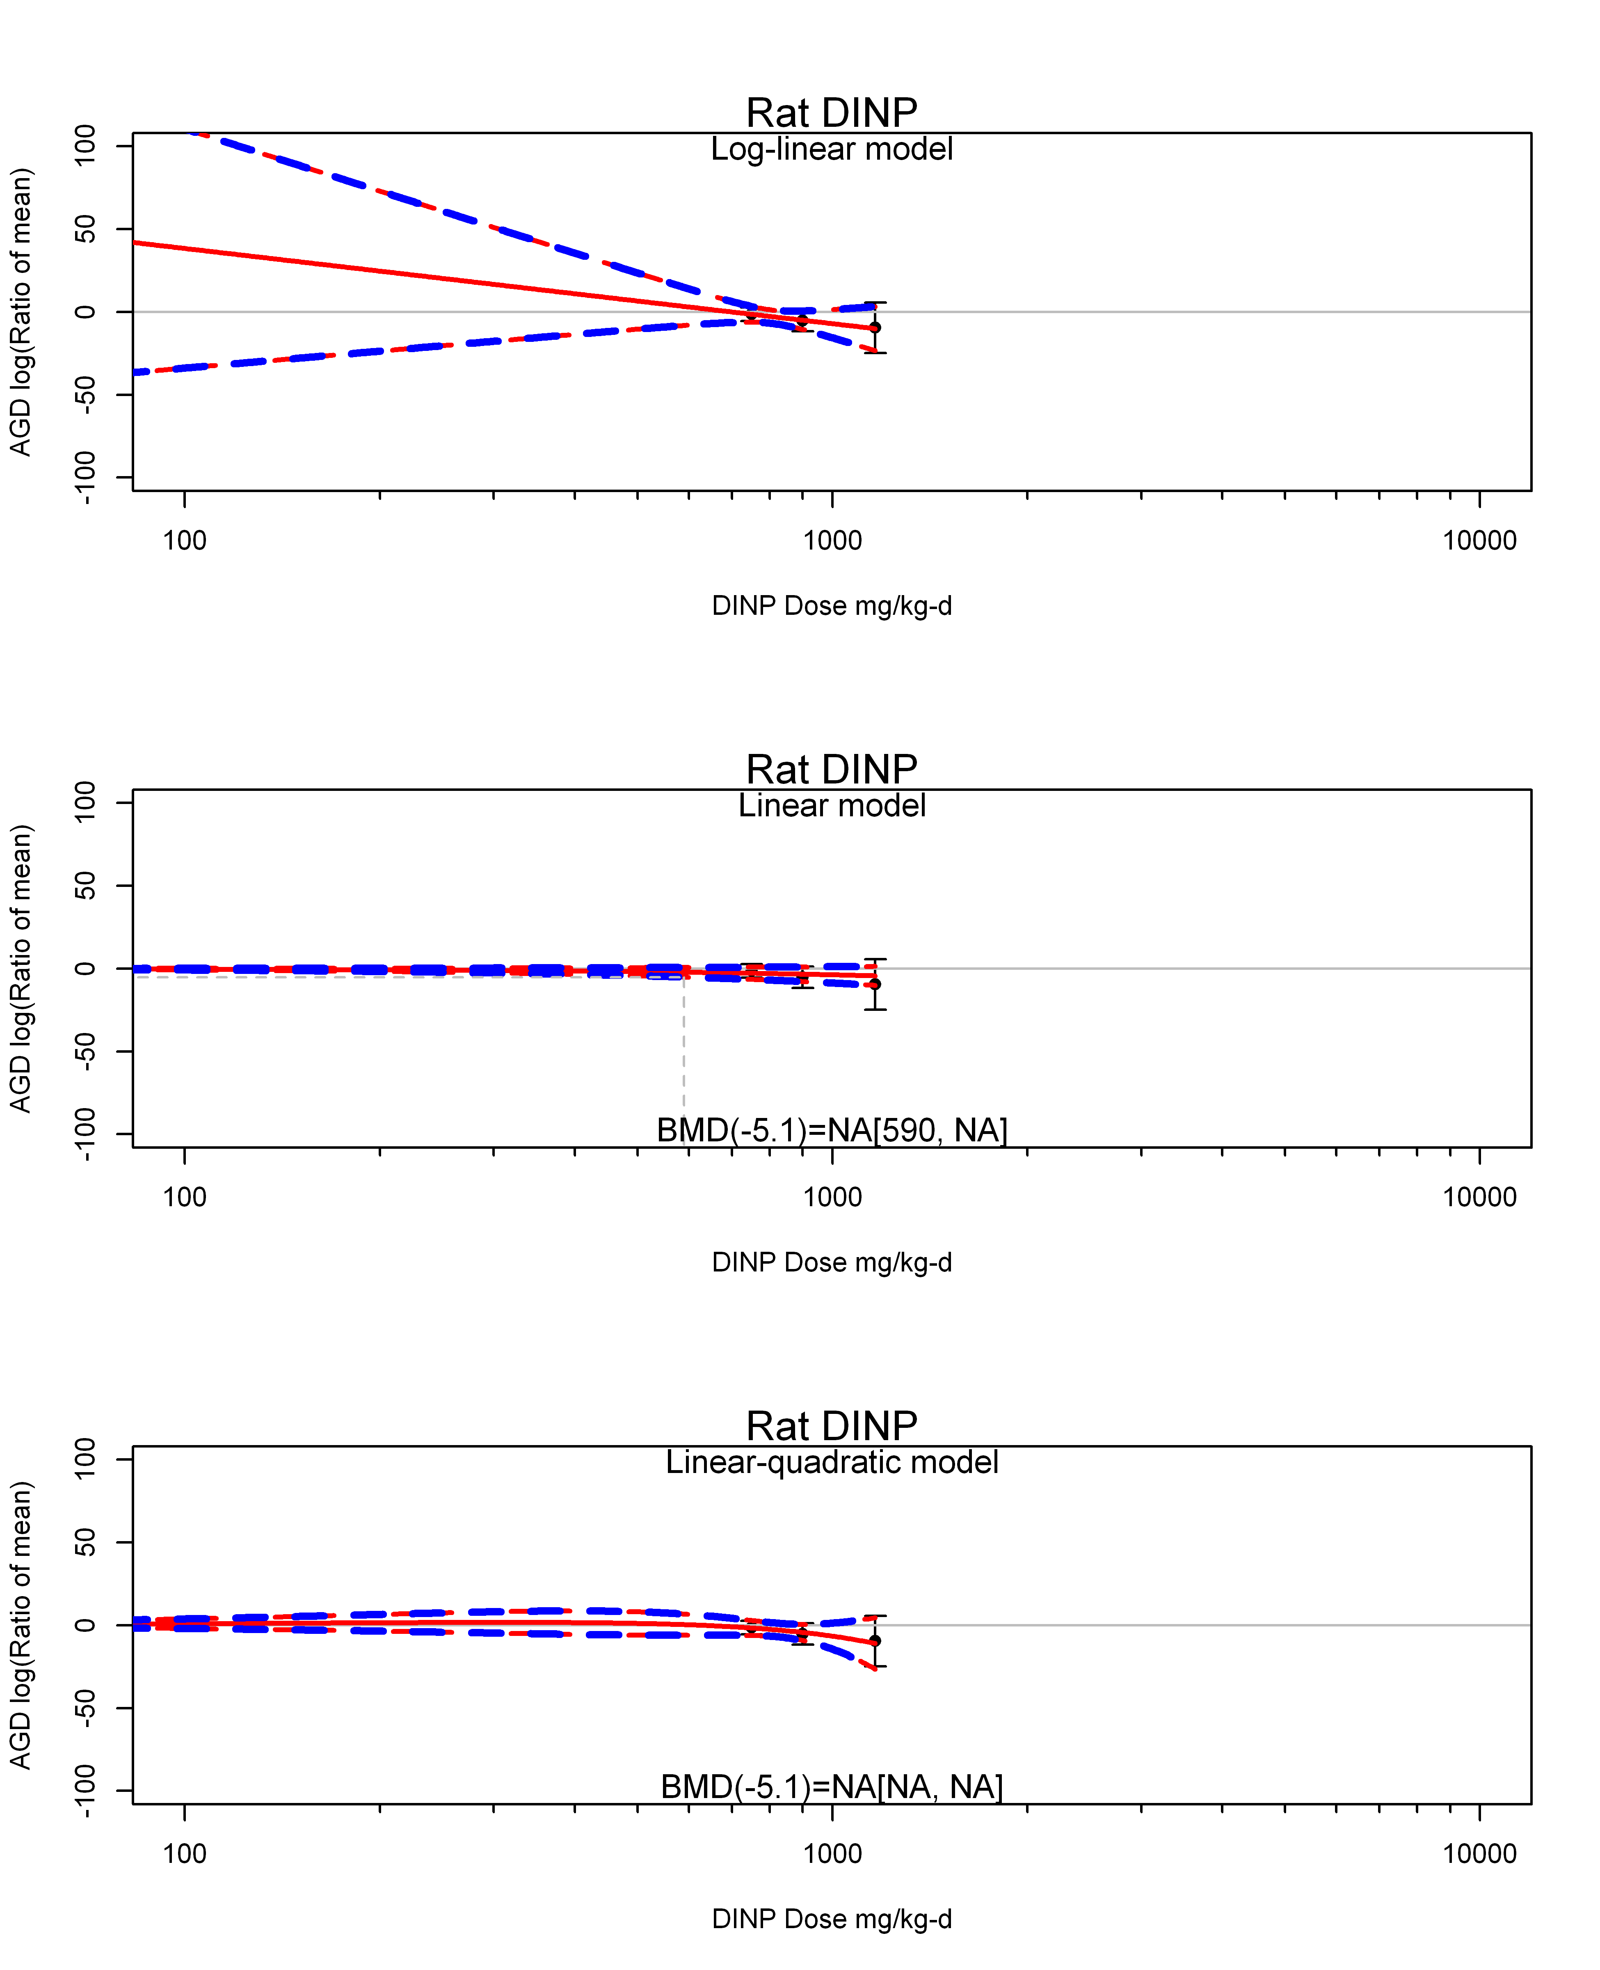

## [1] ""  
## m ci.lb ci.ub bmr  
## 1 NA NA NA -5.129329  
## [1] "AGD log(Ratio of mean) Mouse"  
## [1] "AGD log(Ratio of mean) Rat"  
## [1] "AGD log(Ratio of mean) Mouse"  
## [1] "AGD log(Ratio of mean) Rat"  
## [1] "AGD log(Ratio of mean) Mouse"

## T animal details

## [1] "Fetal testes T log(Ratio of mean) Rat"  
## [1] "Overall---------------------"  
##   
## Random-Effects Model (k = 28; tau^2 estimator: REML)  
##   
## logLik deviance AIC BIC AICc   
## -153.4704 306.9408 310.9408 313.5325 311.4408   
##   
## tau^2 (estimated amount of total heterogeneity): 3510.8075 (SE = 1094.8127)  
## tau (square root of estimated tau^2 value): 59.2521  
## I^2 (total heterogeneity / total variability): 94.78%  
## H^2 (total variability / sampling variability): 19.16  
##   
## Test for Heterogeneity:   
## Q(df = 27) = 628.6864, p-val < .0001  
##   
## Model Results:  
##   
## estimate se zval pval ci.lb ci.ub   
## -56.9745 12.0744 -4.7186 <.0001 -80.6399 -33.3091 ***   
##   
## ---  
## Signif. codes: 0 '***' 0.001 '**' 0.01 '*' 0.05 '.' 0.1 ' ' 1

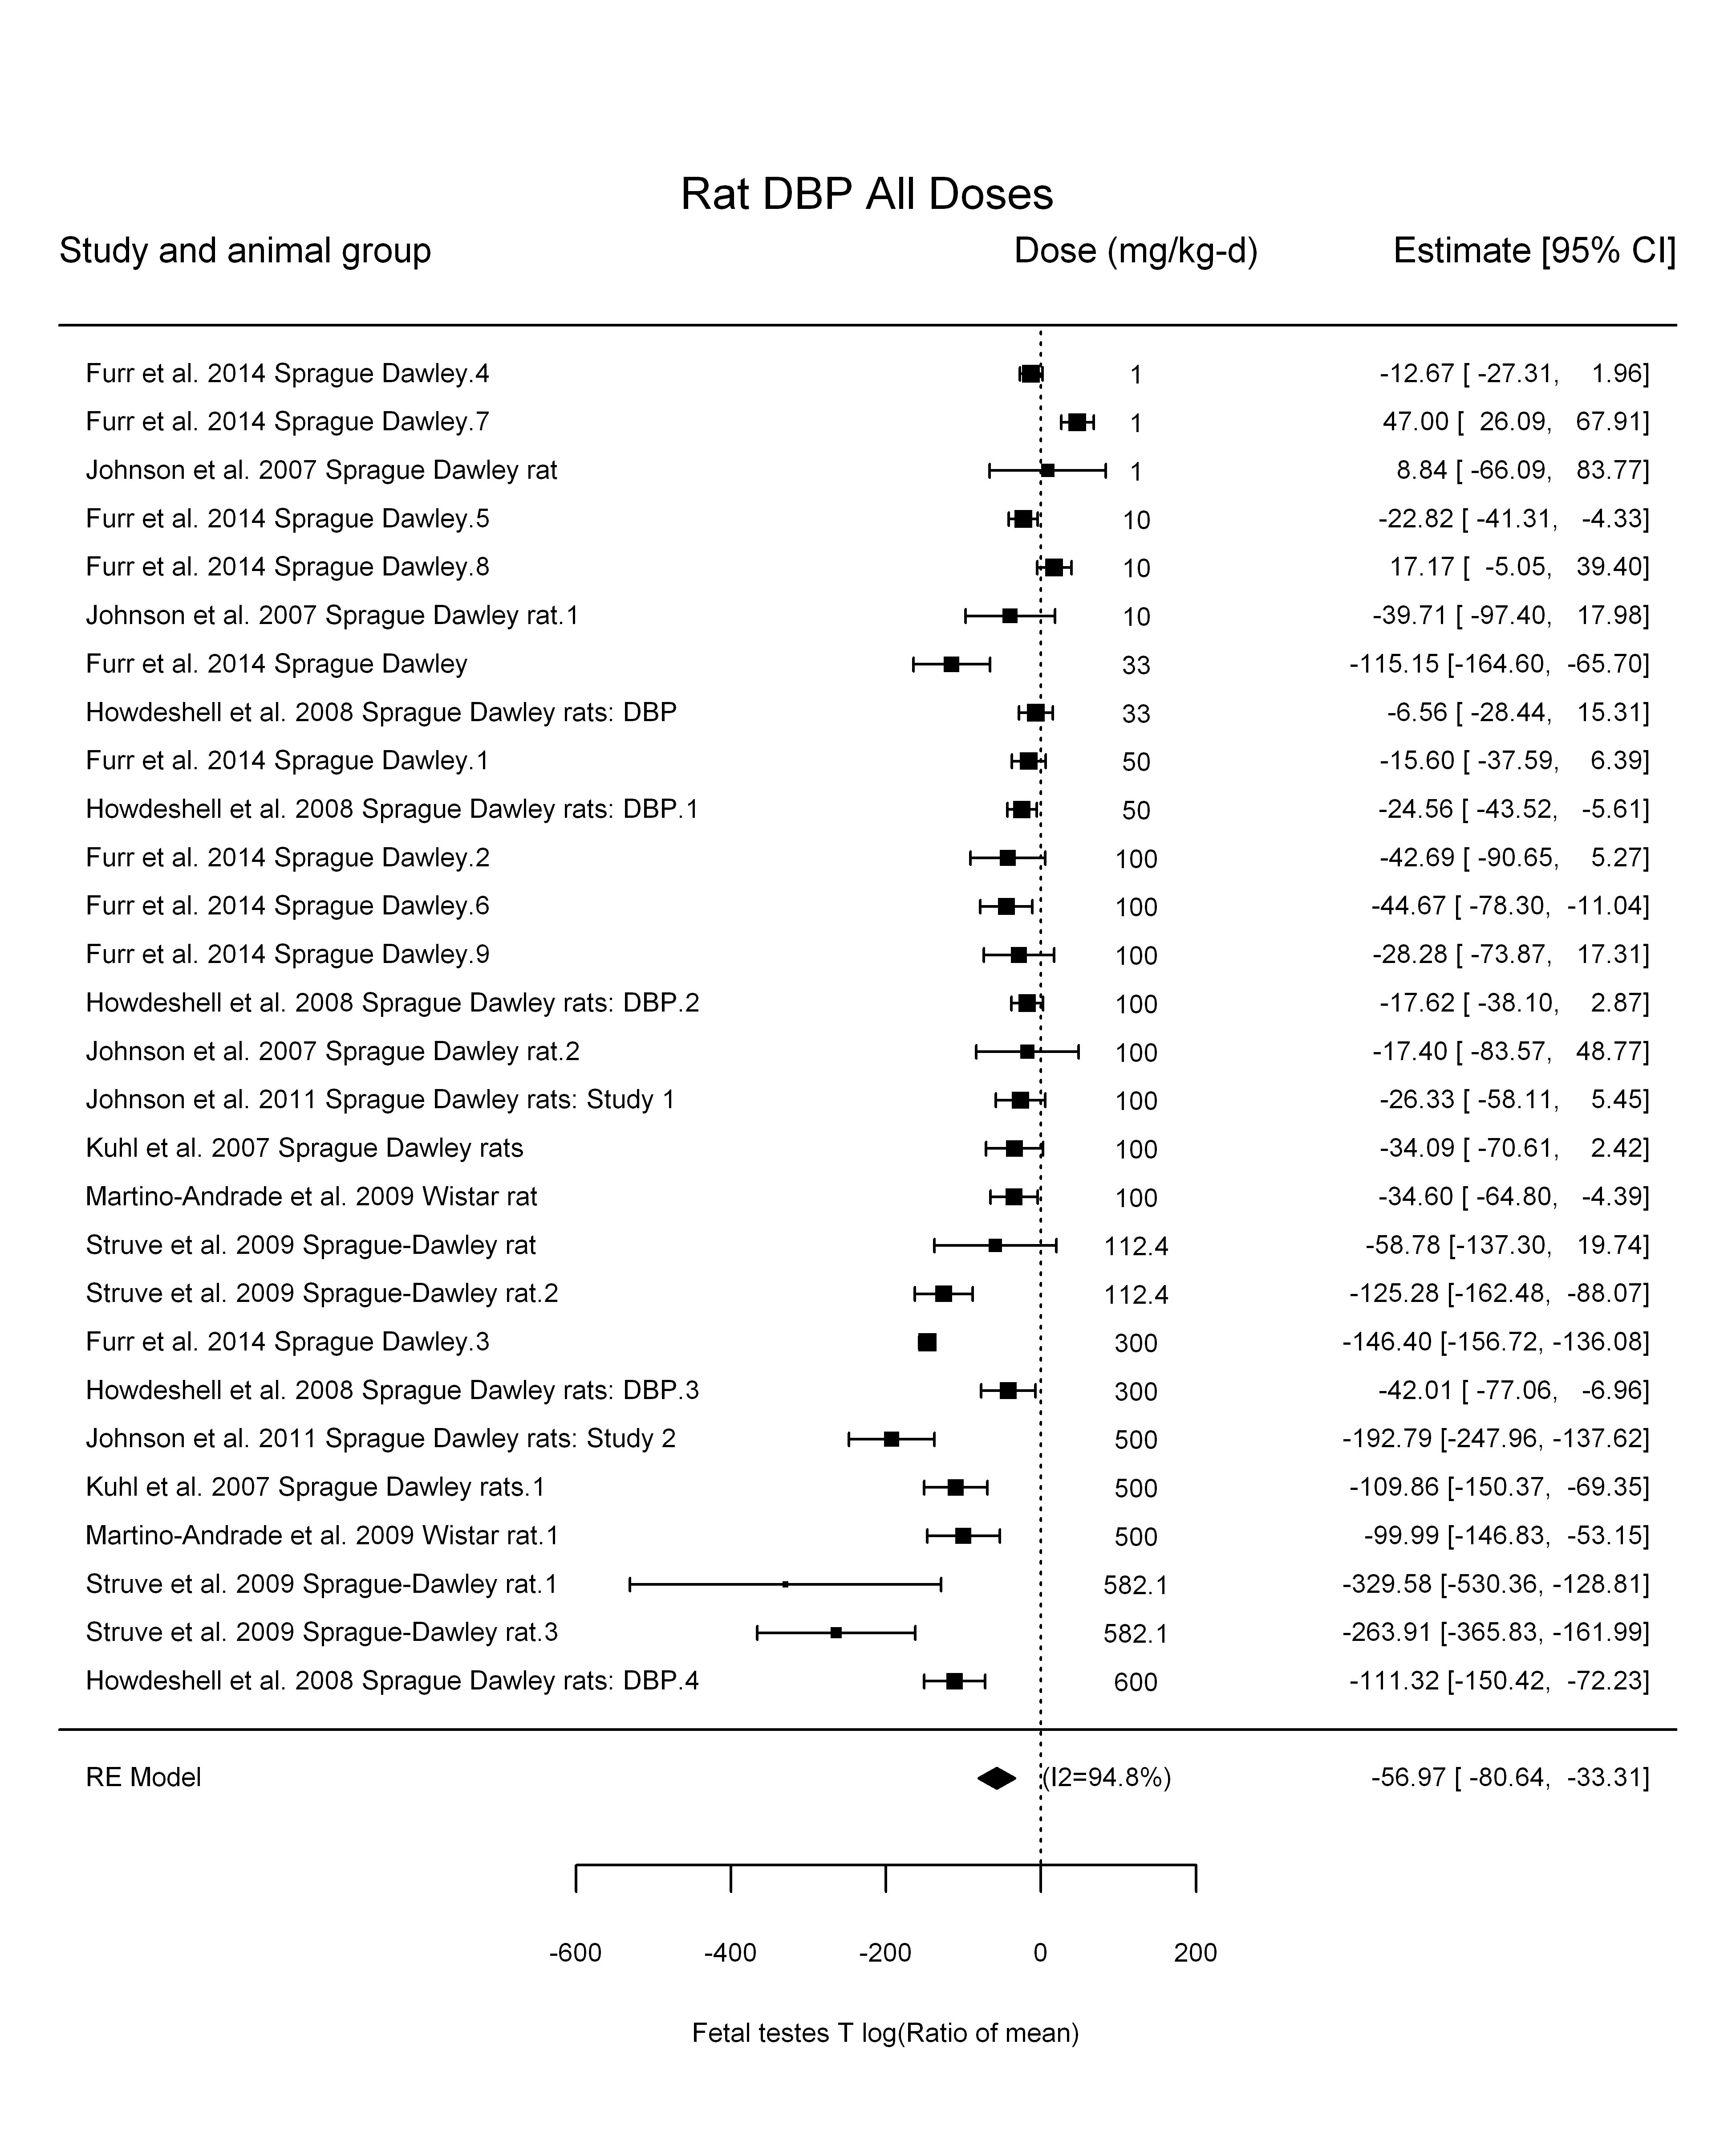

## [1] "Leave one out---------------------"  
##   
## Random-Effects Model (k = 24; tau^2 estimator: REML)  
##   
## tau^2 (estimated amount of total heterogeneity): 2621.6123 (SE = 877.7272)  
## tau (square root of estimated tau^2 value): 51.2017  
## I^2 (total heterogeneity / total variability): 93.92%  
## H^2 (total variability / sampling variability): 16.44  
##   
## Test for Heterogeneity:   
## Q(df = 23) = 590.1282, p-val < .0001  
##   
## Model Results:  
##   
## estimate se zval pval ci.lb ci.ub   
## -45.2297 11.1634 -4.0516 <.0001 -67.1096 -23.3498 ***   
##   
## ---  
## Signif. codes: 0 '***' 0.001 '**' 0.01 '*' 0.05 '.' 0.1 ' ' 1   
##   
##   
## Random-Effects Model (k = 23; tau^2 estimator: REML)  
##   
## tau^2 (estimated amount of total heterogeneity): 4242.2755 (SE = 1465.0279)  
## tau (square root of estimated tau^2 value): 65.1328  
## I^2 (total heterogeneity / total variability): 95.26%  
## H^2 (total variability / sampling variability): 21.11  
##   
## Test for Heterogeneity:   
## Q(df = 22) = 574.6178, p-val < .0001  
##   
## Model Results:  
##   
## estimate se zval pval ci.lb ci.ub   
## -62.1872 14.6385 -4.2482 <.0001 -90.8782 -33.4962 ***   
##   
## ---  
## Signif. codes: 0 '***' 0.001 '**' 0.01 '*' 0.05 '.' 0.1 ' ' 1   
##   
##   
## Random-Effects Model (k = 25; tau^2 estimator: REML)  
##   
## tau^2 (estimated amount of total heterogeneity): 3865.9546 (SE = 1249.7739)  
## tau (square root of estimated tau^2 value): 62.1768  
## I^2 (total heterogeneity / total variability): 95.65%  
## H^2 (total variability / sampling variability): 23.01  
##   
## Test for Heterogeneity:   
## Q(df = 24) = 624.6058, p-val < .0001  
##   
## Model Results:  
##   
## estimate se zval pval ci.lb ci.ub   
## -61.6300 13.2503 -4.6512 <.0001 -87.6000 -35.6600 ***   
##   
## ---  
## Signif. codes: 0 '***' 0.001 '**' 0.01 '*' 0.05 '.' 0.1 ' ' 1   
##   
##   
## Random-Effects Model (k = 26; tau^2 estimator: REML)  
##   
## tau^2 (estimated amount of total heterogeneity): 3007.0169 (SE = 990.3021)  
## tau (square root of estimated tau^2 value): 54.8363  
## I^2 (total heterogeneity / total variability): 94.16%  
## H^2 (total variability / sampling variability): 17.14  
##   
## Test for Heterogeneity:   
## Q(df = 25) = 601.3629, p-val < .0001  
##   
## Model Results:  
##   
## estimate se zval pval ci.lb ci.ub   
## -52.6345 11.7088 -4.4953 <.0001 -75.5833 -29.6858 ***   
##   
## ---  
## Signif. codes: 0 '***' 0.001 '**' 0.01 '*' 0.05 '.' 0.1 ' ' 1   
##   
##   
## Random-Effects Model (k = 26; tau^2 estimator: REML)  
##   
## tau^2 (estimated amount of total heterogeneity): 3732.0950 (SE = 1205.4912)  
## tau (square root of estimated tau^2 value): 61.0909  
## I^2 (total heterogeneity / total variability): 95.24%  
## H^2 (total variability / sampling variability): 21.00  
##   
## Test for Heterogeneity:   
## Q(df = 25) = 620.1301, p-val < .0001  
##   
## Model Results:  
##   
## estimate se zval pval ci.lb ci.ub   
## -56.0766 12.8988 -4.3474 <.0001 -81.3579 -30.7953 ***   
##   
## ---  
## Signif. codes: 0 '***' 0.001 '**' 0.01 '*' 0.05 '.' 0.1 ' ' 1   
##   
##   
## Random-Effects Model (k = 26; tau^2 estimator: REML)  
##   
## tau^2 (estimated amount of total heterogeneity): 3792.6814 (SE = 1222.9990)  
## tau (square root of estimated tau^2 value): 61.5848  
## I^2 (total heterogeneity / total variability): 95.28%  
## H^2 (total variability / sampling variability): 21.21  
##   
## Test for Heterogeneity:   
## Q(df = 25) = 623.3982, p-val < .0001  
##   
## Model Results:  
##   
## estimate se zval pval ci.lb ci.ub   
## -56.6072 12.9904 -4.3576 <.0001 -82.0680 -31.1465 ***   
##   
## ---  
## Signif. codes: 0 '***' 0.001 '**' 0.01 '*' 0.05 '.' 0.1 ' ' 1   
##   
##   
## Random-Effects Model (k = 18; tau^2 estimator: REML)  
##   
## tau^2 (estimated amount of total heterogeneity): 3689.4050 (SE = 1505.7613)  
## tau (square root of estimated tau^2 value): 60.7405  
## I^2 (total heterogeneity / total variability): 91.61%  
## H^2 (total variability / sampling variability): 11.92  
##   
## Test for Heterogeneity:   
## Q(df = 17) = 125.1651, p-val < .0001  
##   
## Model Results:  
##   
## estimate se zval pval ci.lb ci.ub   
## -70.7867 15.7652 -4.4901 <.0001 -101.6859 -39.8874 ***   
##   
## ---  
## Signif. codes: 0 '***' 0.001 '**' 0.01 '*' 0.05 '.' 0.1 ' ' 1   
##   
## [1] "Trend in log10(dose)---------------------"  
##   
## Mixed-Effects Model (k = 28; tau^2 estimator: REML)  
##   
## logLik deviance AIC BIC AICc   
## -139.2584 278.5169 284.5169 288.2912 285.6078   
##   
## tau^2 (estimated amount of residual heterogeneity): 1560.2608 (SE = 551.9936)  
## tau (square root of estimated tau^2 value): 39.5001  
## I^2 (residual heterogeneity / unaccounted variability): 88.01%  
## H^2 (unaccounted variability / sampling variability): 8.34  
## R^2 (amount of heterogeneity accounted for): 55.56%  
##   
## Test for Residual Heterogeneity:   
## QE(df = 26) = 275.7729, p-val < .0001  
##   
## Test of Moderators (coefficient(s) 2):   
## QM(df = 1) = 25.3125, p-val < .0001  
##   
## Model Results:  
##   
## estimate se zval pval ci.lb ci.ub   
## intrcpt 40.8833 20.5935 1.9853 0.0471 0.5208 81.2457 *  
## log10(dose) -53.7156 10.6766 -5.0312 <.0001 -74.6413 -32.7898 ***  
##   
## ---  
## Signif. codes: 0 '***' 0.001 '**' 0.01 '*' 0.05 '.' 0.1 ' ' 1

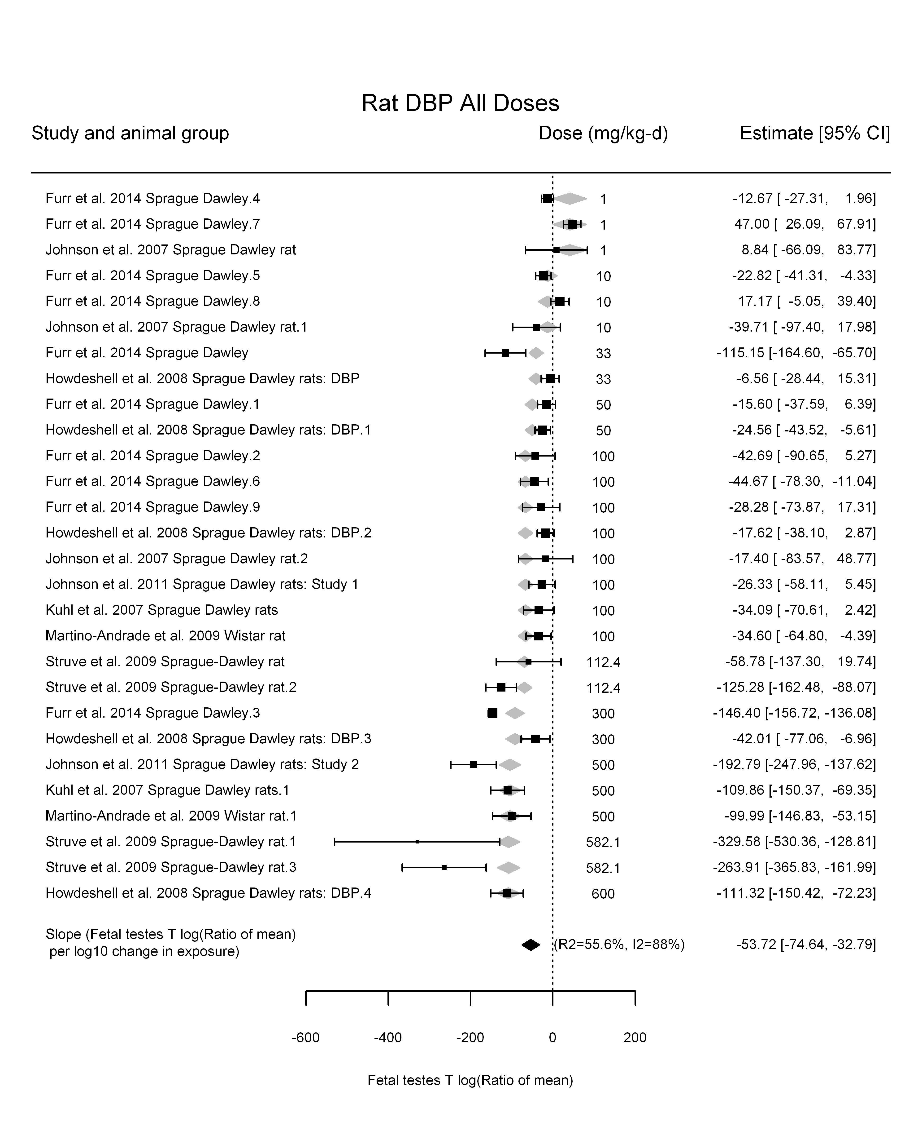

## [1] "Linear---------------------"  
##   
## Mixed-Effects Model (k = 28; tau^2 estimator: REML)  
##   
## logLik deviance AIC BIC AICc   
## -140.6125 281.2250 285.2250 287.8166 285.7250   
##   
## tau^2 (estimated amount of residual heterogeneity): 1242.5787 (SE = 445.0498)  
## tau (square root of estimated tau^2 value): 35.2502  
## I^2 (residual heterogeneity / unaccounted variability): 86.12%  
## H^2 (unaccounted variability / sampling variability): 7.20  
##   
## Test for Residual Heterogeneity:   
## QE(df = 27) = 191.9697, p-val < .0001  
##   
## Model Results:  
##   
## estimate se zval pval ci.lb ci.ub   
## dose100 -29.4334 3.2626 -9.0215 <.0001 -35.8279 -23.0388 ***  
##   
## ---  
## Signif. codes: 0 '***' 0.001 '**' 0.01 '*' 0.05 '.' 0.1 ' ' 1

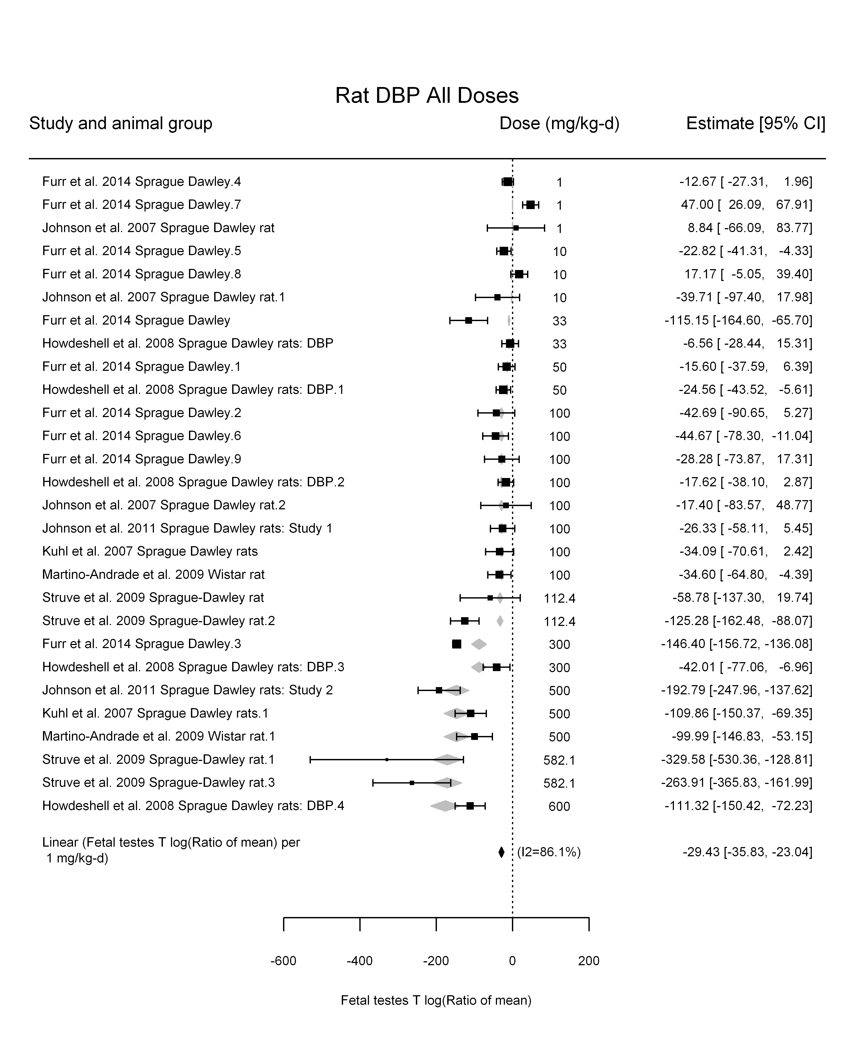

## [1] "LinearQuadratic---------------------"  
##   
## Mixed-Effects Model (k = 28; tau^2 estimator: REML)  
##   
## logLik deviance AIC BIC AICc   
## -134.9544 269.9088 275.9088 279.6831 276.9997   
##   
## tau^2 (estimated amount of residual heterogeneity): 1082.6049 (SE = 406.1348)  
## tau (square root of estimated tau^2 value): 32.9030  
## I^2 (residual heterogeneity / unaccounted variability): 83.99%  
## H^2 (unaccounted variability / sampling variability): 6.25  
##   
## Test for Residual Heterogeneity:   
## QE(df = 26) = 139.2444, p-val < .0001  
##   
## Test of Moderators (coefficient(s) 1,2):   
## QM(df = 2) = 90.7332, p-val < .0001  
##   
## Model Results:  
##   
## estimate se zval pval ci.lb ci.ub   
## dose100 -44.9767 10.9934 -4.0912 <.0001 -66.5234 -23.4299 ***  
## I(dose100^2) 3.2918 2.2144 1.4866 0.1371 -1.0483 7.6318   
##   
## ---  
## Signif. codes: 0 '***' 0.001 '**' 0.01 '*' 0.05 '.' 0.1 ' ' 1

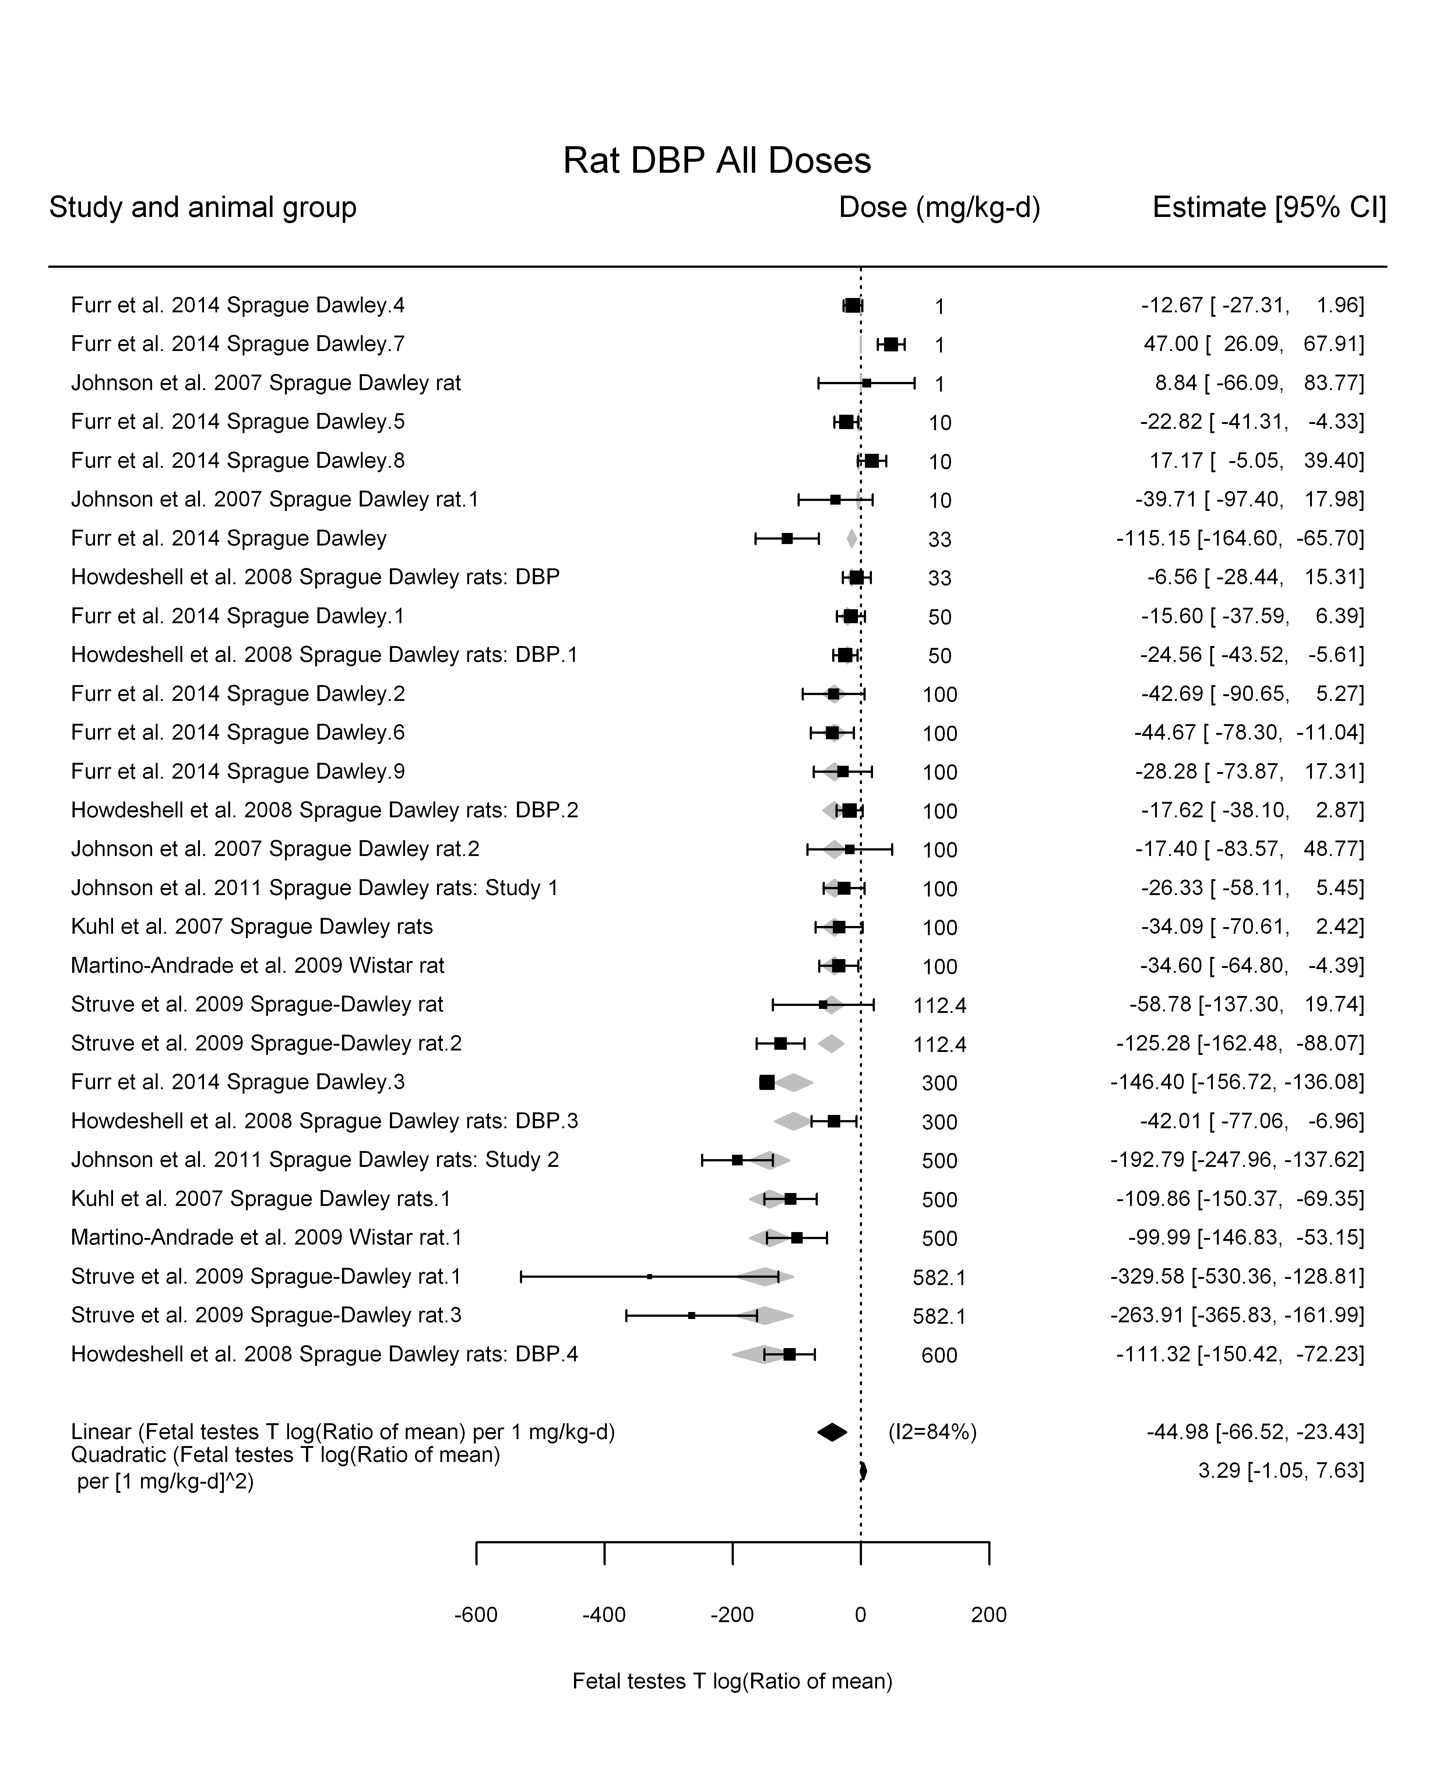

## [1] ""

## [1] ""  
## m ci.lb ci.ub bmr  
## 1 17.42684 14.31649 22.26376 -5.129329  
## m ci.lb ci.ub bmr  
## 1 173.5525 142.5767 221.7229 -51.08256

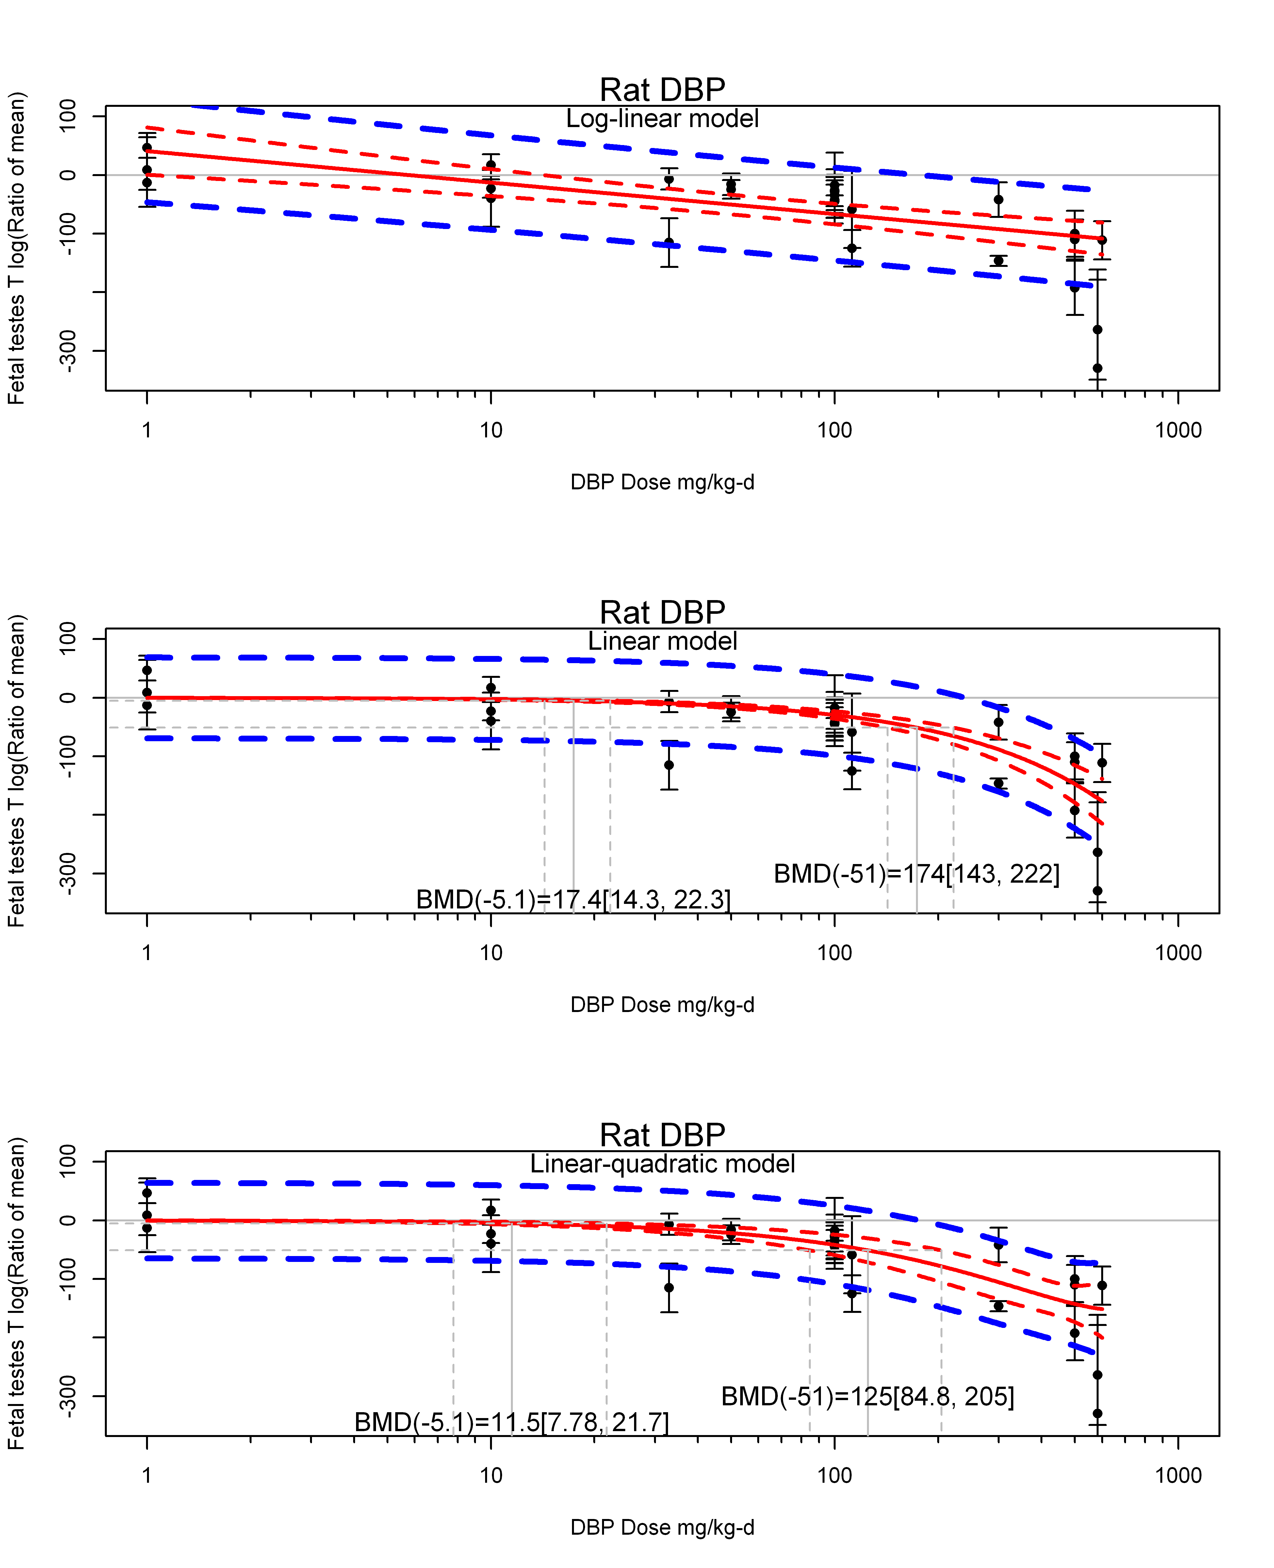

## [1] ""  
## m ci.lb ci.ub bmr  
## 1 11.50118 7.778293 21.7185 -5.129329  
## m ci.lb ci.ub bmr  
## 1 125.0139 84.80958 204.5751 -51.08256  
## [1] "Fetal testes T log(Ratio of mean) Rat Highest Dose"  
## [1] "Overall---------------------"  
##   
## Random-Effects Model (k = 10; tau^2 estimator: REML)  
##   
## logLik deviance AIC BIC AICc   
## -53.0655 106.1311 110.1311 110.5255 112.1311   
##   
## tau^2 (estimated amount of total heterogeneity): 5047.3819 (SE = 2783.3170)  
## tau (square root of estimated tau^2 value): 71.0449  
## I^2 (total heterogeneity / total variability): 94.06%  
## H^2 (total variability / sampling variability): 16.84  
##   
## Test for Heterogeneity:   
## Q(df = 9) = 111.7829, p-val < .0001  
##   
## Model Results:  
##   
## estimate se zval pval ci.lb ci.ub   
## -116.7204 24.5412 -4.7561 <.0001 -164.8203 -68.6205 ***   
##   
## ---  
## Signif. codes: 0 '***' 0.001 '**' 0.01 '*' 0.05 '.' 0.1 ' ' 1

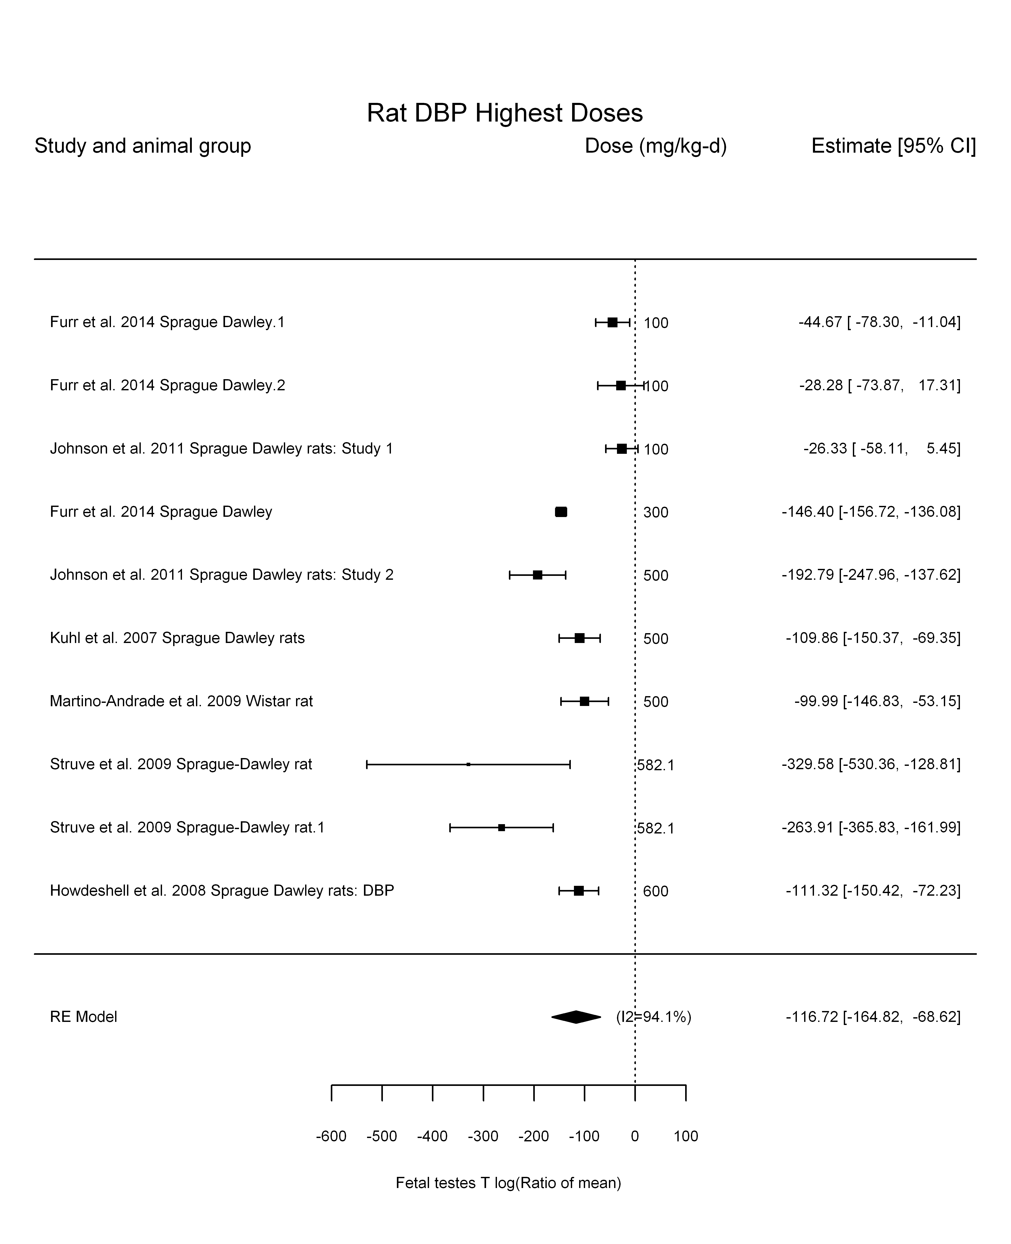

## [1] "Trend in log10(dose)---------------------"  
##   
## Mixed-Effects Model (k = 10; tau^2 estimator: REML)  
##   
## logLik deviance AIC BIC AICc   
## -43.7188 87.4375 93.4375 93.6759 99.4375   
##   
## tau^2 (estimated amount of residual heterogeneity): 1409.2915 (SE = 1008.8023)  
## tau (square root of estimated tau^2 value): 37.5405  
## I^2 (residual heterogeneity / unaccounted variability): 81.20%  
## H^2 (unaccounted variability / sampling variability): 5.32  
## R^2 (amount of heterogeneity accounted for): 72.08%  
##   
## Test for Residual Heterogeneity:   
## QE(df = 8) = 45.9009, p-val < .0001  
##   
## Test of Moderators (coefficient(s) 2):   
## QM(df = 1) = 13.6680, p-val = 0.0002  
##   
## Model Results:  
##   
## estimate se zval pval ci.lb ci.ub  
## intrcpt 284.6131 106.8227 2.6644 0.0077 75.2446 493.9817  
## log10(dose) -160.8929 43.5196 -3.6970 0.0002 -246.1896 -75.5961  
##   
## intrcpt **  
## log10(dose) ***  
##   
## ---  
## Signif. codes: 0 '***' 0.001 '**' 0.01 '*' 0.05 '.' 0.1 ' ' 1

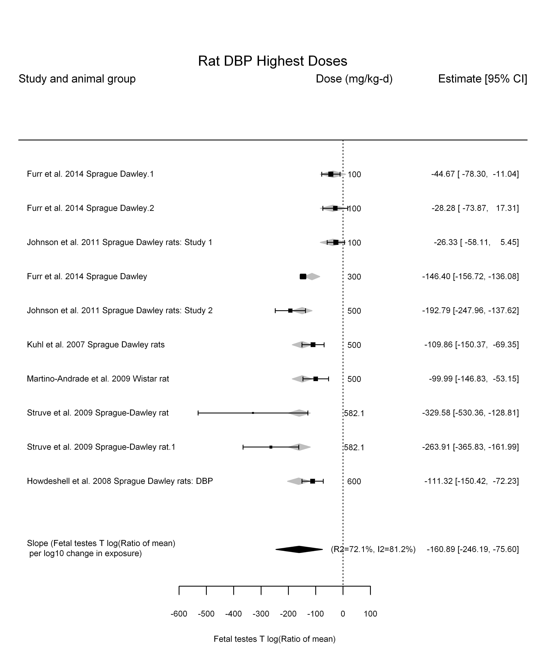

## [1] "Linear---------------------"  
##   
## Mixed-Effects Model (k = 10; tau^2 estimator: REML)  
##   
## logLik deviance AIC BIC AICc   
## -49.0801 98.1602 102.1602 102.5547 104.1602   
##   
## tau^2 (estimated amount of residual heterogeneity): 1801.8238 (SE = 1136.1273)  
## tau (square root of estimated tau^2 value): 42.4479  
## I^2 (residual heterogeneity / unaccounted variability): 86.55%  
## H^2 (unaccounted variability / sampling variability): 7.44  
##   
## Test for Residual Heterogeneity:   
## QE(df = 9) = 103.8983, p-val < .0001  
##   
## Model Results:  
##   
## estimate se zval pval ci.lb ci.ub   
## dose100 -29.7729 3.9425 -7.5518 <.0001 -37.5001 -22.0457 ***  
##   
## ---  
## Signif. codes: 0 '***' 0.001 '**' 0.01 '*' 0.05 '.' 0.1 ' ' 1

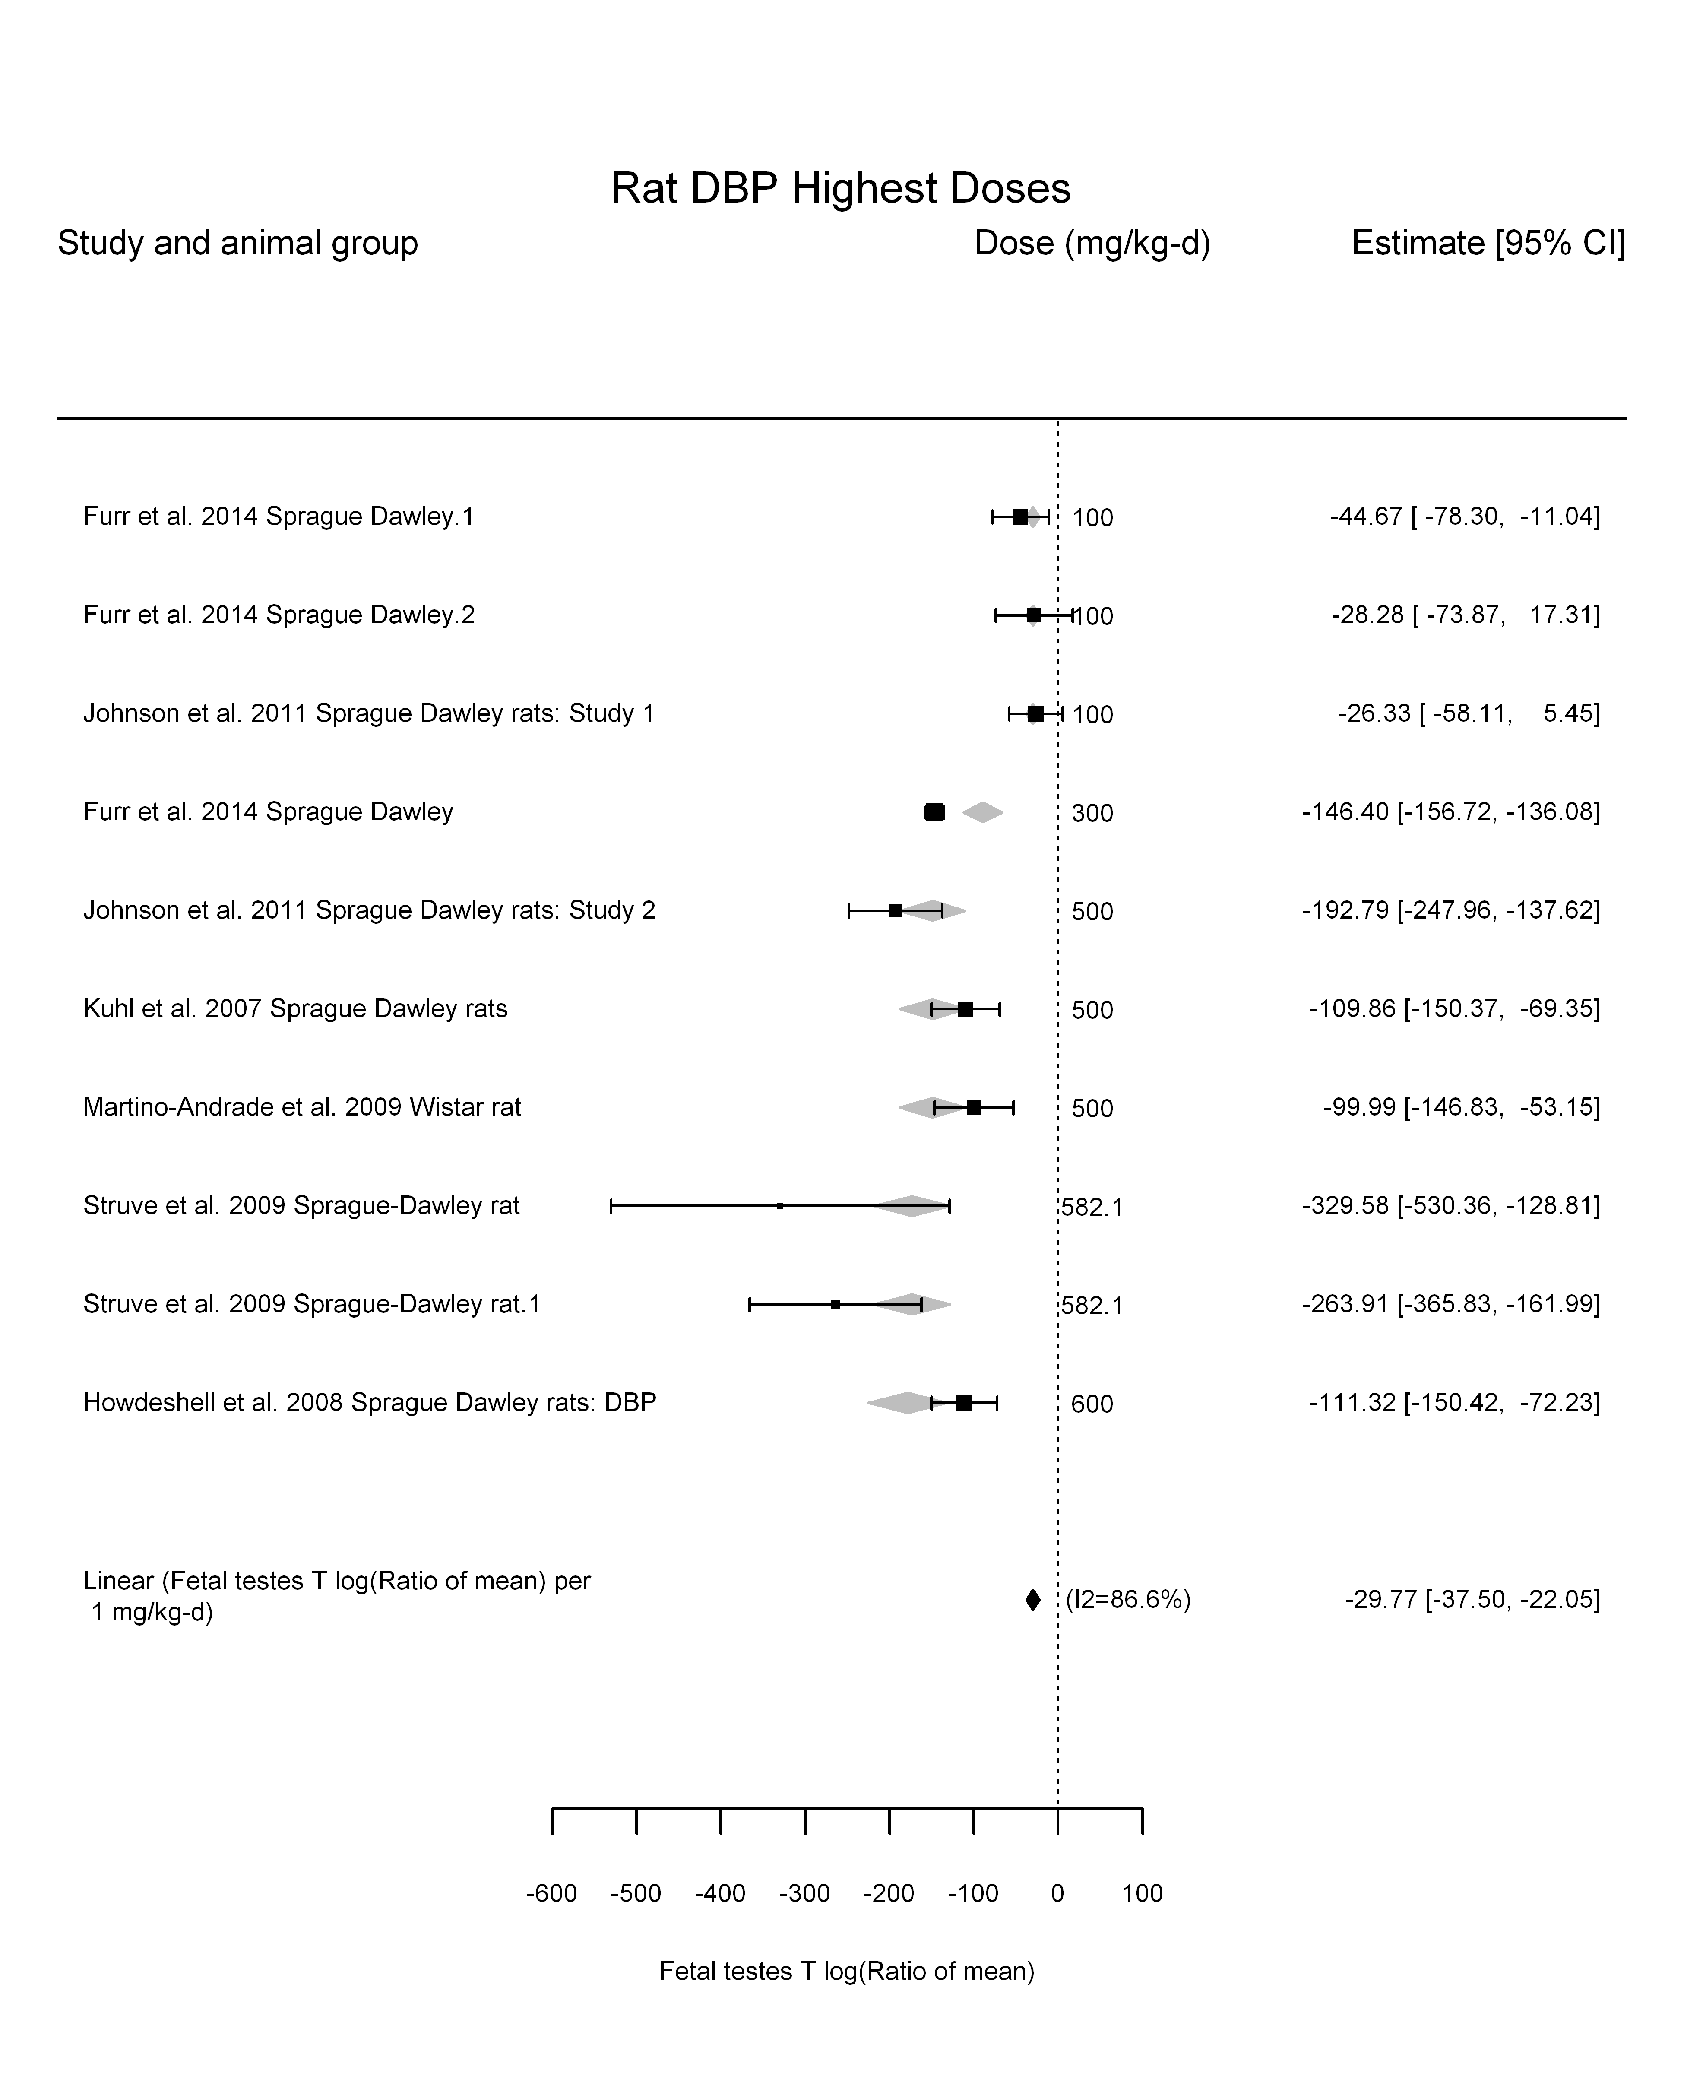

## [1] "LinearQuadratic---------------------"  
##   
## Mixed-Effects Model (k = 10; tau^2 estimator: REML)  
##   
## logLik deviance AIC BIC AICc   
## -43.8369 87.6737 93.6737 93.9120 99.6737   
##   
## tau^2 (estimated amount of residual heterogeneity): 1437.8540 (SE = 1032.6105)  
## tau (square root of estimated tau^2 value): 37.9190  
## I^2 (residual heterogeneity / unaccounted variability): 77.06%  
## H^2 (unaccounted variability / sampling variability): 4.36  
##   
## Test for Residual Heterogeneity:   
## QE(df = 8) = 31.0800, p-val = 0.0001  
##   
## Test of Moderators (coefficient(s) 1,2):   
## QM(df = 2) = 66.8735, p-val < .0001  
##   
## Model Results:  
##   
## estimate se zval pval ci.lb ci.ub   
## dose100 -49.9166 18.8261 -2.6515 0.0080 -86.8151 -13.0180 **  
## I(dose100^2) 3.9834 3.6017 1.1060 0.2687 -3.0758 11.0427   
##   
## ---  
## Signif. codes: 0 '***' 0.001 '**' 0.01 '*' 0.05 '.' 0.1 ' ' 1

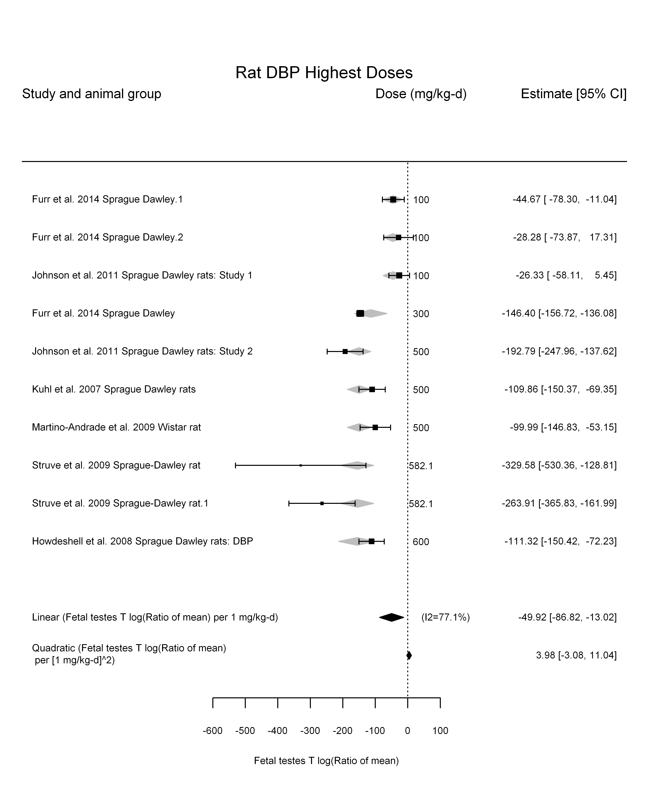

## [1] ""

## [1] ""  
## m ci.lb ci.ub bmr  
## 1 17.22809 13.67811 23.26663 -5.129329  
## m ci.lb ci.ub bmr  
## 1 171.5731 136.2192 231.7105 -51.08256

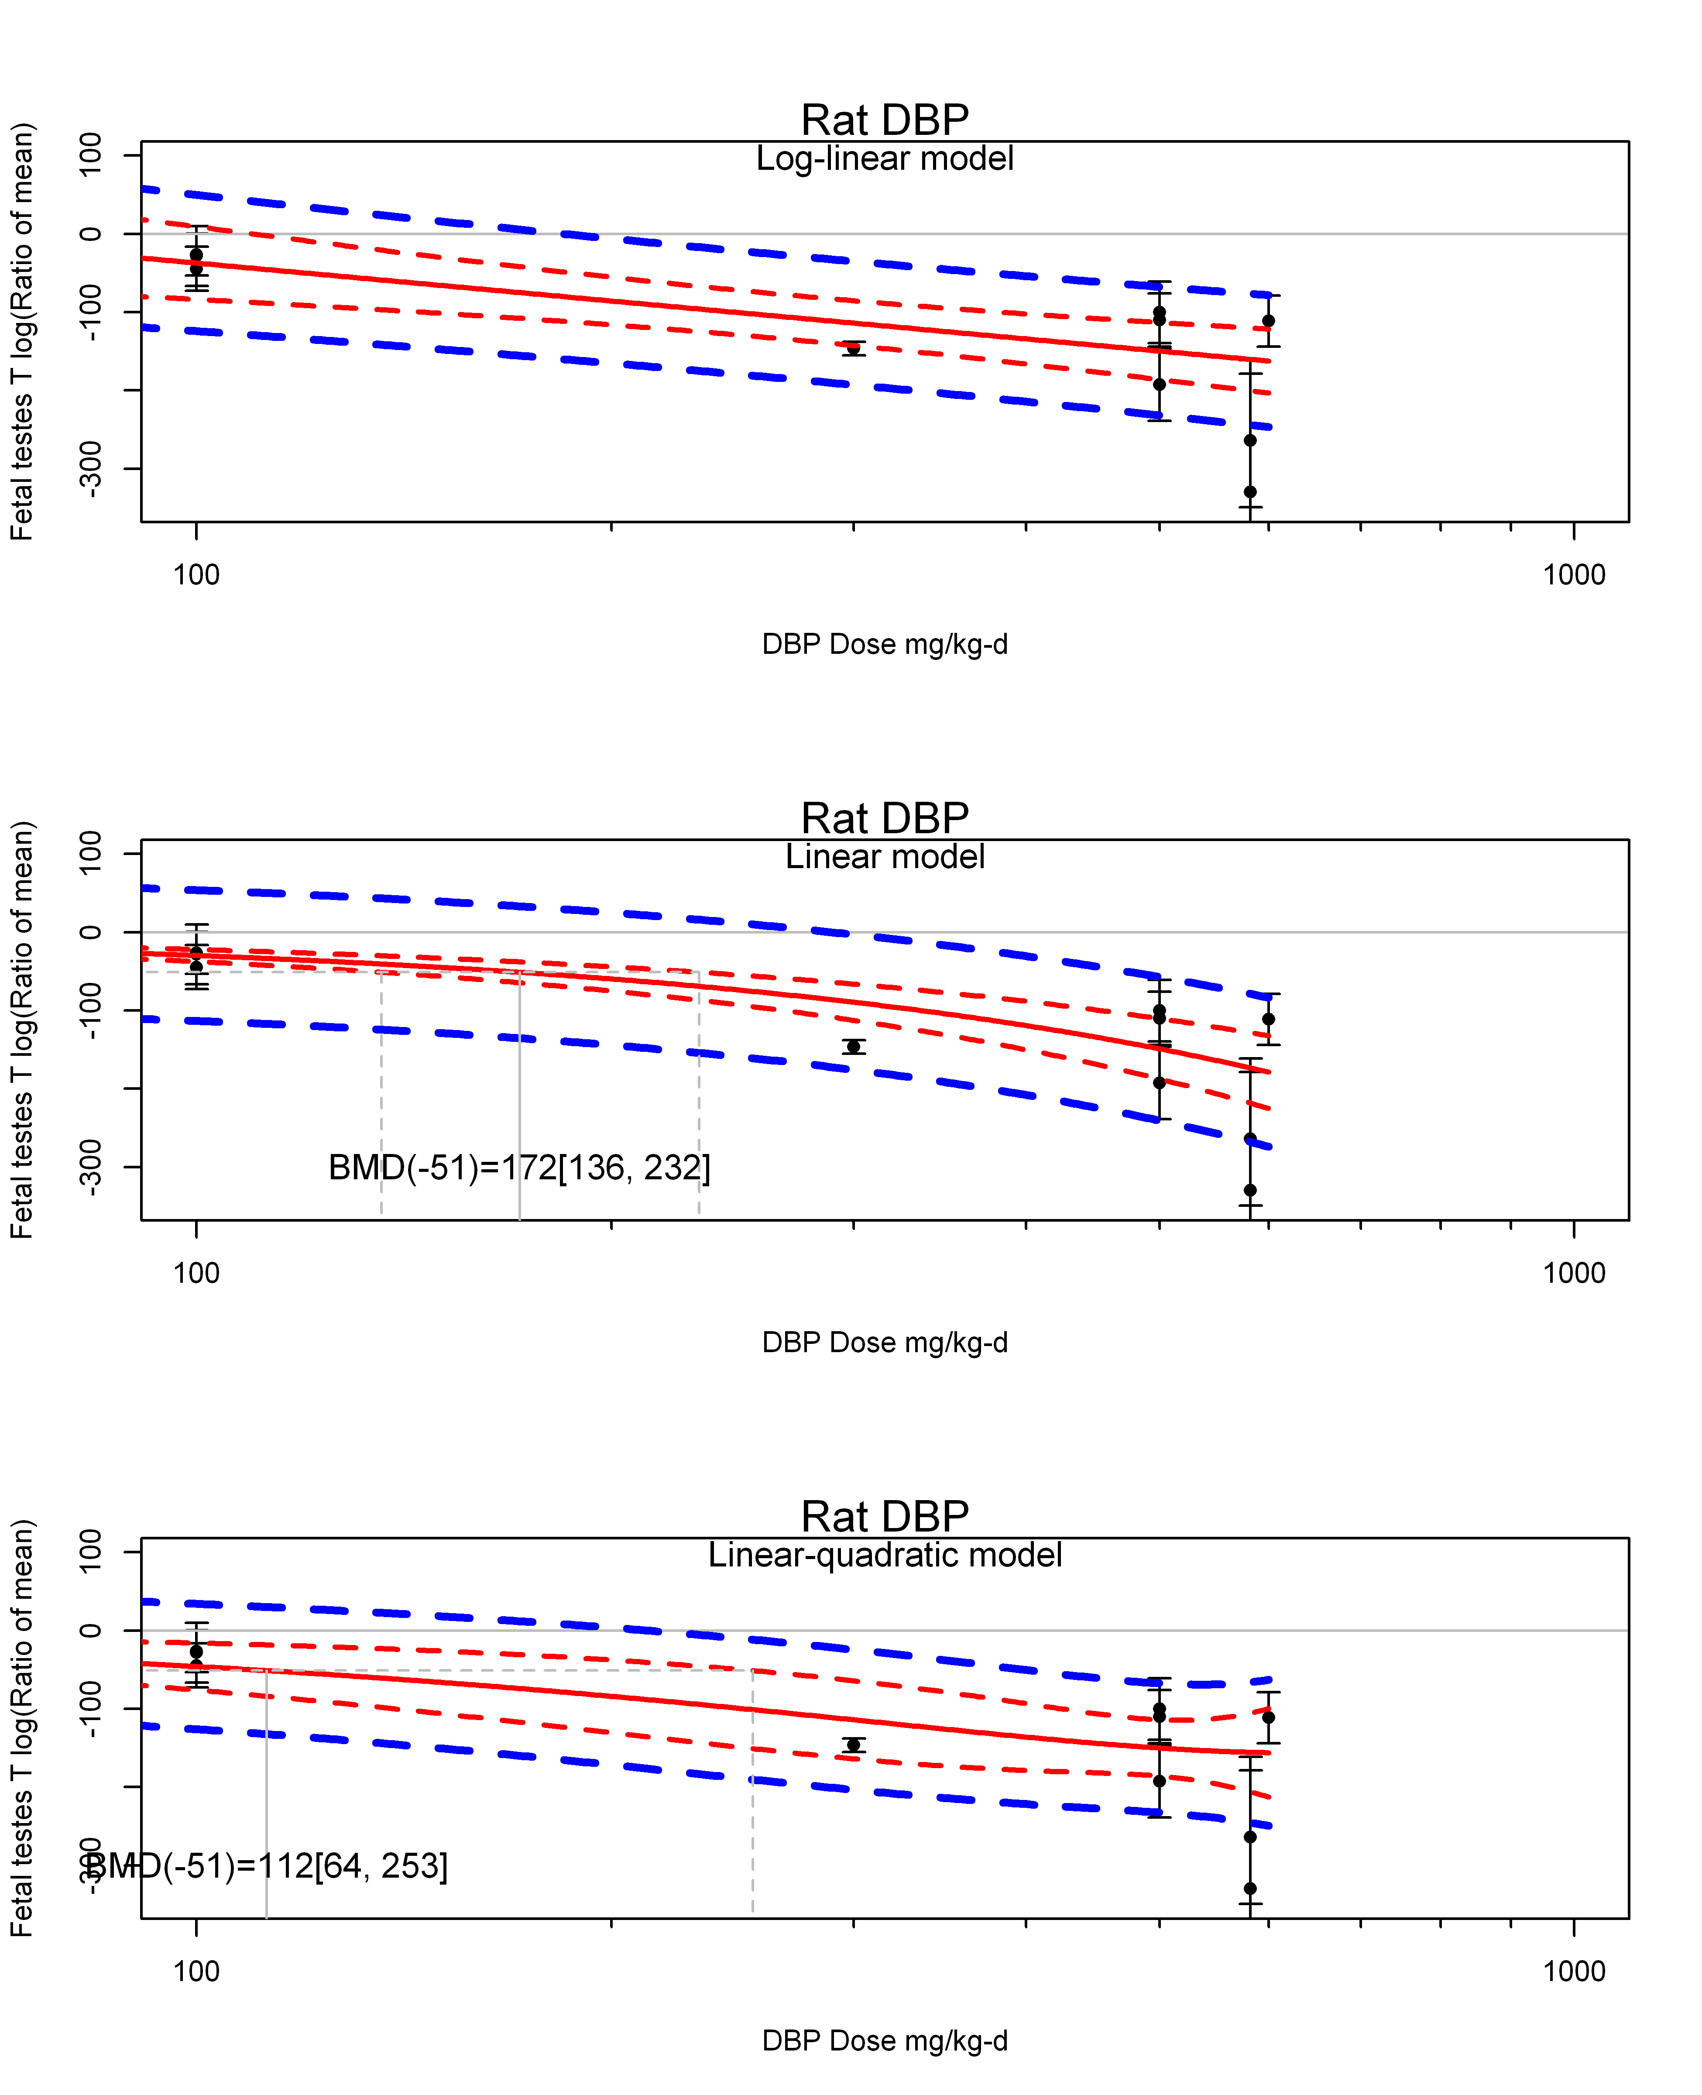

## [1] ""  
## m ci.lb ci.ub bmr  
## 1 10.36146 5.952834 36.41421 -5.129329  
## m ci.lb ci.ub bmr  
## 1 112.4213 63.97493 253.3109 -51.08256  
## [1] "Fetal testes T log(Ratio of mean) Mouse"  
## [1] "Fetal testes T log(Ratio of mean) Rat"  
## [1] "Overall---------------------"  
##   
## Random-Effects Model (k = 34; tau^2 estimator: REML)  
##   
## logLik deviance AIC BIC AICc   
## -191.2360 382.4719 386.4719 389.4649 386.8719   
##   
## tau^2 (estimated amount of total heterogeneity): 5892.3665 (SE = 1539.1523)  
## tau (square root of estimated tau^2 value): 76.7618  
## I^2 (total heterogeneity / total variability): 98.49%  
## H^2 (total variability / sampling variability): 66.03  
##   
## Test for Heterogeneity:   
## Q(df = 33) = 894.2912, p-val < .0001  
##   
## Model Results:  
##   
## estimate se zval pval ci.lb ci.ub   
## -110.1373 13.5679 -8.1175 <.0001 -136.7299 -83.5447 ***   
##   
## ---  
## Signif. codes: 0 '***' 0.001 '**' 0.01 '*' 0.05 '.' 0.1 ' ' 1

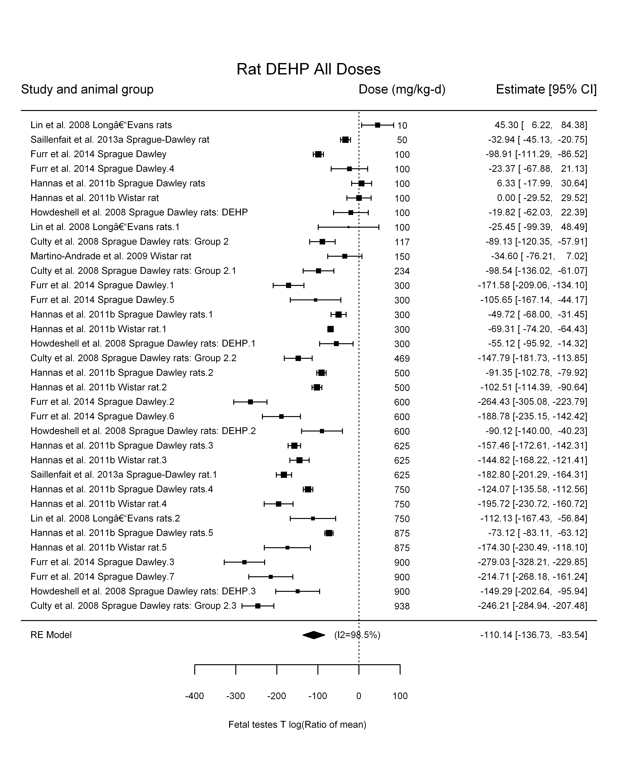

## [1] "Leave one out---------------------"  
##   
## Random-Effects Model (k = 30; tau^2 estimator: REML)  
##   
## tau^2 (estimated amount of total heterogeneity): 6031.6219 (SE = 1679.7743)  
## tau (square root of estimated tau^2 value): 77.6635  
## I^2 (total heterogeneity / total variability): 98.64%  
## H^2 (total variability / sampling variability): 73.70  
##   
## Test for Heterogeneity:   
## Q(df = 29) = 815.9367, p-val < .0001  
##   
## Model Results:  
##   
## estimate se zval pval ci.lb ci.ub   
## -105.4581 14.6105 -7.2180 <.0001 -134.0940 -76.8221 ***   
##   
## ---  
## Signif. codes: 0 '***' 0.001 '**' 0.01 '*' 0.05 '.' 0.1 ' ' 1   
##   
##   
## Random-Effects Model (k = 30; tau^2 estimator: REML)  
##   
## tau^2 (estimated amount of total heterogeneity): 6288.1291 (SE = 1739.2730)  
## tau (square root of estimated tau^2 value): 79.2977  
## I^2 (total heterogeneity / total variability): 98.72%  
## H^2 (total variability / sampling variability): 78.11  
##   
## Test for Heterogeneity:   
## Q(df = 29) = 876.8712, p-val < .0001  
##   
## Model Results:  
##   
## estimate se zval pval ci.lb ci.ub   
## -114.3444 14.8657 -7.6918 <.0001 -143.4807 -85.2081 ***   
##   
## ---  
## Signif. codes: 0 '***' 0.001 '**' 0.01 '*' 0.05 '.' 0.1 ' ' 1   
##   
##   
## Random-Effects Model (k = 31; tau^2 estimator: REML)  
##   
## tau^2 (estimated amount of total heterogeneity): 5460.4990 (SE = 1491.9024)  
## tau (square root of estimated tau^2 value): 73.8952  
## I^2 (total heterogeneity / total variability): 98.49%  
## H^2 (total variability / sampling variability): 66.34  
##   
## Test for Heterogeneity:   
## Q(df = 30) = 846.3912, p-val < .0001  
##   
## Model Results:  
##   
## estimate se zval pval ci.lb ci.ub   
## -117.2806 13.6588 -8.5864 <.0001 -144.0514 -90.5097 ***   
##   
## ---  
## Signif. codes: 0 '***' 0.001 '**' 0.01 '*' 0.05 '.' 0.1 ' ' 1   
##   
##   
## Random-Effects Model (k = 32; tau^2 estimator: REML)  
##   
## tau^2 (estimated amount of total heterogeneity): 5916.2341 (SE = 1599.1885)  
## tau (square root of estimated tau^2 value): 76.9171  
## I^2 (total heterogeneity / total variability): 98.40%  
## H^2 (total variability / sampling variability): 62.51  
##   
## Test for Heterogeneity:   
## Q(df = 31) = 715.2104, p-val < .0001  
##   
## Model Results:  
##   
## estimate se zval pval ci.lb ci.ub   
## -110.3097 14.0344 -7.8599 <.0001 -137.8166 -82.8027 ***   
##   
## ---  
## Signif. codes: 0 '***' 0.001 '**' 0.01 '*' 0.05 '.' 0.1 ' ' 1   
##   
##   
## Random-Effects Model (k = 22; tau^2 estimator: REML)  
##   
## tau^2 (estimated amount of total heterogeneity): 7196.0237 (SE = 2370.6553)  
## tau (square root of estimated tau^2 value): 84.8294  
## I^2 (total heterogeneity / total variability): 96.74%  
## H^2 (total variability / sampling variability): 30.66  
##   
## Test for Heterogeneity:   
## Q(df = 21) = 515.6922, p-val < .0001  
##   
## Model Results:  
##   
## estimate se zval pval ci.lb ci.ub   
## -117.5662 18.6922 -6.2896 <.0001 -154.2023 -80.9302 ***   
##   
## ---  
## Signif. codes: 0 '***' 0.001 '**' 0.01 '*' 0.05 '.' 0.1 ' ' 1   
##   
##   
## Random-Effects Model (k = 33; tau^2 estimator: REML)  
##   
## tau^2 (estimated amount of total heterogeneity): 5909.5291 (SE = 1566.6519)  
## tau (square root of estimated tau^2 value): 76.8735  
## I^2 (total heterogeneity / total variability): 98.52%  
## H^2 (total variability / sampling variability): 67.78  
##   
## Test for Heterogeneity:   
## Q(df = 32) = 888.1214, p-val < .0001  
##   
## Model Results:  
##   
## estimate se zval pval ci.lb ci.ub   
## -112.3967 13.7881 -8.1517 <.0001 -139.4209 -85.3726 ***   
##   
## ---  
## Signif. codes: 0 '***' 0.001 '**' 0.01 '*' 0.05 '.' 0.1 ' ' 1   
##   
##   
## Random-Effects Model (k = 26; tau^2 estimator: REML)  
##   
## tau^2 (estimated amount of total heterogeneity): 4495.5033 (SE = 1358.4897)  
## tau (square root of estimated tau^2 value): 67.0485  
## I^2 (total heterogeneity / total variability): 98.30%  
## H^2 (total variability / sampling variability): 58.75  
##   
## Test for Heterogeneity:   
## Q(df = 25) = 685.8455, p-val < .0001  
##   
## Model Results:  
##   
## estimate se zval pval ci.lb ci.ub   
## -92.9464 13.6033 -6.8327 <.0001 -119.6083 -66.2845 ***   
##   
## ---  
## Signif. codes: 0 '***' 0.001 '**' 0.01 '*' 0.05 '.' 0.1 ' ' 1   
##   
## [1] "Trend in log10(dose)---------------------"  
##   
## Mixed-Effects Model (k = 34; tau^2 estimator: REML)  
##   
## logLik deviance AIC BIC AICc   
## -171.2674 342.5348 348.5348 352.9320 349.3920   
##   
## tau^2 (estimated amount of residual heterogeneity): 2278.8316 (SE = 652.8308)  
## tau (square root of estimated tau^2 value): 47.7371  
## I^2 (residual heterogeneity / unaccounted variability): 96.06%  
## H^2 (unaccounted variability / sampling variability): 25.39  
## R^2 (amount of heterogeneity accounted for): 61.33%  
##   
## Test for Residual Heterogeneity:   
## QE(df = 32) = 575.3838, p-val < .0001  
##   
## Test of Moderators (coefficient(s) 2):   
## QM(df = 1) = 46.4497, p-val < .0001  
##   
## Model Results:  
##   
## estimate se zval pval ci.lb ci.ub   
## intrcpt 221.6650 49.3595 4.4908 <.0001 124.9221 318.4079 ***  
## log10(dose) -132.8275 19.4893 -6.8154 <.0001 -171.0259 -94.6291 ***  
##   
## ---  
## Signif. codes: 0 '***' 0.001 '**' 0.01 '*' 0.05 '.' 0.1 ' ' 1

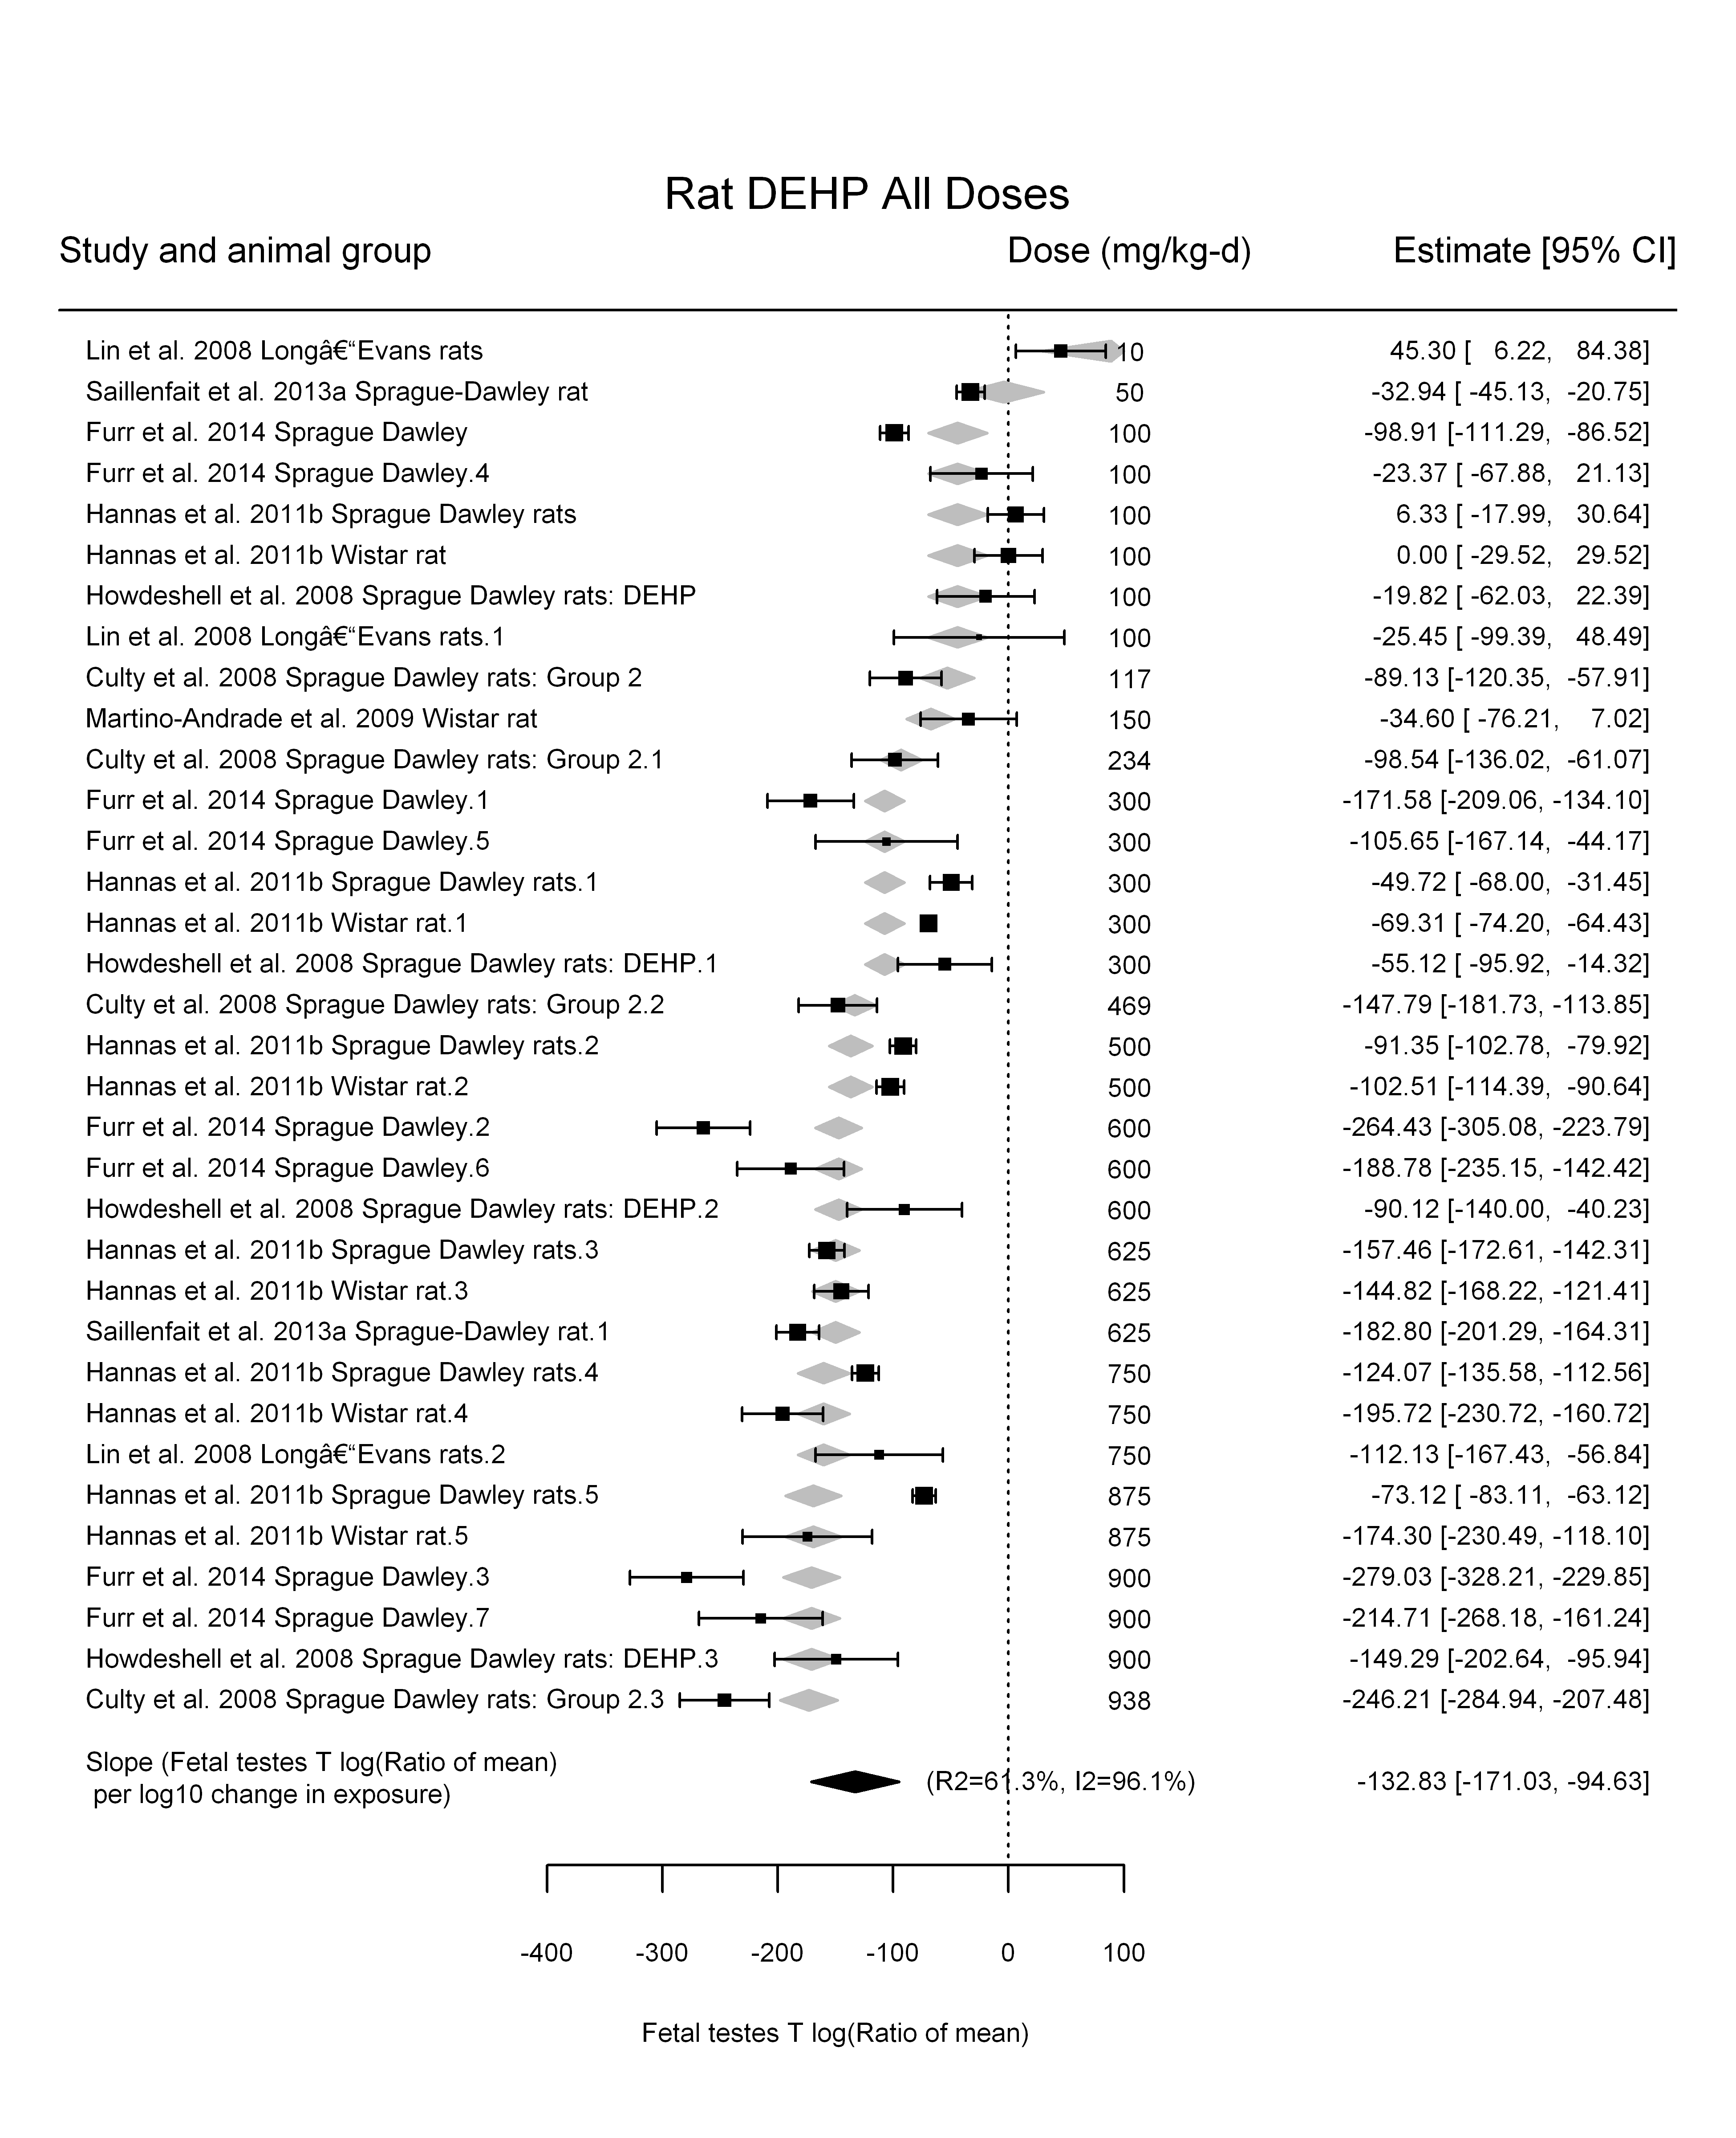

## [1] "Linear---------------------"  
##   
## Mixed-Effects Model (k = 34; tau^2 estimator: REML)  
##   
## logLik deviance AIC BIC AICc   
## -176.9590 353.9180 357.9180 360.9110 358.3180   
##   
## tau^2 (estimated amount of residual heterogeneity): 2354.0365 (SE = 661.1852)  
## tau (square root of estimated tau^2 value): 48.5184  
## I^2 (residual heterogeneity / unaccounted variability): 96.55%  
## H^2 (unaccounted variability / sampling variability): 29.01  
##   
## Test for Residual Heterogeneity:   
## QE(df = 33) = 808.8381, p-val < .0001  
##   
## Model Results:  
##   
## estimate se zval pval ci.lb ci.ub   
## dose100 -23.0059 1.6509 -13.9355 <.0001 -26.2416 -19.7702 ***  
##   
## ---  
## Signif. codes: 0 '***' 0.001 '**' 0.01 '*' 0.05 '.' 0.1 ' ' 1

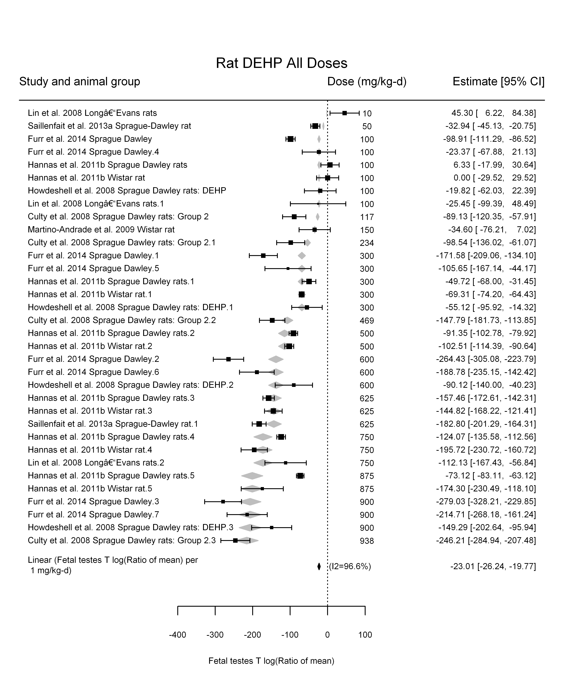

## [1] "LinearQuadratic---------------------"  
##   
## Mixed-Effects Model (k = 34; tau^2 estimator: REML)  
##   
## logLik deviance AIC BIC AICc   
## -170.5776 341.1552 347.1552 351.5524 348.0123   
##   
## tau^2 (estimated amount of residual heterogeneity): 2182.5721 (SE = 627.8910)  
## tau (square root of estimated tau^2 value): 46.7180  
## I^2 (residual heterogeneity / unaccounted variability): 95.49%  
## H^2 (unaccounted variability / sampling variability): 22.16  
##   
## Test for Residual Heterogeneity:   
## QE(df = 32) = 559.3346, p-val < .0001  
##   
## Test of Moderators (coefficient(s) 1,2):   
## QM(df = 2) = 210.2190, p-val < .0001  
##   
## Model Results:  
##   
## estimate se zval pval ci.lb ci.ub   
## dose100 -34.2277 6.5243 -5.2462 <.0001 -47.0151 -21.4403 ***  
## I(dose100^2) 1.5265 0.8596 1.7758 0.0758 -0.1583 3.2114 .  
##   
## ---  
## Signif. codes: 0 '***' 0.001 '**' 0.01 '*' 0.05 '.' 0.1 ' ' 1

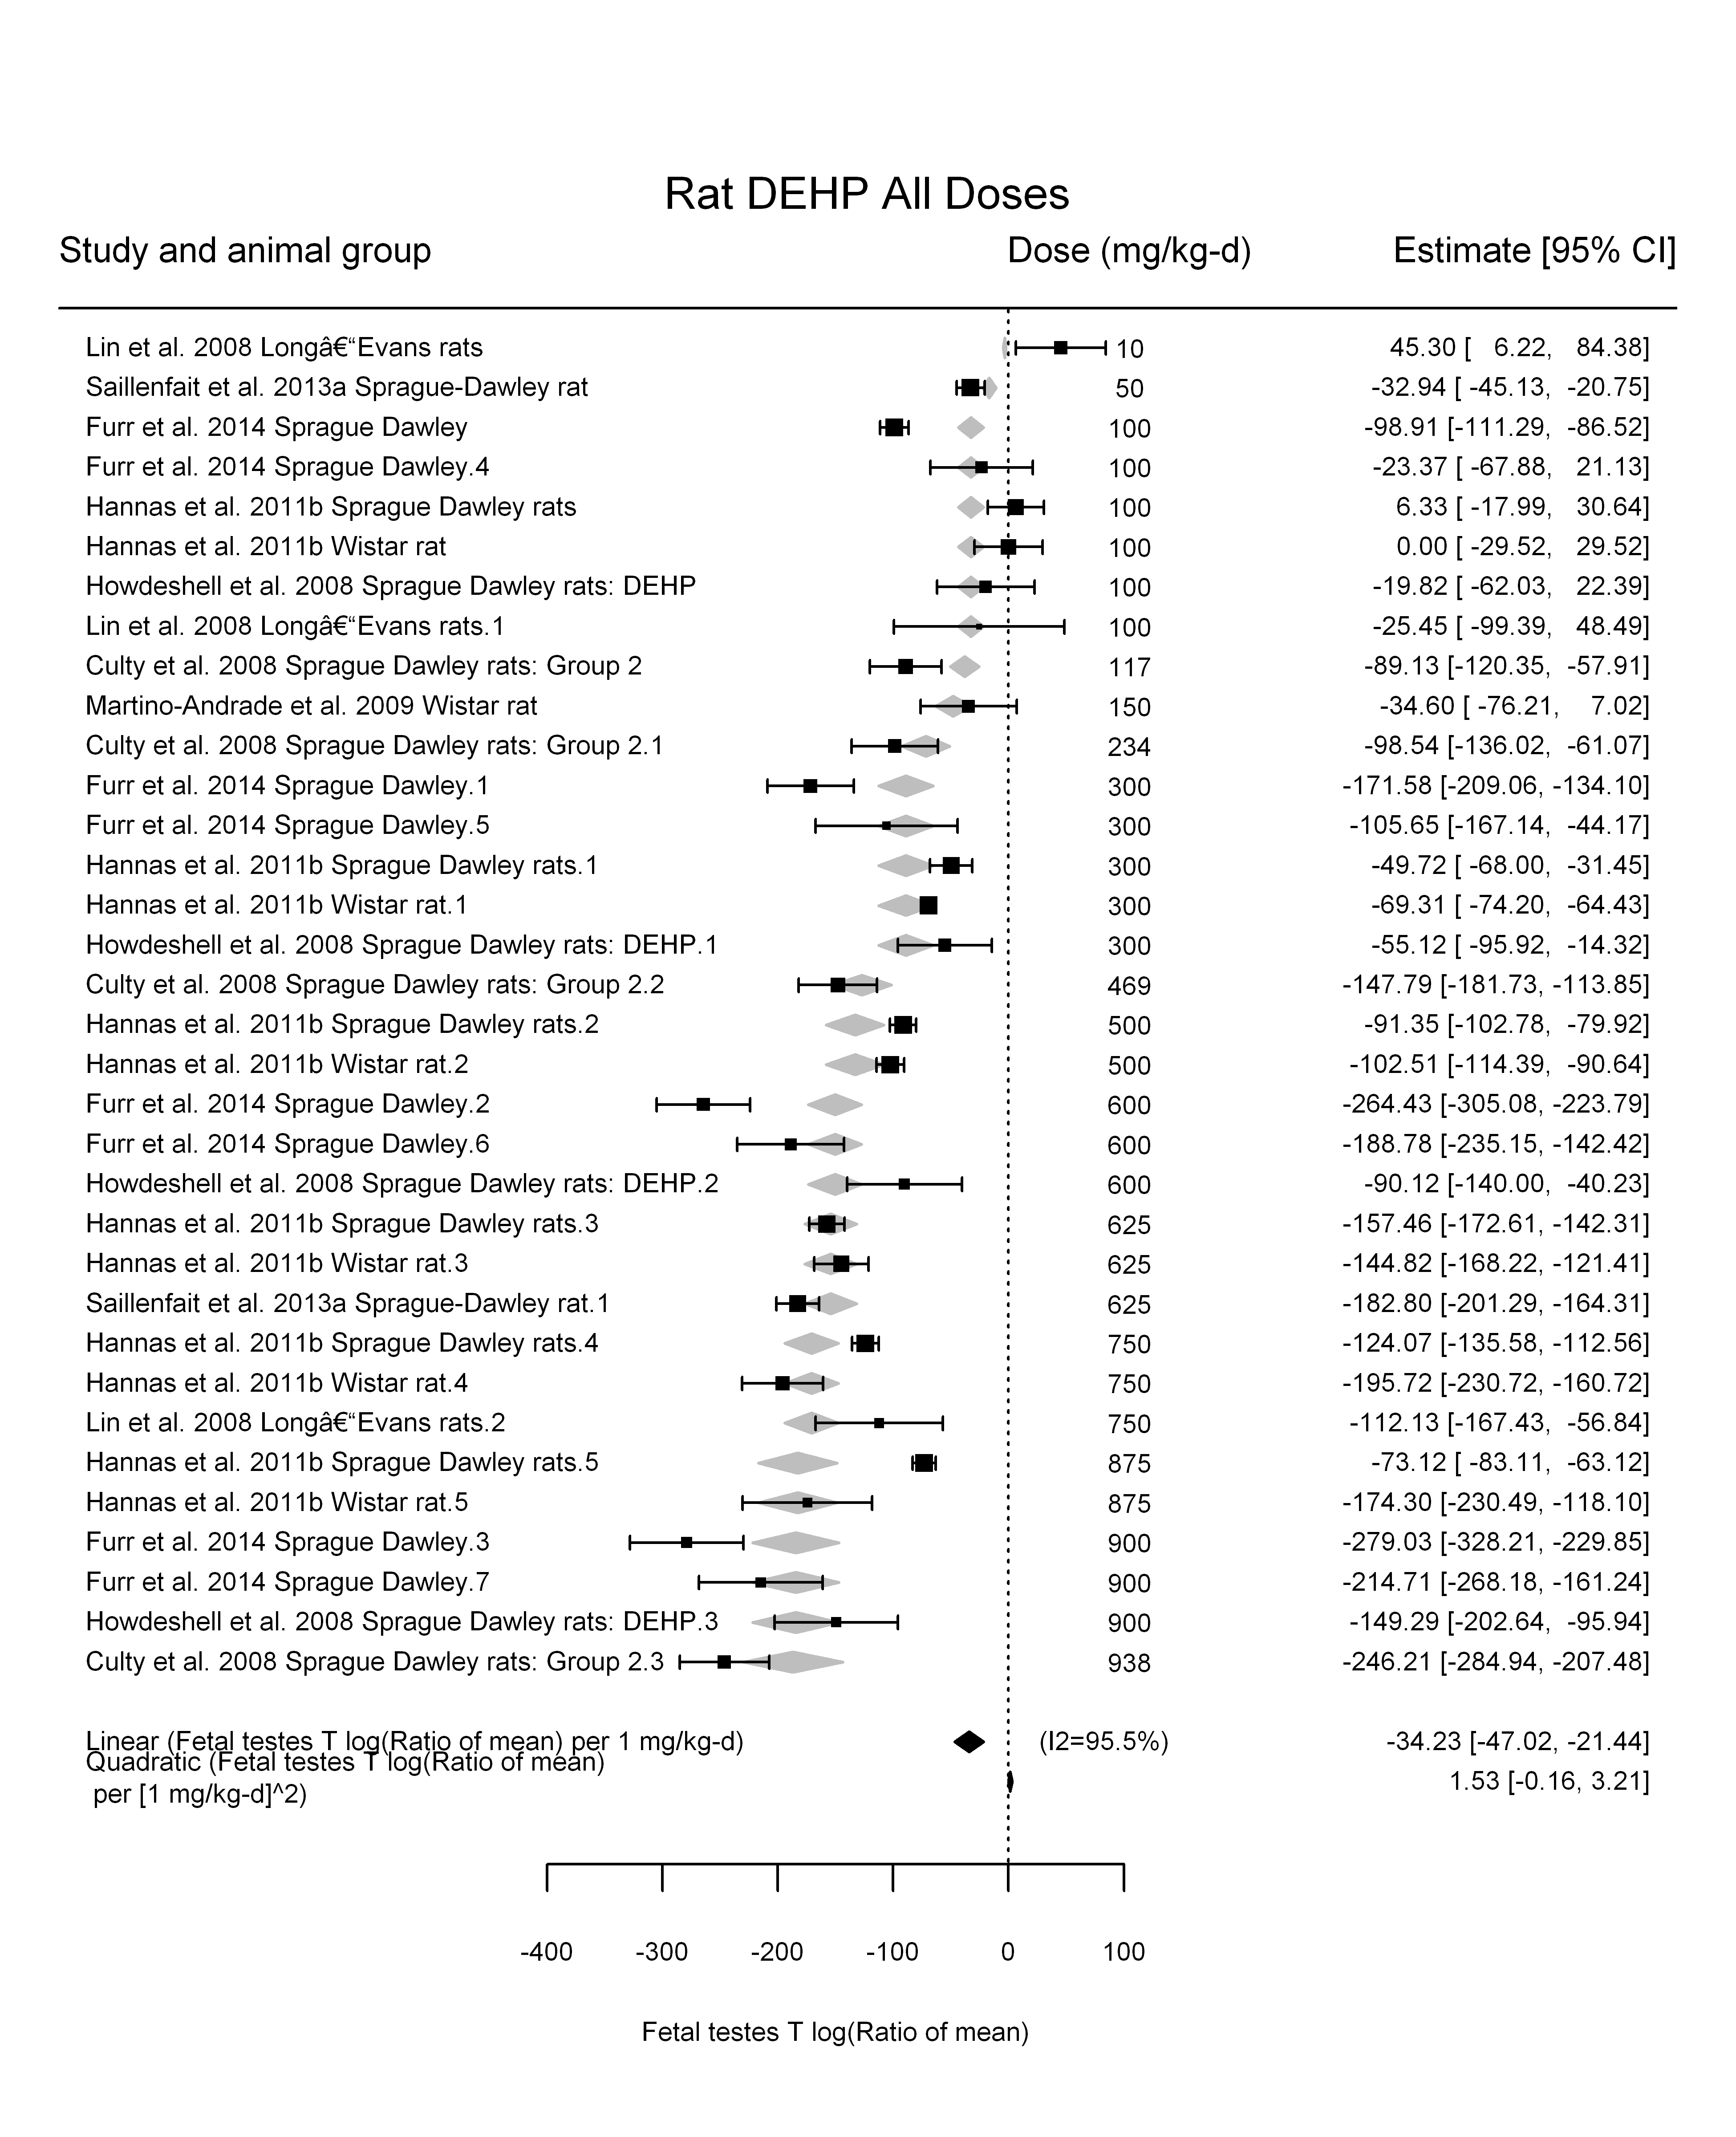

## [1] ""

## [1] ""  
## m ci.lb ci.ub bmr  
## 1 22.29563 19.54654 25.9446 -5.129329  
## m ci.lb ci.ub bmr  
## 1 222.0399 194.6614 258.3803 -51.08256

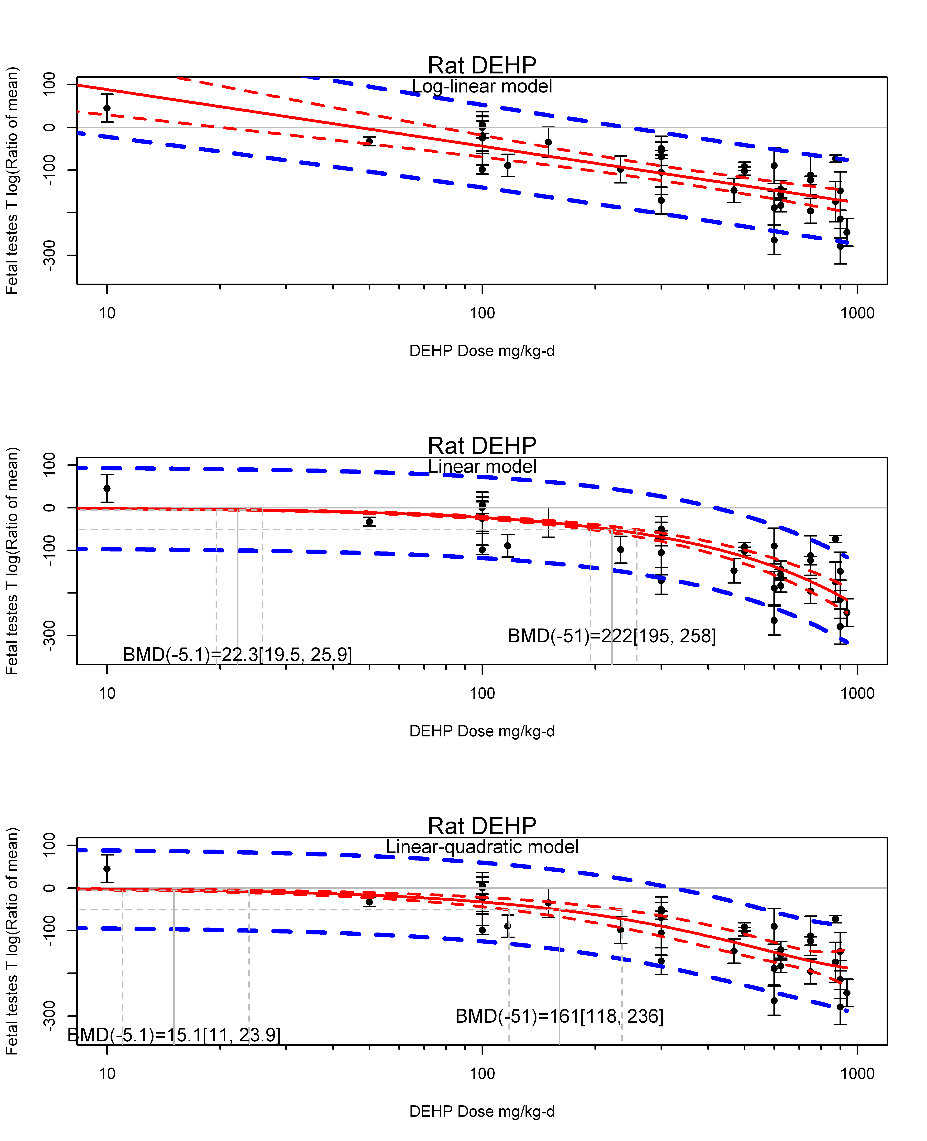

## [1] ""  
## m ci.lb ci.ub bmr  
## 1 15.08738 10.99112 23.89559 -5.129329  
## m ci.lb ci.ub bmr  
## 1 160.7703 117.9791 236.056 -51.08256  
## [1] "Fetal testes T log(Ratio of mean) Rat Highest Dose"  
## [1] "Overall---------------------"  
##   
## Random-Effects Model (k = 9; tau^2 estimator: REML)  
##   
## logLik deviance AIC BIC AICc   
## -46.4282 92.8563 96.8563 97.0152 99.2563   
##   
## tau^2 (estimated amount of total heterogeneity): 5986.5558 (SE = 3245.3374)  
## tau (square root of estimated tau^2 value): 77.3728  
## I^2 (total heterogeneity / total variability): 96.29%  
## H^2 (total variability / sampling variability): 26.94  
##   
## Test for Heterogeneity:   
## Q(df = 8) = 238.9493, p-val < .0001  
##   
## Model Results:  
##   
## estimate se zval pval ci.lb ci.ub   
## -162.1002 26.8633 -6.0343 <.0001 -214.7514 -109.4491 ***   
##   
## ---  
## Signif. codes: 0 '***' 0.001 '**' 0.01 '*' 0.05 '.' 0.1 ' ' 1

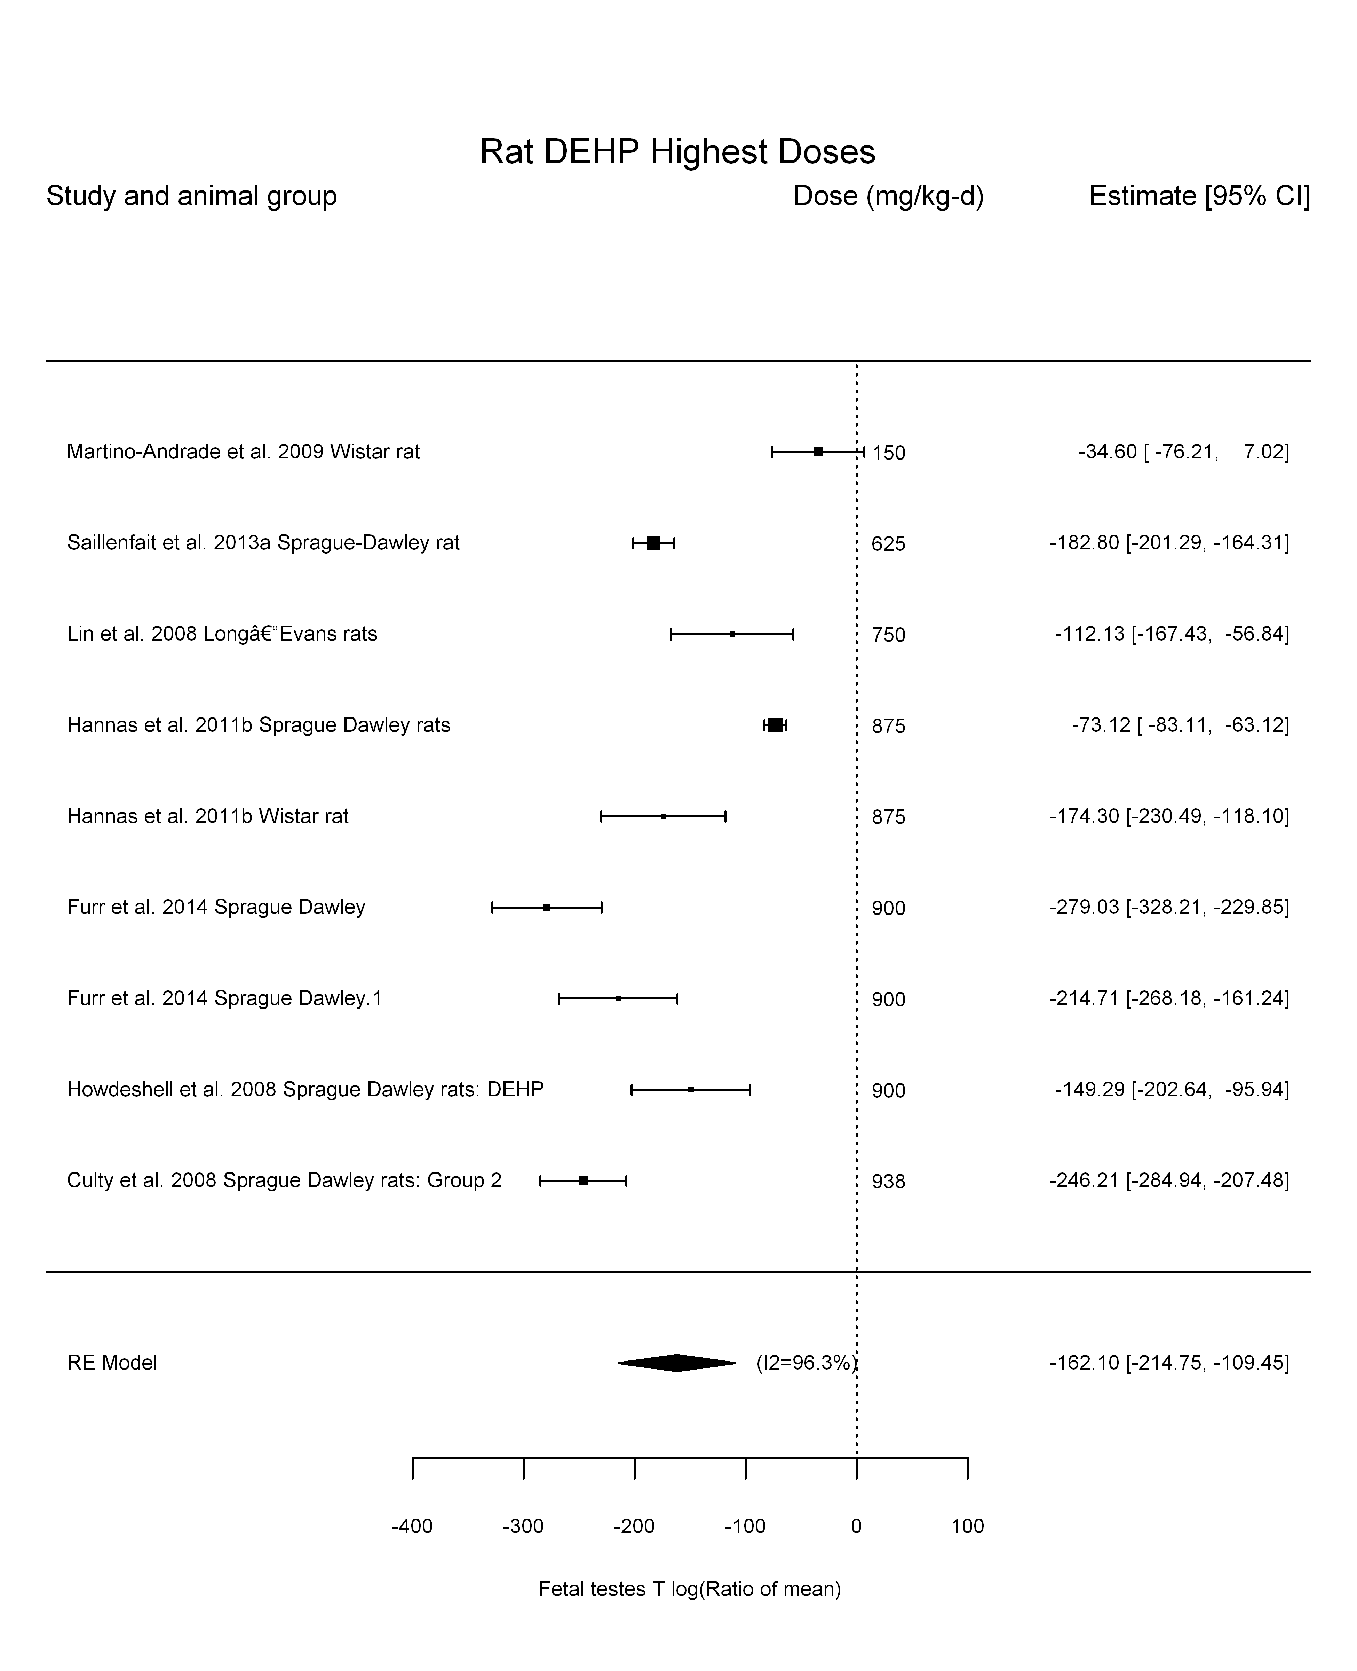

## [1] "Trend in log10(dose)---------------------"  
##   
## Mixed-Effects Model (k = 9; tau^2 estimator: REML)  
##   
## logLik deviance AIC BIC AICc   
## -39.3888 78.7776 84.7776 84.6153 92.7776   
##   
## tau^2 (estimated amount of residual heterogeneity): 4171.2912 (SE = 2498.3998)  
## tau (square root of estimated tau^2 value): 64.5855  
## I^2 (residual heterogeneity / unaccounted variability): 94.51%  
## H^2 (unaccounted variability / sampling variability): 18.22  
## R^2 (amount of heterogeneity accounted for): 30.32%  
##   
## Test for Residual Heterogeneity:   
## QE(df = 7) = 238.2361, p-val < .0001  
##   
## Test of Moderators (coefficient(s) 2):   
## QM(df = 1) = 4.2941, p-val = 0.0382  
##   
## Model Results:  
##   
## estimate se zval pval ci.lb ci.ub   
## intrcpt 392.8275 268.5992 1.4625 0.1436 -133.6173 919.2723   
## log10(dose) -195.3819 94.2866 -2.0722 0.0382 -380.1803 -10.5835 *  
##   
## ---  
## Signif. codes: 0 '***' 0.001 '**' 0.01 '*' 0.05 '.' 0.1 ' ' 1

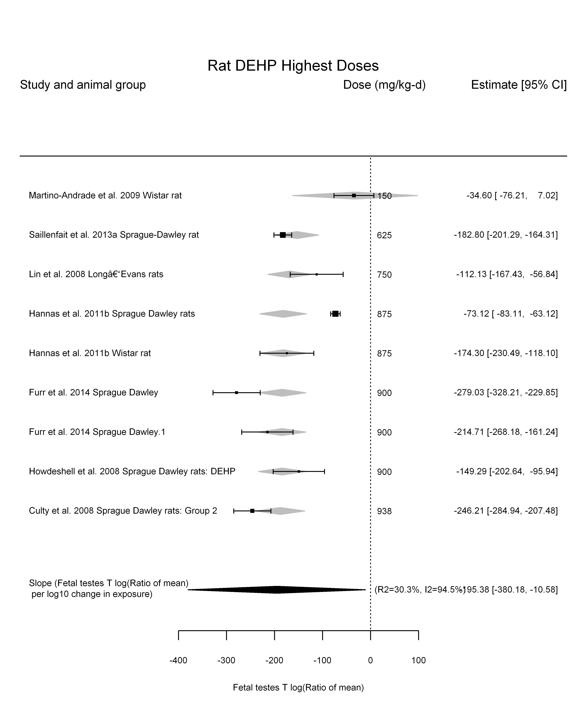

## [1] "Linear---------------------"  
##   
## Mixed-Effects Model (k = 9; tau^2 estimator: REML)  
##   
## logLik deviance AIC BIC AICc   
## -44.4476 88.8951 92.8951 93.0540 95.2951   
##   
## tau^2 (estimated amount of residual heterogeneity): 3619.9062 (SE = 2055.1794)  
## tau (square root of estimated tau^2 value): 60.1657  
## I^2 (residual heterogeneity / unaccounted variability): 93.59%  
## H^2 (unaccounted variability / sampling variability): 15.60  
##   
## Test for Residual Heterogeneity:   
## QE(df = 8) = 279.7300, p-val < .0001  
##   
## Model Results:  
##   
## estimate se zval pval ci.lb ci.ub   
## dose100 -21.0265 2.6708 -7.8728 <.0001 -26.2611 -15.7919 ***  
##   
## ---  
## Signif. codes: 0 '***' 0.001 '**' 0.01 '*' 0.05 '.' 0.1 ' ' 1

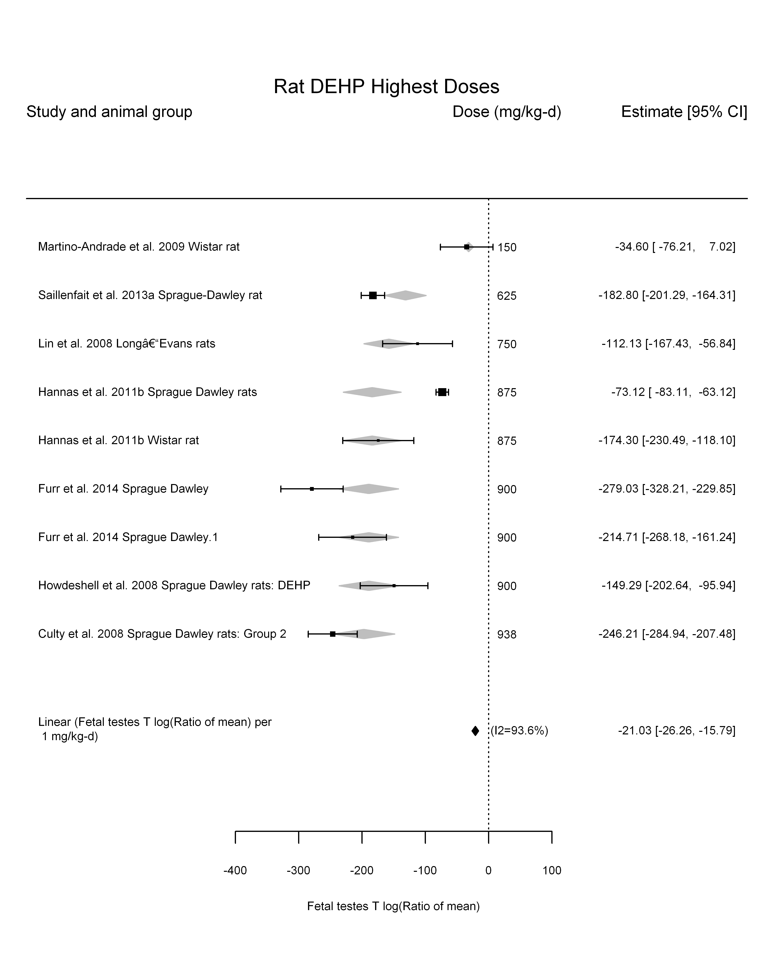

## [1] "LinearQuadratic---------------------"  
##   
## Mixed-Effects Model (k = 9; tau^2 estimator: REML)  
##   
## logLik deviance AIC BIC AICc   
## -39.3550 78.7100 84.7100 84.5477 92.7100   
##   
## tau^2 (estimated amount of residual heterogeneity): 4168.8060 (SE = 2507.5741)  
## tau (square root of estimated tau^2 value): 64.5663  
## I^2 (residual heterogeneity / unaccounted variability): 92.67%  
## H^2 (unaccounted variability / sampling variability): 13.65  
##   
## Test for Residual Heterogeneity:   
## QE(df = 7) = 202.0997, p-val < .0001  
##   
## Test of Moderators (coefficient(s) 1,2):   
## QM(df = 2) = 54.7938, p-val < .0001  
##   
## Model Results:  
##   
## estimate se zval pval ci.lb ci.ub   
## dose100 -21.8708 26.2241 -0.8340 0.4043 -73.2691 29.5275   
## I(dose100^2) 0.0961 3.0241 0.0318 0.9747 -5.8310 6.0232   
##   
## ---  
## Signif. codes: 0 '***' 0.001 '**' 0.01 '*' 0.05 '.' 0.1 ' ' 1

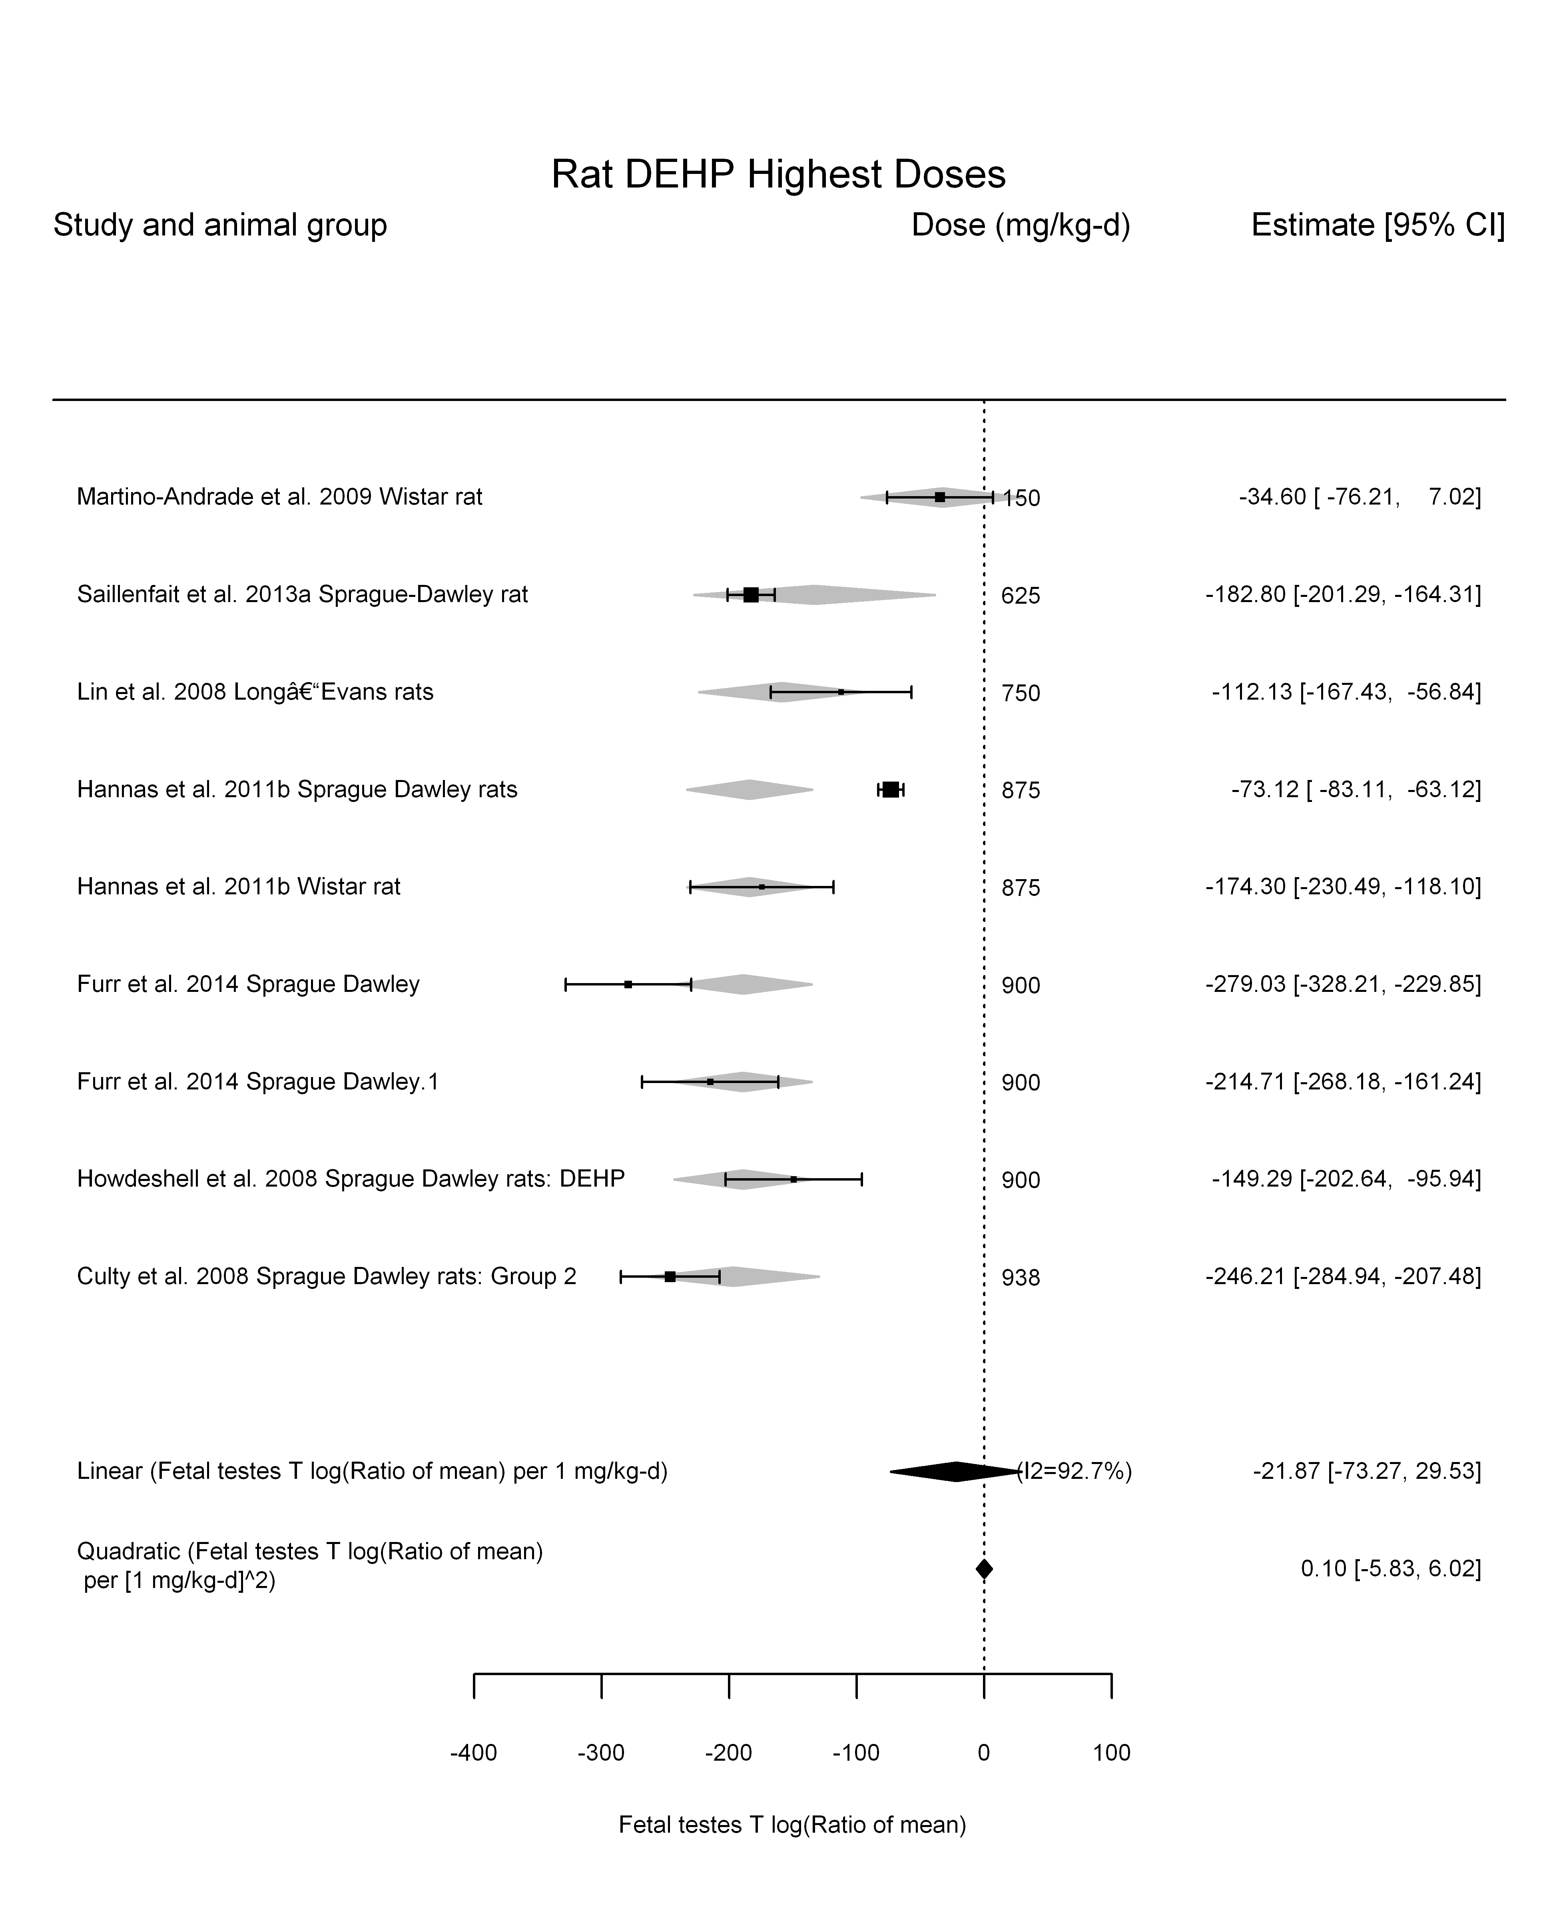

## [1] ""

## [1] ""  
## m ci.lb ci.ub bmr  
## 1 24.39451 19.53199 32.4808 -5.129329  
## m ci.lb ci.ub bmr  
## 1 242.9432 194.5171 323.4723 -51.08256

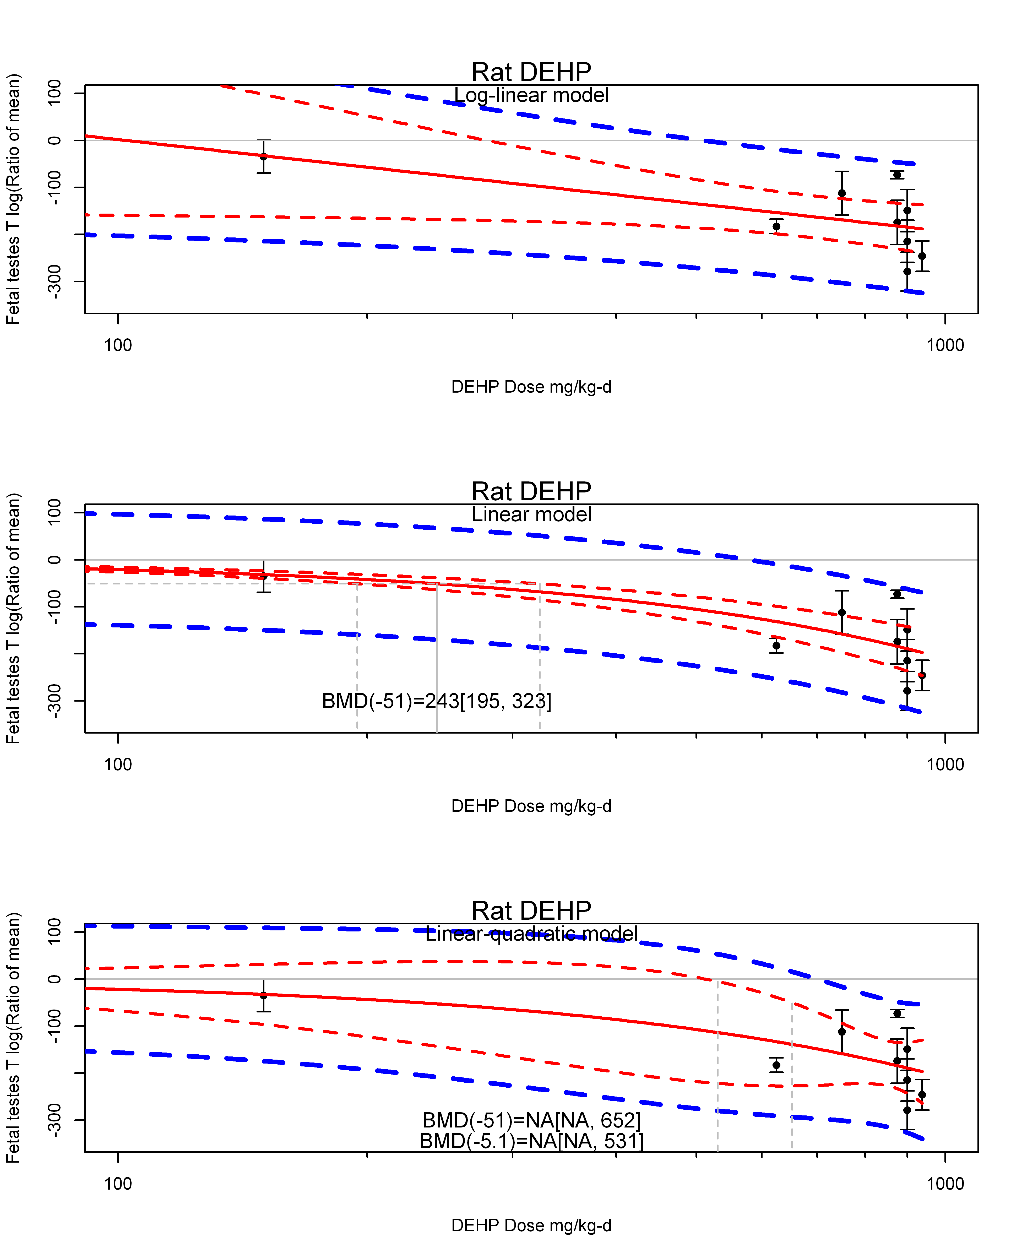

## [1] ""  
## m ci.lb ci.ub bmr  
## 1 NA NA 531.0622 -5.129329  
## m ci.lb ci.ub bmr  
## 1 NA NA 652.4565 -51.08256  
## [1] "Fetal testes T log(Ratio of mean) Mouse"  
## [1] "Fetal testes T log(Ratio of mean) Rat"  
## [1] "Overall---------------------"  
##   
## Random-Effects Model (k = 31; tau^2 estimator: REML)  
##   
## logLik deviance AIC BIC AICc   
## -173.6566 347.3132 351.3132 354.1156 351.7577   
##   
## tau^2 (estimated amount of total heterogeneity): 5814.4603 (SE = 1600.8038)  
## tau (square root of estimated tau^2 value): 76.2526  
## I^2 (total heterogeneity / total variability): 98.14%  
## H^2 (total variability / sampling variability): 53.80  
##   
## Test for Heterogeneity:   
## Q(df = 30) = 2729.7338, p-val < .0001  
##   
## Model Results:  
##   
## estimate se zval pval ci.lb ci.ub   
## -92.5695 14.1627 -6.5361 <.0001 -120.3279 -64.8110 ***   
##   
## ---  
## Signif. codes: 0 '***' 0.001 '**' 0.01 '*' 0.05 '.' 0.1 ' ' 1

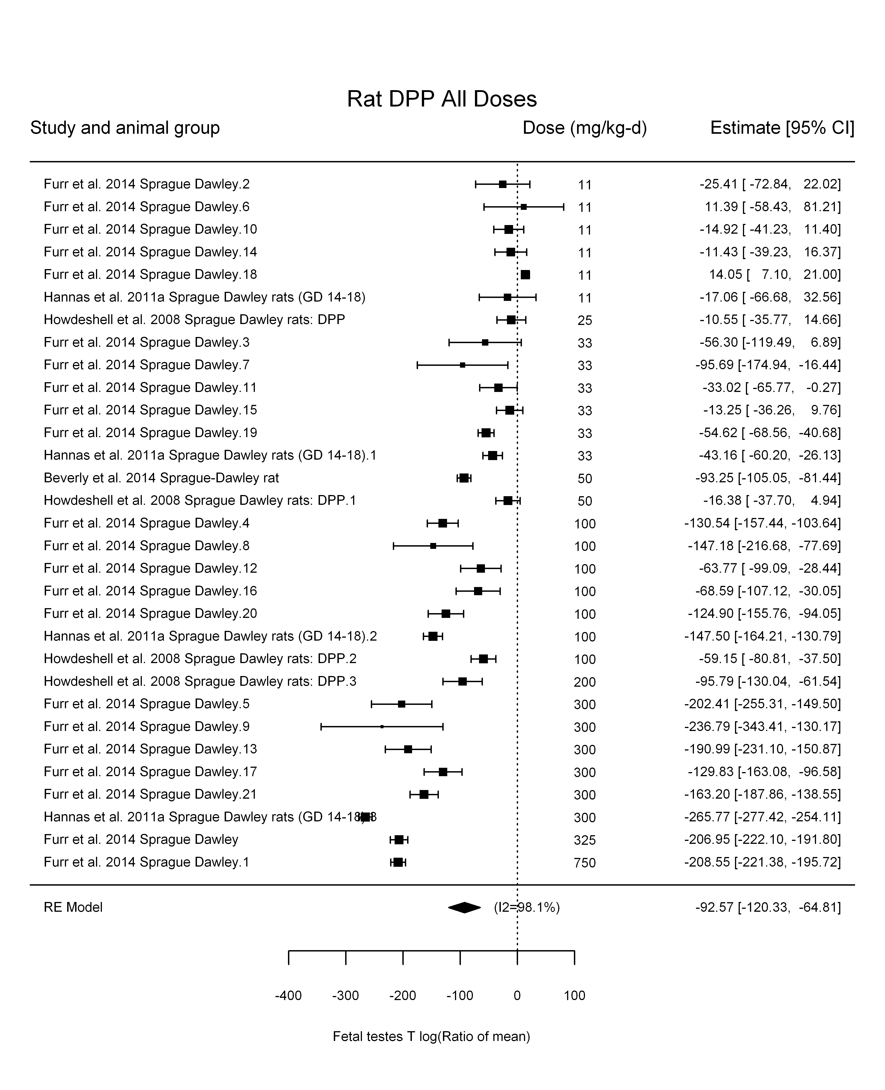

## [1] "Leave one out---------------------"  
##   
## Random-Effects Model (k = 27; tau^2 estimator: REML)  
##   
## tau^2 (estimated amount of total heterogeneity): 6182.5326 (SE = 1831.7245)  
## tau (square root of estimated tau^2 value): 78.6291  
## I^2 (total heterogeneity / total variability): 98.31%  
## H^2 (total variability / sampling variability): 59.04  
##   
## Test for Heterogeneity:   
## Q(df = 26) = 2640.3644, p-val < .0001  
##   
## Model Results:  
##   
## estimate se zval pval ci.lb ci.ub   
## -99.9267 15.6628 -6.3799 <.0001 -130.6253 -69.2282 ***   
##   
## ---  
## Signif. codes: 0 '***' 0.001 '**' 0.01 '*' 0.05 '.' 0.1 ' ' 1   
##   
##   
## Random-Effects Model (k = 30; tau^2 estimator: REML)  
##   
## tau^2 (estimated amount of total heterogeneity): 6039.2091 (SE = 1691.0343)  
## tau (square root of estimated tau^2 value): 77.7123  
## I^2 (total heterogeneity / total variability): 98.07%  
## H^2 (total variability / sampling variability): 51.89  
##   
## Test for Heterogeneity:   
## Q(df = 29) = 2728.5022, p-val < .0001  
##   
## Model Results:  
##   
## estimate se zval pval ci.lb ci.ub   
## -92.5692 14.6712 -6.3096 <.0001 -121.3242 -63.8143 ***   
##   
## ---  
## Signif. codes: 0 '***' 0.001 '**' 0.01 '*' 0.05 '.' 0.1 ' ' 1   
##   
##   
## Random-Effects Model (k = 27; tau^2 estimator: REML)  
##   
## tau^2 (estimated amount of total heterogeneity): 5018.8789 (SE = 1505.1217)  
## tau (square root of estimated tau^2 value): 70.8440  
## I^2 (total heterogeneity / total variability): 97.62%  
## H^2 (total variability / sampling variability): 42.08  
##   
## Test for Heterogeneity:   
## Q(df = 26) = 1631.9644, p-val < .0001  
##   
## Model Results:  
##   
## estimate se zval pval ci.lb ci.ub   
## -88.0233 14.2051 -6.1966 <.0001 -115.8648 -60.1818 ***   
##   
## ---  
## Signif. codes: 0 '***' 0.001 '**' 0.01 '*' 0.05 '.' 0.1 ' ' 1   
##   
##   
## Random-Effects Model (k = 9; tau^2 estimator: REML)  
##   
## tau^2 (estimated amount of total heterogeneity): 6712.0123 (SE = 3440.3344)  
## tau (square root of estimated tau^2 value): 81.9269  
## I^2 (total heterogeneity / total variability): 98.71%  
## H^2 (total variability / sampling variability): 77.53  
##   
## Test for Heterogeneity:   
## Q(df = 8) = 919.0614, p-val < .0001  
##   
## Model Results:  
##   
## estimate se zval pval ci.lb ci.ub   
## -84.0104 27.6527 -3.0380 0.0024 -138.2088 -29.8120 **   
##   
## ---  
## Signif. codes: 0 '***' 0.001 '**' 0.01 '*' 0.05 '.' 0.1 ' ' 1   
##   
## [1] "Trend in log10(dose)---------------------"  
##   
## Mixed-Effects Model (k = 31; tau^2 estimator: REML)  
##   
## logLik deviance AIC BIC AICc   
## -146.7664 293.5328 299.5328 303.6347 300.4928   
##   
## tau^2 (estimated amount of residual heterogeneity): 1175.7722 (SE = 384.3439)  
## tau (square root of estimated tau^2 value): 34.2895  
## I^2 (residual heterogeneity / unaccounted variability): 90.42%  
## H^2 (unaccounted variability / sampling variability): 10.44  
## R^2 (amount of heterogeneity accounted for): 79.78%  
##   
## Test for Residual Heterogeneity:   
## QE(df = 29) = 363.3006, p-val < .0001  
##   
## Test of Moderators (coefficient(s) 2):   
## QM(df = 1) = 97.9646, p-val < .0001  
##   
## Model Results:  
##   
## estimate se zval pval ci.lb ci.ub  
## intrcpt 142.4355 24.6810 5.7711 <.0001 94.0617 190.8094  
## log10(dose) -127.6400 12.8959 -9.8977 <.0001 -152.9155 -102.3644  
##   
## intrcpt ***  
## log10(dose) ***  
##   
## ---  
## Signif. codes: 0 '***' 0.001 '**' 0.01 '*' 0.05 '.' 0.1 ' ' 1

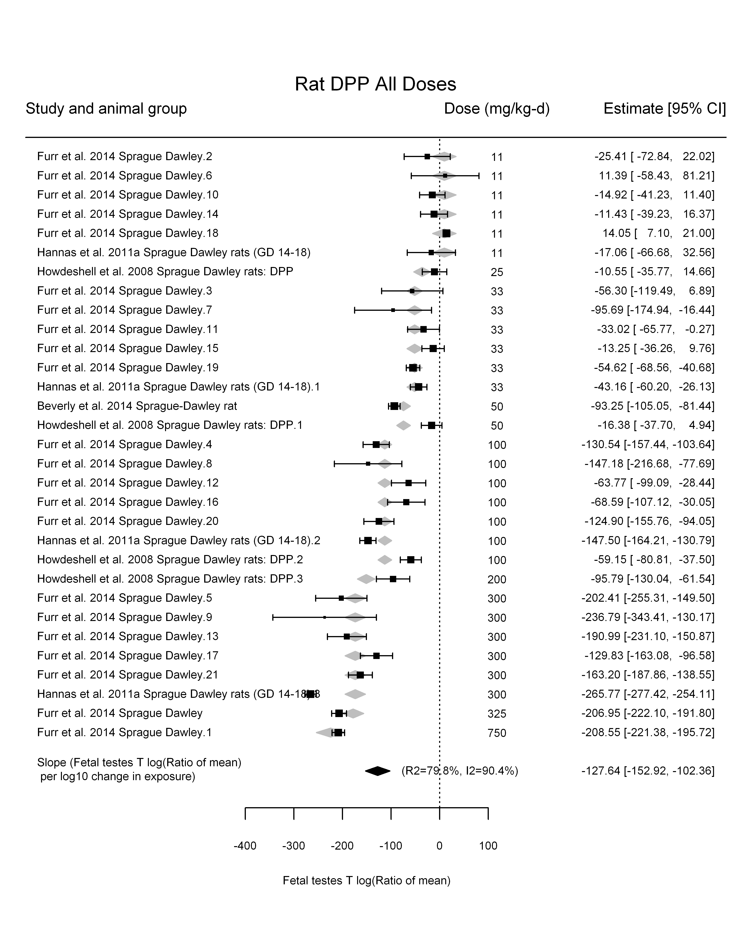

## [1] "Linear---------------------"  
##   
## Mixed-Effects Model (k = 31; tau^2 estimator: REML)  
##   
## logLik deviance AIC BIC AICc   
## -164.8769 329.7538 333.7538 336.5562 334.1983   
##   
## tau^2 (estimated amount of residual heterogeneity): 3149.4204 (SE = 904.9054)  
## tau (square root of estimated tau^2 value): 56.1197  
## I^2 (residual heterogeneity / unaccounted variability): 96.75%  
## H^2 (unaccounted variability / sampling variability): 30.73  
##   
## Test for Residual Heterogeneity:   
## QE(df = 30) = 1389.8836, p-val < .0001  
##   
## Model Results:  
##   
## estimate se zval pval ci.lb ci.ub   
## dose100 -50.2351 5.0680 -9.9123 <.0001 -60.1681 -40.3021 ***  
##   
## ---  
## Signif. codes: 0 '***' 0.001 '**' 0.01 '*' 0.05 '.' 0.1 ' ' 1

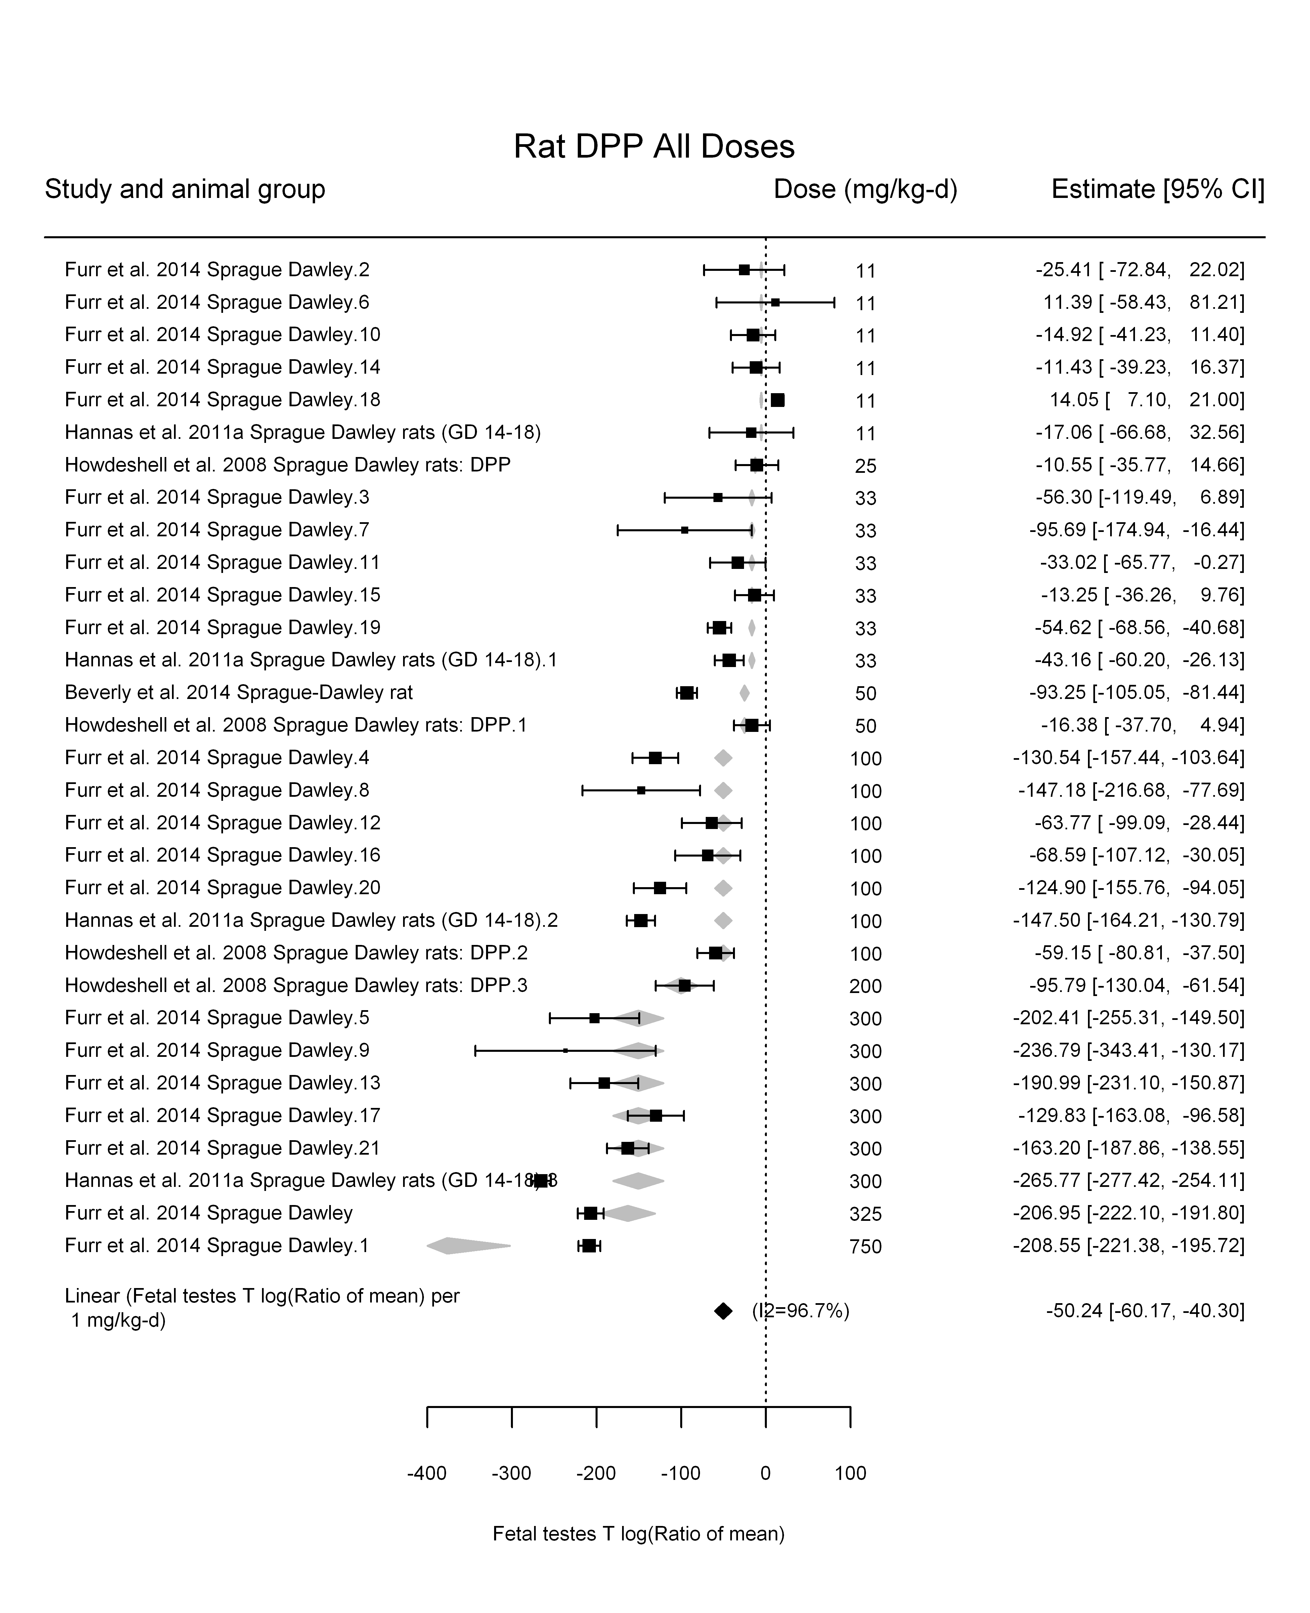

## [1] "LinearQuadratic---------------------"  
##   
## Mixed-Effects Model (k = 31; tau^2 estimator: REML)  
##   
## logLik deviance AIC BIC AICc   
## -145.8135 291.6271 297.6271 301.7290 298.5871   
##   
## tau^2 (estimated amount of residual heterogeneity): 1061.1185 (SE = 354.0877)  
## tau (square root of estimated tau^2 value): 32.5748  
## I^2 (residual heterogeneity / unaccounted variability): 90.61%  
## H^2 (unaccounted variability / sampling variability): 10.65  
##   
## Test for Residual Heterogeneity:   
## QE(df = 29) = 332.3985, p-val < .0001  
##   
## Test of Moderators (coefficient(s) 1,2):   
## QM(df = 2) = 299.9518, p-val < .0001  
##   
## Model Results:  
##   
## estimate se zval pval ci.lb ci.ub   
## dose100 -93.9888 7.1262 -13.1891 <.0001 -107.9559 -80.0216 ***  
## I(dose100^2) 8.9325 1.2708 7.0289 <.0001 6.4417 11.4233 ***  
##   
## ---  
## Signif. codes: 0 '***' 0.001 '**' 0.01 '*' 0.05 '.' 0.1 ' ' 1

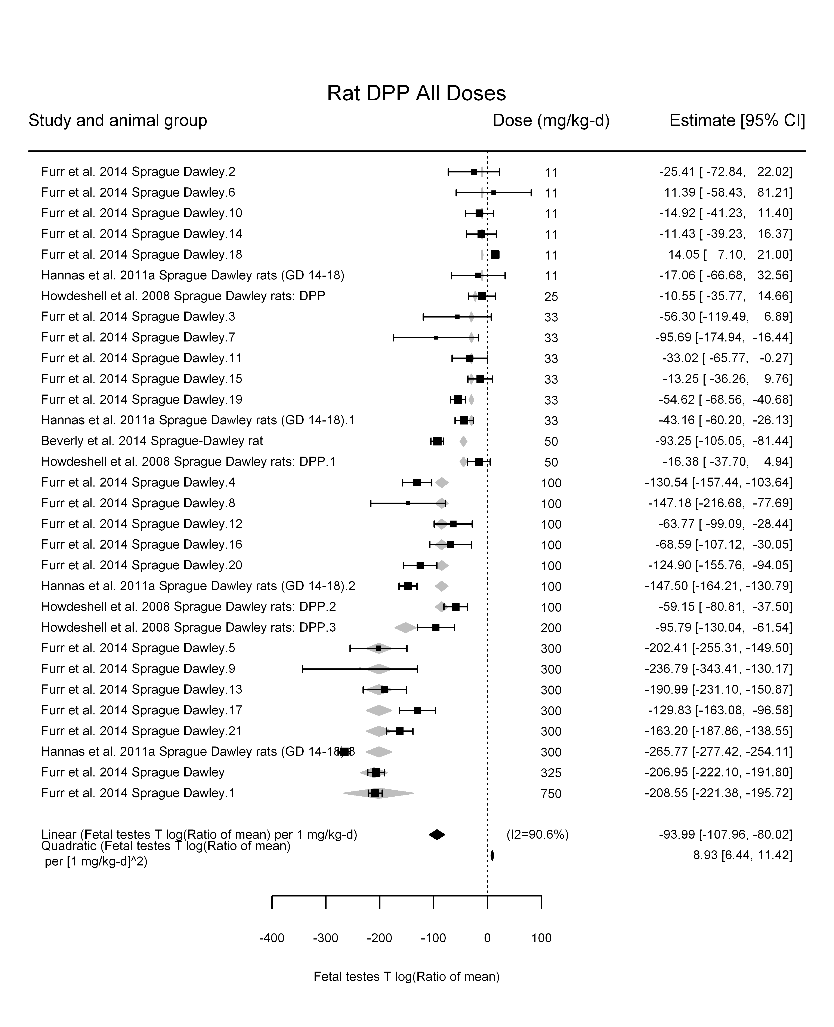

## [1] ""

## [1] ""  
## m ci.lb ci.ub bmr  
## 1 10.21059 8.52495 12.72717 -5.129329  
## m ci.lb ci.ub bmr  
## 1 101.6864 84.89936 126.7486 -51.08256

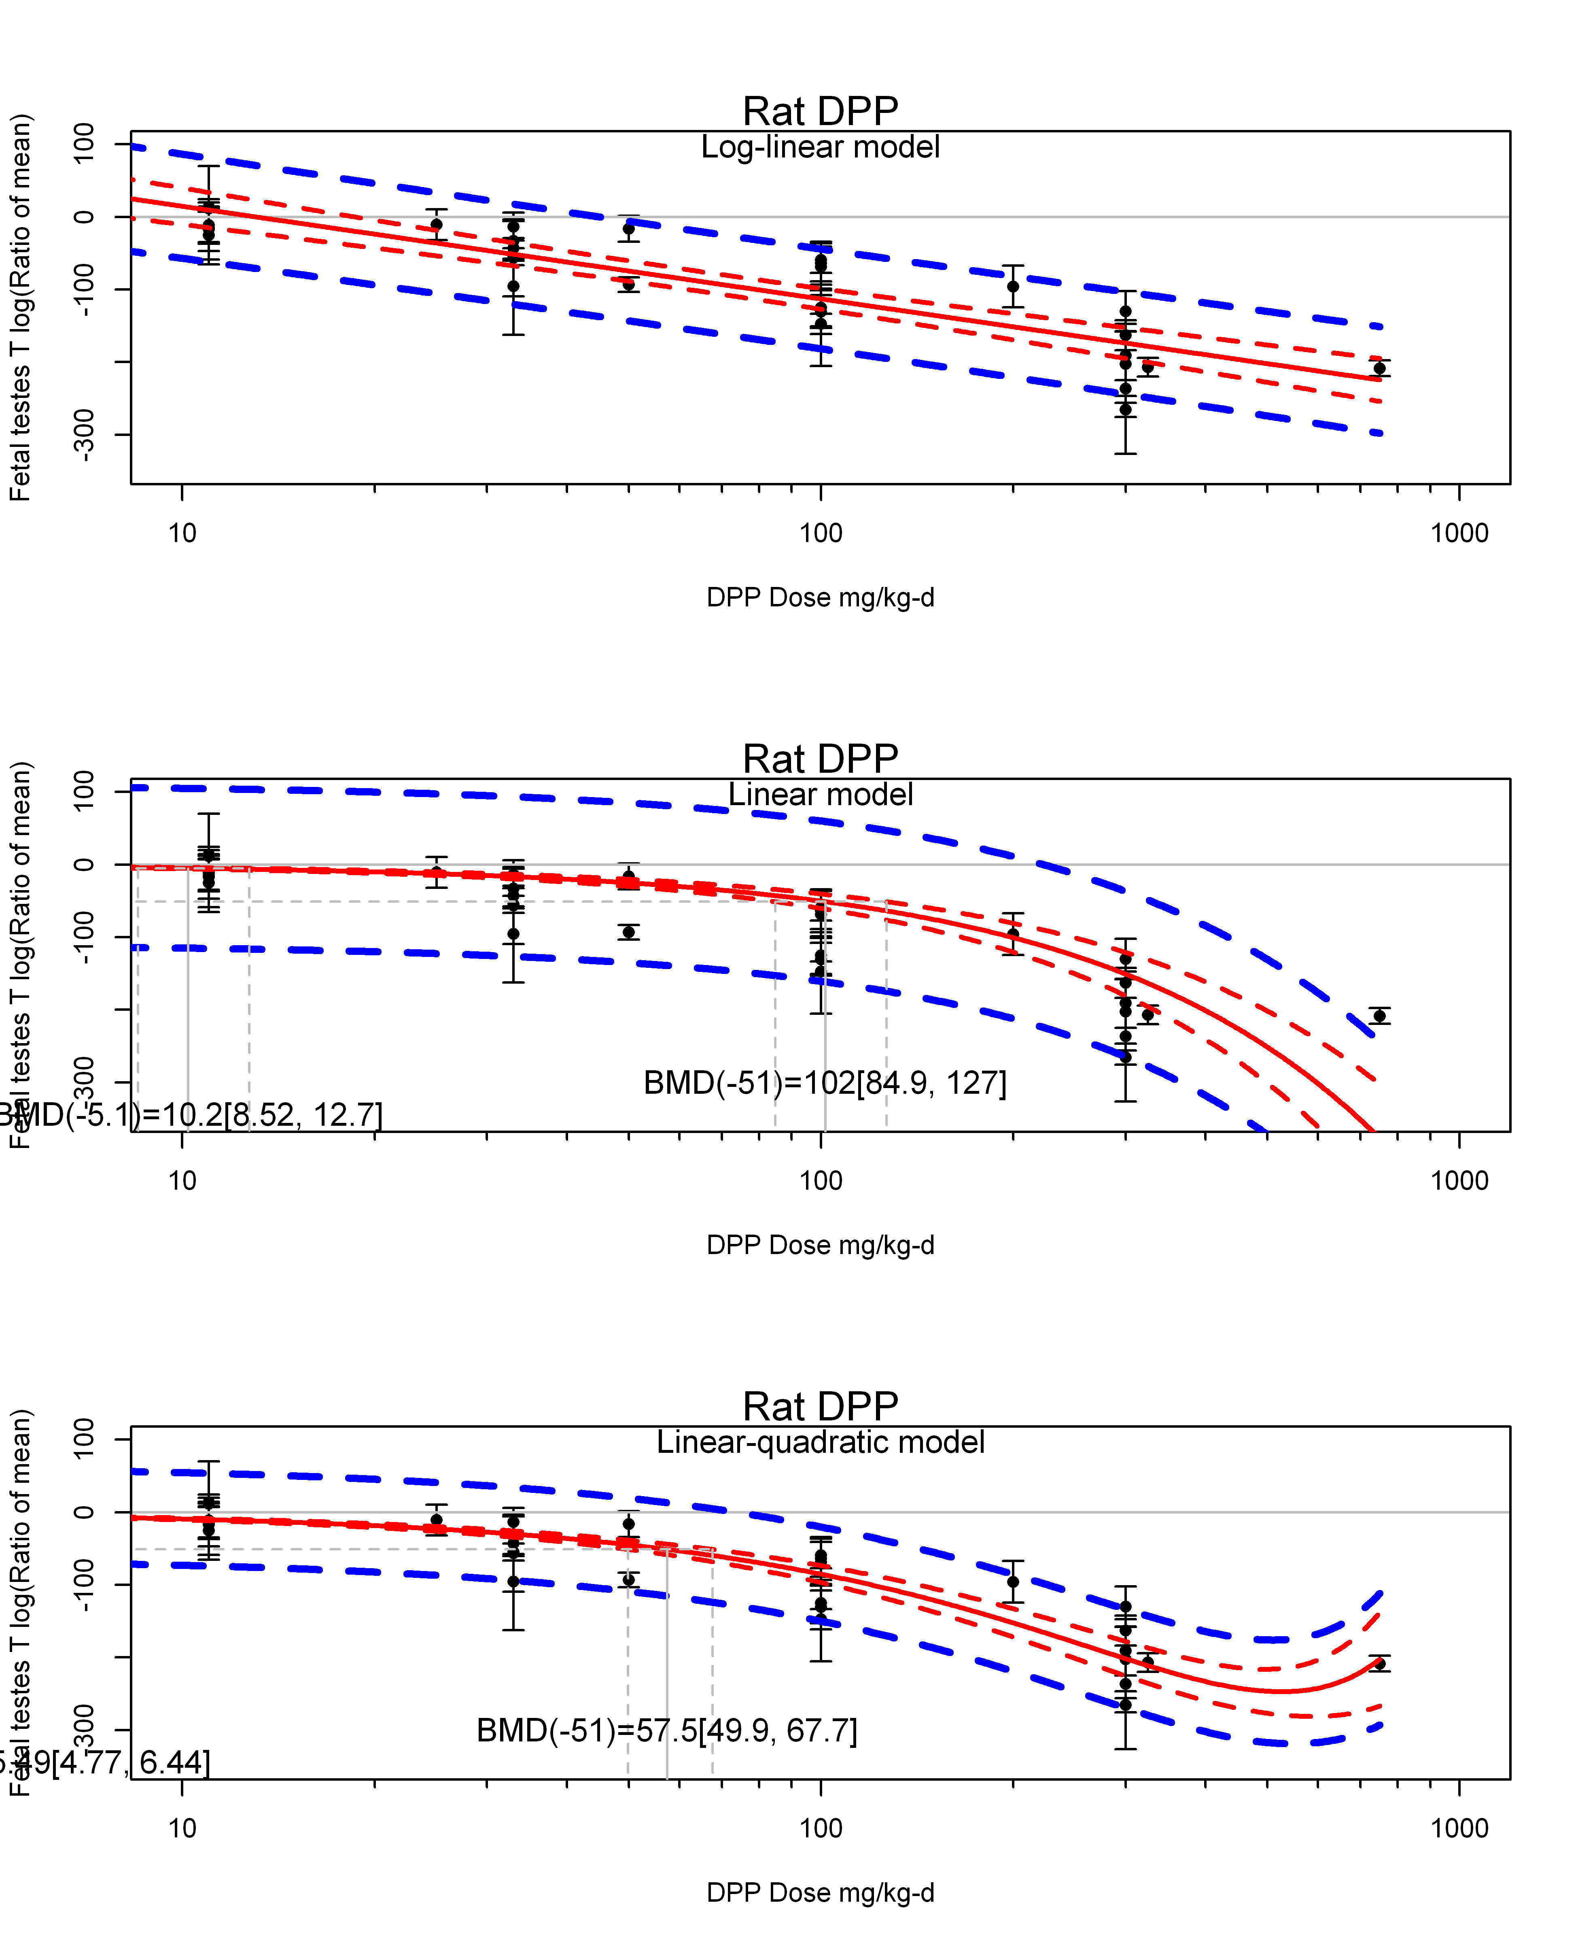

## [1] ""  
## m ci.lb ci.ub bmr  
## 1 5.485975 4.774913 6.444635 -5.129329  
## m ci.lb ci.ub bmr  
## 1 57.49058 49.88987 67.6822 -51.08256  
## [1] "Fetal testes T log(Ratio of mean) Rat Highest Dose"  
## [1] "Overall---------------------"  
##   
## Random-Effects Model (k = 9; tau^2 estimator: REML)  
##   
## logLik deviance AIC BIC AICc   
## -44.3092 88.6183 92.6183 92.7772 95.0183   
##   
## tau^2 (estimated amount of total heterogeneity): 3465.4105 (SE = 1928.2568)  
## tau (square root of estimated tau^2 value): 58.8677  
## I^2 (total heterogeneity / total variability): 96.97%  
## H^2 (total variability / sampling variability): 32.96  
##   
## Test for Heterogeneity:   
## Q(df = 8) = 469.7560, p-val < .0001  
##   
## Model Results:  
##   
## estimate se zval pval ci.lb ci.ub   
## -173.3224 20.7820 -8.3400 <.0001 -214.0544 -132.5904 ***   
##   
## ---  
## Signif. codes: 0 '***' 0.001 '**' 0.01 '*' 0.05 '.' 0.1 ' ' 1

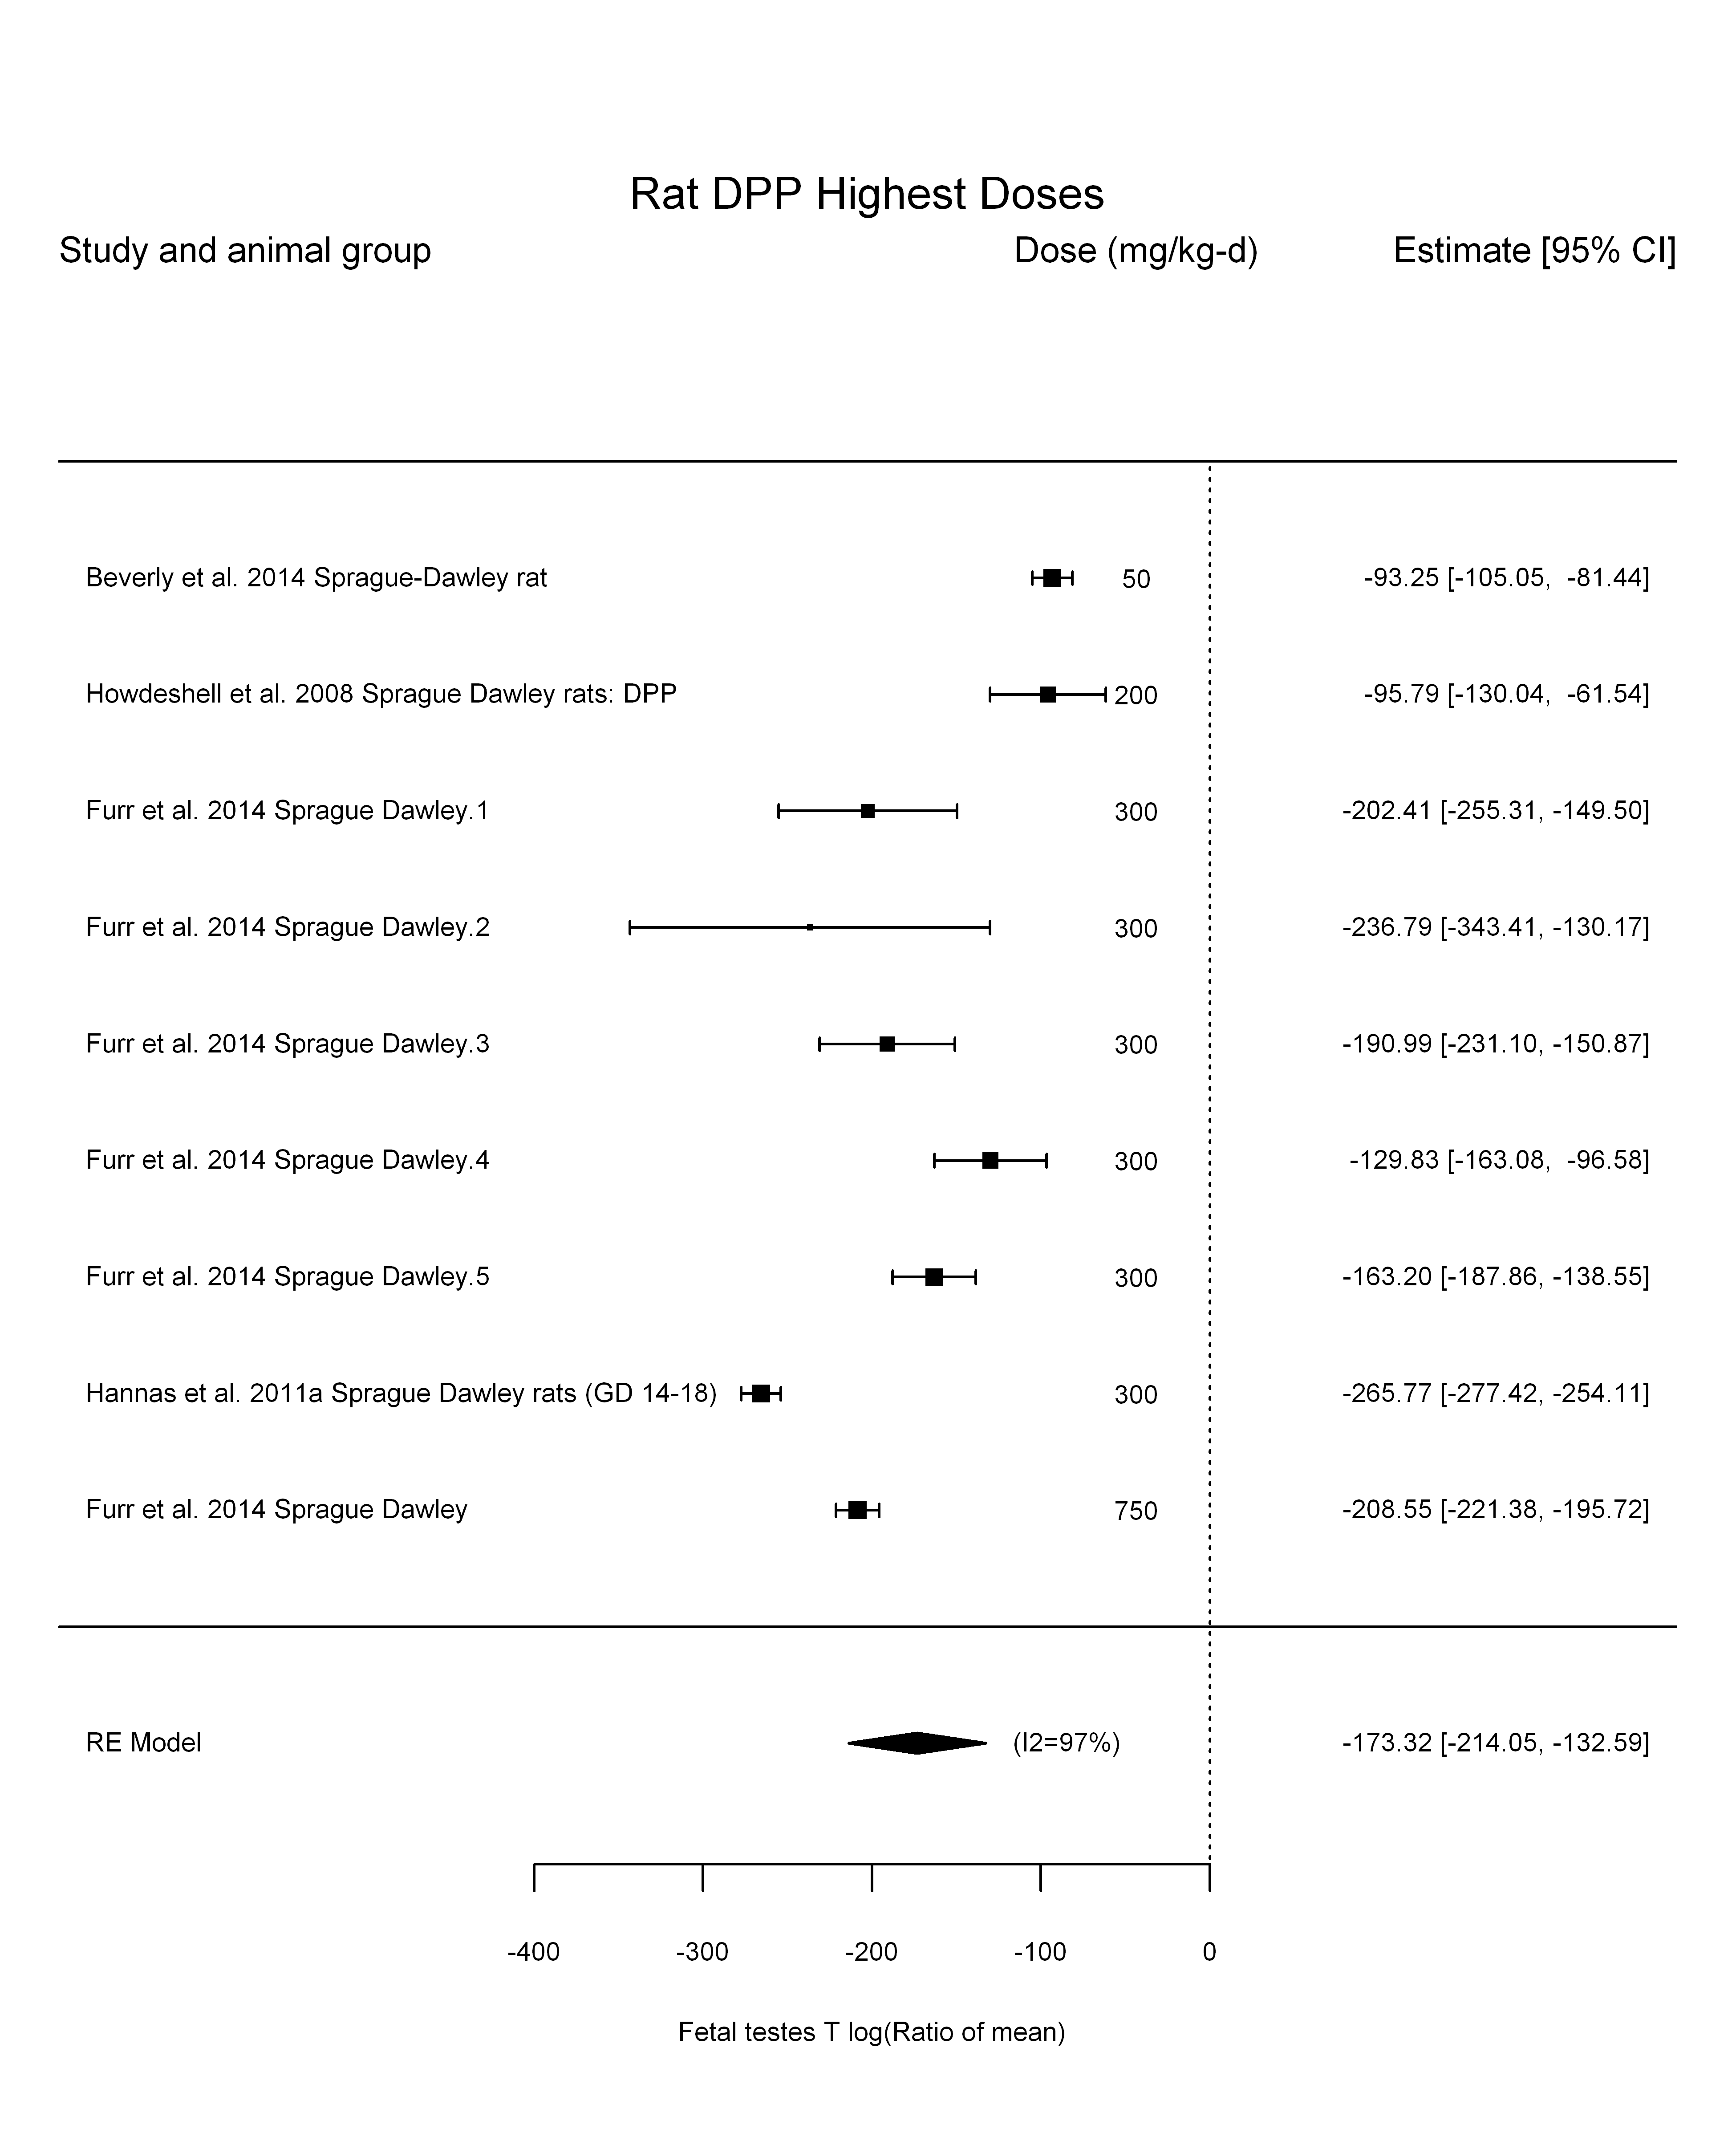

## [1] "Trend in log10(dose)---------------------"  
##   
## Mixed-Effects Model (k = 9; tau^2 estimator: REML)  
##   
## logLik deviance AIC BIC AICc   
## -37.6265 75.2529 81.2529 81.0907 89.2529   
##   
## tau^2 (estimated amount of residual heterogeneity): 2376.4767 (SE = 1489.8974)  
## tau (square root of estimated tau^2 value): 48.7491  
## I^2 (residual heterogeneity / unaccounted variability): 94.22%  
## H^2 (unaccounted variability / sampling variability): 17.29  
## R^2 (amount of heterogeneity accounted for): 31.42%  
##   
## Test for Residual Heterogeneity:   
## QE(df = 7) = 211.5705, p-val < .0001  
##   
## Test of Moderators (coefficient(s) 2):   
## QM(df = 1) = 4.2797, p-val = 0.0386  
##   
## Model Results:  
##   
## estimate se zval pval ci.lb ci.ub   
## intrcpt 109.0694 137.3394 0.7942 0.4271 -160.1108 378.2496   
## log10(dose) -117.0075 56.5598 -2.0687 0.0386 -227.8627 -6.1524 *  
##   
## ---  
## Signif. codes: 0 '***' 0.001 '**' 0.01 '*' 0.05 '.' 0.1 ' ' 1

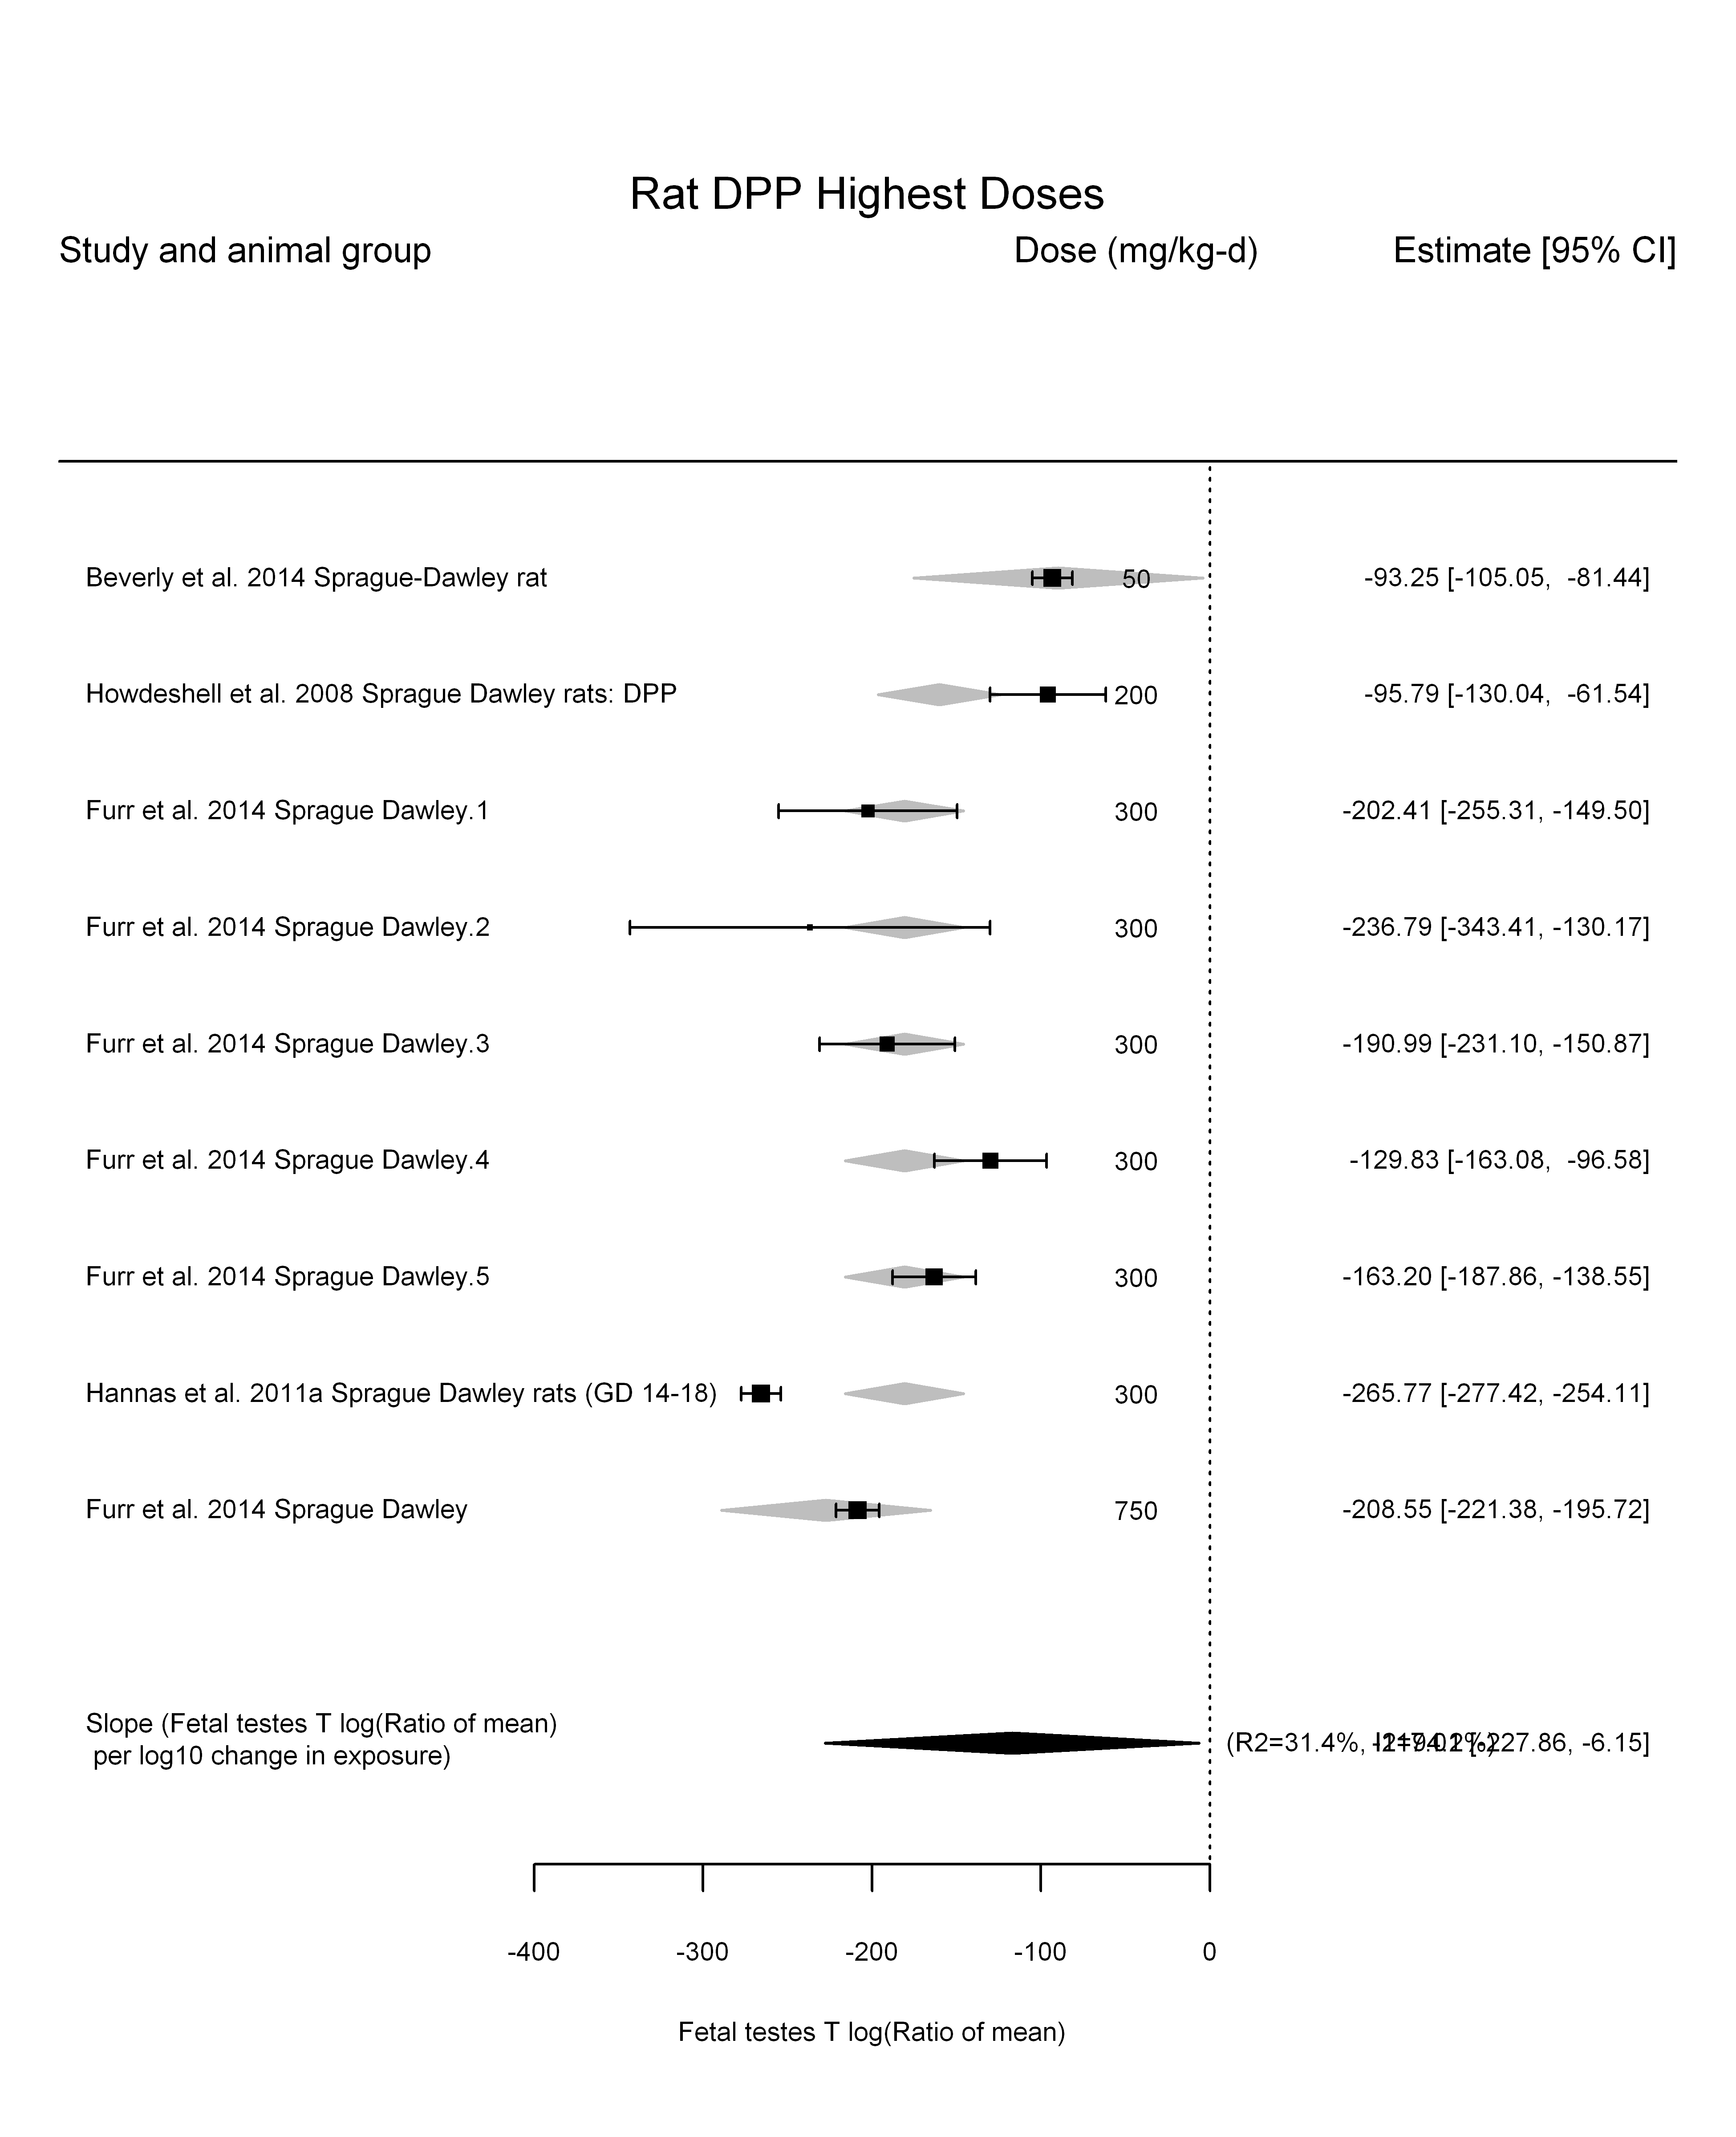

## [1] "Linear---------------------"  
##   
## Mixed-Effects Model (k = 9; tau^2 estimator: REML)  
##   
## logLik deviance AIC BIC AICc   
## -46.8875 93.7750 97.7750 97.9339 100.1750   
##   
## tau^2 (estimated amount of residual heterogeneity): 6797.8037 (SE = 3630.0875)  
## tau (square root of estimated tau^2 value): 82.4488  
## I^2 (residual heterogeneity / unaccounted variability): 98.43%  
## H^2 (unaccounted variability / sampling variability): 63.70  
##   
## Test for Residual Heterogeneity:   
## QE(df = 8) = 982.6116, p-val < .0001  
##   
## Model Results:  
##   
## estimate se zval pval ci.lb ci.ub   
## dose100 -45.8868 7.8887 -5.8168 <.0001 -61.3484 -30.4252 ***  
##   
## ---  
## Signif. codes: 0 '***' 0.001 '**' 0.01 '*' 0.05 '.' 0.1 ' ' 1

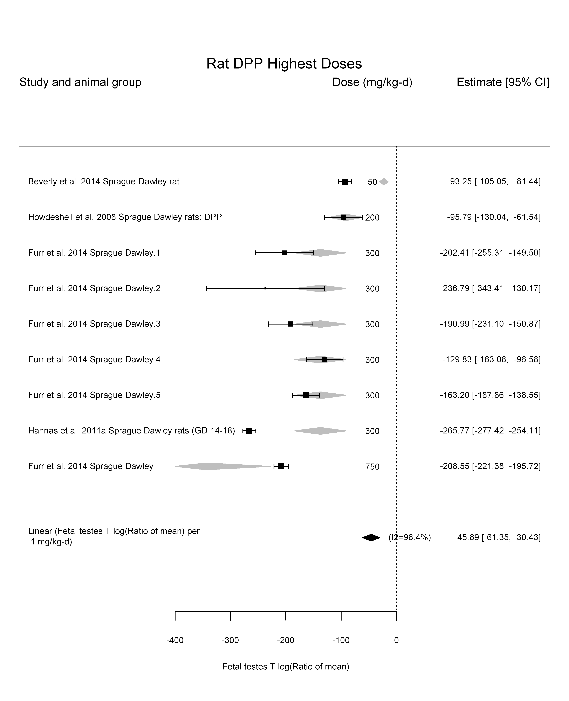

## [1] "LinearQuadratic---------------------"  
##   
## Mixed-Effects Model (k = 9; tau^2 estimator: REML)  
##   
## logLik deviance AIC BIC AICc   
## -37.5248 75.0496 81.0496 80.8873 89.0496   
##   
## tau^2 (estimated amount of residual heterogeneity): 2362.3785 (SE = 1475.2368)  
## tau (square root of estimated tau^2 value): 48.6043  
## I^2 (residual heterogeneity / unaccounted variability): 94.72%  
## H^2 (unaccounted variability / sampling variability): 18.93  
##   
## Test for Residual Heterogeneity:   
## QE(df = 7) = 170.7329, p-val < .0001  
##   
## Test of Moderators (coefficient(s) 1,2):   
## QM(df = 2) = 102.0024, p-val < .0001  
##   
## Model Results:  
##   
## estimate se zval pval ci.lb ci.ub   
## dose100 -87.6212 12.1948 -7.1851 <.0001 -111.5226 -63.7198 ***  
## I(dose100^2) 7.9641 2.0859 3.8181 0.0001 3.8759 12.0523 ***  
##   
## ---  
## Signif. codes: 0 '***' 0.001 '**' 0.01 '*' 0.05 '.' 0.1 ' ' 1

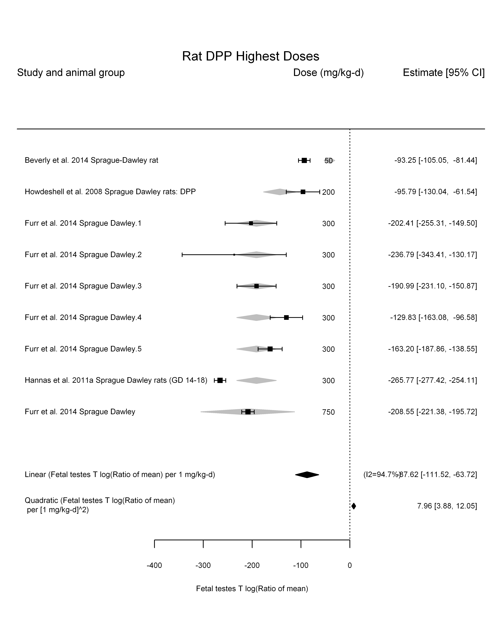

## [1] ""

## [1] ""  
## m ci.lb ci.ub bmr  
## 1 11.17817 8.360942 16.85872 -5.129329  
## m ci.lb ci.ub bmr  
## 1 111.3227 83.26598 167.8949 -51.08256

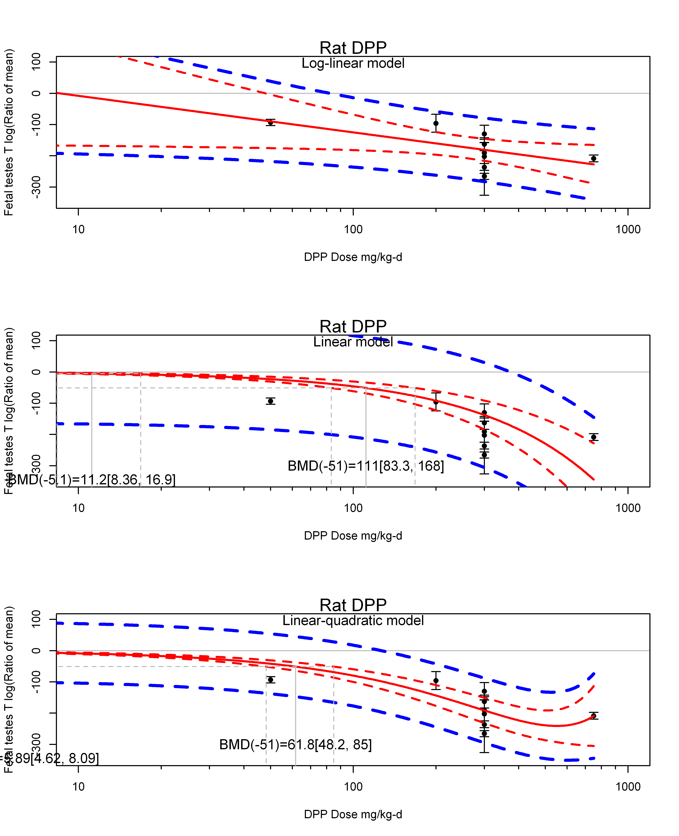

## [1] ""  
## m ci.lb ci.ub bmr  
## 1 5.885433 4.621811 8.093045 -5.129329  
## m ci.lb ci.ub bmr  
## 1 61.76677 48.24558 84.99409 -51.08256  
## [1] "Fetal testes T log(Ratio of mean) Mouse"  
## [1] "Fetal testes T log(Ratio of mean) Rat"  
## [1] "Overall---------------------"  
##   
## Random-Effects Model (k = 8; tau^2 estimator: REML)  
##   
## logLik deviance AIC BIC AICc   
## -40.1414 80.2829 84.2829 84.1747 87.2829   
##   
## tau^2 (estimated amount of total heterogeneity): 5149.5304 (SE = 3090.3443)  
## tau (square root of estimated tau^2 value): 71.7602  
## I^2 (total heterogeneity / total variability): 96.96%  
## H^2 (total variability / sampling variability): 32.90  
##   
## Test for Heterogeneity:   
## Q(df = 7) = 155.0756, p-val < .0001  
##   
## Model Results:  
##   
## estimate se zval pval ci.lb ci.ub   
## -82.3141 26.9375 -3.0557 0.0022 -135.1106 -29.5176 **   
##   
## ---  
## Signif. codes: 0 '***' 0.001 '**' 0.01 '*' 0.05 '.' 0.1 ' ' 1

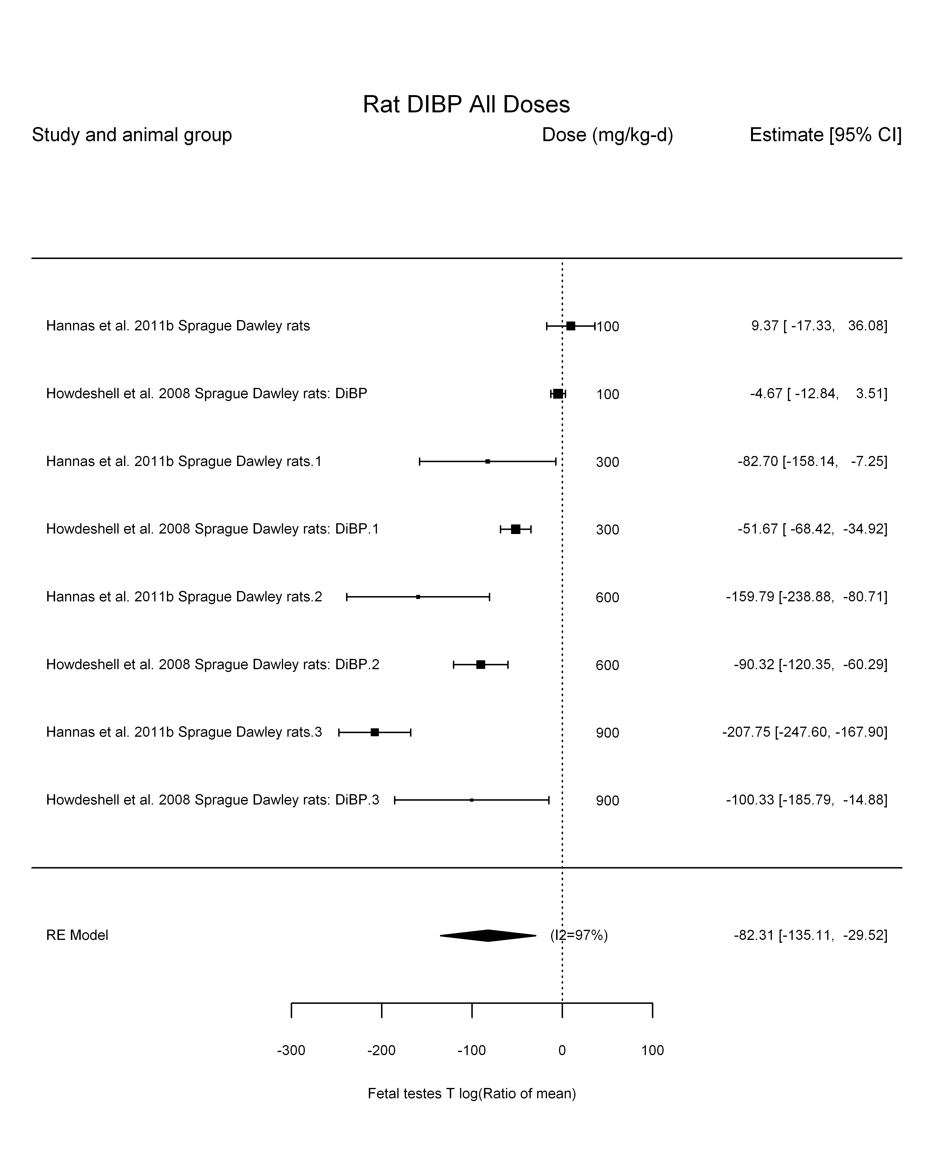

## [1] "Leave one out---------------------"  
## [1] "Trend in log10(dose)---------------------"  
##   
## Mixed-Effects Model (k = 8; tau^2 estimator: REML)  
##   
## logLik deviance AIC BIC AICc   
## -30.2606 60.5213 66.5213 65.8966 78.5213   
##   
## tau^2 (estimated amount of residual heterogeneity): 791.9533 (SE = 705.3891)  
## tau (square root of estimated tau^2 value): 28.1417  
## I^2 (residual heterogeneity / unaccounted variability): 77.83%  
## H^2 (unaccounted variability / sampling variability): 4.51  
## R^2 (amount of heterogeneity accounted for): 84.62%  
##   
## Test for Residual Heterogeneity:   
## QE(df = 6) = 21.7639, p-val = 0.0013  
##   
## Test of Moderators (coefficient(s) 2):   
## QM(df = 1) = 26.1197, p-val < .0001  
##   
## Model Results:  
##   
## estimate se zval pval ci.lb ci.ub  
## intrcpt 346.1527 82.5223 4.1947 <.0001 184.4120 507.8934  
## log10(dose) -169.2291 33.1124 -5.1107 <.0001 -234.1282 -104.3300  
##   
## intrcpt ***  
## log10(dose) ***  
##   
## ---  
## Signif. codes: 0 '***' 0.001 '**' 0.01 '*' 0.05 '.' 0.1 ' ' 1

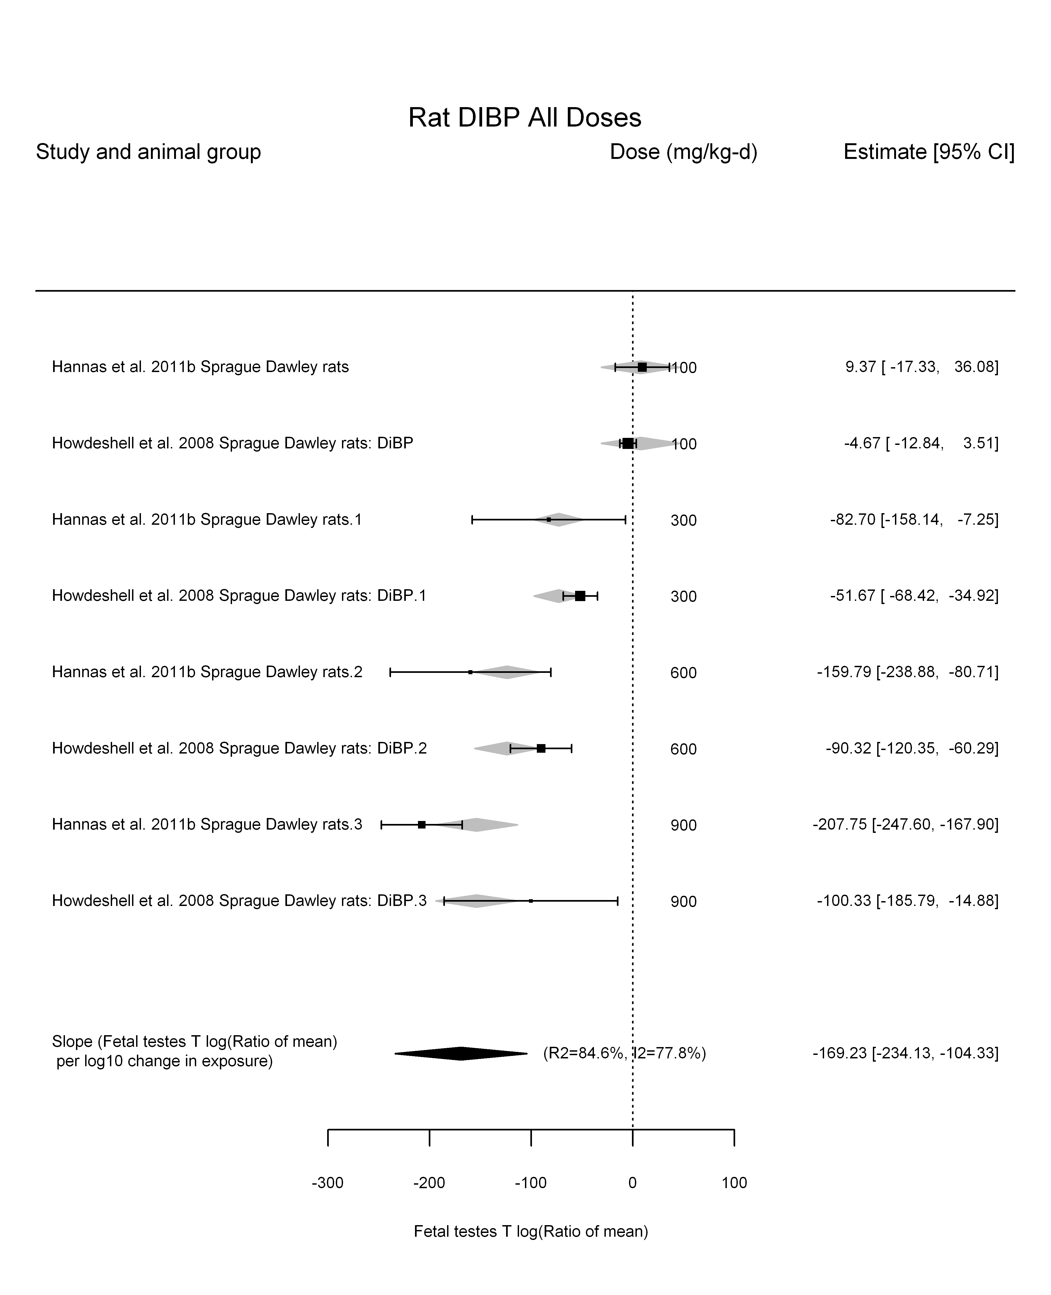

## [1] "Linear---------------------"  
##   
## Mixed-Effects Model (k = 8; tau^2 estimator: REML)  
##   
## logLik deviance AIC BIC AICc   
## -34.2550 68.5101 72.5101 72.4019 75.5101   
##   
## tau^2 (estimated amount of residual heterogeneity): 347.2727 (SE = 318.4220)  
## tau (square root of estimated tau^2 value): 18.6353  
## I^2 (residual heterogeneity / unaccounted variability): 78.78%  
## H^2 (unaccounted variability / sampling variability): 4.71  
##   
## Test for Residual Heterogeneity:   
## QE(df = 7) = 24.4967, p-val = 0.0009  
##   
## Model Results:  
##   
## estimate se zval pval ci.lb ci.ub   
## dose100 -18.8363 1.9860 -9.4845 <.0001 -22.7288 -14.9438 ***  
##   
## ---  
## Signif. codes: 0 '***' 0.001 '**' 0.01 '*' 0.05 '.' 0.1 ' ' 1

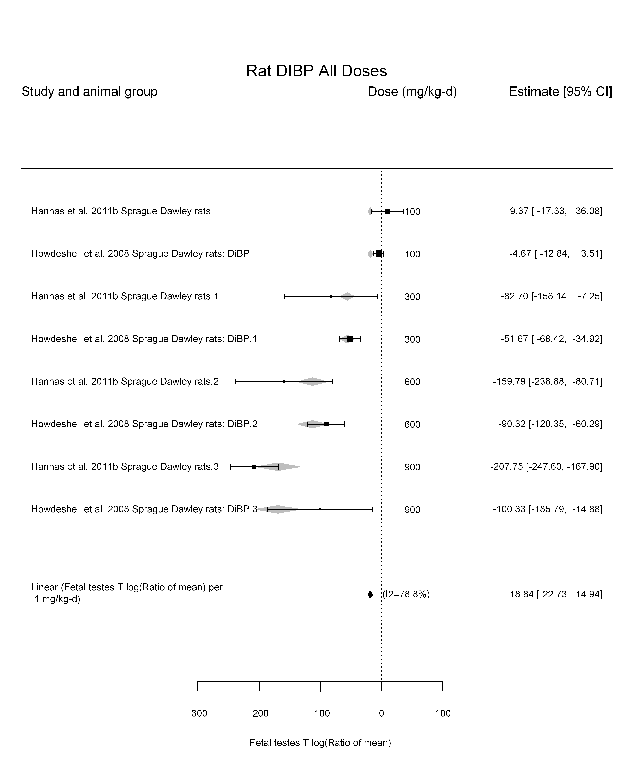

## [1] "LinearQuadratic---------------------"  
##   
## Mixed-Effects Model (k = 8; tau^2 estimator: REML)  
##   
## logLik deviance AIC BIC AICc   
## -29.5211 59.0421 65.0421 64.4174 77.0421   
##   
## tau^2 (estimated amount of residual heterogeneity): 149.2101 (SE = 192.4268)  
## tau (square root of estimated tau^2 value): 12.2152  
## I^2 (residual heterogeneity / unaccounted variability): 57.12%  
## H^2 (unaccounted variability / sampling variability): 2.33  
##   
## Test for Residual Heterogeneity:   
## QE(df = 6) = 15.0132, p-val = 0.0202  
##   
## Test of Moderators (coefficient(s) 1,2):   
## QM(df = 2) = 124.1292, p-val < .0001  
##   
## Model Results:  
##   
## estimate se zval pval ci.lb ci.ub   
## dose100 -11.6075 5.3705 -2.1614 0.0307 -22.1335 -1.0816 *  
## I(dose100^2) -0.9961 0.7241 -1.3755 0.1690 -2.4153 0.4232   
##   
## ---  
## Signif. codes: 0 '***' 0.001 '**' 0.01 '*' 0.05 '.' 0.1 ' ' 1

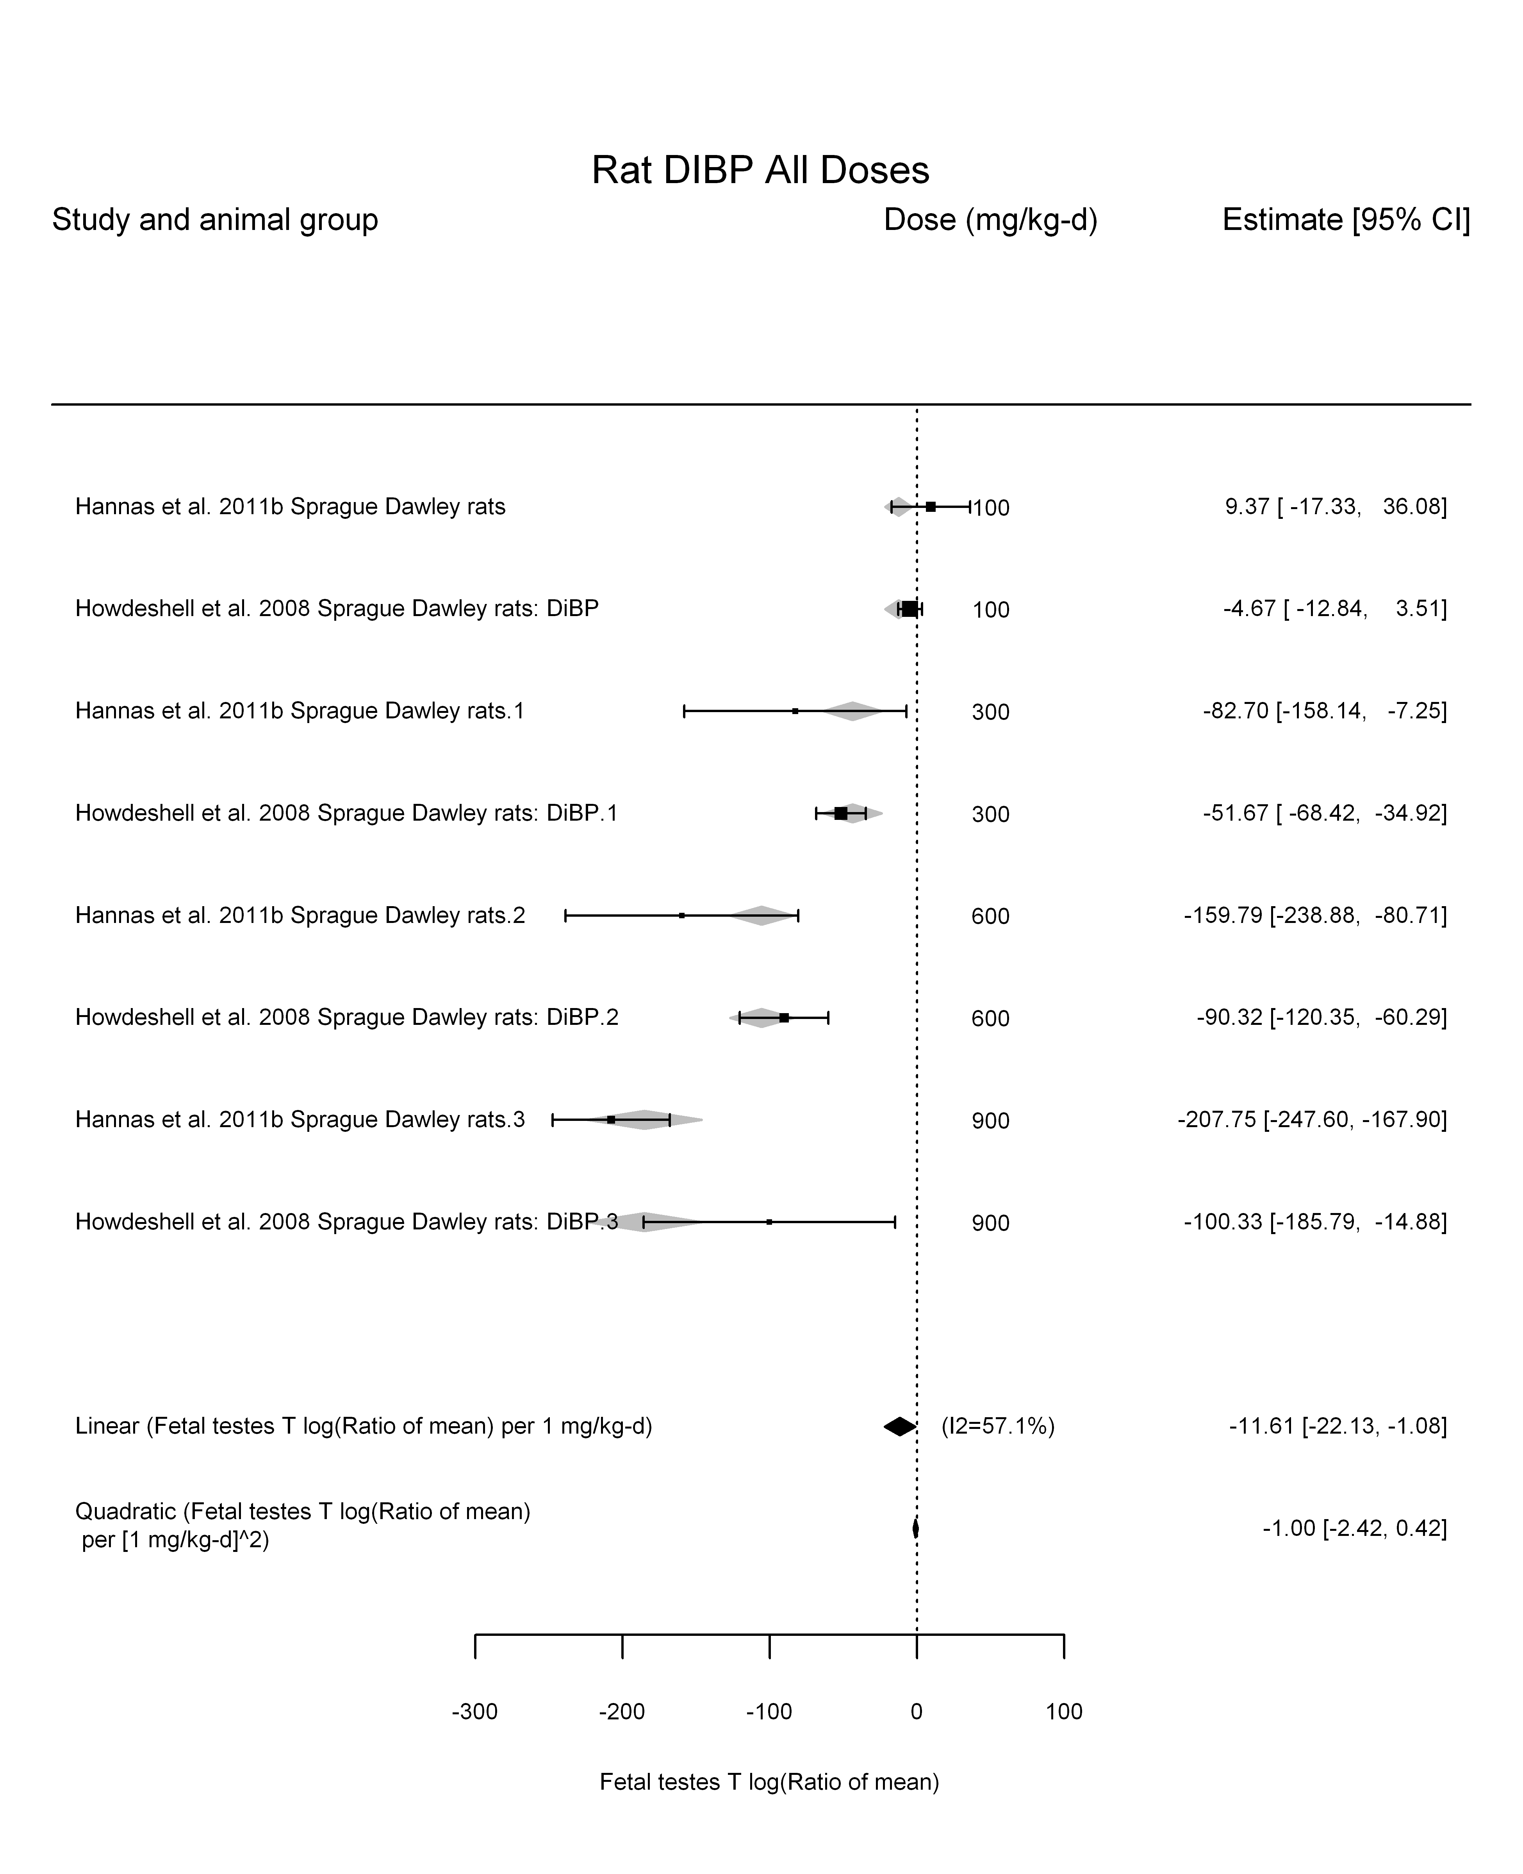

## [1] ""

## [1] ""  
## m ci.lb ci.ub bmr  
## 1 27.23102 22.56747 34.32404 -5.129329  
## m ci.lb ci.ub bmr  
## 1 271.1918 224.7477 341.8307 -51.08256

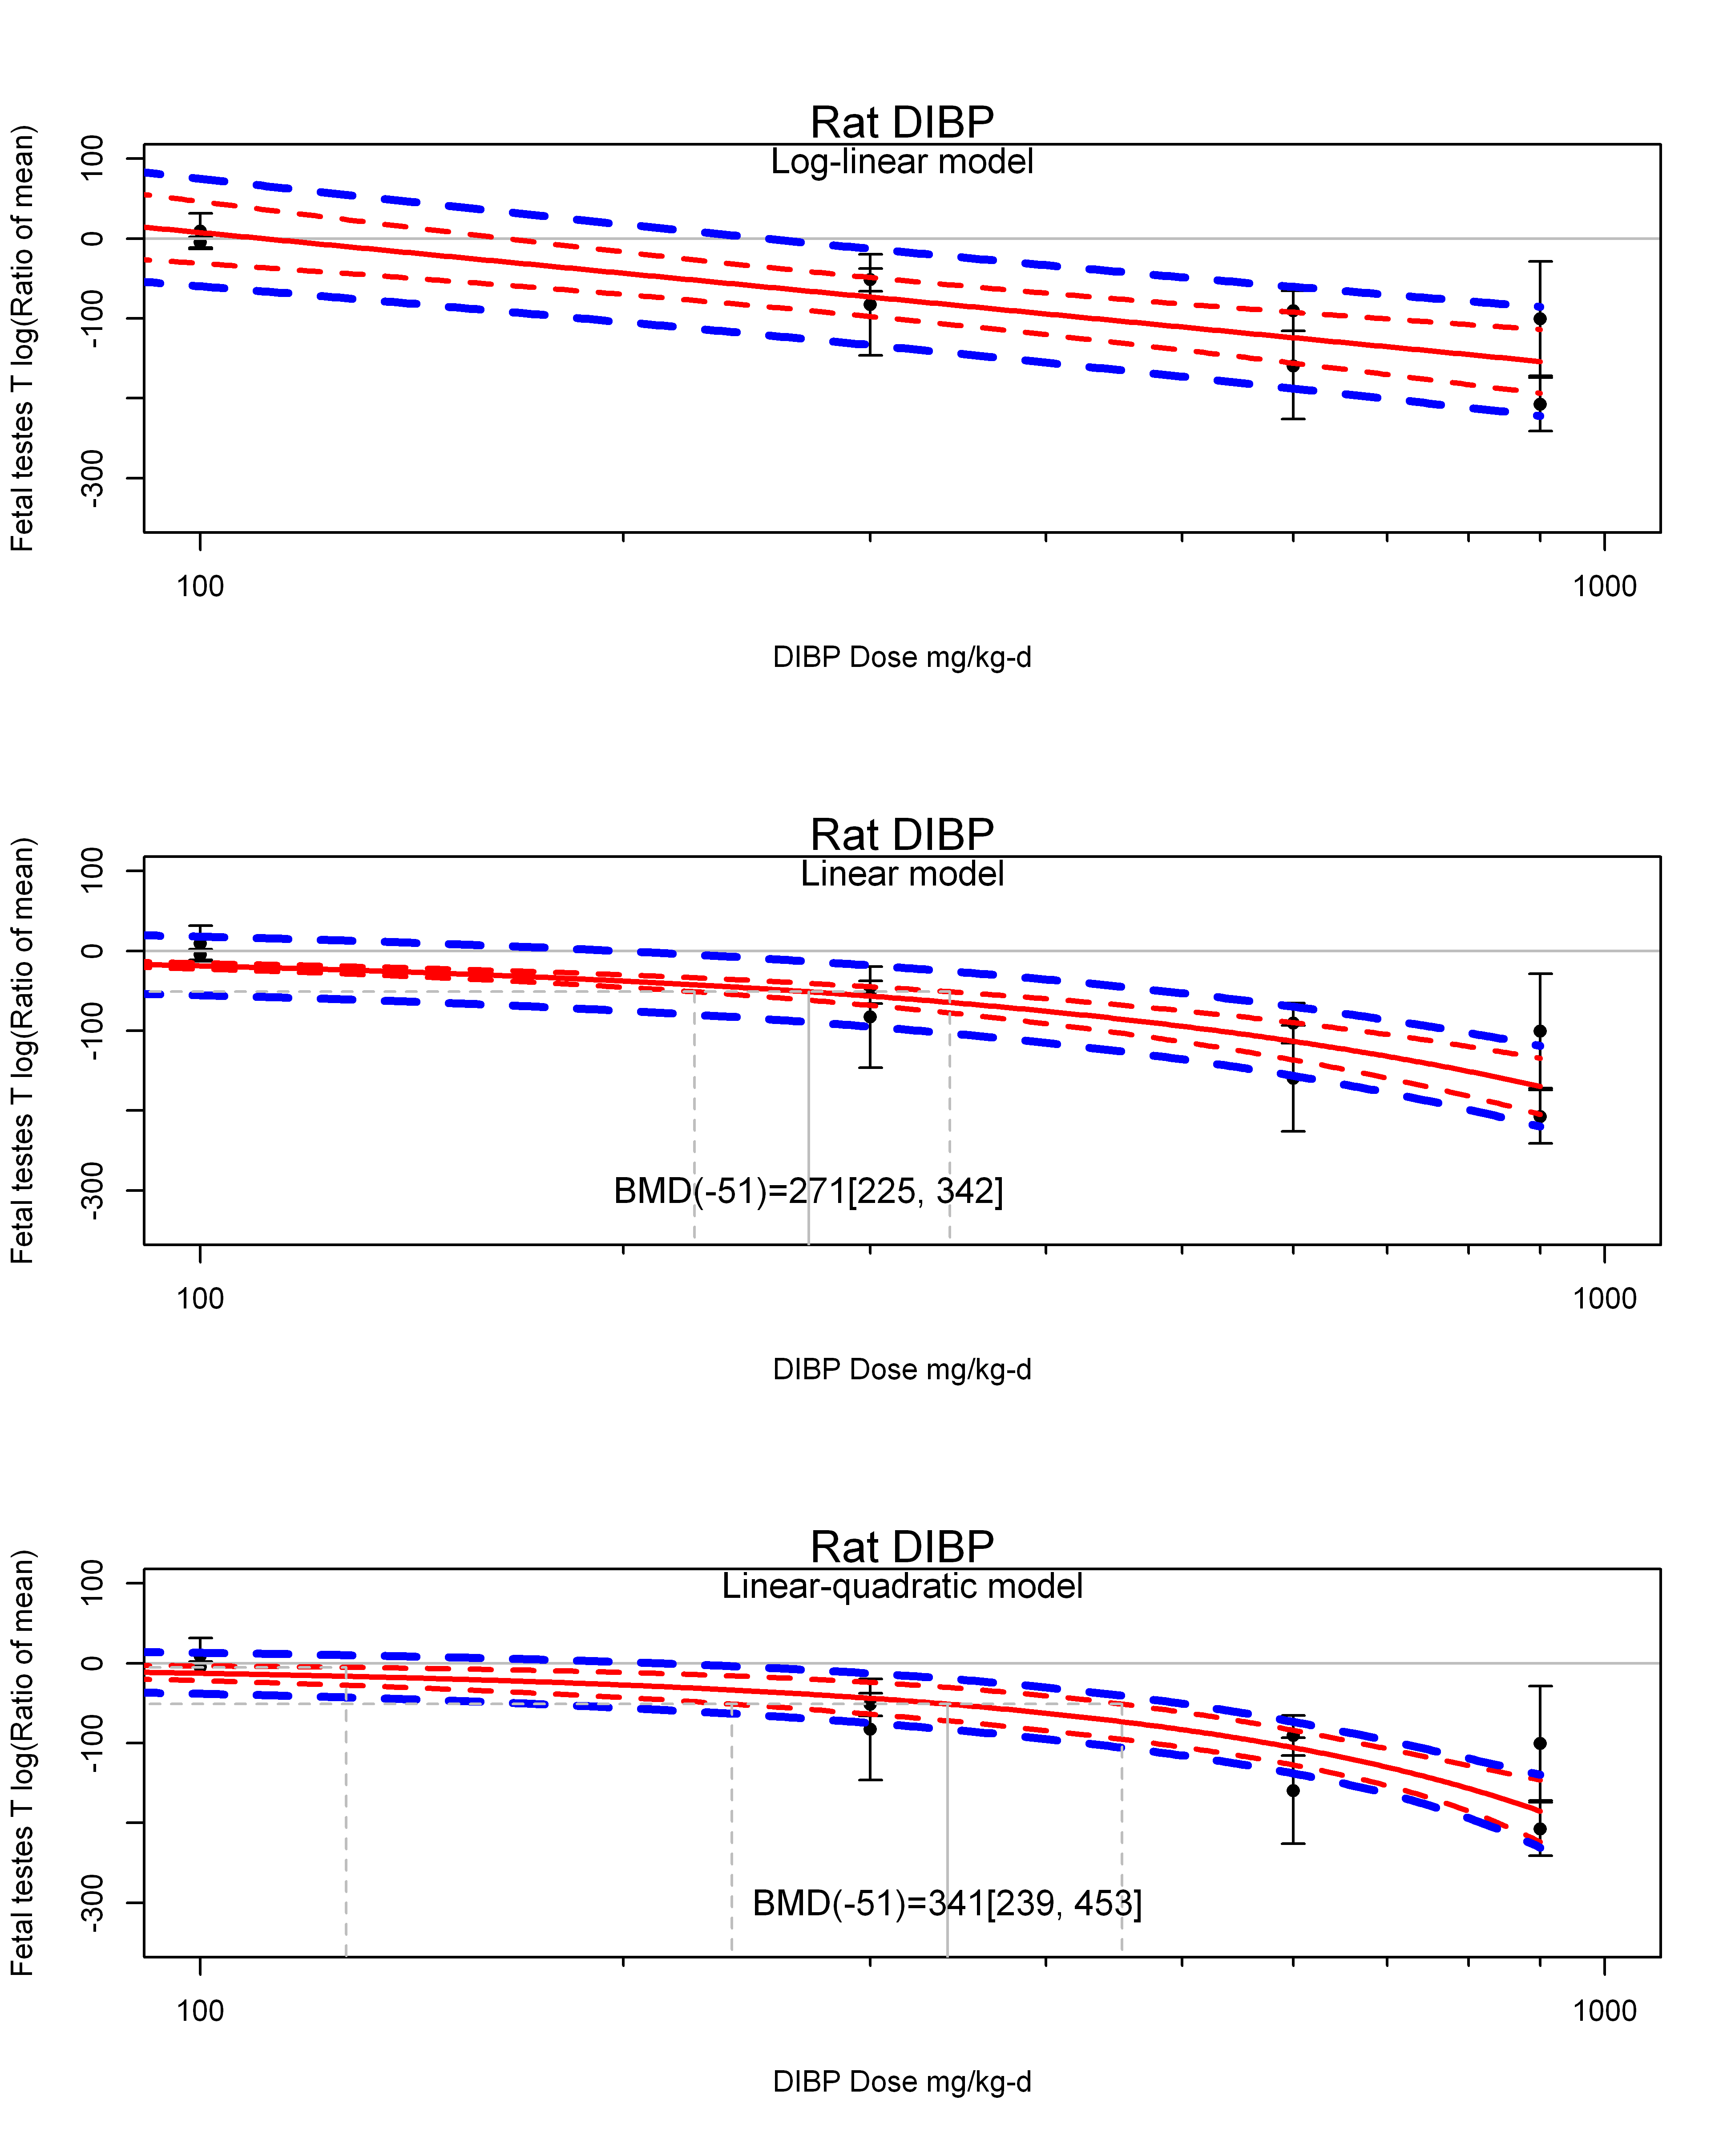

## [1] ""  
## m ci.lb ci.ub bmr  
## 1 42.63011 23.25983 126.9785 -5.129329  
## m ci.lb ci.ub bmr  
## 1 340.5553 239.0357 453.3512 -51.08256  
## [1] "Fetal testes T log(Ratio of mean) Rat Highest Dose"  
## [1] "Fetal testes T log(Ratio of mean) Mouse"  
## [1] "Fetal testes T log(Ratio of mean) Rat"  
## [1] "Fetal testes T log(Ratio of mean) Mouse"  
## [1] "Fetal testes T log(Ratio of mean) Rat"  
## [1] "Overall---------------------"  
##   
## Random-Effects Model (k = 11; tau^2 estimator: REML)  
##   
## logLik deviance AIC BIC AICc   
## -58.1900 116.3801 120.3801 120.9852 122.0944   
##   
## tau^2 (estimated amount of total heterogeneity): 6040.3036 (SE = 2852.7435)  
## tau (square root of estimated tau^2 value): 77.7194  
## I^2 (total heterogeneity / total variability): 98.17%  
## H^2 (total variability / sampling variability): 54.66  
##   
## Test for Heterogeneity:   
## Q(df = 10) = 611.7355, p-val < .0001  
##   
## Model Results:  
##   
## estimate se zval pval ci.lb ci.ub   
## -78.4682 24.0984 -3.2562 0.0011 -125.7002 -31.2362 **   
##   
## ---  
## Signif. codes: 0 '***' 0.001 '**' 0.01 '*' 0.05 '.' 0.1 ' ' 1

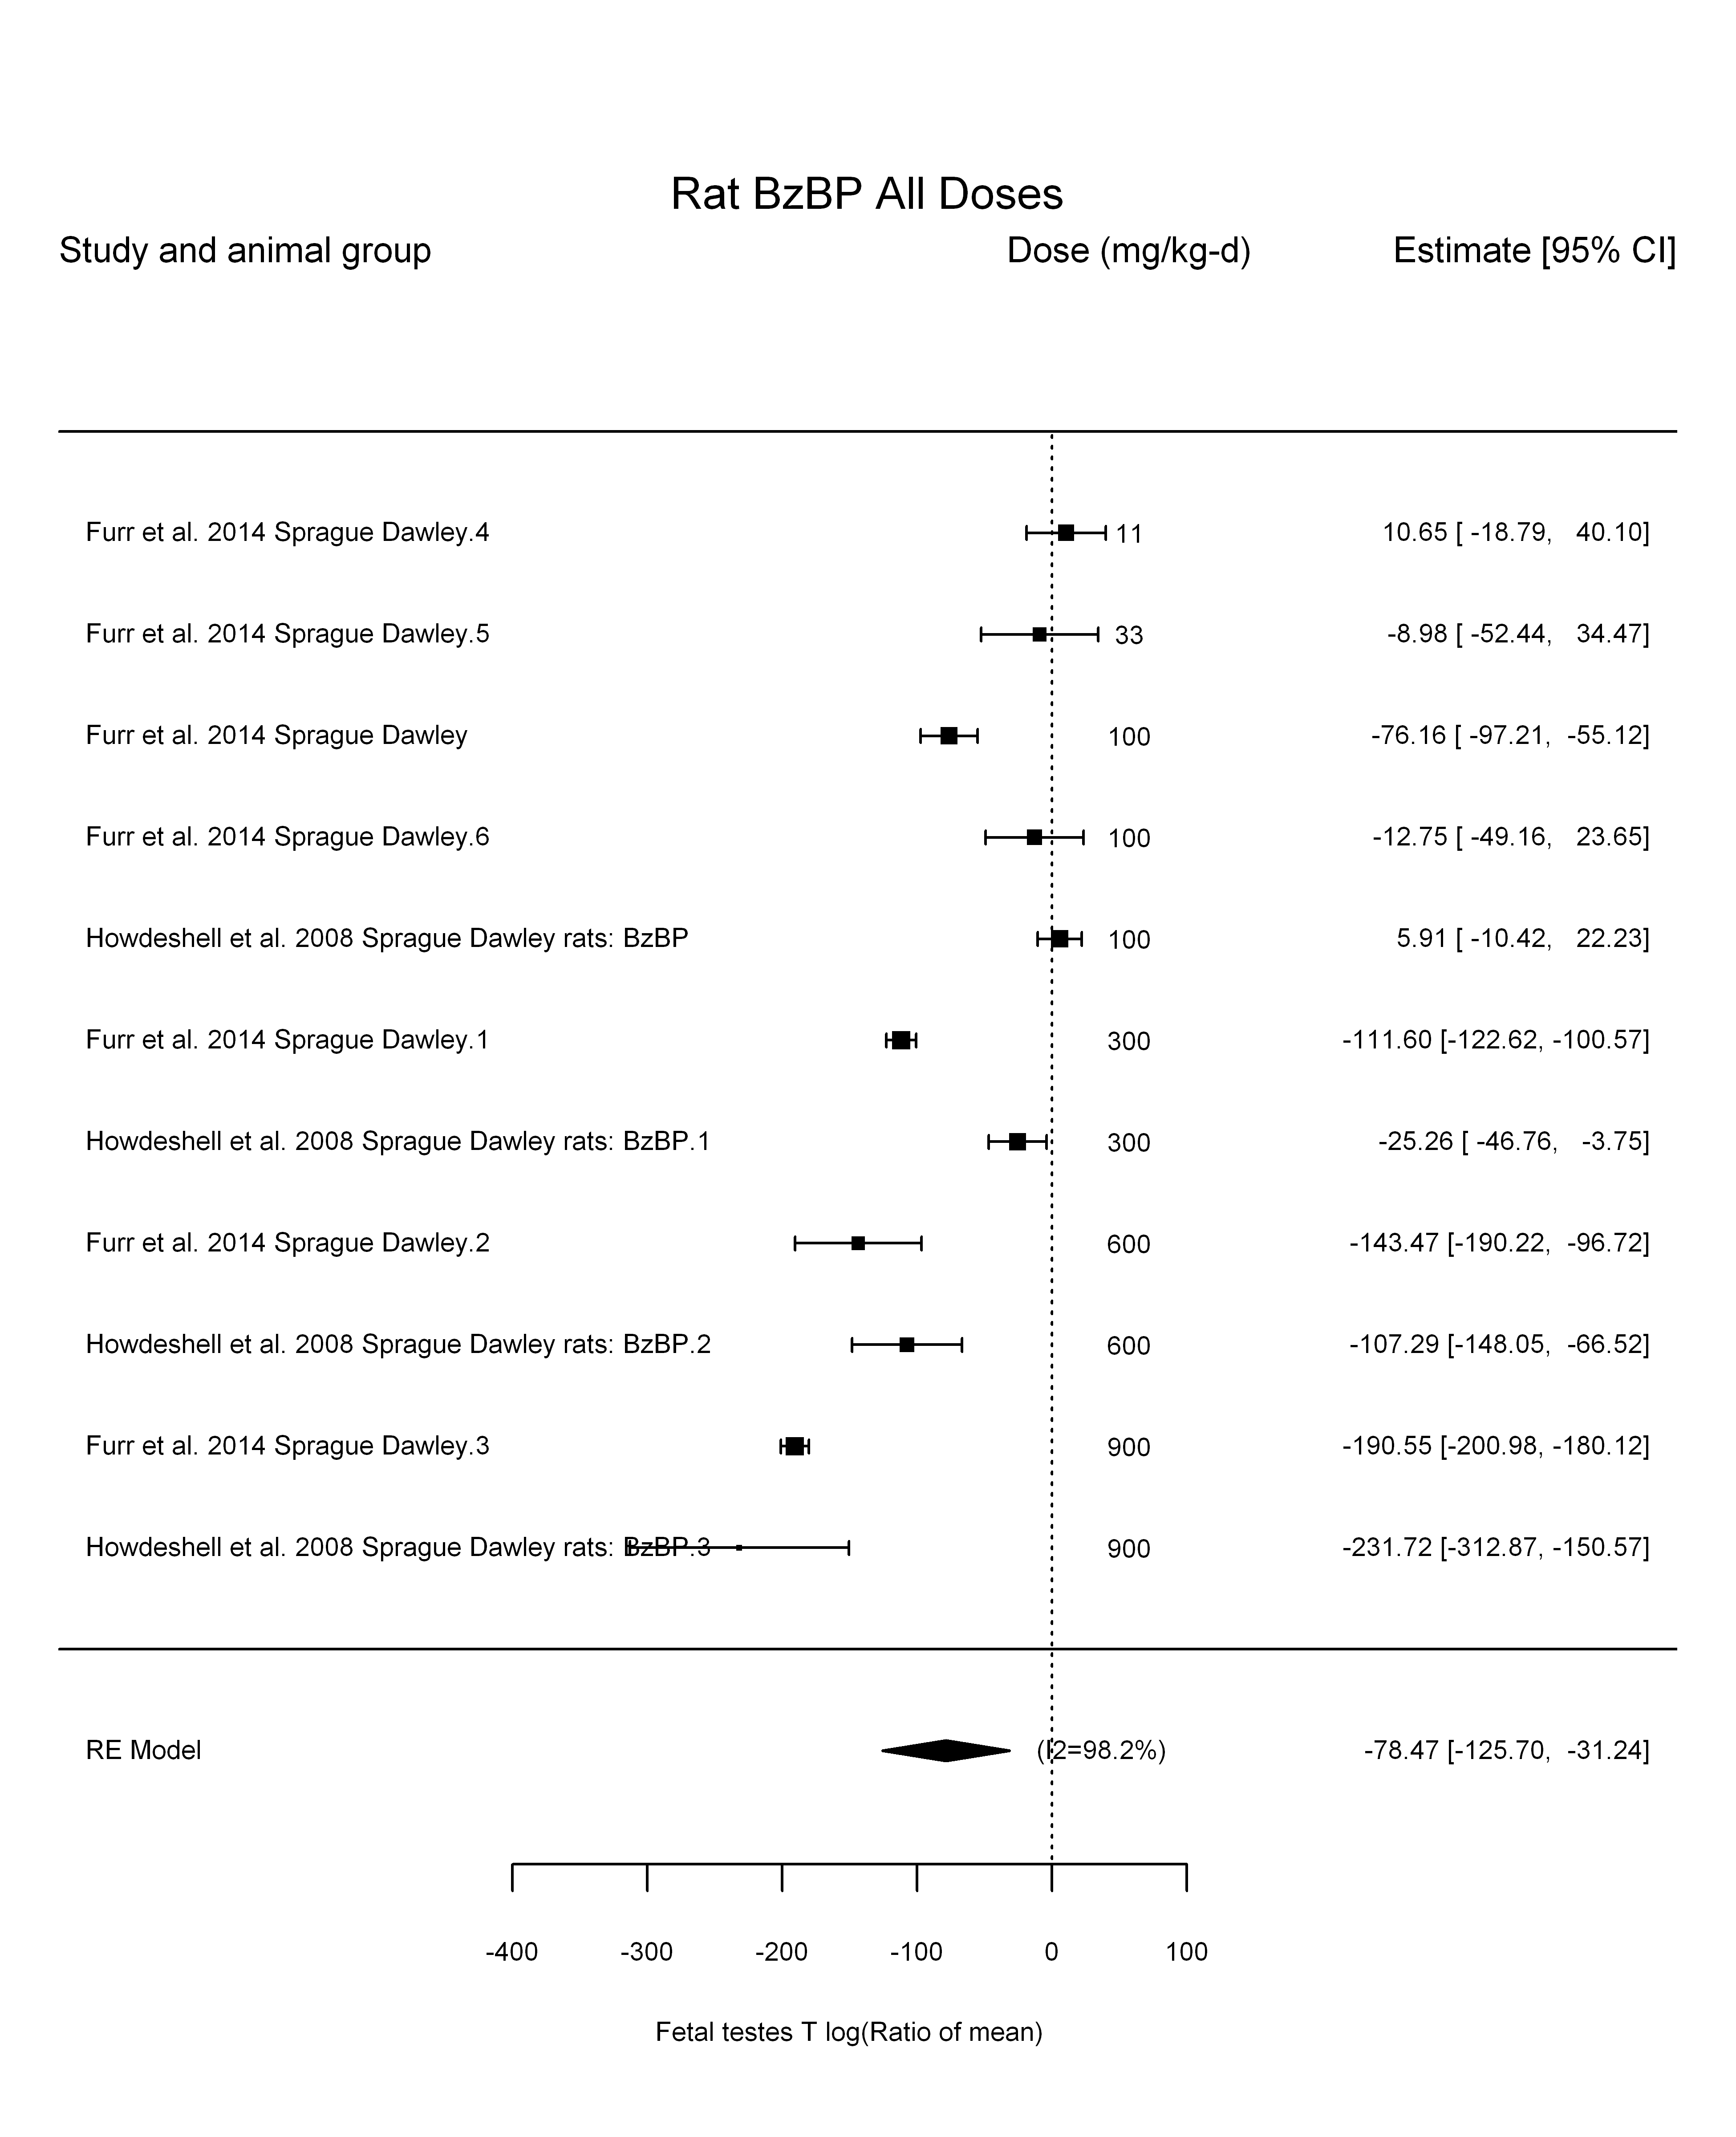

## [1] "Leave one out---------------------"  
## [1] "Trend in log10(dose)---------------------"  
##   
## Mixed-Effects Model (k = 11; tau^2 estimator: REML)  
##   
## logLik deviance AIC BIC AICc   
## -47.5630 95.1260 101.1260 101.7177 105.9260   
##   
## tau^2 (estimated amount of residual heterogeneity): 1920.6942 (SE = 1043.0957)  
## tau (square root of estimated tau^2 value): 43.8257  
## I^2 (residual heterogeneity / unaccounted variability): 93.93%  
## H^2 (unaccounted variability / sampling variability): 16.48  
## R^2 (amount of heterogeneity accounted for): 68.20%  
##   
## Test for Residual Heterogeneity:   
## QE(df = 9) = 148.9754, p-val < .0001  
##   
## Test of Moderators (coefficient(s) 2):   
## QM(df = 1) = 18.9733, p-val < .0001  
##   
## Model Results:  
##   
## estimate se zval pval ci.lb ci.ub   
## intrcpt 164.4037 56.9186 2.8884 0.0039 52.8452 275.9621 **  
## log10(dose) -106.7427 24.5057 -4.3558 <.0001 -154.7730 -58.7125 ***  
##   
## ---  
## Signif. codes: 0 '***' 0.001 '**' 0.01 '*' 0.05 '.' 0.1 ' ' 1

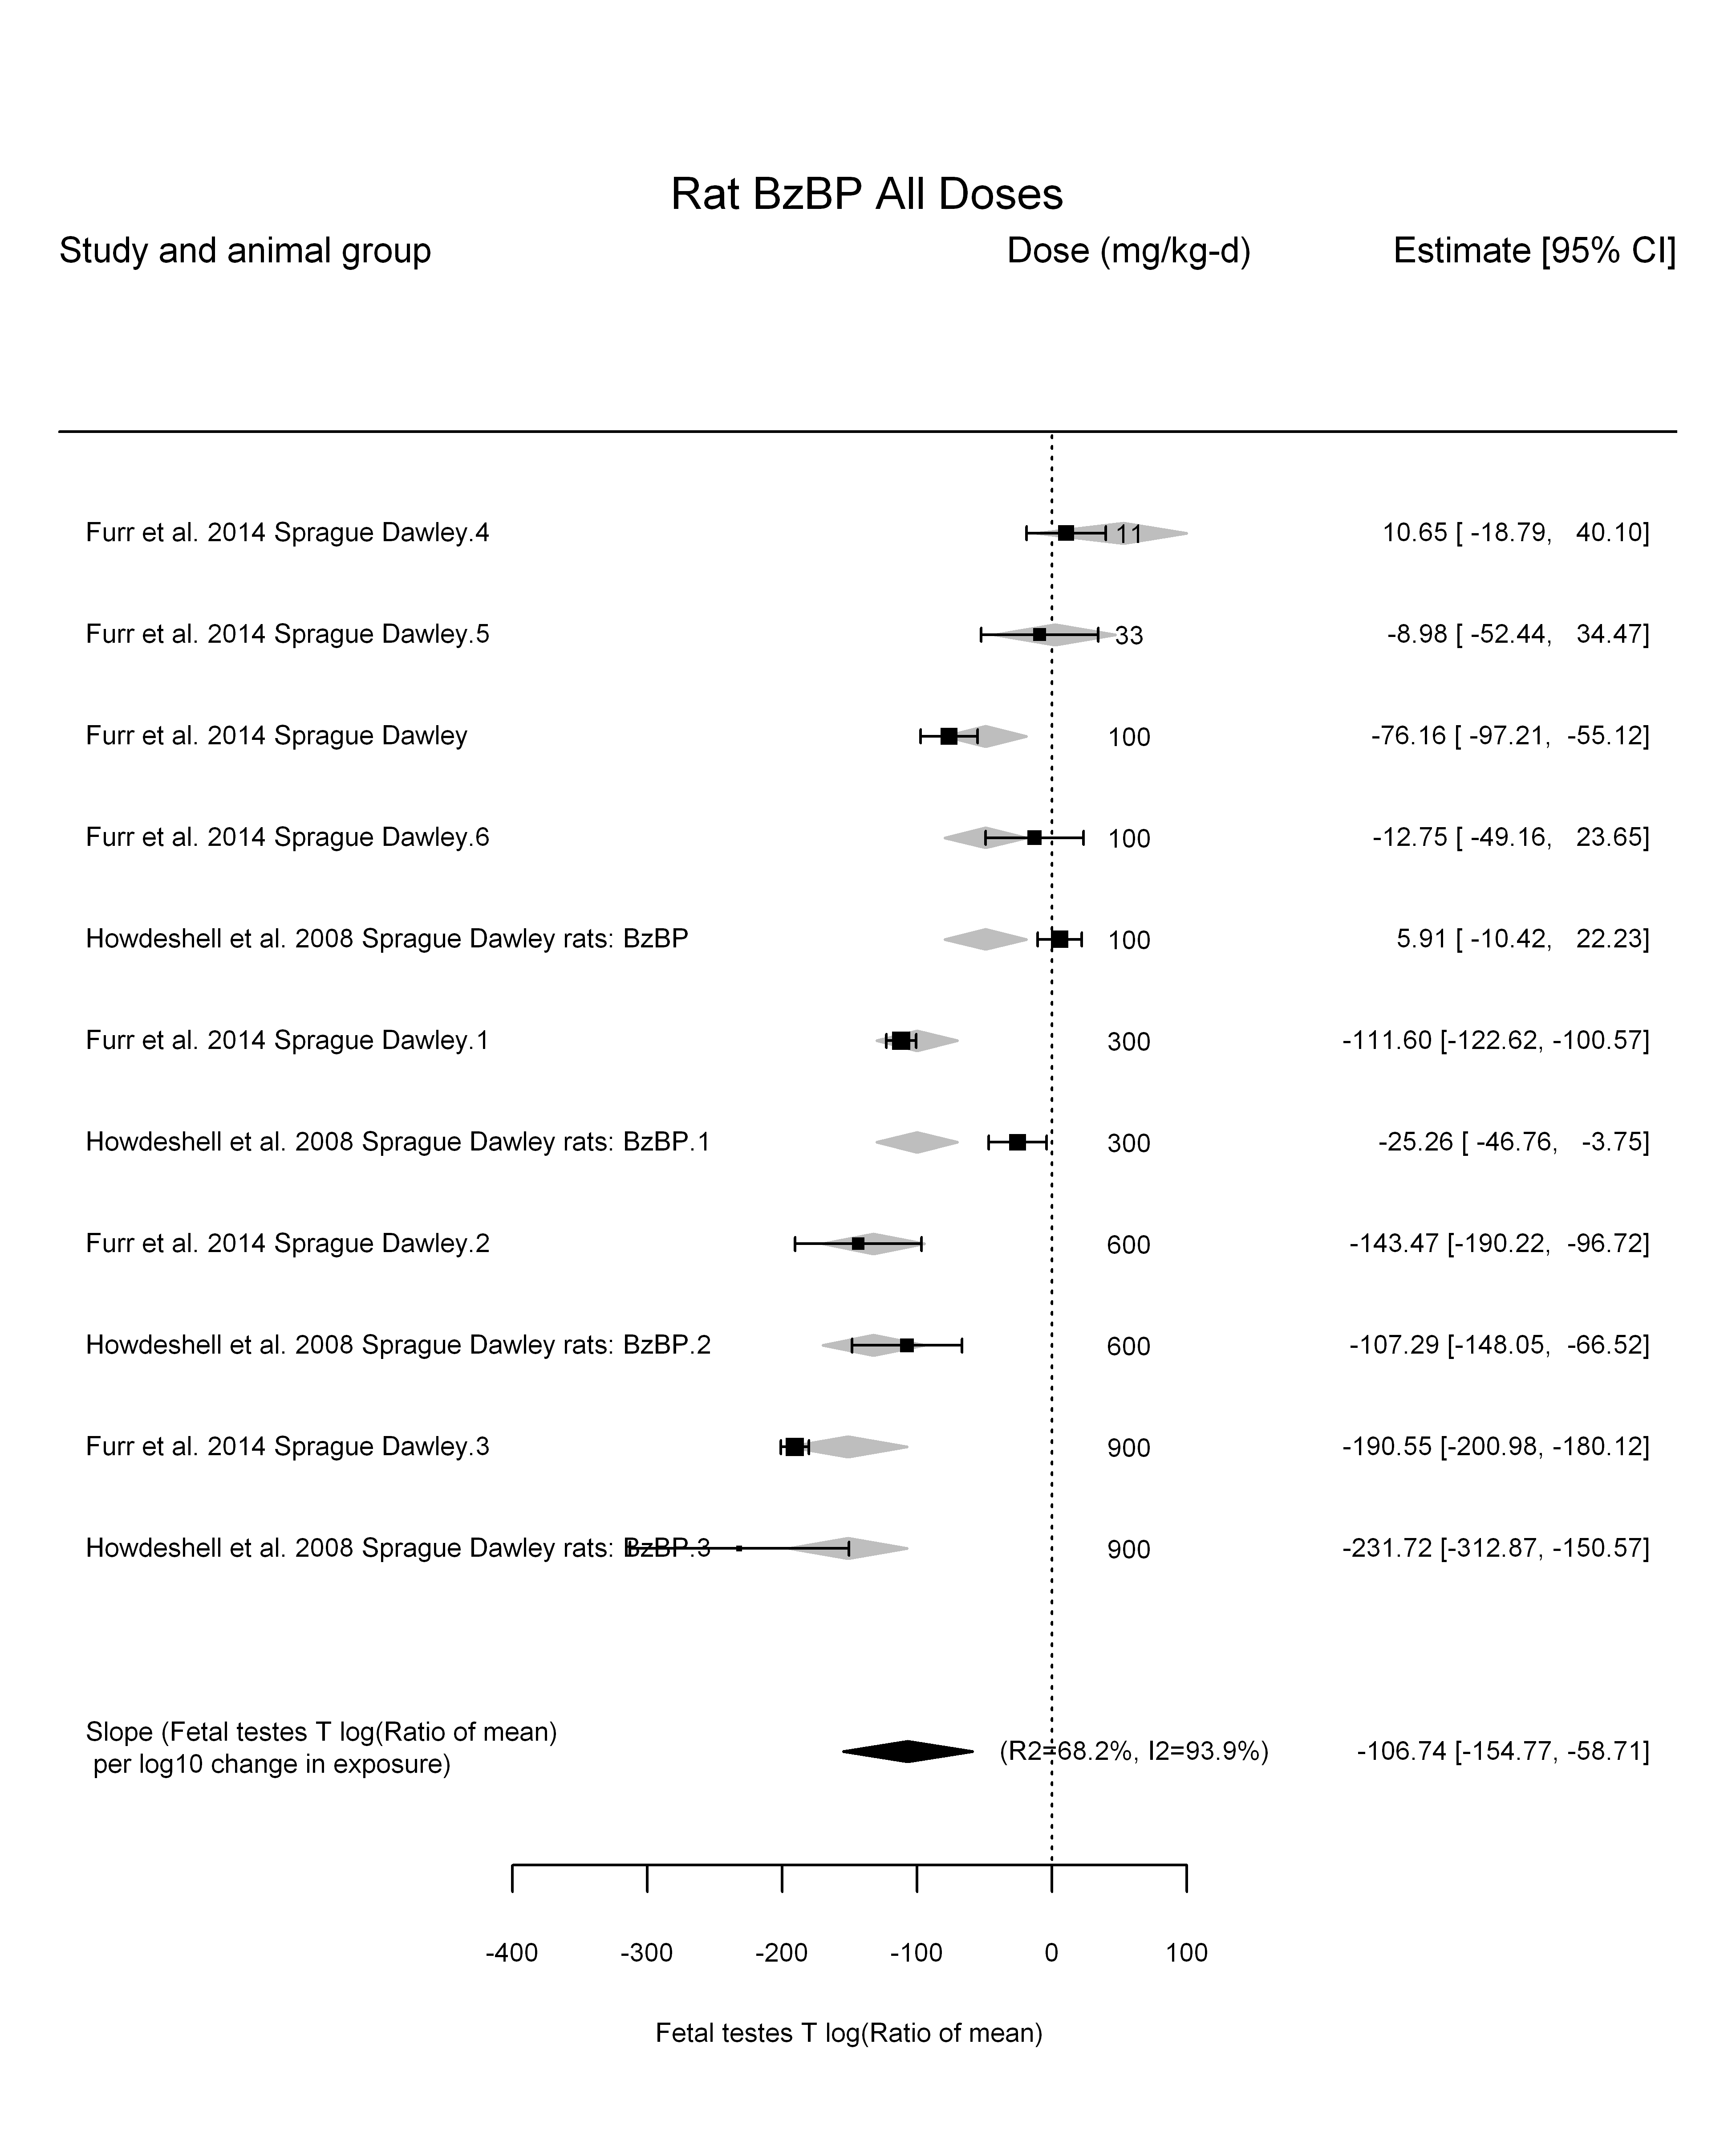

## [1] "Linear---------------------"  
##   
## Mixed-Effects Model (k = 11; tau^2 estimator: REML)  
##   
## logLik deviance AIC BIC AICc   
## -49.0708 98.1416 102.1416 102.7468 103.8559   
##   
## tau^2 (estimated amount of residual heterogeneity): 899.0224 (SE = 514.0735)  
## tau (square root of estimated tau^2 value): 29.9837  
## I^2 (residual heterogeneity / unaccounted variability): 87.79%  
## H^2 (unaccounted variability / sampling variability): 8.19  
##   
## Test for Residual Heterogeneity:   
## QE(df = 10) = 121.2095, p-val < .0001  
##   
## Model Results:  
##   
## estimate se zval pval ci.lb ci.ub   
## dose100 -22.1185 2.2863 -9.6744 <.0001 -26.5996 -17.6375 ***  
##   
## ---  
## Signif. codes: 0 '***' 0.001 '**' 0.01 '*' 0.05 '.' 0.1 ' ' 1

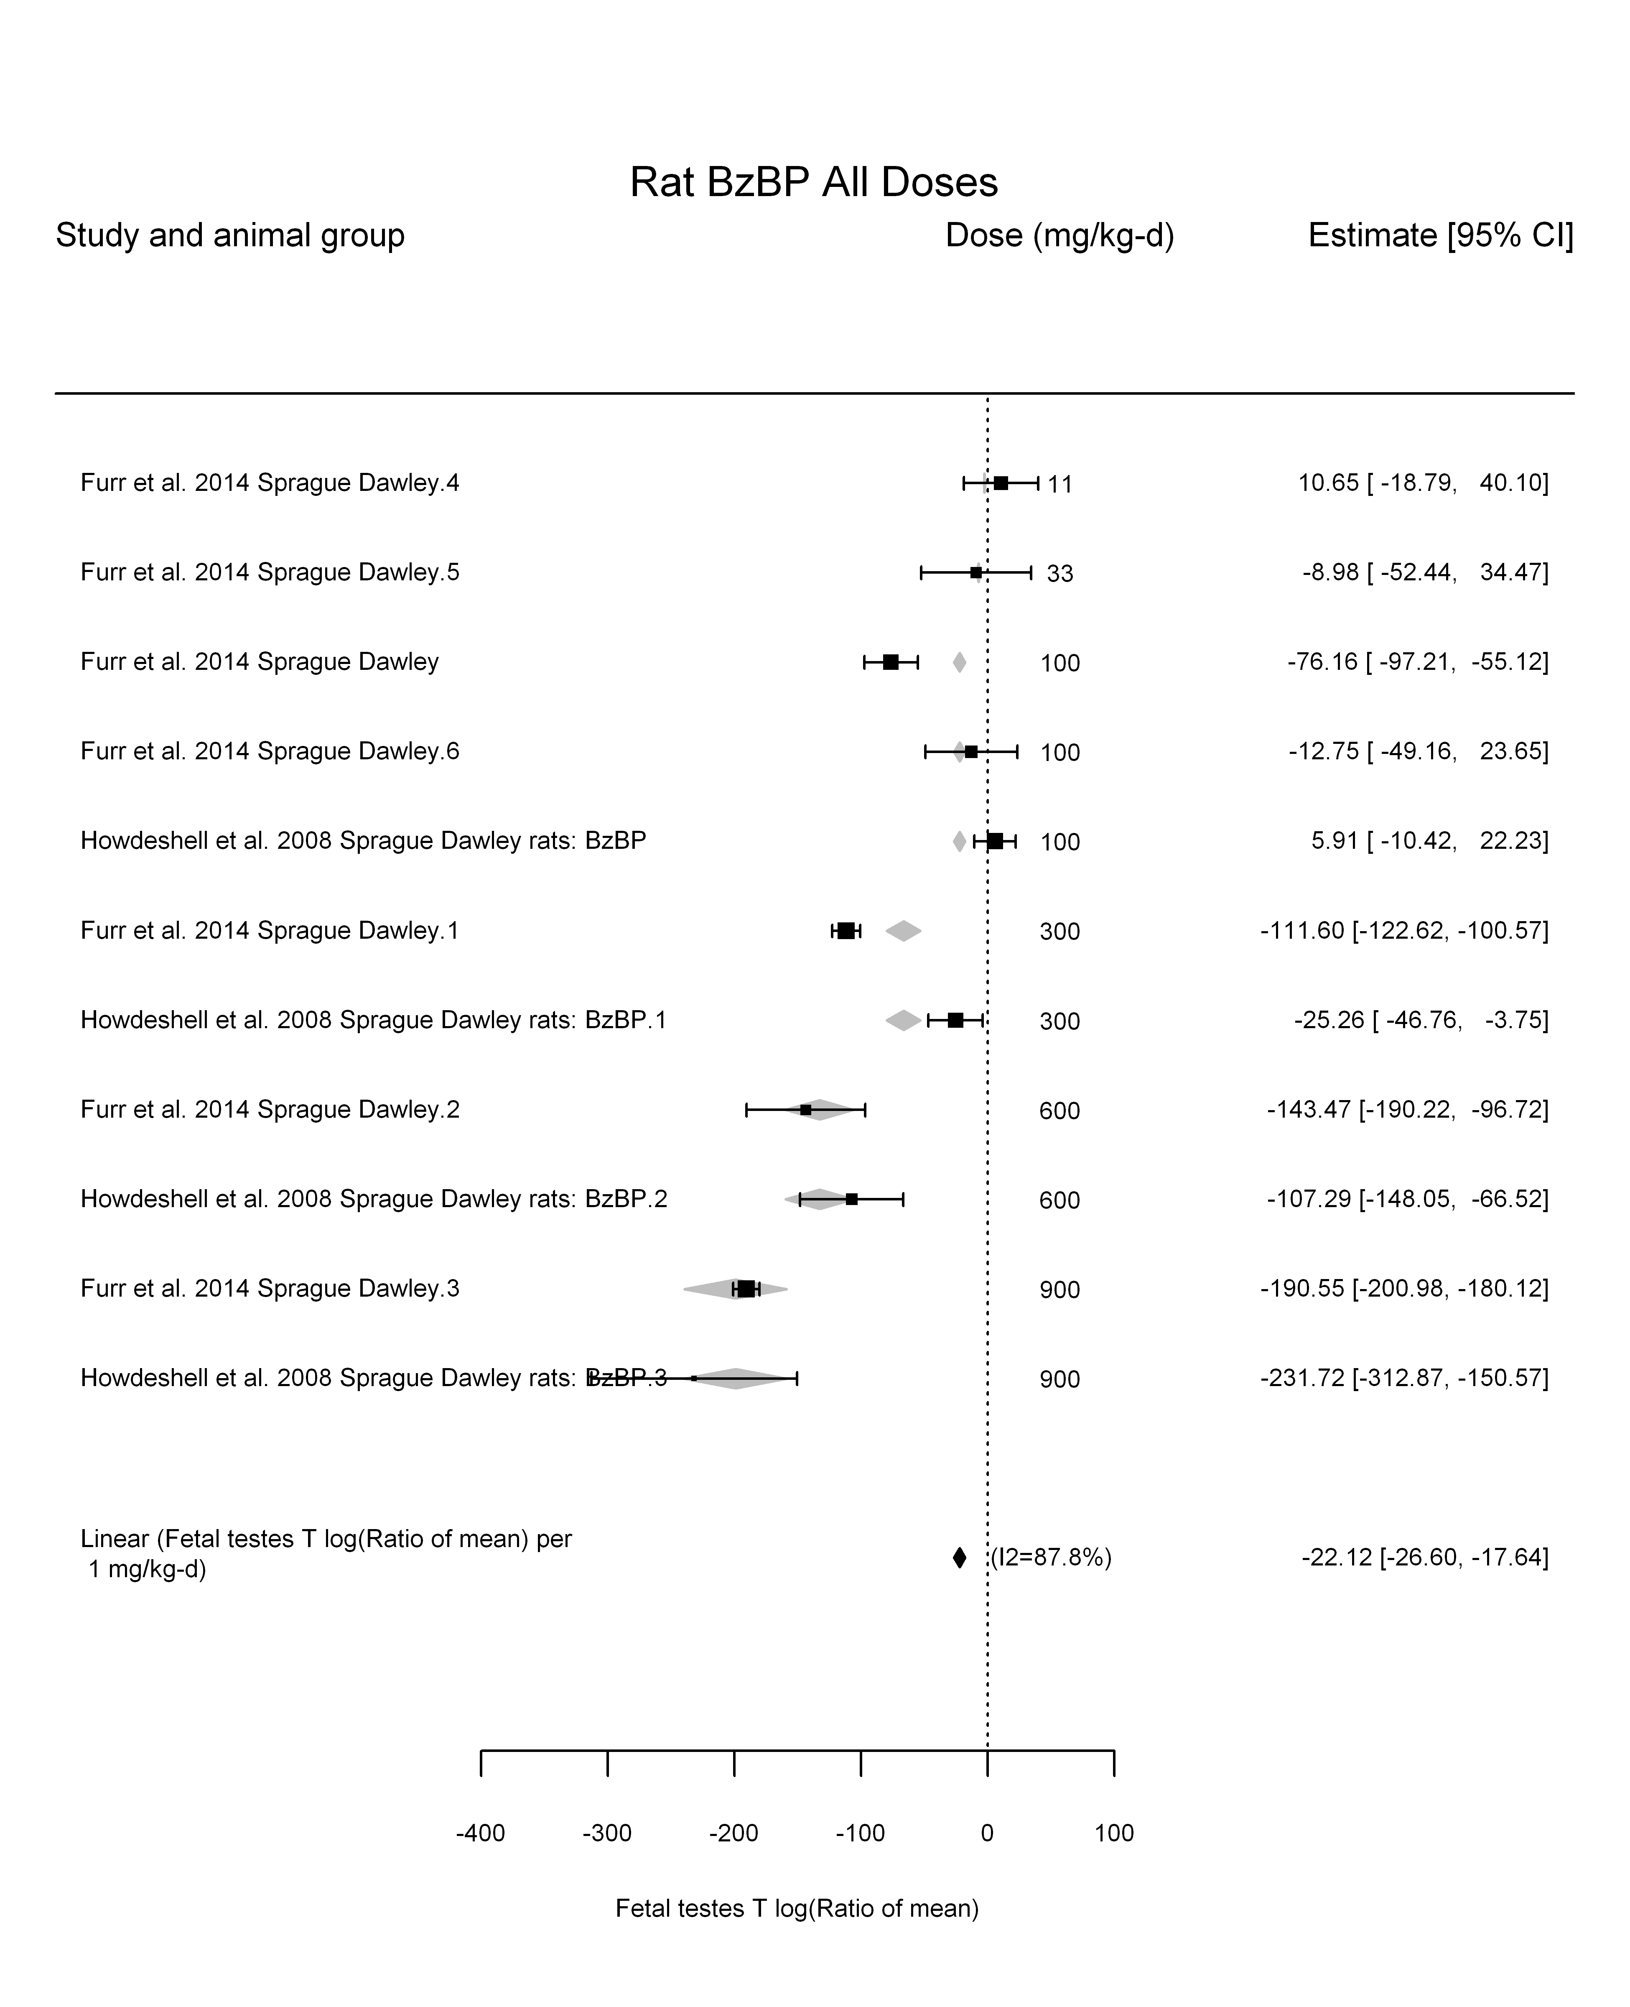

## [1] "LinearQuadratic---------------------"  
##   
## Mixed-Effects Model (k = 11; tau^2 estimator: REML)  
##   
## logLik deviance AIC BIC AICc   
## -44.5994 89.1988 95.1988 95.7904 99.9988   
##   
## tau^2 (estimated amount of residual heterogeneity): 1008.4250 (SE = 603.9377)  
## tau (square root of estimated tau^2 value): 31.7557  
## I^2 (residual heterogeneity / unaccounted variability): 86.02%  
## H^2 (unaccounted variability / sampling variability): 7.15  
##   
## Test for Residual Heterogeneity:   
## QE(df = 9) = 95.5628, p-val < .0001  
##   
## Test of Moderators (coefficient(s) 1,2):   
## QM(df = 2) = 85.7990, p-val < .0001  
##   
## Model Results:  
##   
## estimate se zval pval ci.lb ci.ub   
## dose100 -22.5197 8.7115 -2.5851 0.0097 -39.5940 -5.4455 **  
## I(dose100^2) 0.0500 1.1186 0.0447 0.9643 -2.1424 2.2424   
##   
## ---  
## Signif. codes: 0 '***' 0.001 '**' 0.01 '*' 0.05 '.' 0.1 ' ' 1

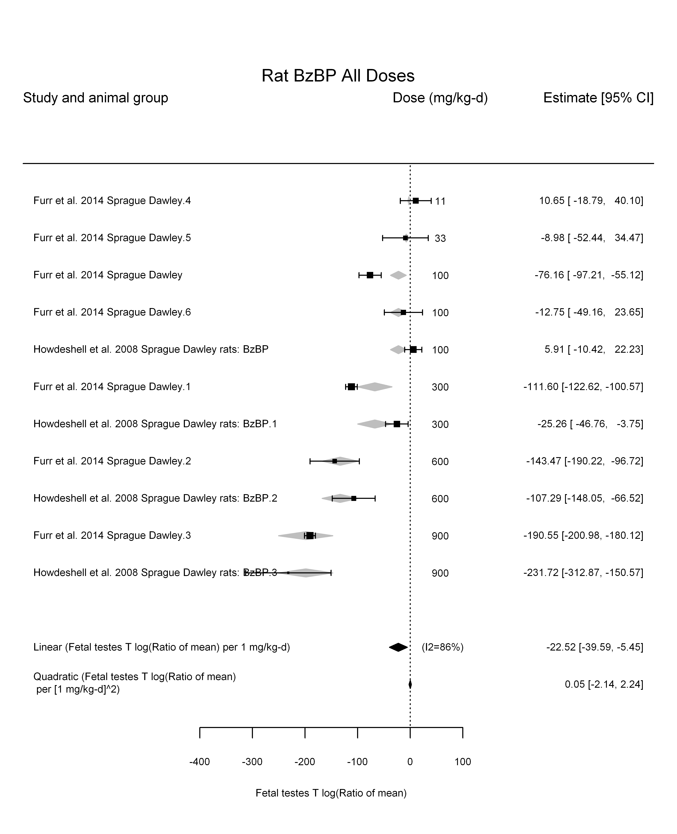

## [1] ""

## [1] ""  
## m ci.lb ci.ub bmr  
## 1 23.19009 19.2834 29.08195 -5.129329  
## m ci.lb ci.ub bmr  
## 1 230.9483 192.0423 289.6235 -51.08256

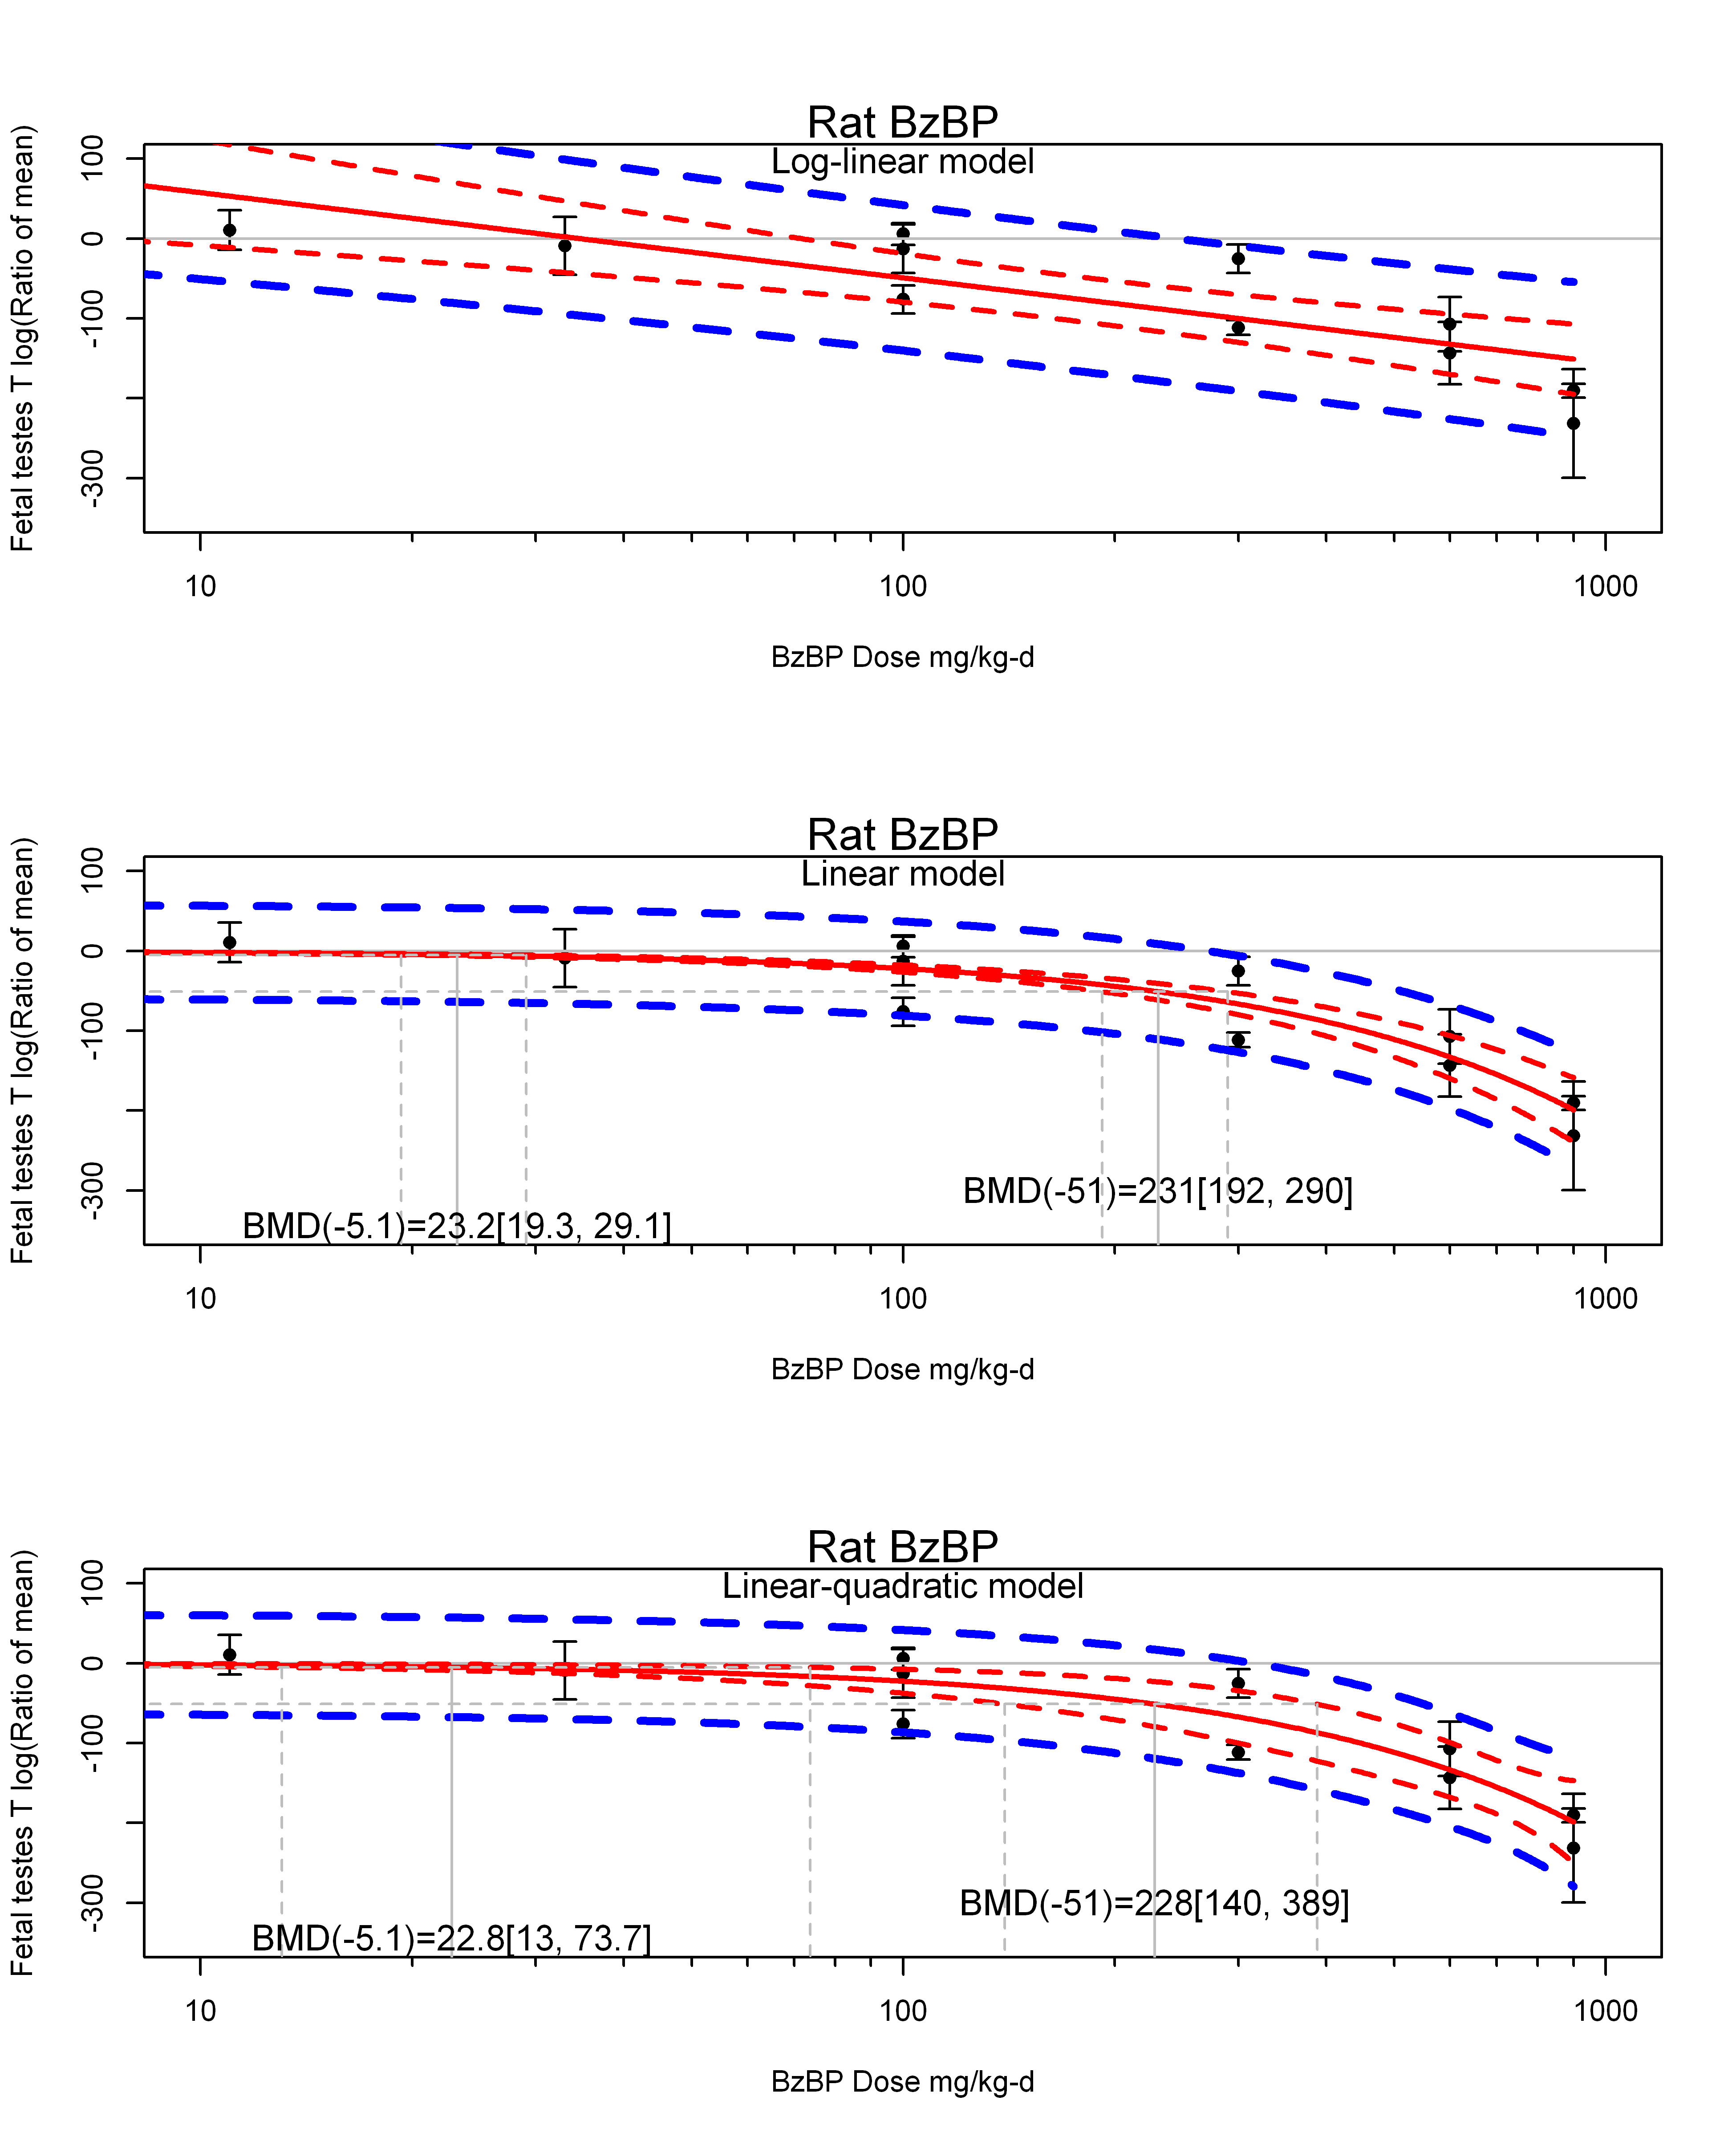

## [1] ""  
## m ci.lb ci.ub bmr  
## 1 22.78853 13.0475 73.73192 -5.129329  
## m ci.lb ci.ub bmr  
## 1 227.9877 139.5414 388.6796 -51.08256  
## [1] "Fetal testes T log(Ratio of mean) Rat Highest Dose"  
## [1] "Fetal testes T log(Ratio of mean) Mouse"  
## [1] "Fetal testes T log(Ratio of mean) Rat"  
## [1] "Overall---------------------"  
##   
## Random-Effects Model (k = 12; tau^2 estimator: REML)  
##   
## logLik deviance AIC BIC AICc   
## -56.3284 112.6568 116.6568 117.4525 118.1568   
##   
## tau^2 (estimated amount of total heterogeneity): 970.9569 (SE = 616.4444)  
## tau (square root of estimated tau^2 value): 31.1602  
## I^2 (total heterogeneity / total variability): 83.28%  
## H^2 (total variability / sampling variability): 5.98  
##   
## Test for Heterogeneity:   
## Q(df = 11) = 65.8598, p-val < .0001  
##   
## Model Results:  
##   
## estimate se zval pval ci.lb ci.ub   
## -63.9510 11.4284 -5.5958 <.0001 -86.3502 -41.5518 ***   
##   
## ---  
## Signif. codes: 0 '***' 0.001 '**' 0.01 '*' 0.05 '.' 0.1 ' ' 1

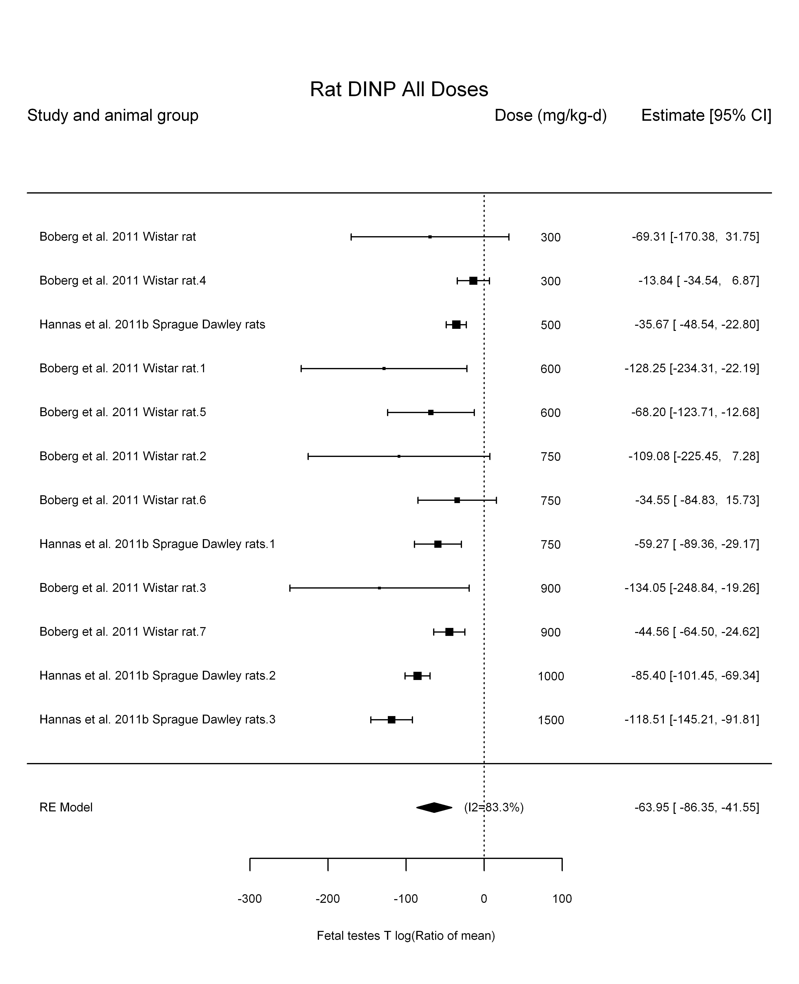

## [1] "Leave one out---------------------"  
## [1] "Trend in log10(dose)---------------------"  
##   
## Mixed-Effects Model (k = 12; tau^2 estimator: REML)  
##   
## logLik deviance AIC BIC AICc   
## -48.1200 96.2401 102.2401 103.1478 106.2401   
##   
## tau^2 (estimated amount of residual heterogeneity): 158.6260 (SE = 181.3806)  
## tau (square root of estimated tau^2 value): 12.5947  
## I^2 (residual heterogeneity / unaccounted variability): 42.01%  
## H^2 (unaccounted variability / sampling variability): 1.72  
## R^2 (amount of heterogeneity accounted for): 83.66%  
##   
## Test for Residual Heterogeneity:   
## QE(df = 10) = 16.9288, p-val = 0.0760  
##   
## Test of Moderators (coefficient(s) 2):   
## QM(df = 1) = 18.7411, p-val < .0001  
##   
## Model Results:  
##   
## estimate se zval pval ci.lb ci.ub   
## intrcpt 305.9772 84.4733 3.6222 0.0003 140.4126 471.5419 ***  
## log10(dose) -128.3476 29.6476 -4.3291 <.0001 -186.4558 -70.2393 ***  
##   
## ---  
## Signif. codes: 0 '***' 0.001 '**' 0.01 '*' 0.05 '.' 0.1 ' ' 1

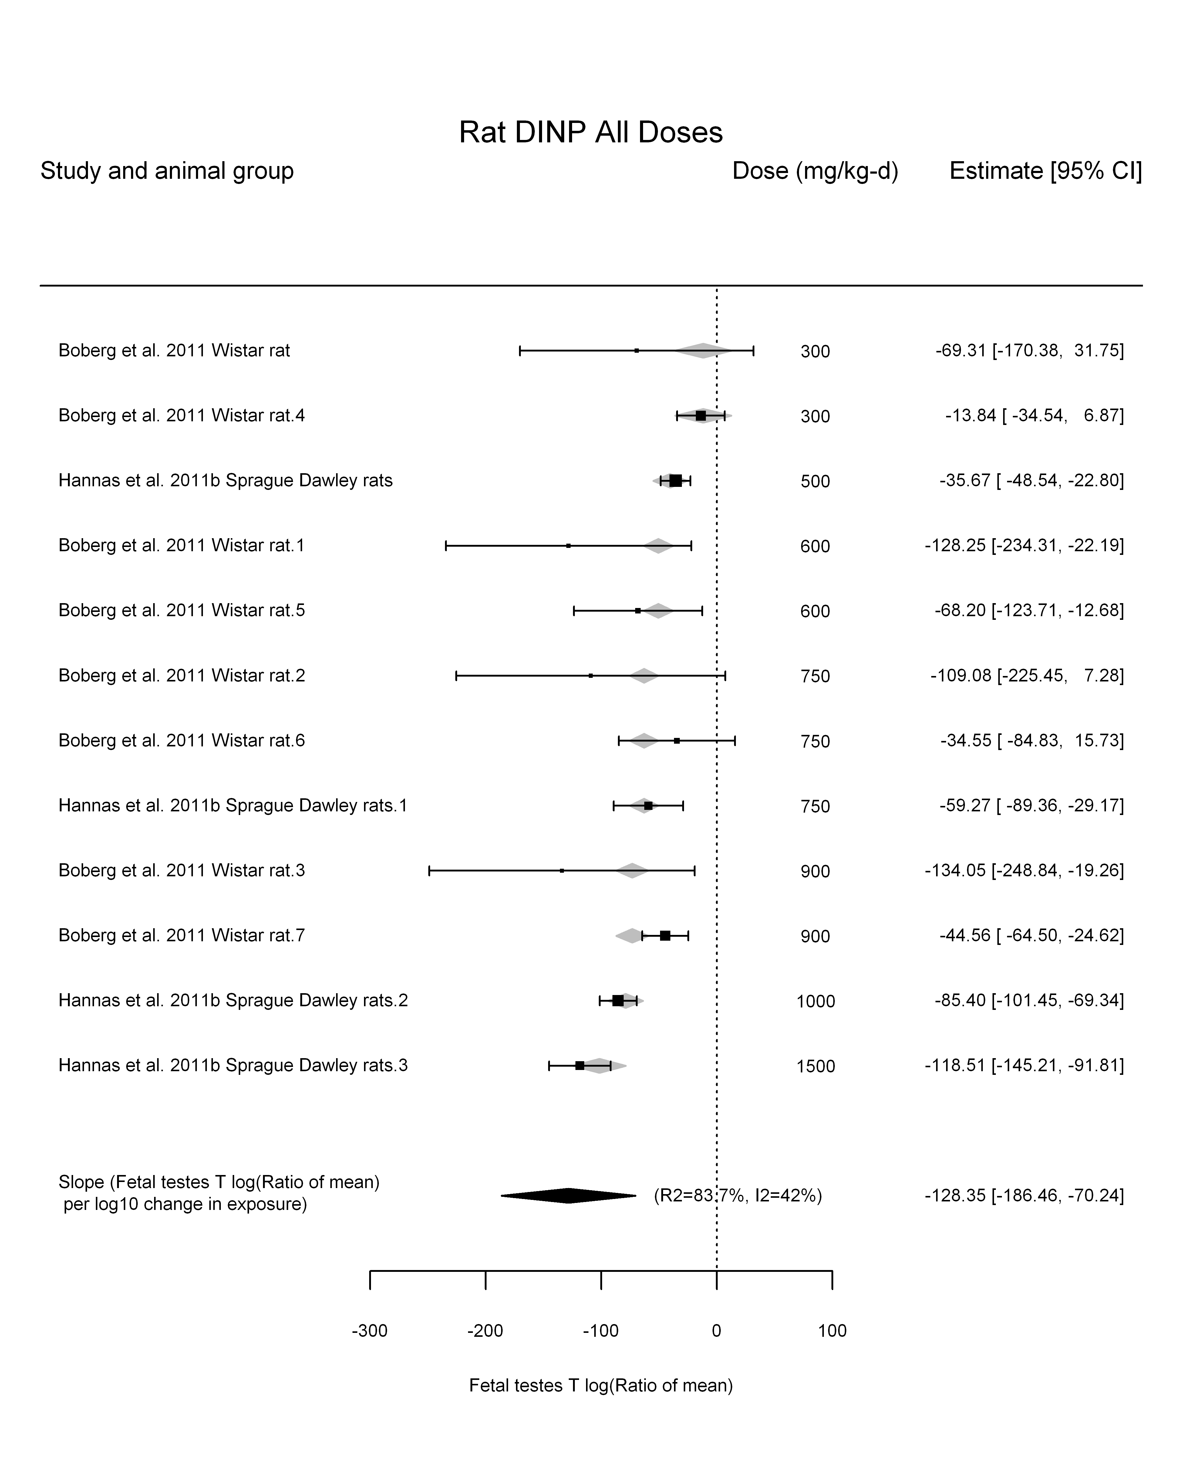

## [1] "Linear---------------------"  
##   
## Mixed-Effects Model (k = 12; tau^2 estimator: REML)  
##   
## logLik deviance AIC BIC AICc   
## -51.1374 102.2749 106.2749 107.0707 107.7749   
##   
## tau^2 (estimated amount of residual heterogeneity): 52.0232 (SE = 90.7033)  
## tau (square root of estimated tau^2 value): 7.2127  
## I^2 (residual heterogeneity / unaccounted variability): 21.84%  
## H^2 (unaccounted variability / sampling variability): 1.28  
##   
## Test for Residual Heterogeneity:   
## QE(df = 11) = 14.3359, p-val = 0.2150  
##   
## Model Results:  
##   
## estimate se zval pval ci.lb ci.ub   
## dose100 -7.5615 0.5777 -13.0879 <.0001 -8.6939 -6.4291 ***  
##   
## ---  
## Signif. codes: 0 '***' 0.001 '**' 0.01 '*' 0.05 '.' 0.1 ' ' 1

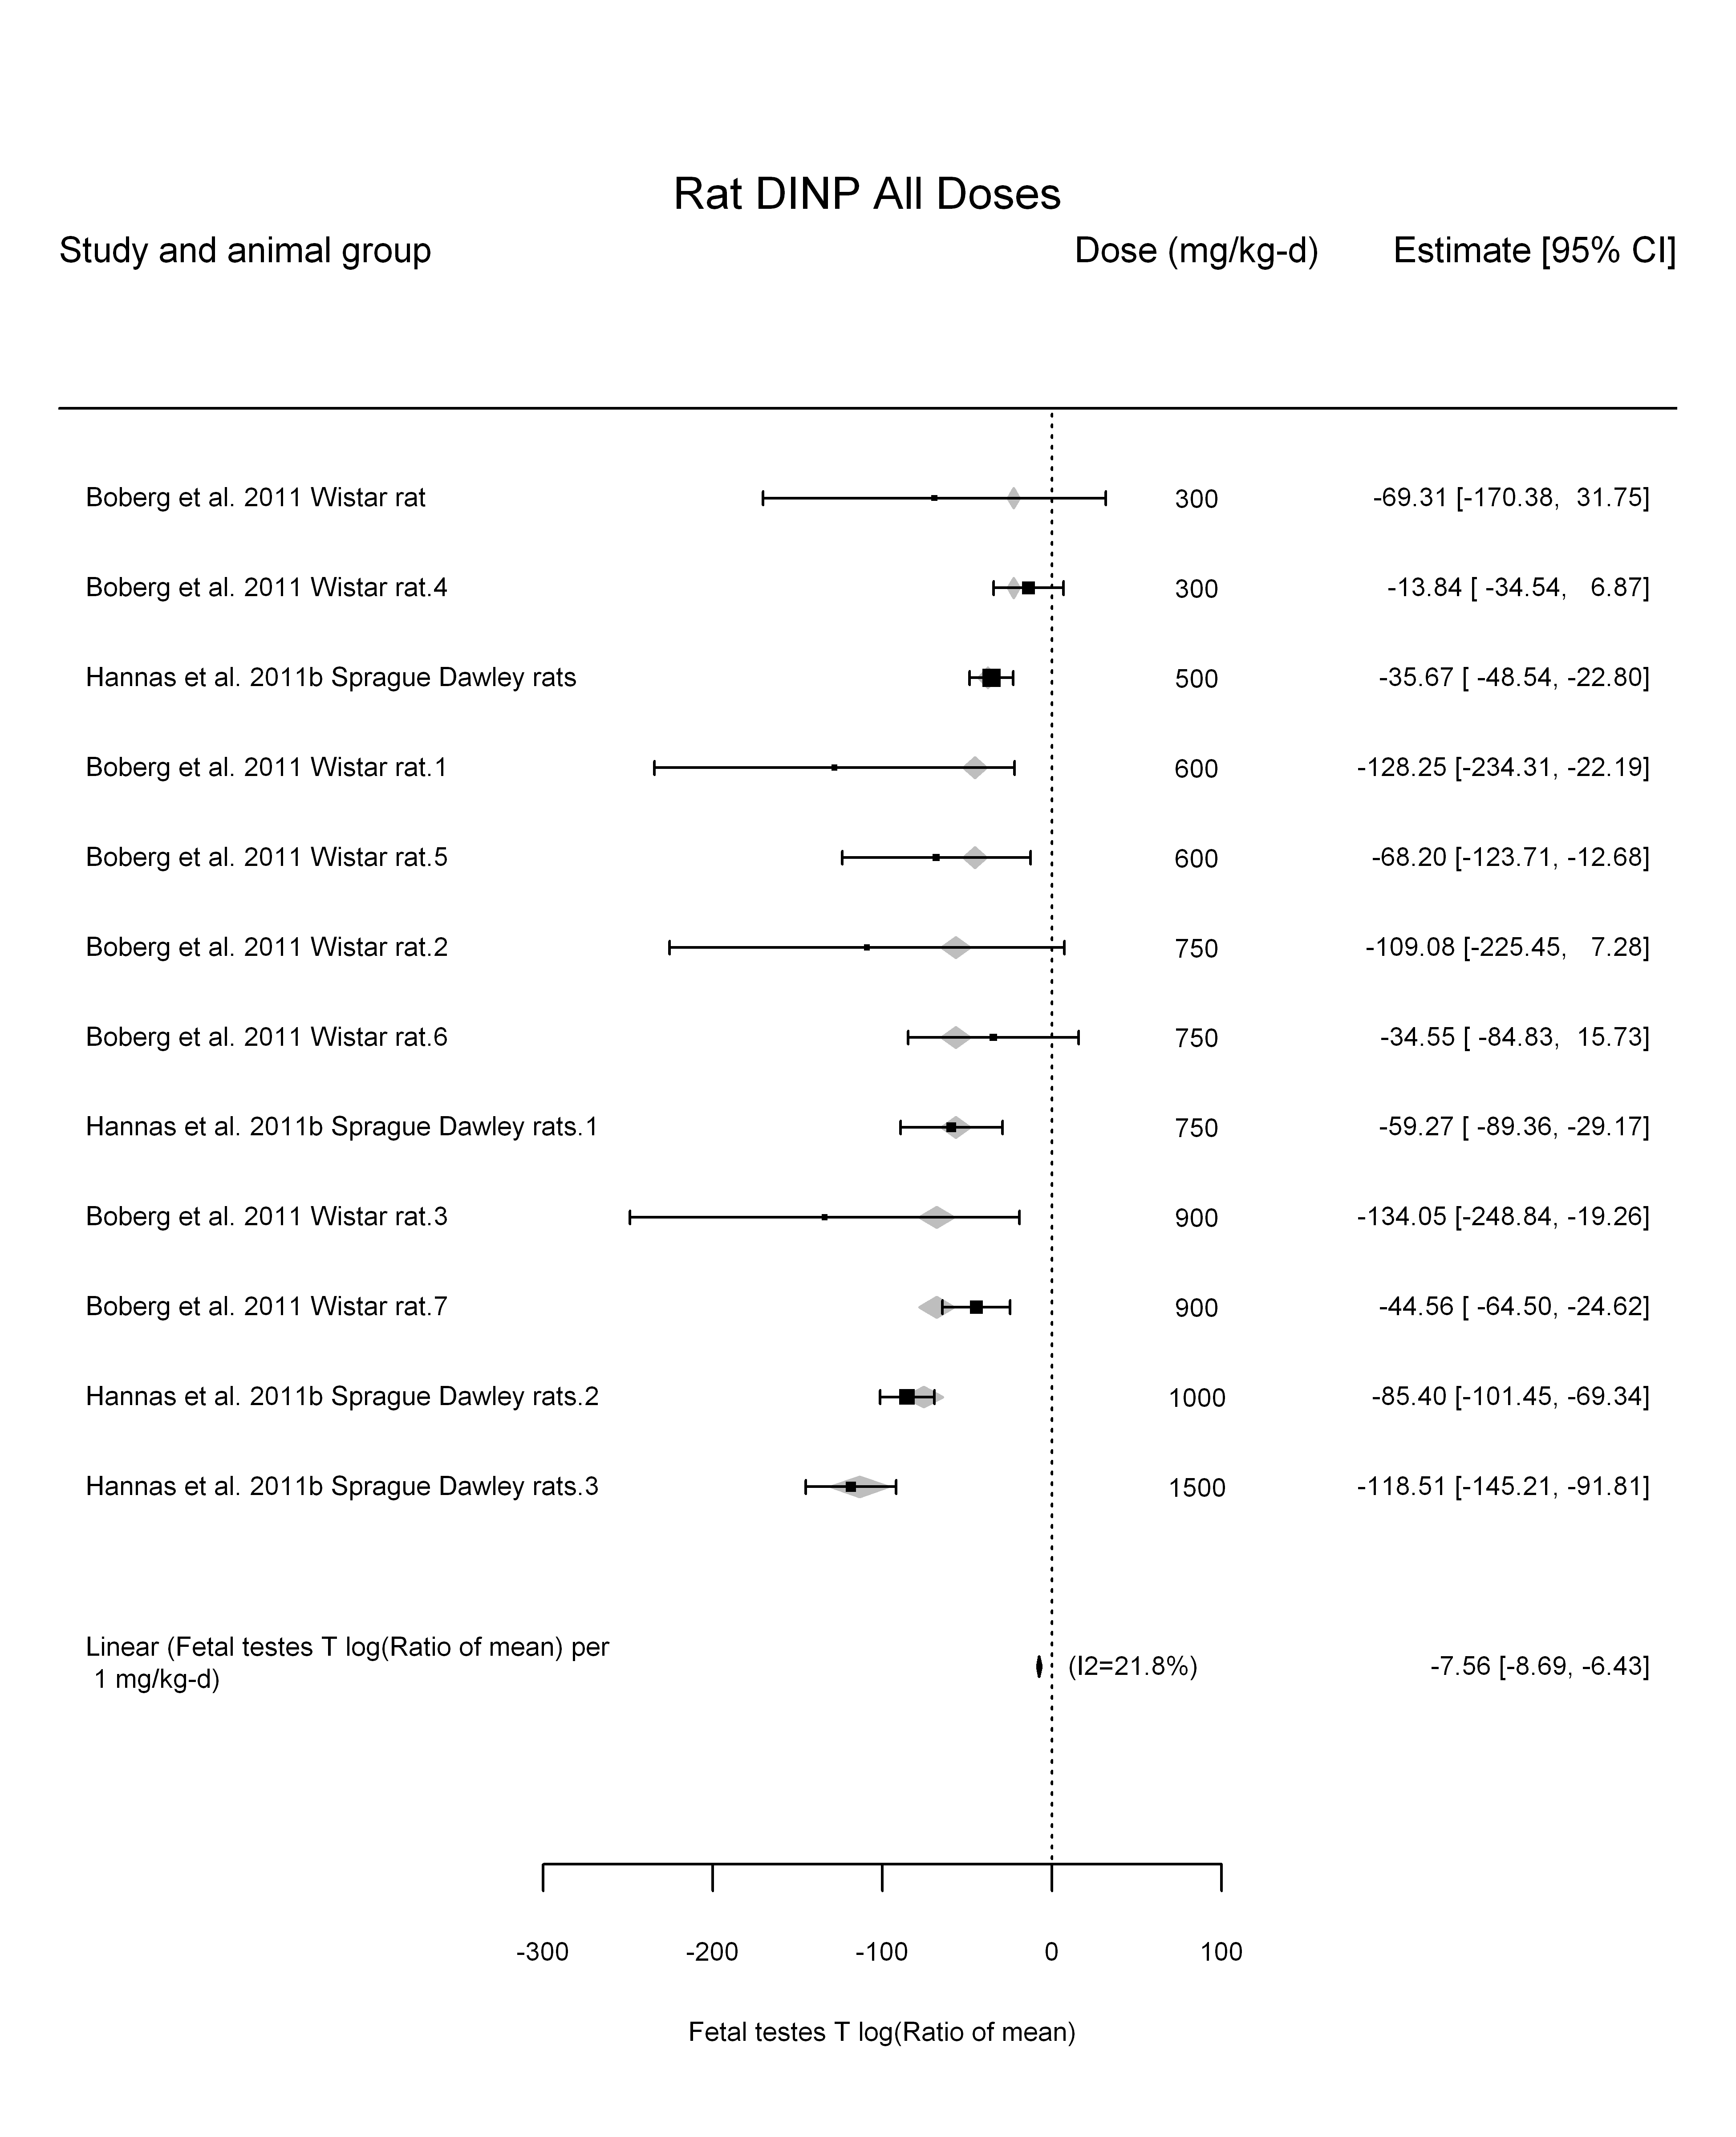

## [1] "LinearQuadratic---------------------"  
##   
## Mixed-Effects Model (k = 12; tau^2 estimator: REML)  
##   
## logLik deviance AIC BIC AICc   
## -47.2937 94.5875 100.5875 101.4952 104.5875   
##   
## tau^2 (estimated amount of residual heterogeneity): 64.6737 (SE = 110.0797)  
## tau (square root of estimated tau^2 value): 8.0420  
## I^2 (residual heterogeneity / unaccounted variability): 23.81%  
## H^2 (unaccounted variability / sampling variability): 1.31  
##   
## Test for Residual Heterogeneity:   
## QE(df = 10) = 13.8078, p-val = 0.1819  
##   
## Test of Moderators (coefficient(s) 1,2):   
## QM(df = 2) = 159.7723, p-val < .0001  
##   
## Model Results:  
##   
## estimate se zval pval ci.lb ci.ub   
## dose100 -6.7356 1.9266 -3.4960 0.0005 -10.5117 -2.9595 ***  
## I(dose100^2) -0.0793 0.1735 -0.4568 0.6478 -0.4194 0.2609   
##   
## ---  
## Signif. codes: 0 '***' 0.001 '**' 0.01 '*' 0.05 '.' 0.1 ' ' 1

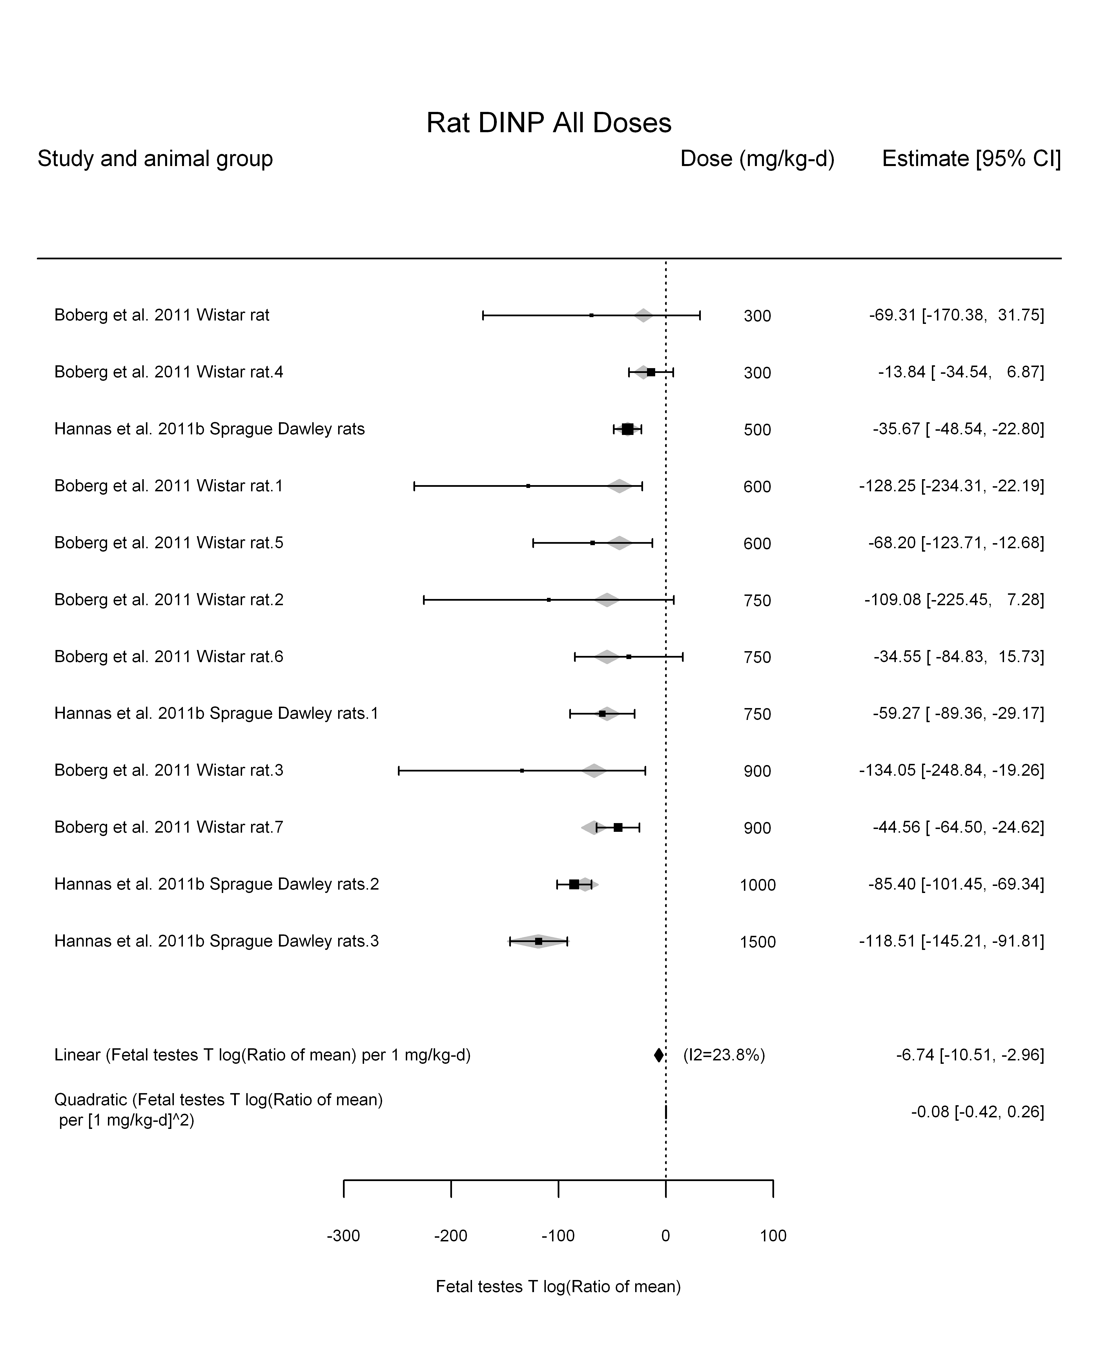

## [1] ""

## [1] ""  
## m ci.lb ci.ub bmr  
## 1 67.83476 58.99947 79.78225 -5.129329  
## m ci.lb ci.ub bmr  
## 1 675.5611 587.5704 794.5451 -51.08256

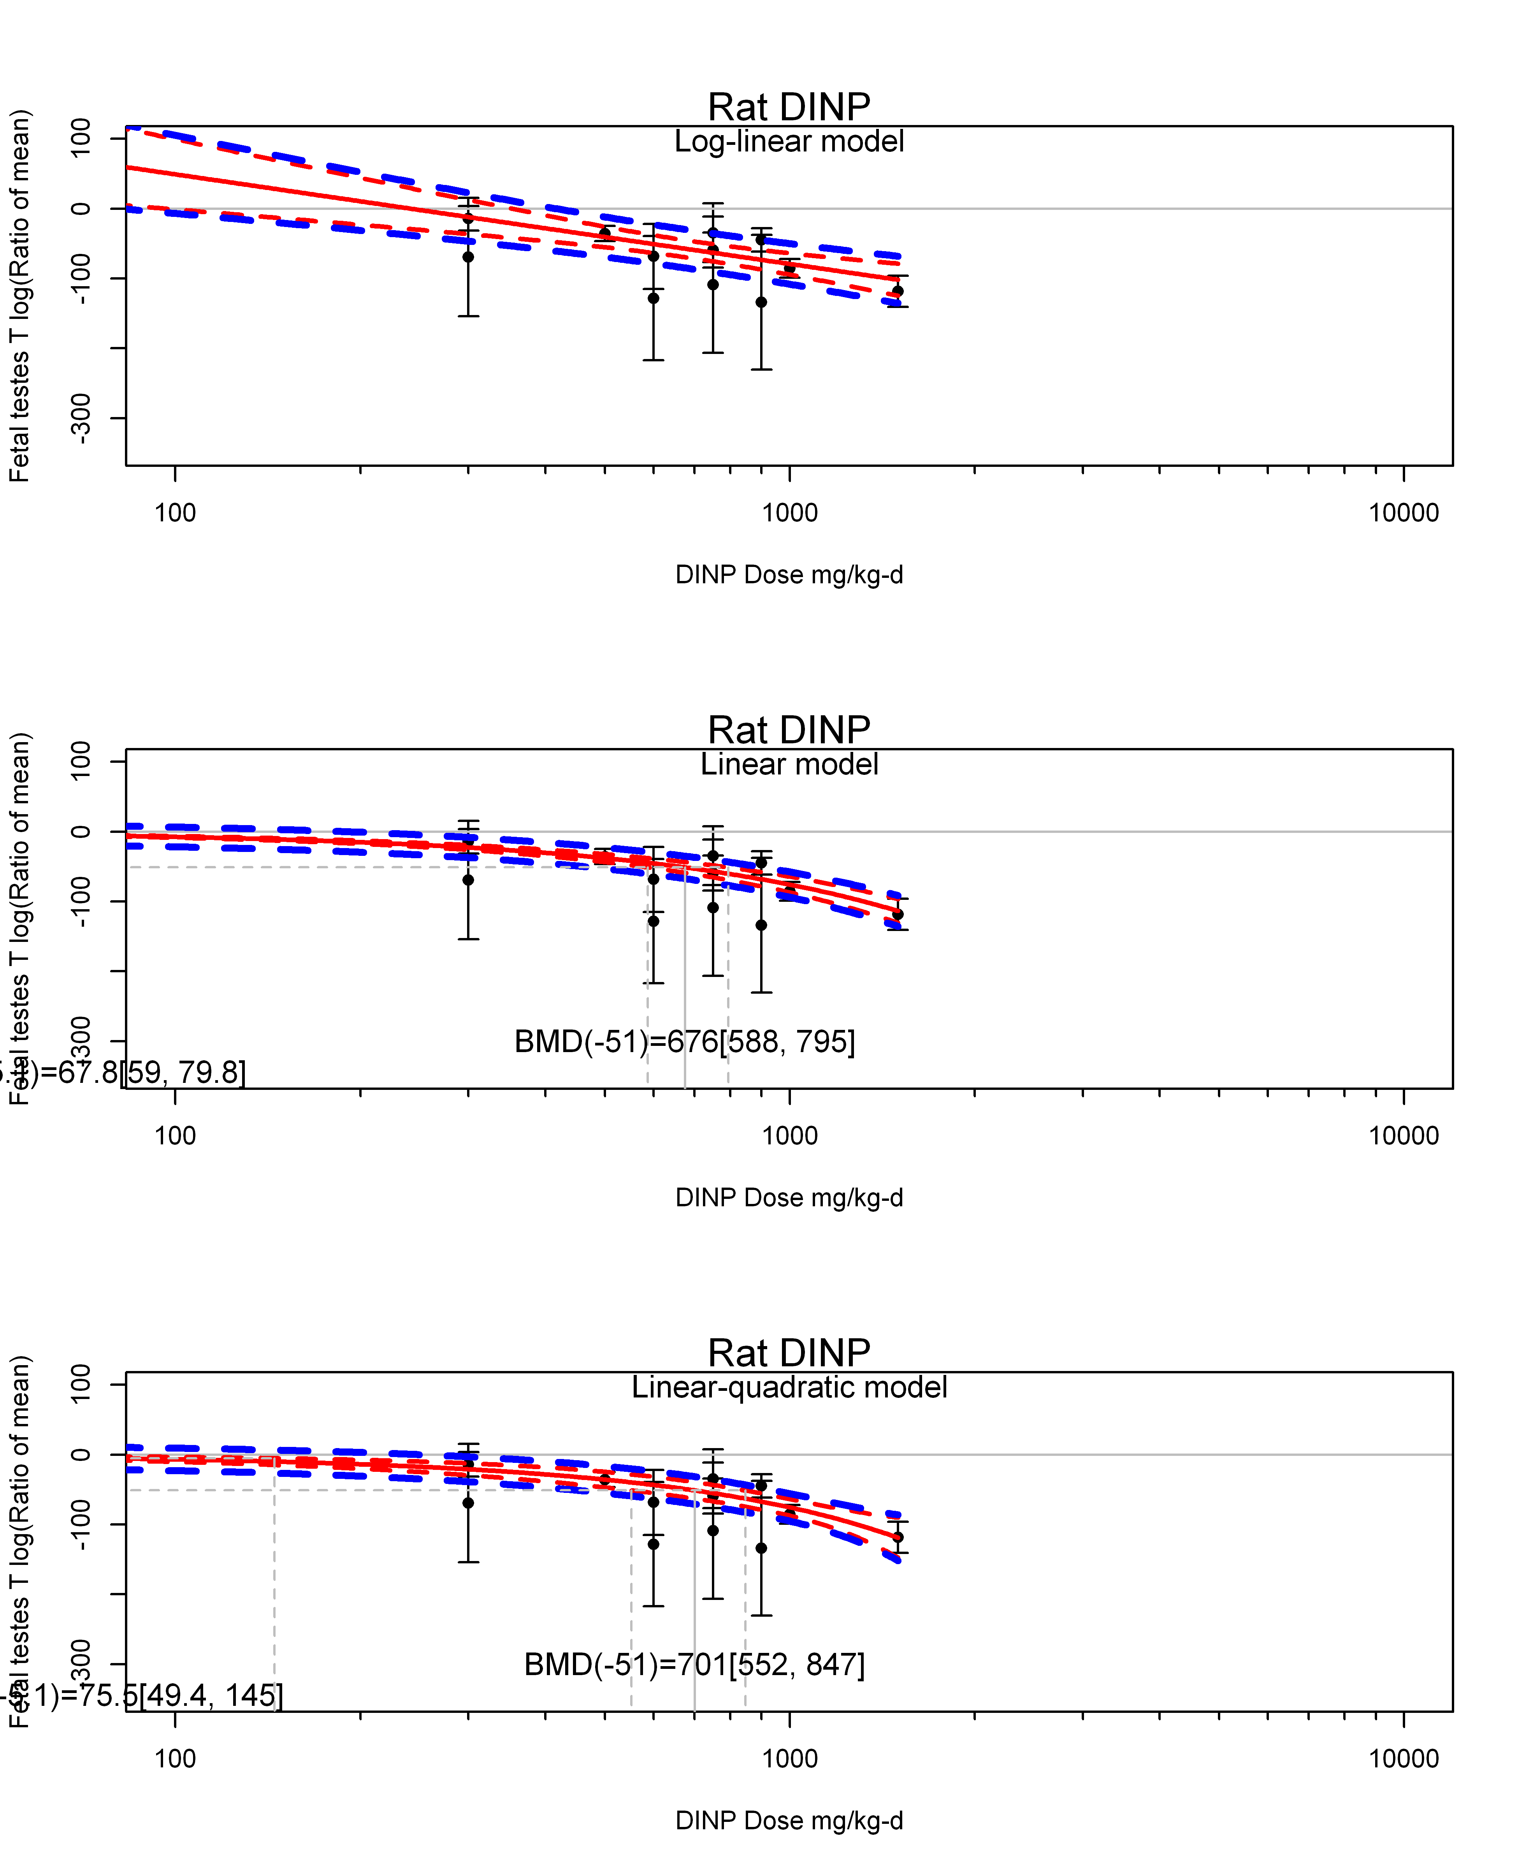

## [1] ""  
## m ci.lb ci.ub bmr  
## 1 75.48175 49.35975 144.9261 -5.129329  
## m ci.lb ci.ub bmr  
## 1 700.6301 552.3539 846.547 -51.08256  
## [1] "Fetal testes T log(Ratio of mean) Rat Highest Dose"  
## [1] "Fetal testes T log(Ratio of mean) Mouse"  
## [1] "Fetal testes T log(Ratio of mean) Rat"  
## [1] "Fetal testes T log(Ratio of mean) Mouse"  
## [1] "Fetal testes T log(Ratio of mean) Rat"  
## [1] "Fetal testes T log(Ratio of mean) Mouse"